1. POST /public/v2/users

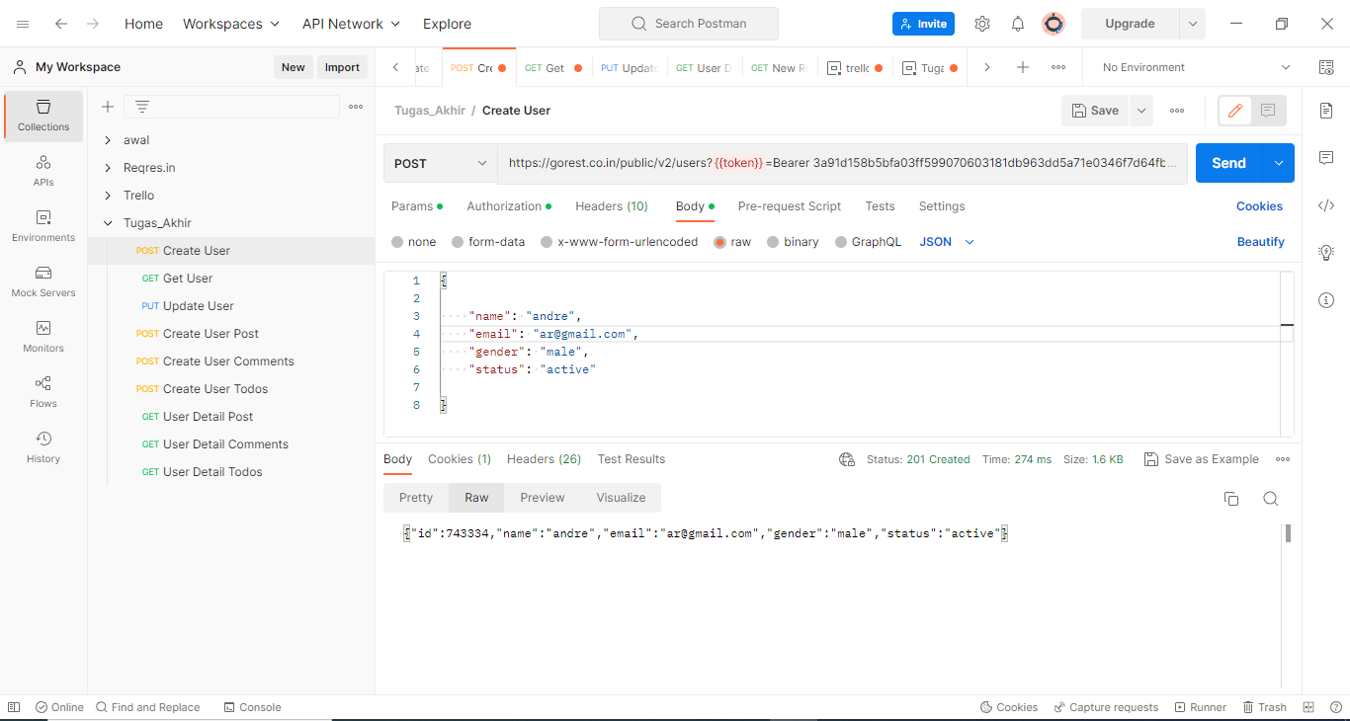

1. GET /public/v2/users/741595

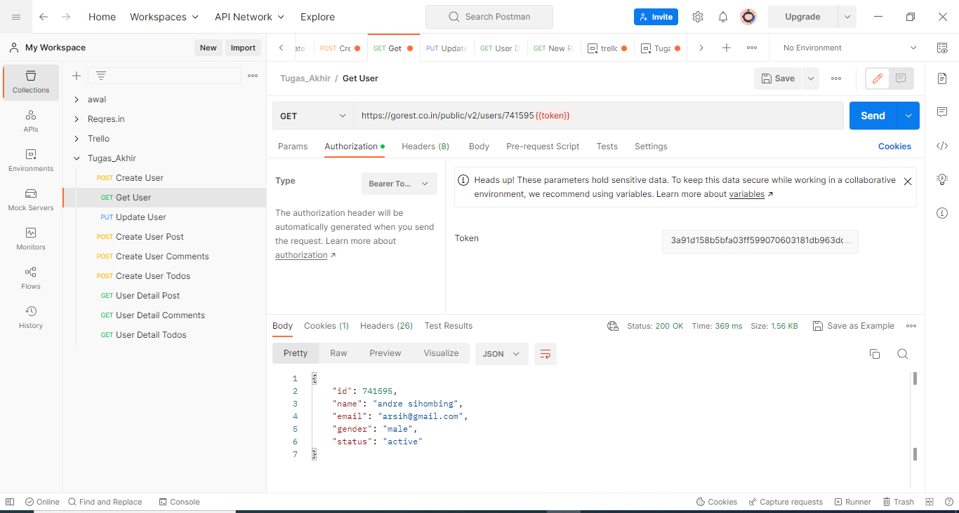

1. PUT|PATCH /public/v2/users/741595

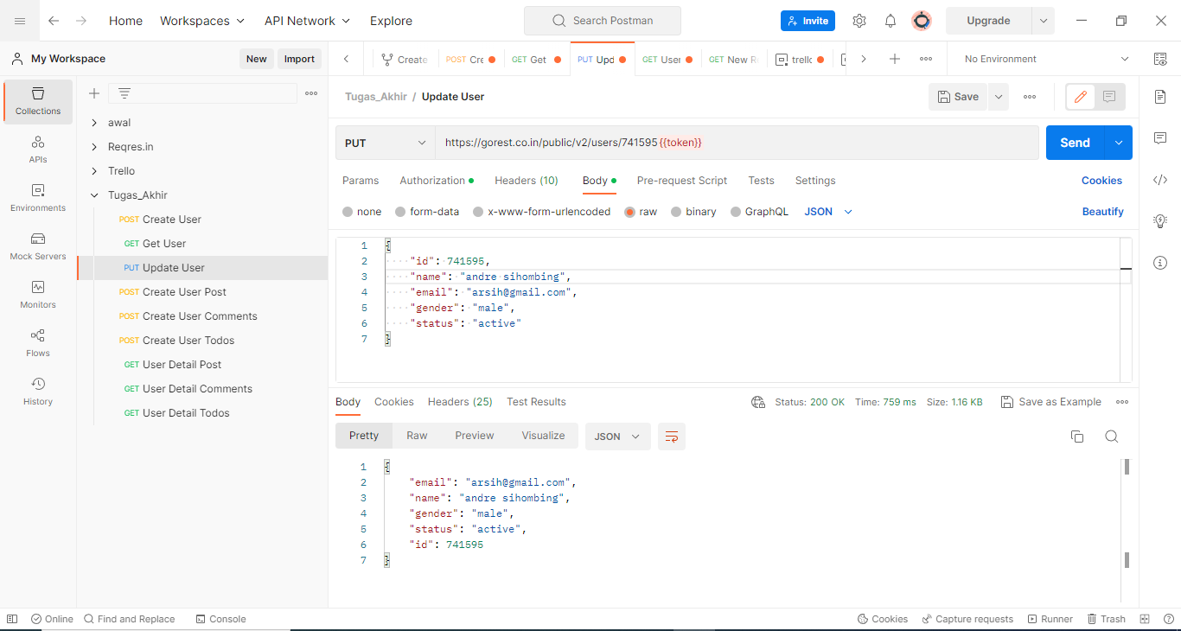

1. DELETE /public/v2/users/326

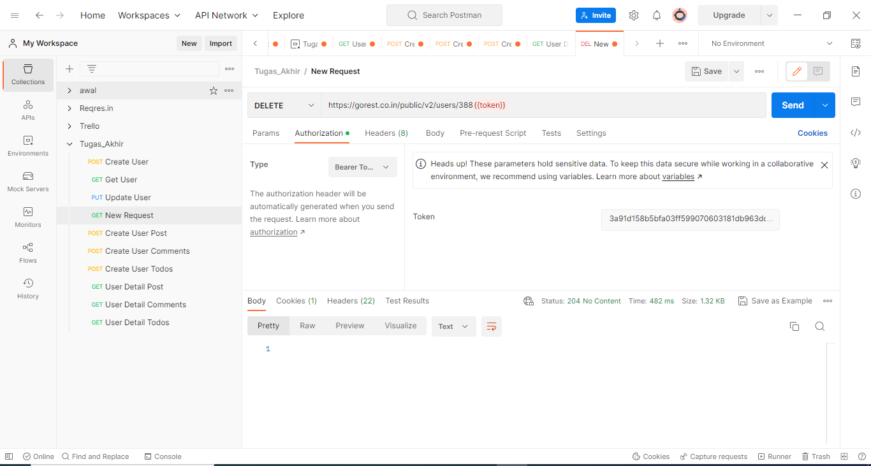

1. GET [/public/v2/users/741595/posts](https://gorest.co.in/public/v2/users/346/posts)

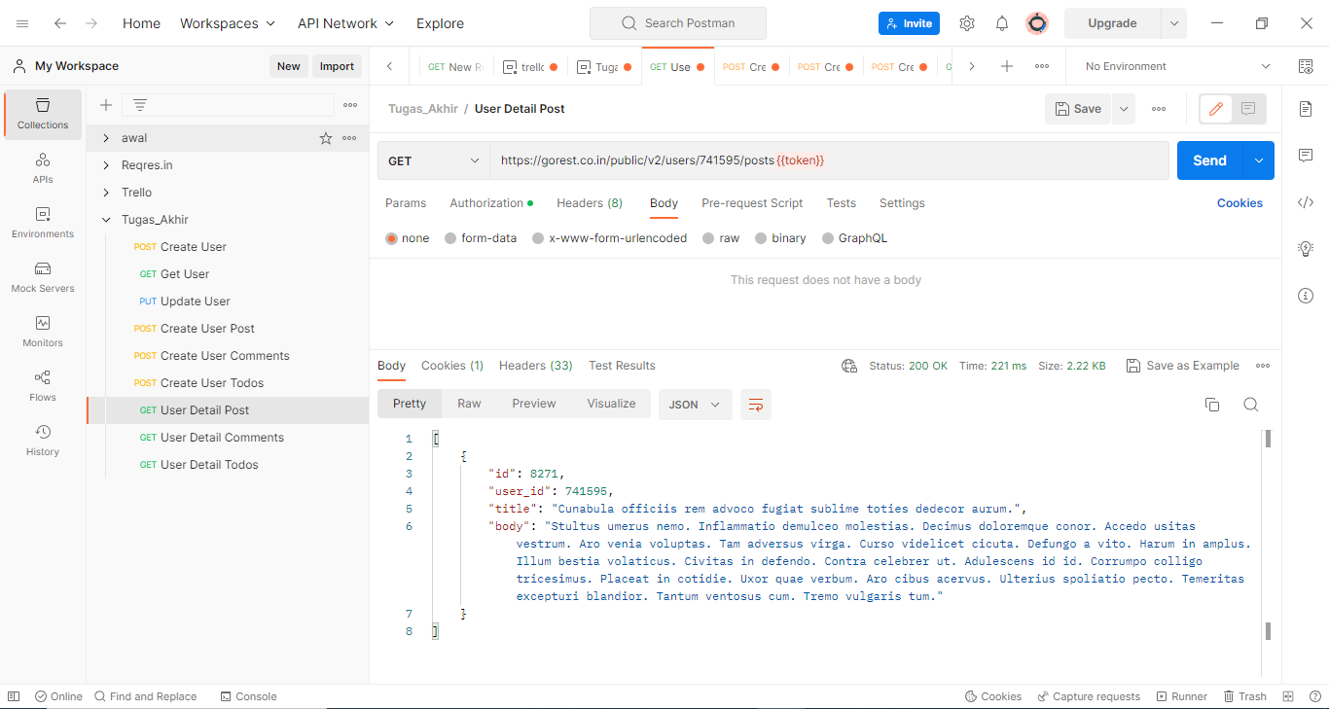

1. GET /public/v2/posts/388/comments

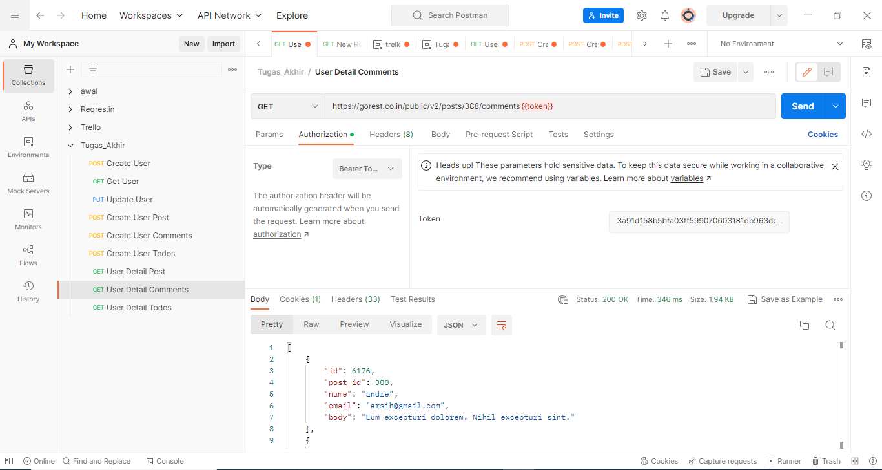

1. GET [/public/v2/posts/388/todos](https://gorest.co.in/public/v2/posts/346/comments)

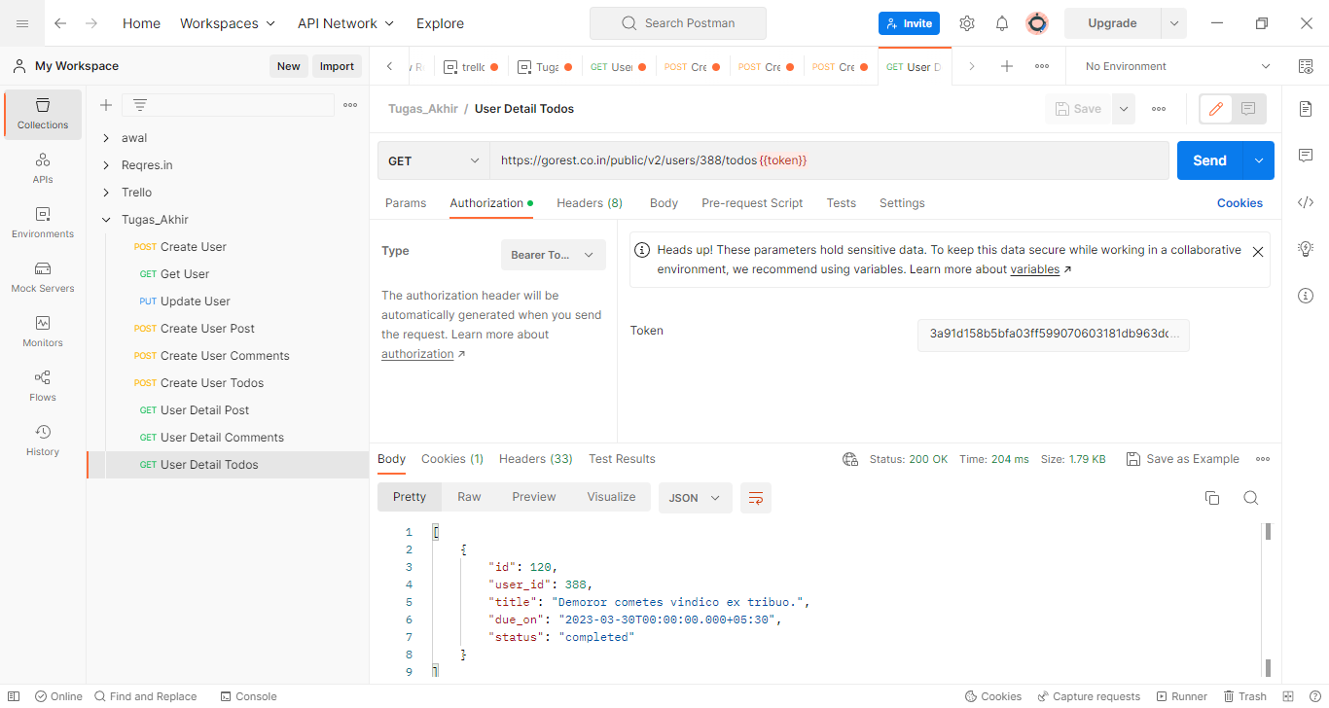

1. POST /public/v2/users/741595/posts

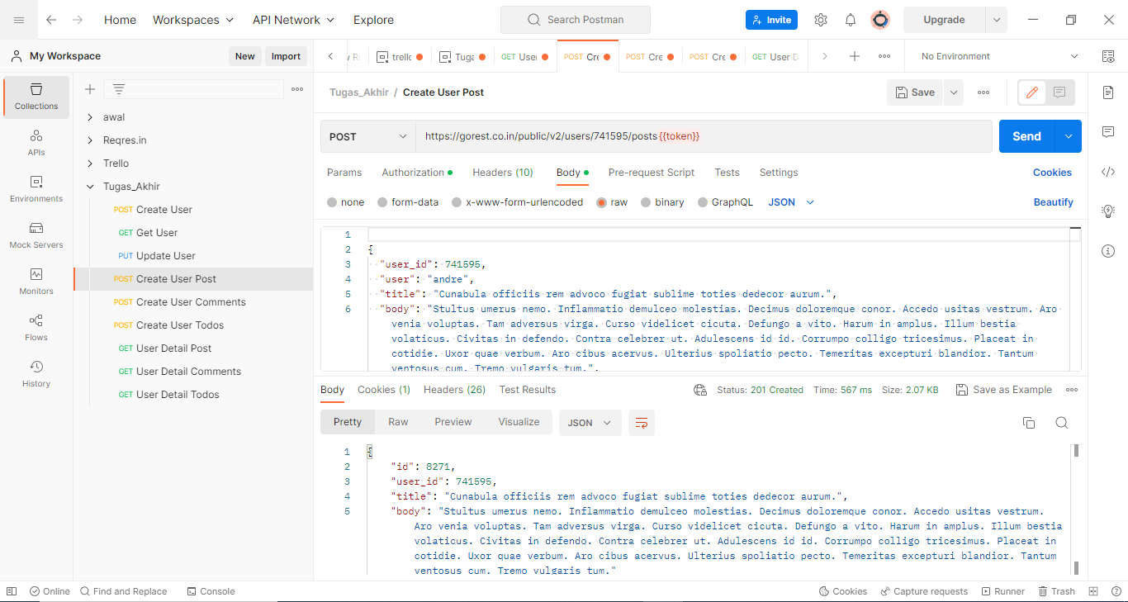

1. POST /public/v2/posts/388/comments

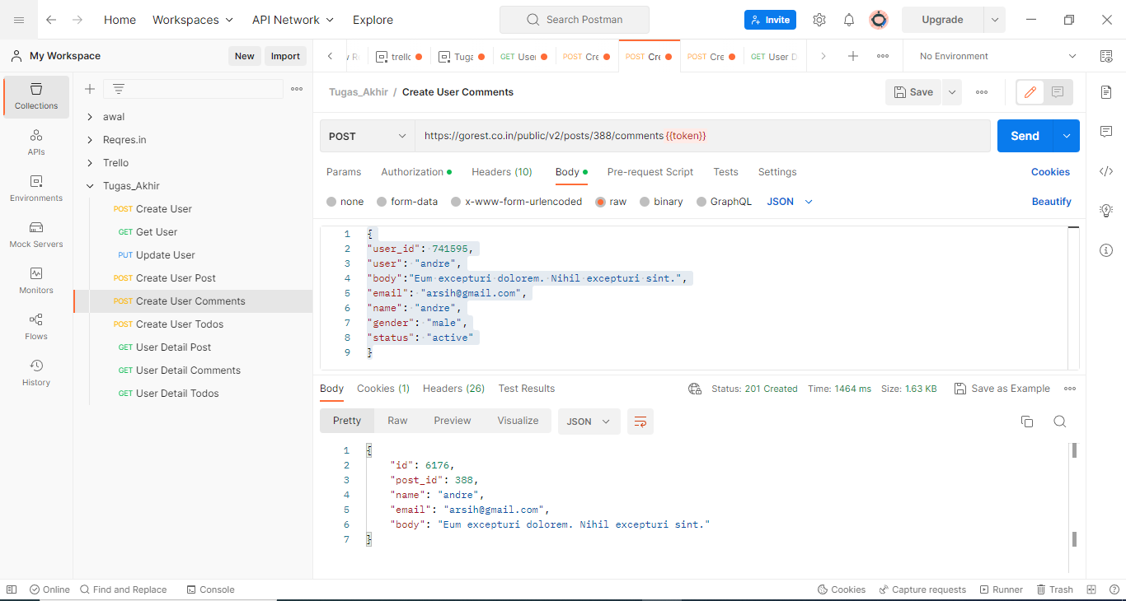

1. POST /public/v2/users/388/todos

