<https://mas2023.atlassian.net>

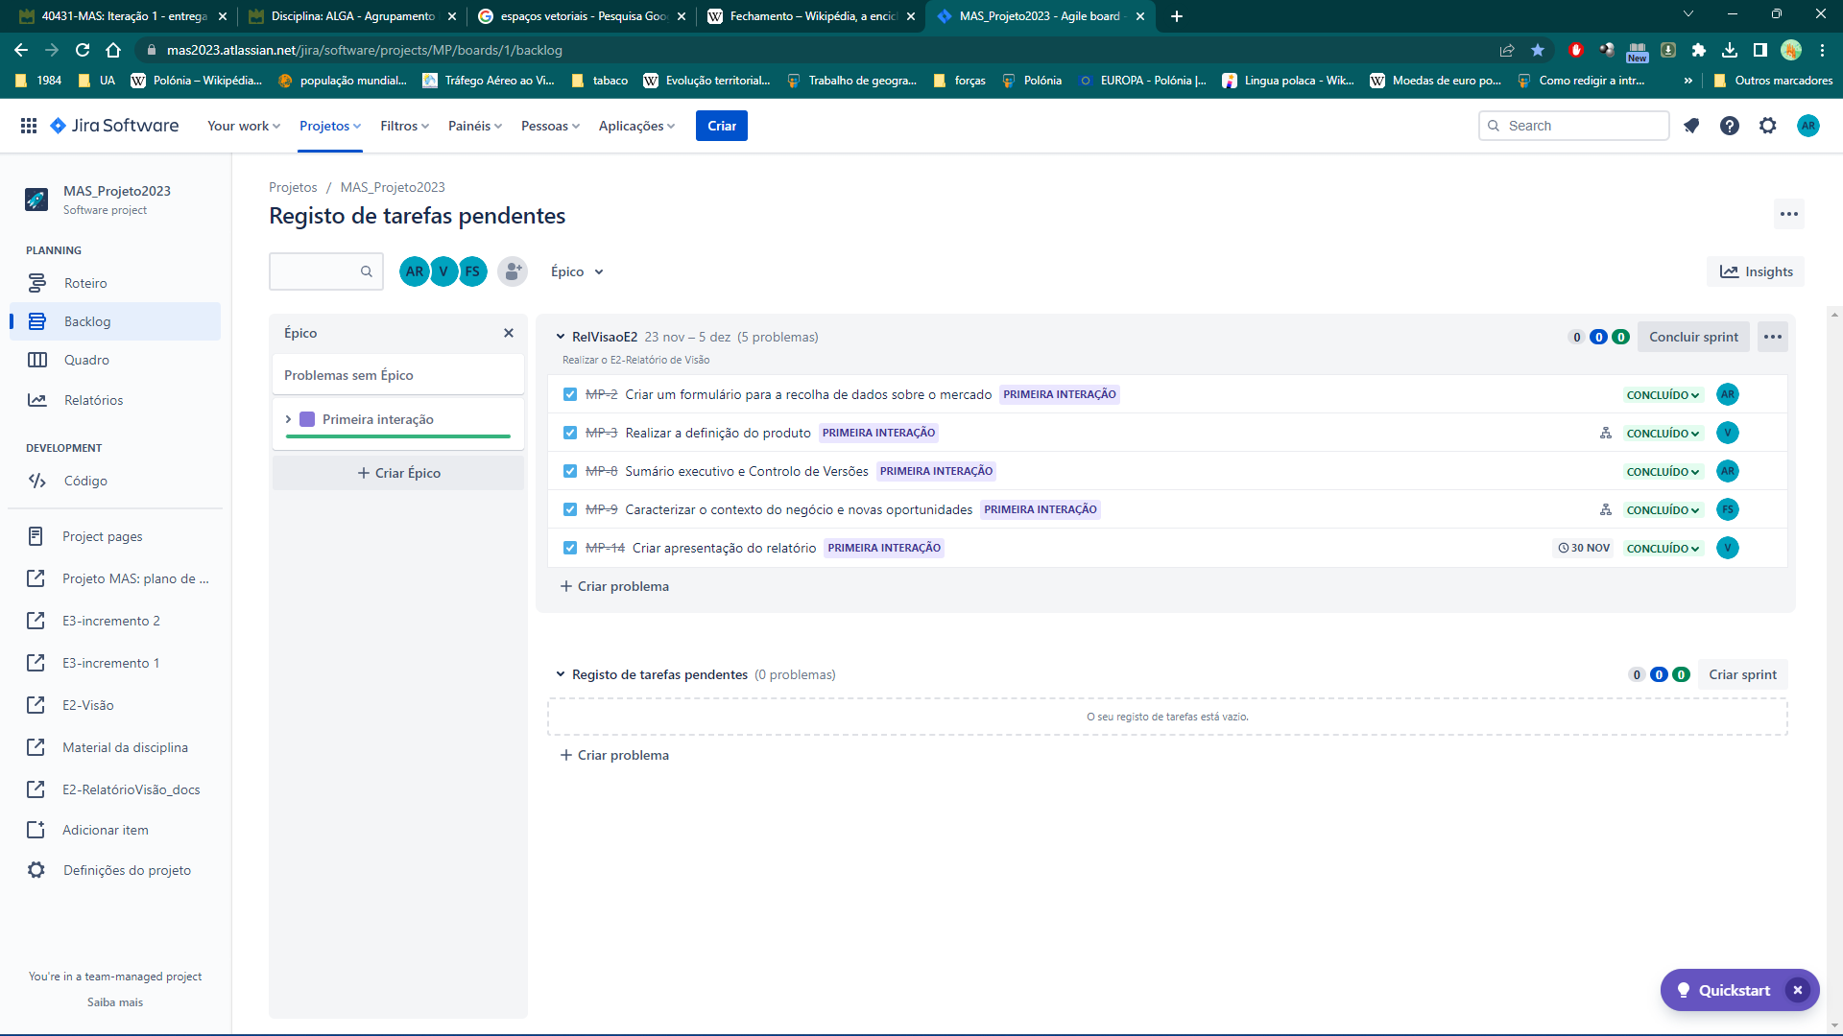

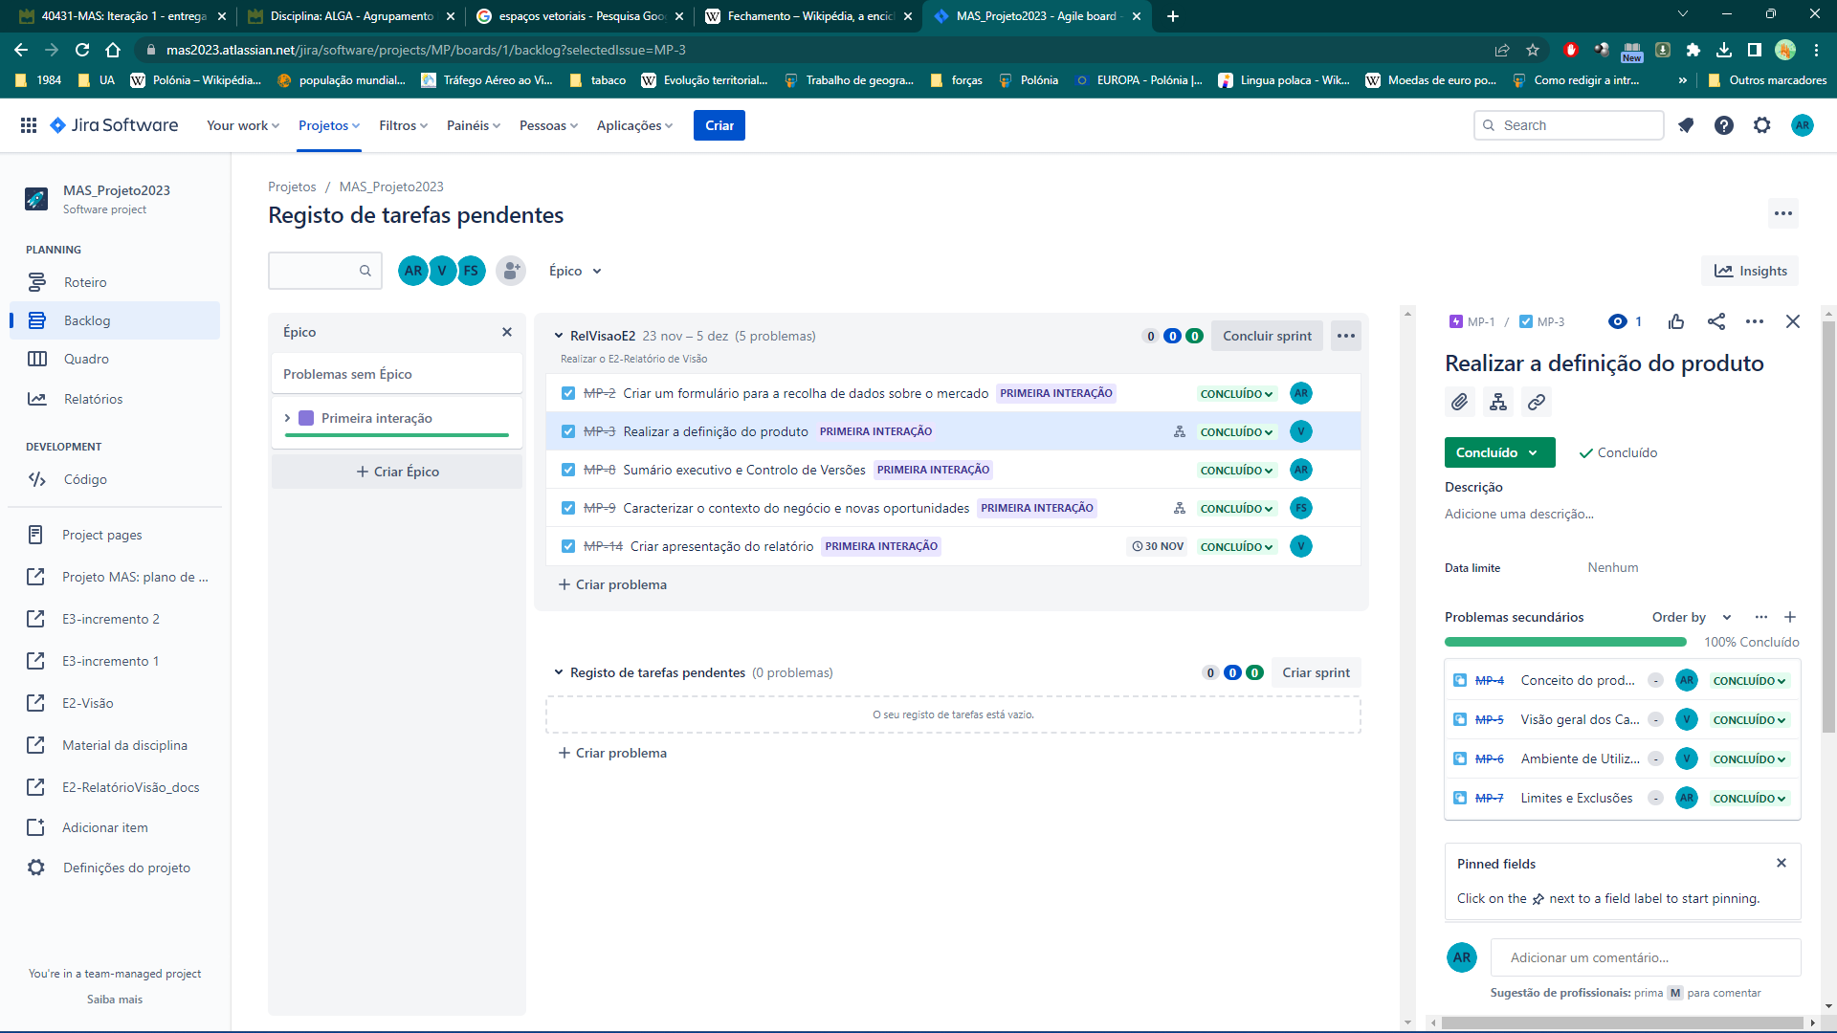

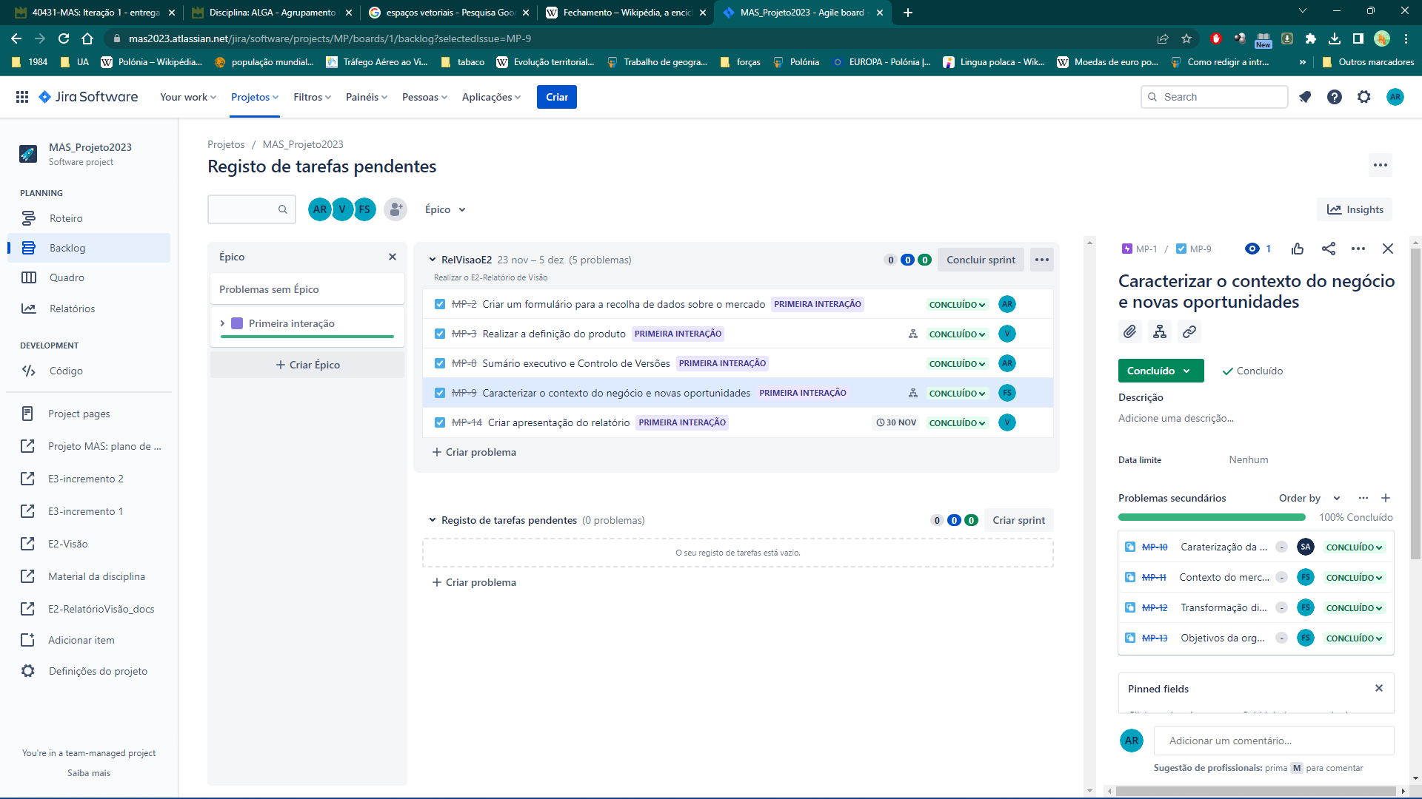

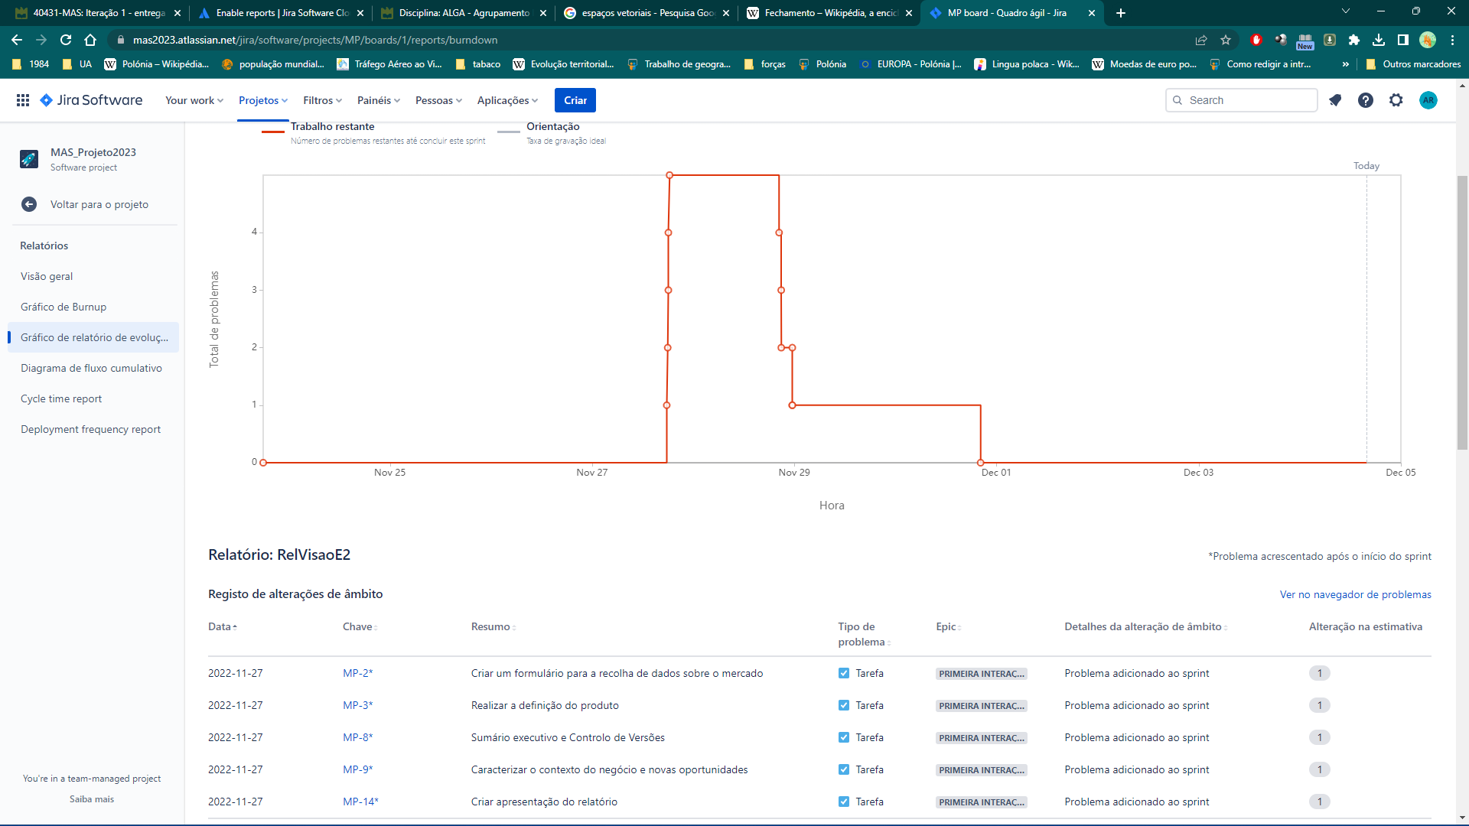

**André Ribeiro (112974), Daniel Ramos (113170), Filipe Sousa (114196), Shelton Agostinho (115697)**