Table of Contents

Adding Decision Support to RPA Deployments 1

# Adding Decision Support to RPA Deployments

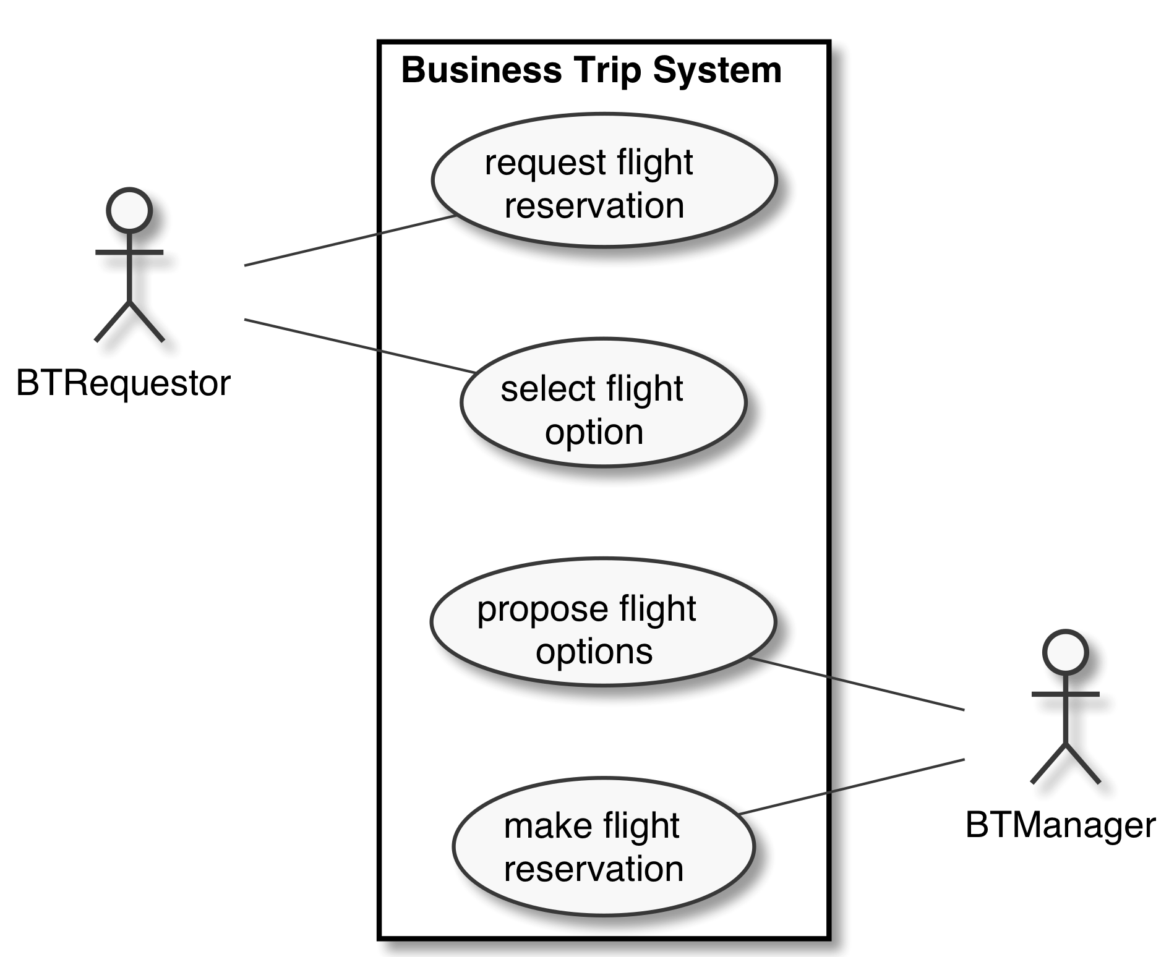

Flight Reservation Use Cases

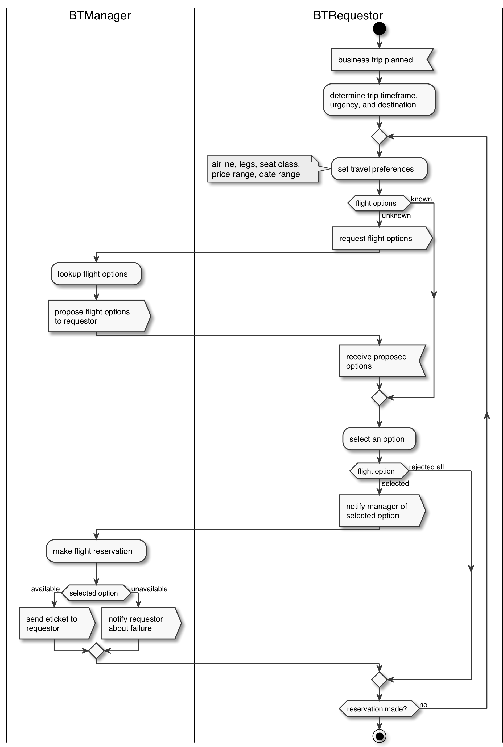

Flight Reservation Process

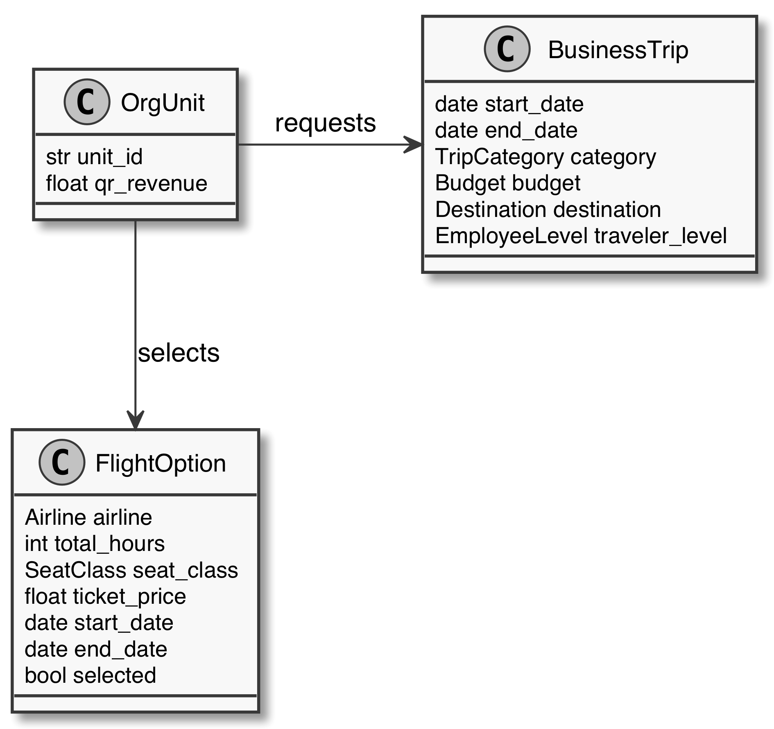

Flight Reservation Domain

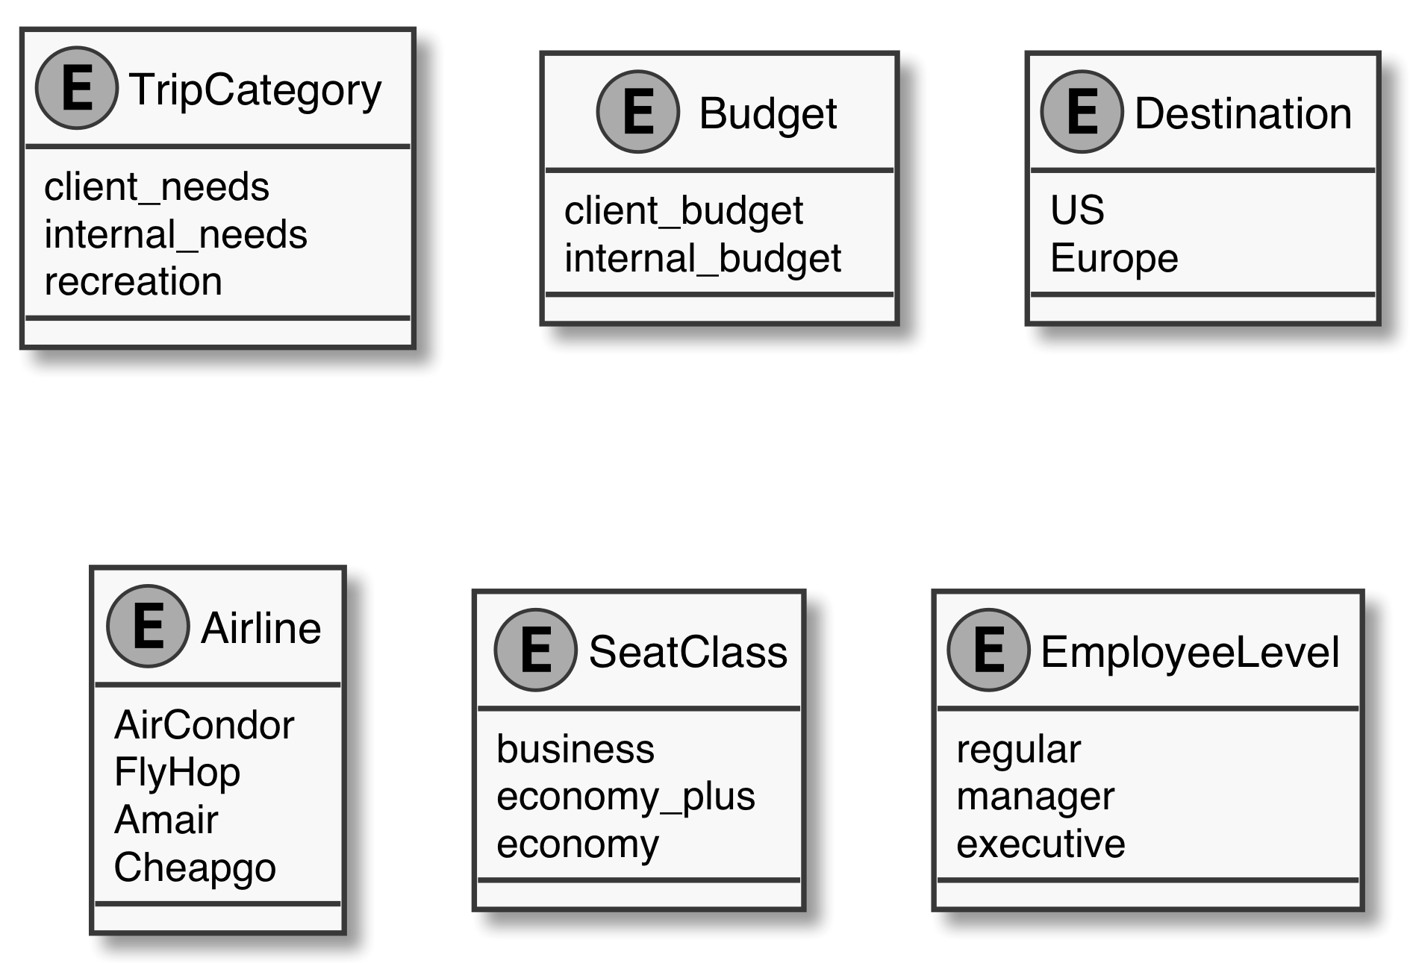

Flight Reservation Factors

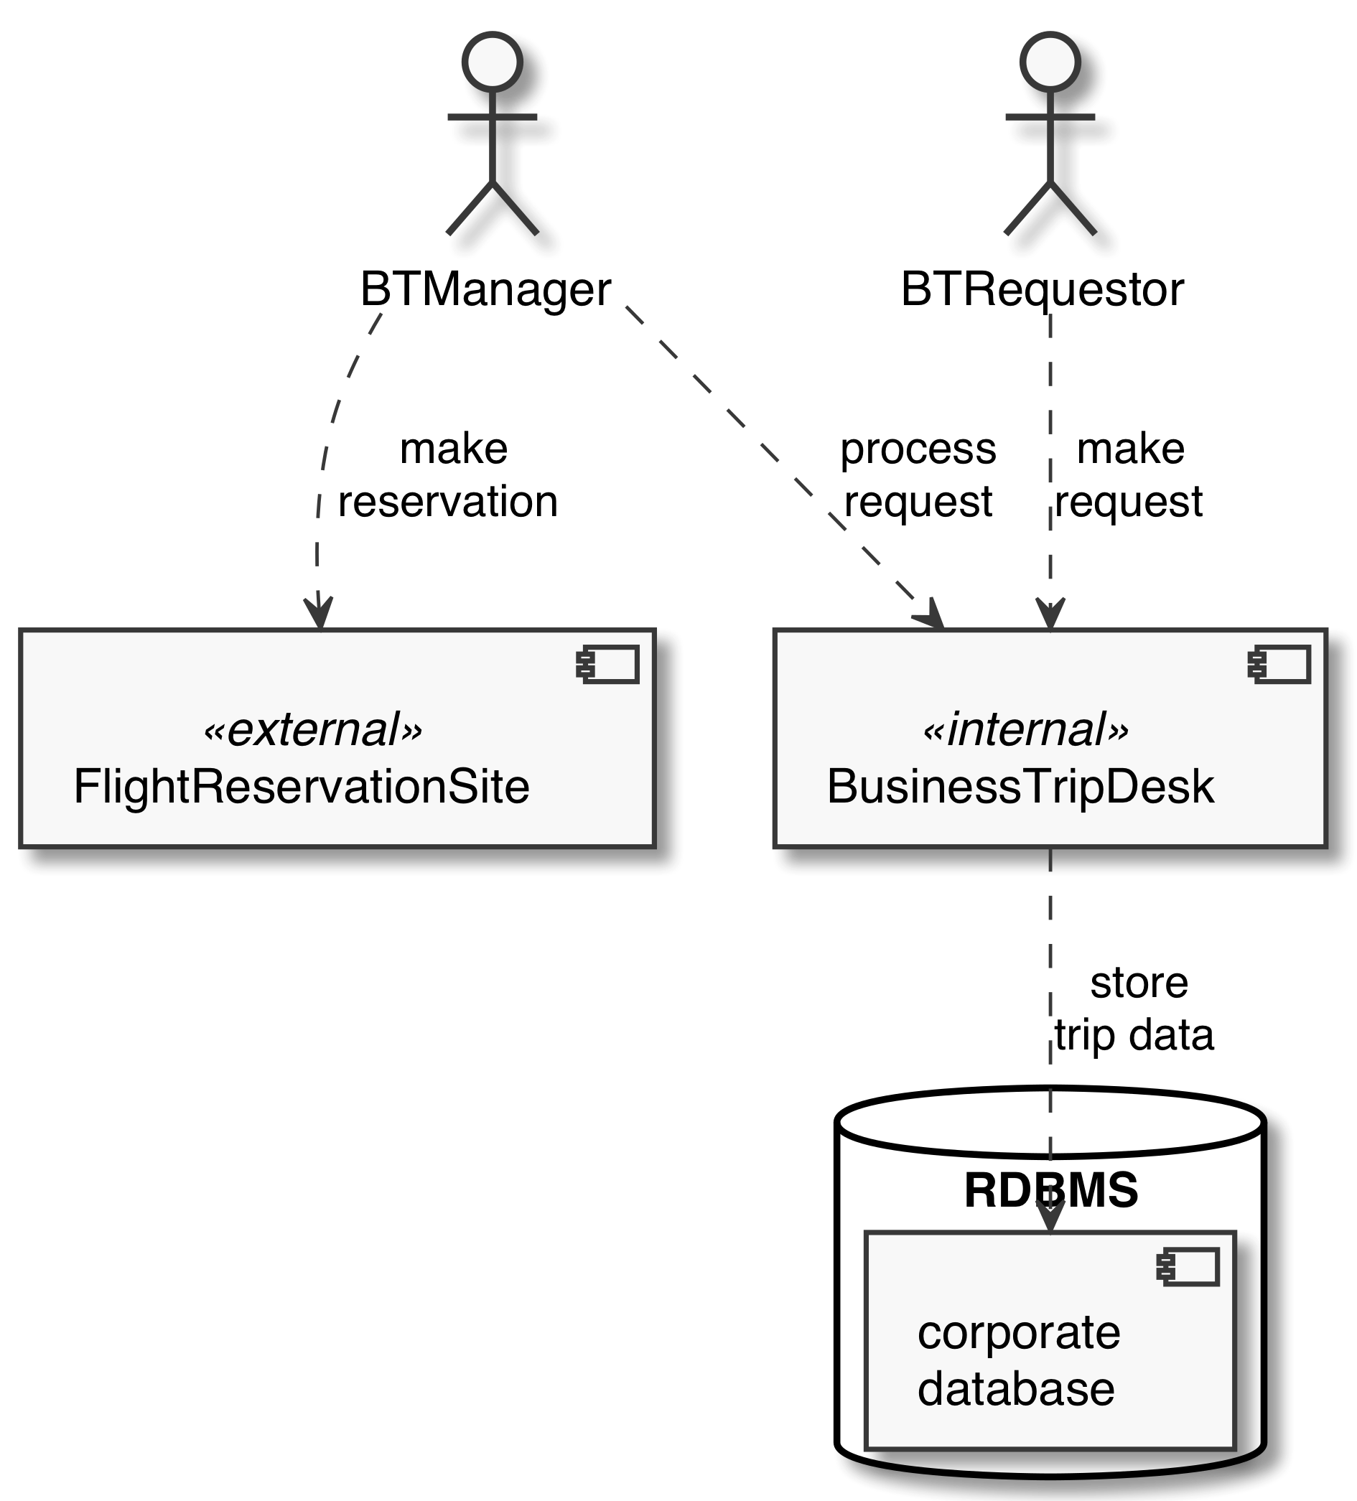

Flight Reservation System

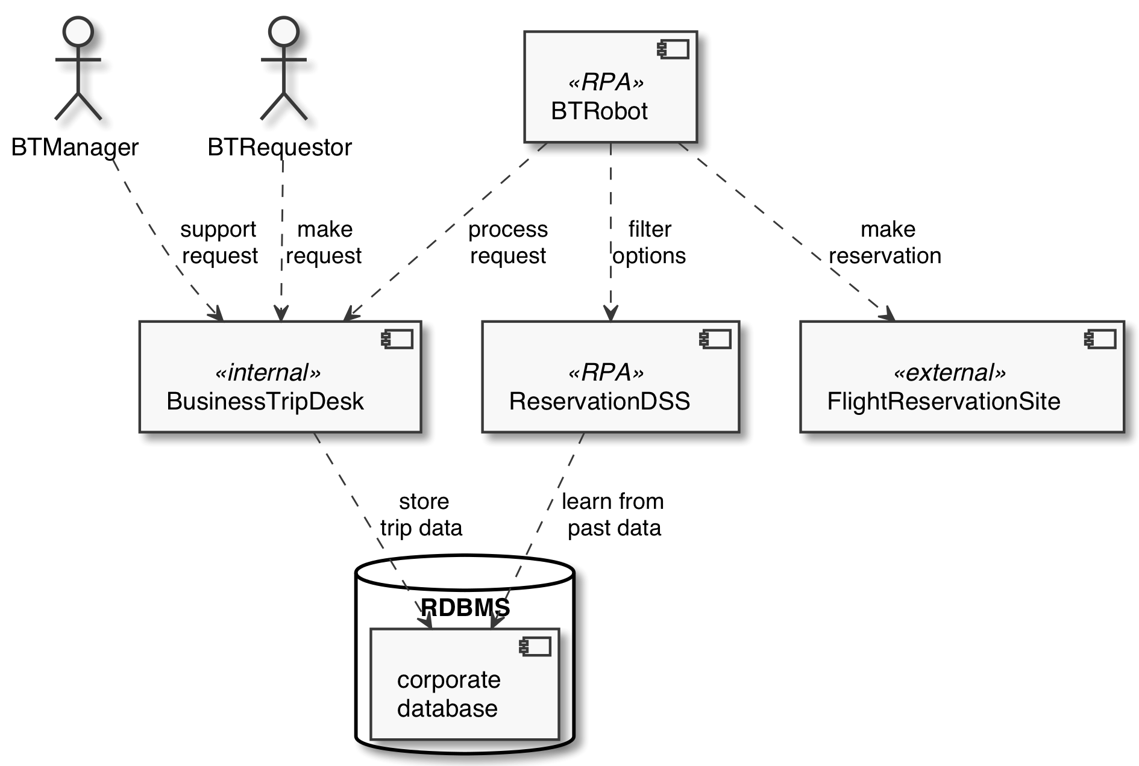

Flight Reservation System RPA

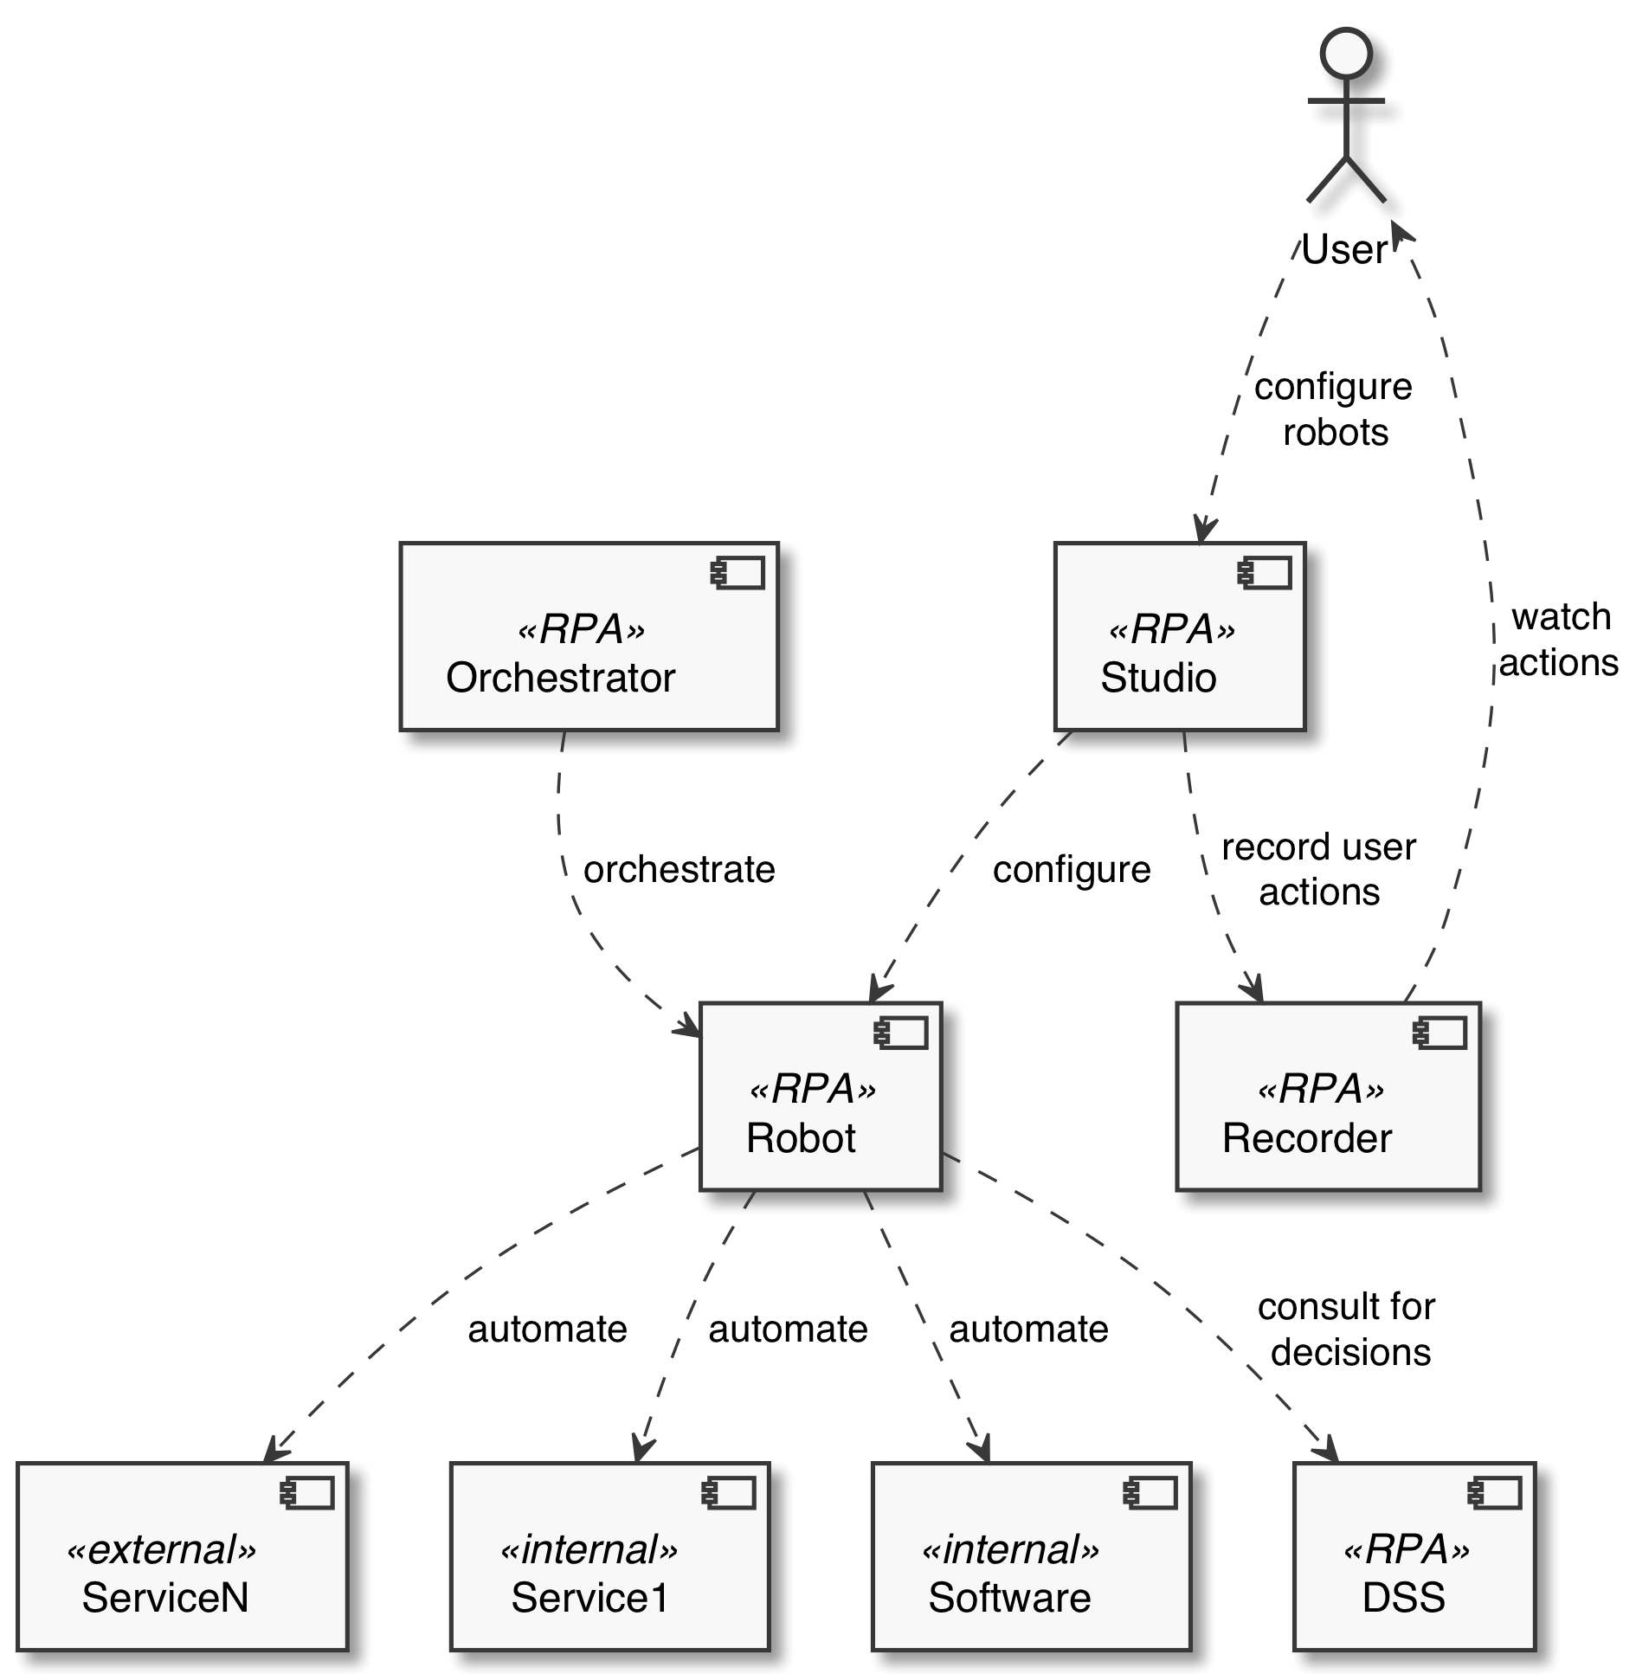

Reference RPA Architecture with DSS

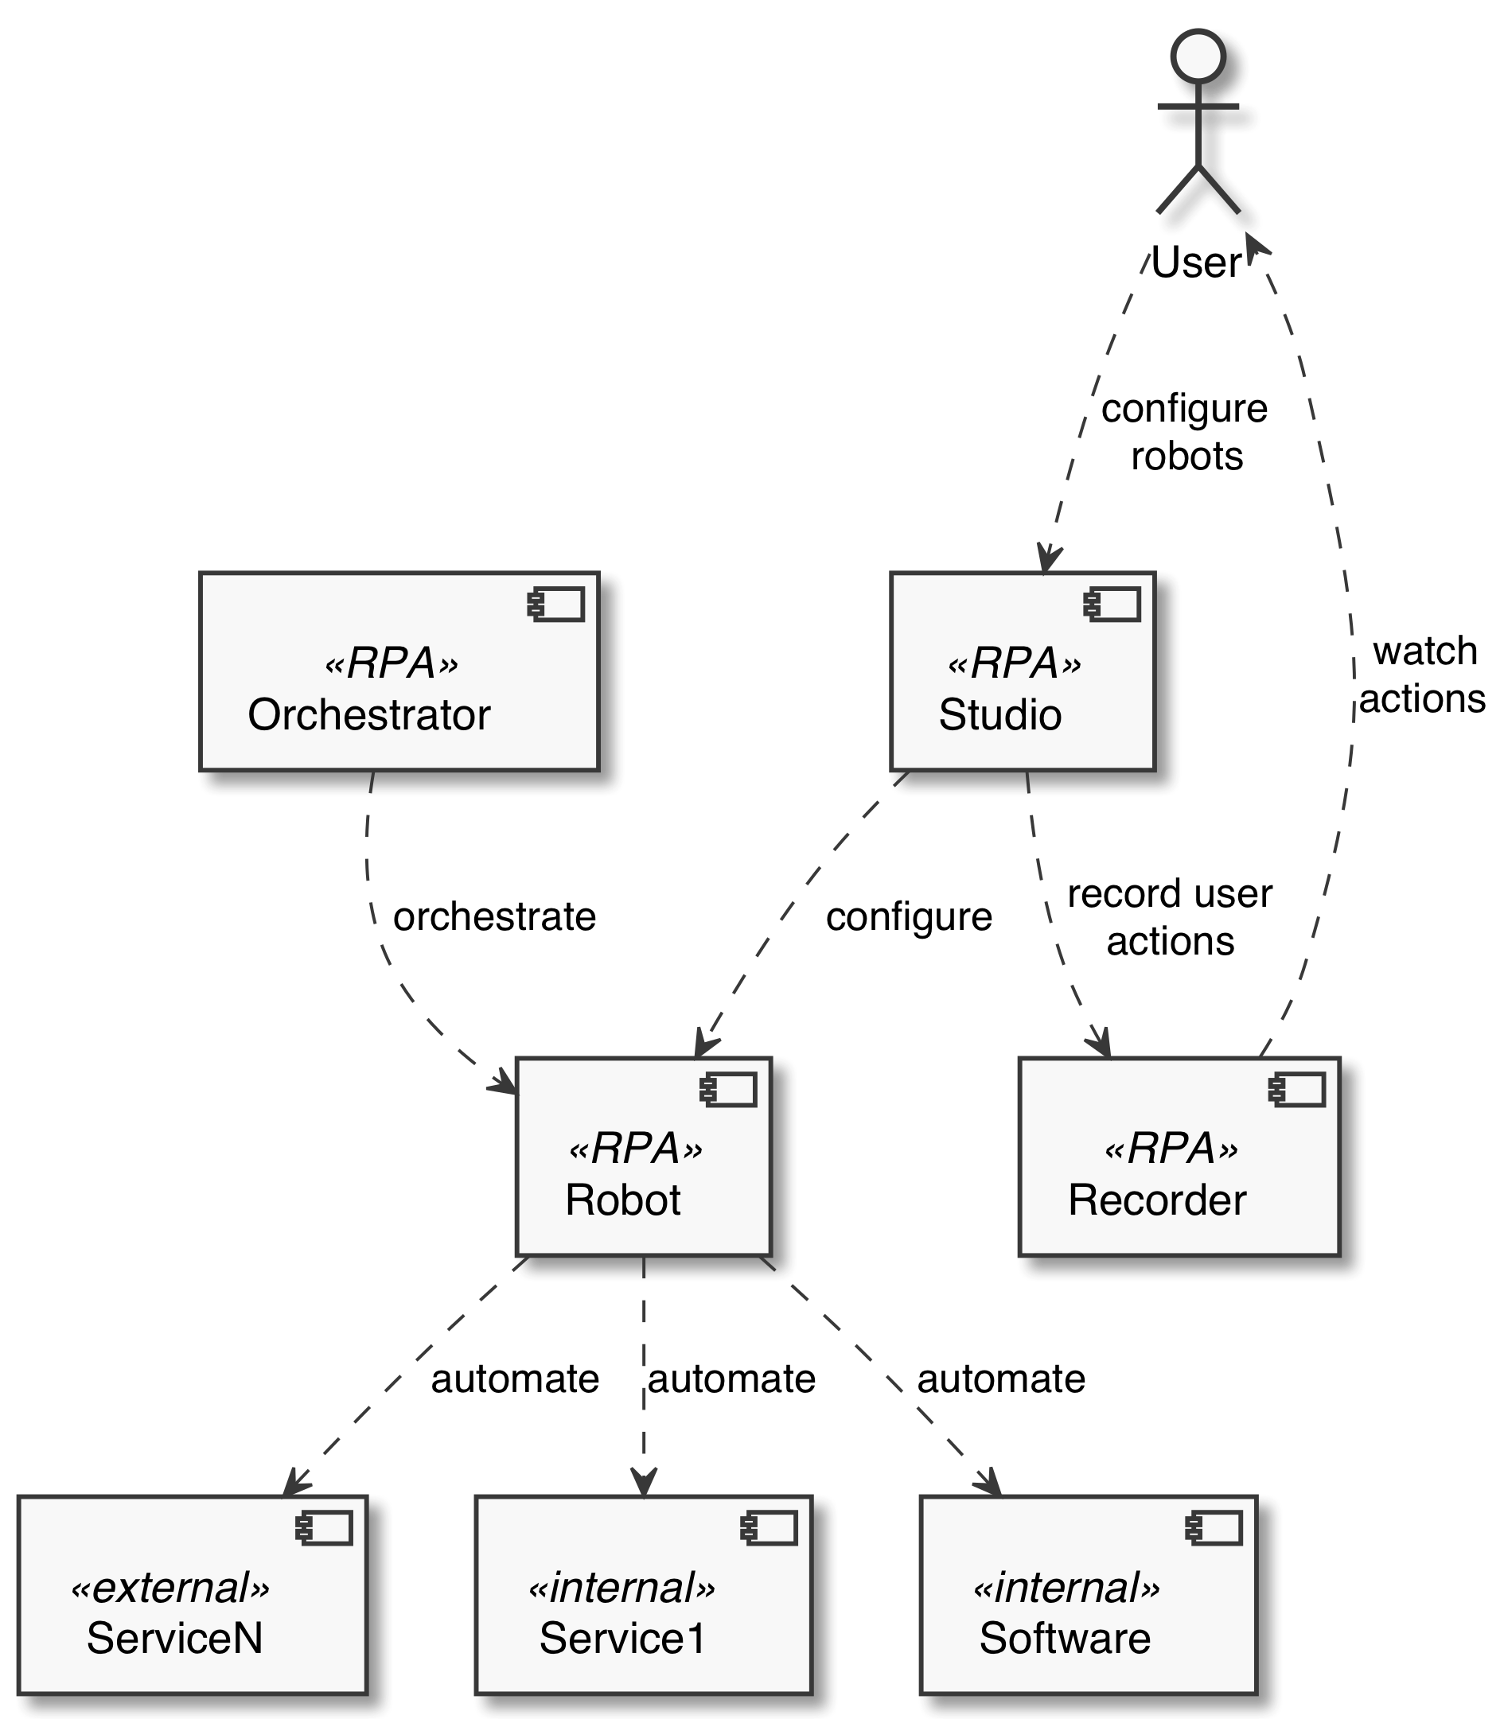

Reference RPA Architecture