Lab 3: Bayes Filter
EEME E6911 — Probabilistic Robotics
Howard Wang | UNI: hw3214
Andres Permuy | UNI: app2164
Samwel Waweru | UNI: swk2139

Assignment 1: Vision pipeline nodes
How many ROS nodes (including the simulation model interface) does the vision pipeline that produces /feature_mean topic consist of? List node names.
rqt_graph screenshot

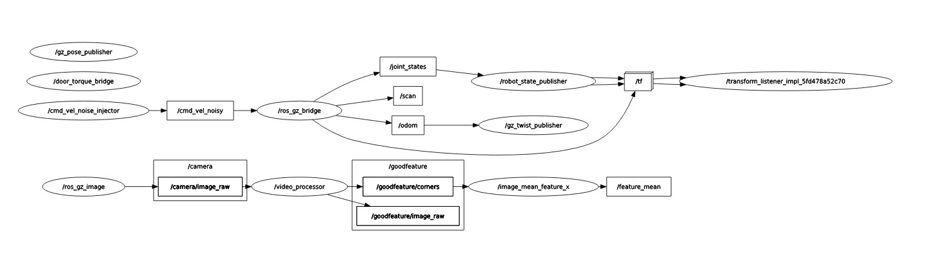
Figure 1: rqt_graph of the vision pipeline producing /feature_mean.
# | Node name | Role (subscribes to / publishes)
1 | /ros_gz_image | Simulation model interface. Bridges the Gazebo camera image to the ROS topic /camera/image_raw.
2 | /video_processor | Subscribes to /camera/image_raw, runs Shi-Tomasi corner detection, and publishes /goodfeature/corners (pixel coordinates) and the annotated /goodfeature/image_raw.
3 | /image_mean_feature_x | Subscribes to /goodfeature/corners, computes the mean x-coordinate of the detected features, and publishes /feature_mean.

Total number of nodes: 3 Nodes

Assignment 2: How open-door detection works
Explain in your own words how the detection of the open door works using the feature-mean signal. Think about which features the vision algorithm picks up and what happens to the features as the door opens and closes.
The camera algorithm detects distinctive features in the image, such as corners around the door handle, door frame and other textured parts of the scene as shown in Figure 2. As the door opens and rotates around its hinge, the handle and other features on the door change their positions in the camera's image. This changes the mean horizontal coordinate of all the detected features, which is published as the feature-mean signal. By observing how this signal changes when the door opens and closes, we can choose a threshold to distinguish between the two states. If the feature-mean signal crosses the threshold, the robot can determine that the door is open or closed, depending on the direction of the change.

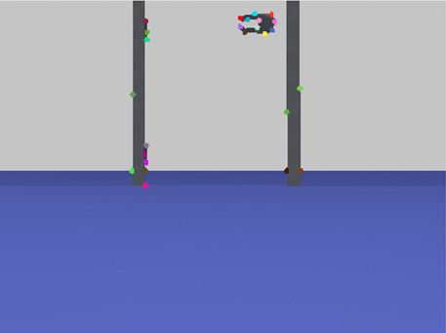
Figure 2: Camera View: The colored points represent detected visual features.

Assignment 3: Threshold from the feature-mean plot
Open and close the door a few times and capture the feature-mean signal on the plot. Take a screenshot and use the plot to determine the threshold. Include the annotated plot in your lab report.
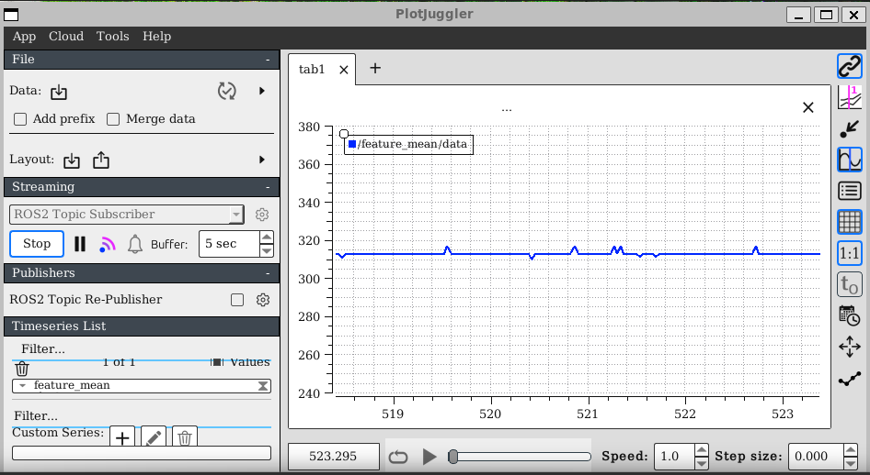
312.5
Figure 3: /feature_mean while the door is closed (no fire truck)..

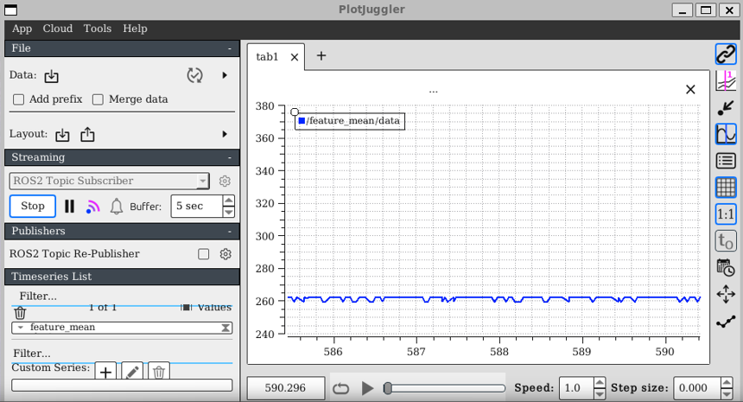
262.5

Figure 4: /feature_mean while the door is opened (no fire truck)..
Quantity | Value | Comment
Typical feature mean, door closed | 312.5 | Signal when door is closed (ignoring noise)
Typical feature mean, door open | 262.5 | Signal when door is opened (ignoring noise)
Chosen threshold | 287.5 | The midpoint between the open and closed values. A feature mean below 287.5 indicates an open door, while a value above 287.5 indicates a closed door.

Assignment 4: Motion node that checks the door before moving
Modify the node from the previous lab that instead of waiting for some arbitrary time for the door to presumably open uses the feature-mean signal to check that the door is open before proceeding forward. Submit the code.

Part 2: Background Noise and Uncertainty
Simulation launched with the fire truck visible through the door (turtlebot3_door_and_firetruck_launch.py, run_vision_processor:=true).

Assignment 5: Noise statistics and conditional probabilities
Write the node that subscribes to the feature-mean topic and, for a given time window and given threshold value, reports how many times the signal was above and below the threshold. Use the measurements to estimate the four conditional probabilities: P(z=open | x = closed), P(z=closed | x = open), P(z=open | x=closed), and P(z=closed | x=closed). Submit the plot that justifies your selection of the threshold and mark example measurements that can create confusion.

Assignment 6: Bayesian inference to decide if the door is open
Extend the control node to use Bayesian inference to decide if the door is open. The node should estimate the probability of the door being open and compare it with a threshold. The threshold is a tradeoff between not bumping into the door and the motion delay. Good values are 0.999, 0.9999, or 0.99999, etc. Submit the code and calculated beliefs during the transition.

Part 3: Full Bayes Filter
Simulation launched with run_door_opener:=true so that the /flaky_door_opener node and /door_open topic are available.

Assignment 7: Flaky door opener probability

Publish to the door-open topic multiple times and record if the door has opened or not. If the door opens, close it by publishing to the hinge-torque topic and continue to publish to the door-open topic. Do enough measurements to estimate the probability of door opening when commanded. Find the Flaky Door Opener code in the repository and deduce from the code what the actual probability is. Report both numbers.

Assignment 8: Controller with a full Bayes filter
Design the controller that attempts to open the door using the door-opener topic, and estimates the probability of the door being opened using the Bayes filter. Use the probabilities you measured to design the prediction and measurement model. The robot should move if the estimated probability of the door being open is 0.99 or higher. Submit the code and demonstrate to the instructor that your estimator works.

