**GOLAZO!**

By: Andrés Vasquez

andres.vasquez.agramont@gmail.com

App for Bolivian soccer fans

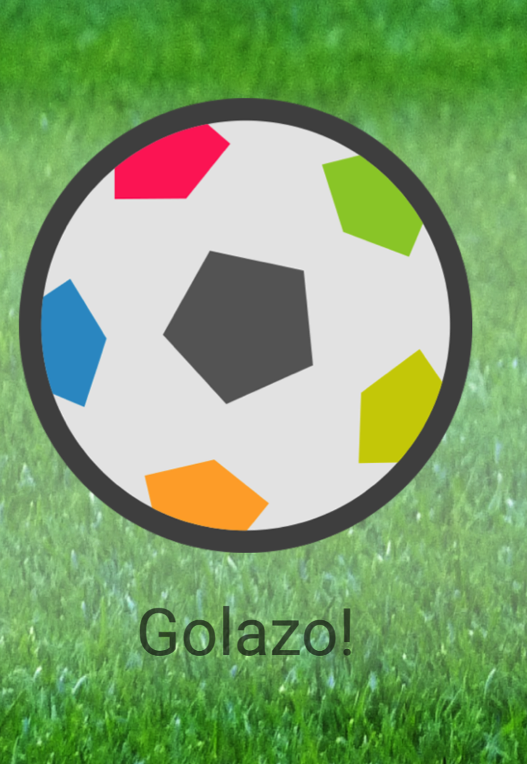

**PROBLEM.**

There are many mobile applications for sports, talking about soccer you can find a lot, however, most it covers many international leagues and can’t find rich information about the Bolivian Professional Soccer League.

**SOLUTION:**

This application provides to fans of the Bolivian soccer the complete information about Bolivian soccer teams such as players, lineups, scores, matches and notifications for each goal made.

The user can follow local soccer matches updated minute by minute with our web platform, this project will be presented to dedicated Radio emisor or TV Program for maintain updated all the info bringing to the user the best soccer fan experience.

This Android mobile Application still in development and I'm planning publish it on Google Play Store when the Web Platform and User Interface looks better but I consider sending this Release for educational purpose expecting positive feedback about it.