ZEPHYR 2012 Guidance, Navigation and Control Trade Study for the Guidance Computer and Inertial Measurement Unit

Prepared by Date _______________

Sophie Taylor, Guidance, Navigation and Control

Checked by Date _______________

Scott Wong, Power and Propulsion

Approved by Date _______________

Joshua Ham, Project Manager

Authorised for use by Date _______________

Dr Felipe Gonzalez, Project Coordinator

Queensland University of Technology

CRCSS-EESE, GPO Box 2434

Gardens Point Campus

Brisbane, Australia, 4001.

**Revision Record**

|  |  |  |  |
| --- | --- | --- | --- |
| Document Issue/Revision Status | **Description of Change** | **Date** | **Approved**  **by** |
| 1.0 | Initial Issue | 17 May 2012 | Joshua Ham |

**Foreword**

This document will outline a recommendation on a possible guidance computer and inertial measurement unit to be used in the on the UAV for the ZEPHYR 2012 project. The guidance computer will control the airborne segment of the Zephyr system, while the inertial measurement unit will determine the kinematic state vector. Both components will be required to be light weight, cheap, and consume little power.

In this document different computers and inertial measurement units will be analysed, this includes discussing both the advantages and disadvantages. After analysing the different types of sensors the appropriate sensors will be selected for the guidance, navigation and control subsystem of the ZEPHYR 2012 project.

**Table of Contents**

**List of Figures** 6

**List of Tables** 7

**Definitions** 8

1 Introduction 9

1.1 Scope 9

1.2 Background 9

2 Reference Documents 11

2.1 QUT Avionics Documents 11

2.2 Non-QUT Documents 11

3 Background Research 12

3.1 Guidance computer 12

3.2 Navigation 12

3.2.1 Dead reckoning 12

3.2.2 Radio triangulation 13

3.2.3 RADAR 13

4 Guidance, Navigation and Control Requirements 14

5 Criteria 15

5.1 Guidance Computer Assessment Criteria 15

5.1.1 Processor capability 15

5.1.2 Weight 15

5.1.3 Interfacing 15

5.1.4 RAM 16

5.1.5 Analogue to Digital Converters (ADC) 16

5.1.6 Max power usage 16

5.1.7 Price 16

5.1.8 Availability 16

5.1.9 Video out 16

5.2 Inertial Measurement Unit Assessment Criteria 16

5.2.1 Price 16

5.2.2 Degrees of freedom 16

5.2.3 Internal processing 17

5.3 Criteria Tables 17

5.3.1 Guidance Computer 18

5.3.2 Inertial Measurement Unit 19

6 Guidance Computer 1: BeagleBone 20

6.1 Summary 20

6.2 Characteristics 21

7 Guidance Computer 2: Raspberry Pi 22

7.1 Summary 22

7.2 Characteristics 23

8 Guidance Computer 3: Ts-7260-64-128F 24

8.1 Summary 24

8.2 Characteristics 25

9 Guidance Computer 4: PandaBoard ES 26

9.1 Summary 26

9.2 Characteristics 27

10 Guidance Computer Comparison 28

11 Inertial Measurement Unit 1: ArduIMU+ V3 30

11.1 Summary 30

11.2 Characteristics 31

12 Inertial Measurement Unit 2: IMU Digital Combo Board - 6 Degrees of Freedom ITG3200/ADXL345 32

12.1 Summary 32

12.2 Characteristics 33

13 Inertial Measurement Unit Comparison 34

14 Conclusions 35

15 Recommendations 36

**Definitions**

|  |  |
| --- | --- |
| QUT | Queensland University of Technology |
| TS | Trade Study |
| UAV | Unmanned Aerial Vehicle |
| GNC | Guidance, Navigation and Control |
| Circumnavigation | Flying around the disaster zone. |
| Detect  Obstacles  RD  IMU | To discover or determine the presence of something whether it be a wall, table or person.  The walls, floor or ceiling.  Reference Document  Inertial Measurement Unit |
| GC | Guidance Computer |
|  |  |
|  |  |
|  |  |
|  |  |
|  |  |
|  |  |
|  |  |
|  |  |
|  |  |

# Introduction

The guidance computer (GC) is the brains of the blimp. On it runs the autopilot, which determines where to go (guidance), and how to get there (control). It also retrieves where the blimp is (navigation) by asking the inertial measurement unit. The GC is also used to generate all the needed telemetry for the communication subsystem.

The inertial measurement unit is a component which determines both the position and attitude of the blimp by integrating the accelerations detected. This requires three accelerometers, to determine the linear acceleration, and gyroscopes, to determine the angular velocity. Alternatively, magnetometers can be used to determine attitude instead of integrating the gyros; however, magnetometers tend to not be very accurate, especially indoors and around metallic objects. Often a combination of the two is used to determine attitude.

## Scope

In this document various types of embedded computers and inertial measurement units that can be used on the UAV will be compared, investigating the strengths and limits of the sensors. Finally a recommended guidance computer and inertial measurement unit combination will be presented to be selected for the UAV. This will all be done in a structured manner, a simplification of the method outlined in (ERD/2).

## Background

Student teams from ENB354 are required to design, build, test and demonstrate a dirigible search and rescue platform for ARCAA. The blimp is required to navigate autonomously around a disaster zone and seek and identify survivors. If required, the blimp must be able to deliver a rescue package to a stranded survivor. The platform is controlled via a remote ground control station, where platform telemetry and imagery is displayed, and operator commands are issued. Further information on the project can be found on the project brief document which can be found on ENB354’s university database.

# Reference Documents

## QUT Avionics Documents

|  |  |  |
| --- | --- | --- |
| RD/1 | Customer Needs Document | The ZEPHYR Project Indoor Search & Rescue 2012 |
| RD/2 | ZEPH4-PMP-2012-0001 | ZEPHYR 2012, System Requirements |

## Non-QUT Documents

|  |  |  |
| --- | --- | --- |
| ERD/1 | Avionics Navigation Systems | M. Kayton and W. Fried, Avionics Navigation Systems, 2nd ed., Wiley Interscience, 1997 |
| ERD/2 | Space Mission Analysis and Design | W. Larson and J. Wertz, Space Mission Analysis and Design, 3rd ed., Microcosm 1999 |

# Background Research

## Guidance computer

The GNC subsystem is a complex subsystem to design and implement. It must combine search algorithms, modelling and measurement of its own motion, and obstacle avoidance. Along with these, it has to be easily debuggable, testable, and changeable, as well as robust to changes of parameters of the blimp (such as changing mass as integration is performed). While it is possible to do all this using a simple microcontroller, such as an AVR ATMega 1280, this requires lots of experience with low level hardware management. This is undesirable, as it requires extra time to get right. Linux distributions, however, often provide easy management of GPIO using simple file read/write semantics. It also vastly increases debugability, due to the highly developed debugger gdb. This means a single board computer is desirable, as opposed to a simple microcontroller.

Single board computers are often designed for embedded applications, so they often include plenty of IO pins such as I2C and analogue to digital converters.

## Navigation

There are several commonly used methods of determining position and attitude. They are dead reckoning, radio triangulation, and ground based systems such as RADAR (ERD/1).

### Dead reckoning

Dead reckoning is an ancient method of navigation. Throughout history, it has been performed by measuring the motion of the vessel by various means (the Imperial measurement “knot” comes from when ships would float the end of a rope in the water, and measure the number of equally-spaced knots that were pulled out in a certain time). They would then integrate the measured velocity, to determine the distance travelled in a particular direction. Modern applications employ measurements of precisely machined proof masses to determine acceleration, and integrate twice in the body frame. For super high precision applications, such as ballistic missile submarine positioning, large weights are suspended by springs; however, there are extremely light weight MEMS integrated circuits which perform adequately for most applications.

Gyroscopes are used in a similar way; by measuring the rate of precession of a spinning object, the angular velocity can be measured.

### Radio triangulation

By measuring the distance from multiple beacons whose positions are known, this provides the ability to triangulate one’s position. Two examples of this are the VOR system, a VHF radio beacon system used for aircraft, and GPS, which measures the distance from multiple orbiting satellites. High precision GPS systems can achieve accuracies of around 1mm; however, most civilian versions are usually only accurate to about five or ten meters. Radio triangulation methods also have reduced effectiveness indoors and in certain environmental conditions. Since a high precision GPS unit would be both too heavy and too expensive, it will not be considered as a navigation method.

### RADAR

Most RADAR systems work by emitting a pulse of radio energy in a certain direction, and measure the time it takes to bounce back. RADAR is most often used as a detection method, not a navigation method, however there are several navigation methods using on-board RADAR systems (e.g. terrain mapping and radio altimeters). Since centimetre accuracy is required, this means that multi-gigahertz RADAR must be used. There are several cheap radar systems available in this band; however, they require a large amount of power and are not very accurate, in addition to not being able to determine attitude, at least without extensive modifications and processing (e.g. inverse synthetic aperture methods). Therefore, RADAR will not be considered.

# Guidance, Navigation and Control Requirements

The requirements for this subsystem are the followings (RD/2):

Table 3-1 2012 ZEPHYR Group 4 Guidance, Navigation and Control Requirements

|  |  |
| --- | --- |
| Subsystem Requirements | Description |
| Functional Requirements | |
| REQ-Q | The Guidance, Navigation and Control subsystem shall determine the position of the airborne segment to within 25cm. |
| REQ-R | Airframe propulsion control commands shall be generated by the Guidance, Navigation and Control subsystem. |
| REQ-S | The Guidance, Navigation and Control subsystem shall provide control commands to the propulsion subsystem in order to move the airborne segment to a specified position. |
| REQ-T | The Guidance, Navigation and Control subsystem shall prevent the airborne segment leaving the disaster zone. |

If the potential components cannot meet these requirements then they cannot be used for the project.

# Criteria

The trade study will provide a recommendation for an adequate GNC solution to the ZEPHYR 2012 project. A variety of computers and inertial measurement units will be compared and evaluated against a set of standards and criteria that need to be met to ensure the success of the subsystem and the project.

## Guidance Computer Assessment Criteria

There are nine different criteria that the sensors will be assed against. These criteria will be separately weighted depending on their importance towards the success of the project. Each potential GC will receive a score for each criterion. The score given to each criterion will be ranging from one to five. A score of one will be awarded when the GC performs very poorly in that criterion, whist a score of five is awarded when the GC is very suitable.

The nine criteria are:

### Processor capability

A computer which can run a full operating system is highly desirable due to all the benefits it brings – on-board debugging, remote desktop connections, multithreading, and graphical capabilities during development. Due to the large amount of embedded computers available, only computers capable of running Linux were included in this study. Due to reasons outlined above, this is a highly weighted criterion.

### Weight

Weight plays a vital role in this project, as it is very important to keep the weight of the subsystems to a minimum. Therefore, weight is the most important criterion, and the highest weighted.

### Interfacing

The ability to connect to various peripherals is required in order to use an inertial measurement unit, to connect to digital sensors, and to connect to other computers if necessary. Having this ability is mandatory. As long as some basic ability to interface exists, the contribution is not terribly important; this is more of a convenience feature.

### RAM

The more RAM available, the better the ability to run on-board services, such as a web server and graphical environment, in addition to the autopilot. RAM isn’t too highly weighted, as again, it is more of a convenient feature for debugging and development.

### Analogue to Digital Converters (ADC)

The number and precision of analogue to digital converters available to read analogue sensors directly determines the number of sensors available without extension boards. This isn’t strictly necessary; however, it again is desirable in order to indirectly reduce weight of the system.

### Max power usage

Due to the weight restriction imposed by the nature of the airship, this means that a limited amount of batteries are possible, and with that means limited power available to use on the autopilot. Therefore, power usage is weighted highly.

### Price

As little money as possible should be paid in order to meet the performance requirements. It is weighted highly so if necessary, replacements can be bought easily.

### Availability

If the computer breaks and a replacement is necessary, then a replacement should be available as quickly as possible. It is not weighted highly due to quick shipment of electronics is usually an option.

### Video out

While not necessary for actual operation of the system, video output would be very helpful during development. Thus, it is not weighted highly.

## Inertial Measurement Unit Assessment Criteria

### Price

As little money as possible should be paid in order to meet the performance requirements. It is weighted highly so if necessary, replacements can be bought easily.

### Degrees of freedom

To determine the complete kinematic state vector, a minimum of six degrees of freedom are required. However, by including more degrees of freedom, it is possible to be more accurate using data fusion algorithms.

### Internal processing

By offloading the processing to the IMU itself, the guidance computer is free to perform other tasks.

## Criteria Tables

In this table all of the above criteria is summarised and it will be used to analyse each component separately.

### Guidance Computer

|  |  |  |  |  |  |  |
| --- | --- | --- | --- | --- | --- | --- |
| **Score** | **5** | **4** | **3** | **2** | **1** | **Weighting** |
| Processor capability | Linux – full | Linux – stripped | microLinux | Bare microcontroller | fail | 1 |
| Weight | 0-20g | 20-50g | 50-90g | 90-130g | 130g+ | 1.25 |
| Interfacing | All of:   * Wi-Fi * USB * SPI * I2C * UART * Ethernet | All of:   * USB * SPI * I2C * UART * Ethernet | All of:   * SPI * I2C * UART * Ethernet or Wi-Fi or USB | All of:   * SPI * I2C * UART | fail | 0.7 |
| RAM | >256MB | 129-256 MB | 65-128 MB | 33-64MB | 1-32MB | 0.7 |
| ADC | >8 12 bit ADC  Or  >6 16 bit ADC | 8 12 bit ADC  Or  6 16 bit ADC | 6-8 12 bit ADC  Or  4-6 16 bit ADC | < 6 12 bit ADC  Or  < 4 16 bit ADC | No ADC | 0.7 |
| Max power usage | <1W | 1-1.5W | 1.5-2W | 2-3W | >3W | 1 |
| Price | $0-80 | $80-130 | $130-190 | $190-250 | $250+ | 1 |
| Availability | Within QUT | Within Brisbane | Within Australia | Within SE Asia/Oceania | Other | 0.6 |
| Video Out | HDMI/VGA |  | Analogue |  | - | 0.4 |

### Inertial Measurement Unit

|  |  |  |  |  |  |  |
| --- | --- | --- | --- | --- | --- | --- |
| **Score** | **5** | **4** | **3** | **2** | **1** | **Weighting** |
| Price | $0-50 | $50-70 | $70-90 | $90-120 | $120+ | 1 |
| Degrees of Freedom | 9 | - | 6 | - | fail | 1.25 |
| Internal processing | Full microcontroller | - | CPLD | - | None | 0.7 |

# Guidance Computer 1: BeagleBone

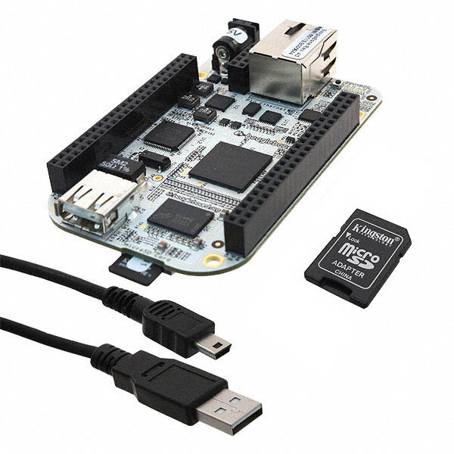

*The BeagleBone is the latest addition to the BeagleBoard.org family and like its’ predecessors, is designed to address the Open Source Community, early adopters, and anyone interested in a low cost ARM Cortex A8 based processor. It has been equipped with a minimum set of features to allow the user to experience the power of the processor and is not intended as a full development platform as many of the features and interfaces supplied by the processor are not accessible from the BeagleBone via on-board support of some interfaces.* – BeagleBone System Reference Manual

## Summary

The BeagleBone is a low-cost single board computer capable of running full installations of Linux, and possibly the ARM port of Windows 9. It has plenty of GPIO, RAM, and processing power. In addition, it has USB, Ethernet, SPI, I2C, UART, CAN, and analogue to digital converters. It is a simplified derivation of the BeagleBoard computer

## Characteristics

|  |  |
| --- | --- |
|  | BeagleBone |
| Processor capability | Linux – full |
| Weight | 39.68 g |
| Interfacing | * Ethernet * USB * SPI * I2C * UART |
| RAM | 256 MB DDR2 |
| ADC | 7 x 12 bit |
| Max power usage | 1.75 W for no USB; 2.5 W for USB. Idles much lower. |
| Price | $89 + $34 shipping |
| Availability | Other |
| Video Out | - |

# Guidance Computer 2: Raspberry Pi

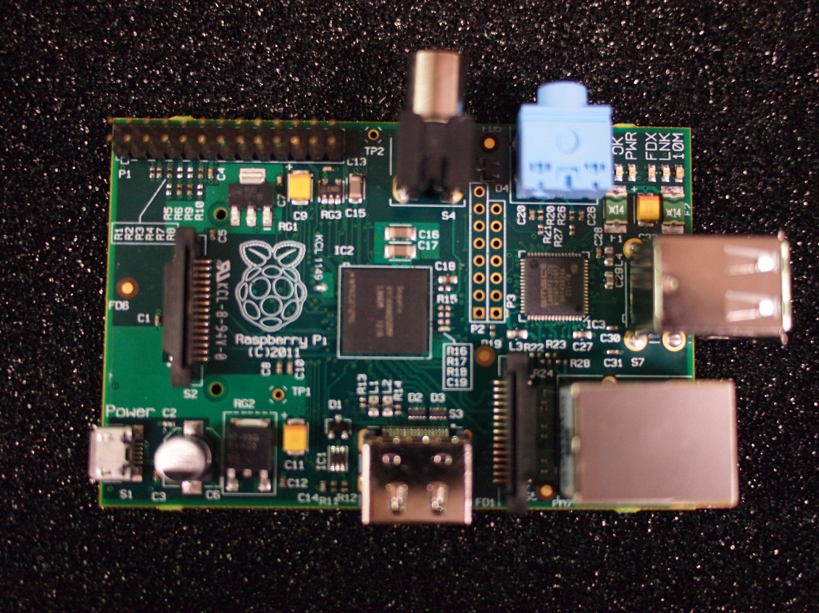

*The Raspberry Pi is a credit-card sized computer that plugs into your TV and a keyboard. It’s a capable little PC which can be used for many of the things that your desktop PC does, like spread sheets, word-processing and games. It also plays high-definition video. We want to see it being used by kids all over the world to learn programming.* – Raspberry Pi FAQ

## Summary

The Raspberry Pi is a low cost Linux computer designed for educational purposes. It can be easily configured to be a cheap desktop computer, or an embedded platform.

## Characteristics

|  |  |
| --- | --- |
|  | Raspberry Pi |
| Processor capability | Linux - full |
| Weight | 45 g |
| Interfacing | * Ethernet * USB * SPI * I2C * UART |
| RAM | 256 MB DDR2 |
| ADC | No ADC |
| Max power usage | 3.5 W |
| Price | $35 + approximately $30 shipping |
| Availability | Other – high demand |
| Video Out | HDMI |

# Guidance Computer 3: Ts-7260-64-128F

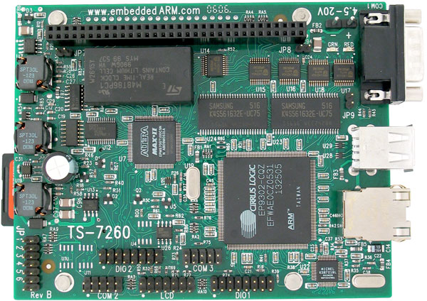

*The TS-7260 is a compact, full-featured Single Board Computer (SBC) based upon the Cirrus EP9302 ARM9 CPU, which provides a standard set of on-board peripherals. The EP9302 features an advanced ARM920T 200MHz processor design with MMU. TS-7260 includes software power consumption control for on-board peripherals, making this board ideal for use in power sensitive designs, such as battery-powered systems. In addition, the TS-XDIO standard feature can be replaced by either 2 extra serial ports or an SD card socket, which enables fast boot to Debian Linux from an SD card. –* TS-7260 product page

## Summary

The TS-7260 is an embedded ARM computer with a large amount of IO capability, as well as low power consumption. However, the processing speed isn’t too high.

## Characteristics

|  |  |
| --- | --- |
|  | TS-7260-64-128F |
| Processor capability | Linux - full |
| Weight | 60g (estimated) |
| Interfacing | * Ethernet * USB * SPI * I2C * UART |
| RAM | 64 MB SDRAM |
| ADC | 2 x 12 bit |
| Max power usage | 1 W |
| Price | $229 + $ approximately $30 shipping |
| Availability | Other |
| Video Out | - |

# Guidance Computer 4: PandaBoard ES

## http://www.cnx-software.com/wp-content/uploads/2011/12/pandaboard_es_OMAP4460.jpg

*Pandaboard ES is an OMAP4460 platform designed to provide access to as many of the powerful features of the OMAP4460 Multimedia Processor as possible, while maintaining a low cost. This will allow the user to develop software to utilize the features of the powerful OMAP4460 processor. In addition, by providing expandability via onboard connectors, the Pandaboard ES supports development of additional capabilities/functionality.* – Pandaboard ES System Reference Manual

## Summary

The PandaBoard ES is a very powerful single board computer, with a large amount of extensibility. The processor is more powerful than some handheld gaming systems, and comes with plenty of RAM. However, it has a very high power consumption.

## Characteristics

|  |  |
| --- | --- |
|  | PandaBoard ES |
| Processor capability | Linux - full |
| Weight | 81.5g |
| Interfacing | * Ethernet * USB * SPI * I2C * UART * Wi-Fi |
| RAM | 1 GB DDR2 |
| ADC | No ADC |
| Max power usage | Up to 20W |
| Price | $182+$34 shipping |
| Availability | Other |
| Video Out | HDMI |

# Guidance Computer Comparison

|  |  |  |  |  |
| --- | --- | --- | --- | --- |
|  | BeagleBone | Raspberry Pi | TS-7260-64-128F | PandaBoard ES |
| Processor capability | Linux – full | Linux - full | Linux - full | Linux - full |
| Weight | 39.68 g | 45 g | 60g (estimated) | 81.5g |
| Interfacing | * Ethernet * USB * SPI * I2C * UART | * Ethernet * USB * SPI * I2C * UART | * Ethernet * USB * SPI * I2C * UART | * Ethernet * USB * SPI * I2C * UART * Wi-Fi |
| RAM | 256 MB DDR2 | 256 MB DDR2 | 64 MB SDRAM | 1 GB DDR2 |
| ADC | 7 x 12 bit | No ADC | 2 x 12 bit | No ADC |
| Max power usage | 1.75 W for no USB; 2.5 W for USB. Idles much lower. | 3.5 W | 1 W | Up to 20W |
| Price | $89 + $34 shipping | $35 + approximately $30 shipping | $229 + $ approximately $30 shipping | $182+$34 shipping |
| Availability | Other | Other – high demand | Other | Other |
| Video Out | - | HDMI | - | HDMI |

|  |  |  |  |  |
| --- | --- | --- | --- | --- |
|  | BeagleBone | Raspberry Pi | TS-7260-64-128F | PandaBoard ES |
| Processor capability – 1 | 5 | 5 | 5 | 5 |
| Weight – 1.25 | 4 | 4 | 3 | 3 |
| Interfacing – 0.7 | 4 | 4 | 4 | 5 |
| RAM – 0.7 | 4 | 4 | 2 | 5 |
| ADC – 0.7 | 3 | 1 | 2 | 1 |
| Max power usage – 1 | 3 | 1 | 4 | 1 |
| Price – 1 | 4 | 5 | 1 | 2 |
| Availability – 0.6 | 1 | 1 | 1 | 1 |
| Video Out – 0.2 | 1 | 5 | 1 | 5 |
| **Total** | 24.4 | 23.9 | 20.15 | 21.05 |

# Inertial Measurement Unit 1: ArduIMU+ V3

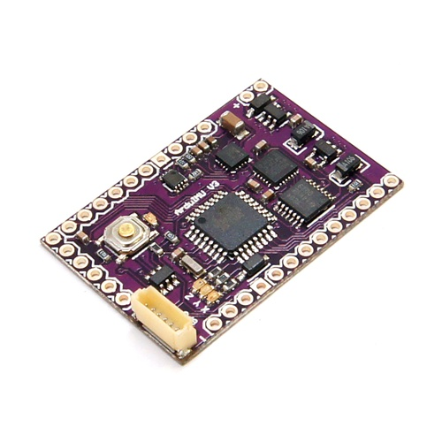

ArduIMU V3 features the new MPU-6000 that includes 3 axis gyros & accells built-in, the latest 3 axis I2C magnetometer HMC-5883L and the classic but very robust Arduino Atmega328 running at 16Mhz... – ArduIMU+ V3 store page

## Summary

The ArduIMU+ V3 is a powerful, low cost 9 degree of freedom IMU with an onboard AVR microcontroller, with provisions for added GPS for improved accuracy when filtering. It has a three axis accelerometer, a three axis gyroscope, and a three axis magnetometer.

## Characteristics

|  |  |
| --- | --- |
|  | ArduIMU+ V3 |
| Price | $78.90 USD |
| Degrees of Freedom | 9 |
| Internal processing | Full microcontroller |

# Inertial Measurement Unit 2: IMU Digital Combo Board - 6 Degrees of Freedom ITG3200/ADXL345

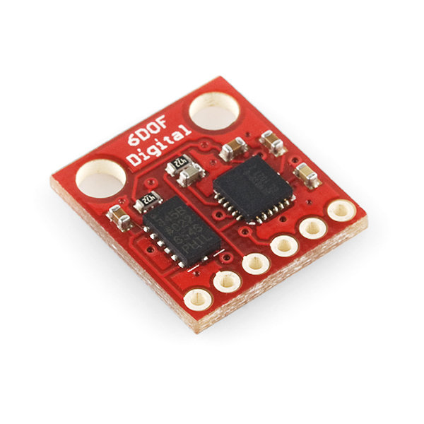

*This is a simple breakout for the ADXL345 accelerometer and the ITG-3200 gyro. With this board, you get a full 6 degrees of freedom. The sensors communicate over I2C and one INT output pin from each sensor is broken out. If you need a simple and tiny board that gives you 6 degrees of freedom, this would be a good choice.* – Store page

## Summary

This board is just a simple breakout board, meaning just a direct access to the data pins. This makes it cheaper, but it also requires more supporting hardware. It features a three axis accelerometer, and a three axis gyroscope.

## Characteristics

|  |  |
| --- | --- |
|  | IMU Digital Combo Board |
| Price | $64.95 AUD |
| Degrees of Freedom | 6 |
| Internal processing | None |

# Inertial Measurement Unit Comparison

|  |  |  |
| --- | --- | --- |
|  | ArduIMU+ V3 | IMU Digital Combo Board |
| Price | $78.90 USD | $64.95 AUD |
| Degrees of Freedom | 9 | 6 |
| Internal processing | Full microcontroller | None |

|  |  |  |
| --- | --- | --- |
|  | ArduIMU+ V3 | IMU Digital Combo Board |
| Price - 1 | 3 | 4 |
| Degrees of Freedom – 1.25 | 5 | 3 |
| Internal processing – 0.7 | 5 | 1 |
| Total | 12.75 | 8.45 |

# Conclusions

Due to the large number of features available on the BeagleBone and the price of the Raspberry Pi, these were the top two contenders. The BeagleBone narrowly won, thanks to its lower power usage and number of ADCs. While initially, the TS-7260-64-128F looked like it would be the best option, systematic analysis revealed it was the poorest choice of the computers considered.

On the other hand, the ArduIMU+ V3 was a clear winner for the IMU; its relatively higher price being vastly compensated for by its extra abilities. Thanks to its extra magnetometer, an additional check on the attitude can be performed.

# Recommendations

The recommended combination of components used is the BeagleBone single board computer, with the ArduIMU+ V3 inertial measurement unit. They are cheap, powerful, and readily available.