CyberTrace Final Report
Clustering and Analysis of Suspicious Network Traffic
Group Members: Victor Andrade and Ben Miller

Abstract
CyberTrace is a cybersecurity analysis project that uses Python to prepare a safe public intrusion-detection dataset, cluster network behavior records, and interpret the resulting groups from an analyst perspective. Using a small NSL-KDD sample with 1,011 records, the project produced three clusters that separated mostly benign traffic from two malicious-heavy groups. The final workflow shows that clustering can support investigation beyond simple signature matching by organizing records into interpretable groups.

Problem Statement
The problem addressed by CyberTrace is how to compare suspicious network-related artifacts without depending only on exact signature matching. In cybersecurity practice, analysts often need to decide whether network behavior looks normal, suspicious, or malicious based on observable characteristics rather than perfect known-bad matches.
This project therefore asks whether a safe benchmark dataset can be transformed into a feature representation that supports unsupervised clustering and useful interpretation. The goal is not to replace detection systems, but to create a workflow that helps explain what samples have in common and why certain groups appear suspicious.
A useful final project in this space should represent the problem in a way that resembles real analyst reasoning, be reproducible as software, and produce results that can be explained in cybersecurity language rather than only in abstract machine learning terms. CyberTrace was designed with those priorities in mind.

Motivation
This problem matters because analysts routinely face large volumes of events and cannot manually investigate everything. A clustering-based view can reduce that burden by grouping similar records together, allowing analysts to focus on suspicious clusters first.
The project is also motivated by the need for explainable, analyst-friendly workflows. Rather than centering the project entirely on predictive performance, CyberTrace emphasizes cybersecurity interpretation, reproducibility, and safe handling of data.
This motivation is practical for incident response. When analysts face many events that are not immediately conclusive, they need structure. Clustering can help provide that structure by showing which records belong together, which behaviors repeat, and which groups should be reviewed first.

Dataset and Safety
The final project uses a small public NSL-KDD training CSV sample. This benchmark is safe for coursework because it provides labeled benign and attack records without requiring live malware samples or sensitive production traffic.
- Total records: 1011
- Benign records: 516
- Malicious records: 495
- Source mirror: Jehuty4949/NSL_KDD GitHub repository
- Benchmark reference: Canadian Institute for Cybersecurity NSL-KDD page
This choice keeps the project safe for classroom use while still supporting meaningful discussion of benign and malicious behavior patterns.
The dataset also includes several attack categories, allowing the project to discuss not only whether traffic is malicious, but whether malicious behavior itself splits into more than one kind of cluster.

Contributions
- Built a Python repository and command-line workflow for cybersecurity clustering analysis.
- Added a real dataset preparation step for NSL-KDD using reproducible code.
- Implemented clustering, notebook analysis, figures, tests, and submission packaging.
- Produced an interpreted real-data result that distinguishes normal-like and malicious-heavy clusters.
A further contribution is that the project packages the work into reusable deliverables. Instead of stopping at code execution, it creates a final report, slide deck, and submission zip, making the entire project easier to inspect and hand in.

Methodology
- Store safe raw datasets in data/raw/.
- Prepare NSL-KDD records into a numeric CyberTrace feature table.
- Standardize features and cluster them with KMeans.
- Interpret the clusters by comparing labels and attack types after clustering.
The preparer keeps metadata such as sample identifiers, attack type, source, and difficulty while transforming the usable model inputs into numeric columns. Categorical protocol, service, and flag fields are one-hot encoded so they can be included in the clustering step.
This separation matters because labels are used only after clustering for interpretation. That keeps the analysis unsupervised while still allowing the project to explain what kinds of behaviors each cluster contains.
KMeans was selected as the baseline clustering method because it is easy to explain, easy to reproduce, and suitable for a first pass over standardized features. The baseline run uses three clusters so the results can be interpreted in a straightforward way.
The methodology also includes software validation. Tests cover the main preparation, feature-loading, extraction, and clustering paths so the workflow is repeatable and less dependent on ad hoc notebook execution.
From an investigative standpoint, the feature preparation step is critical. Raw network-style records are rarely useful unless they can be summarized into stable technical signals. In this project, those signals include byte counts, rates, service indicators, and protocol or flag fields. Clustering then evaluates how those signals align across the full dataset.
This feature-centric view keeps the project interpretable. Even if the clustering model is unsupervised, the inputs still have concrete cybersecurity meaning, which makes the final analysis easier to explain and defend.

Implementation
CyberTrace is implemented as a Python package with CLI commands for dataset preparation, clustering, notebooks, figures, and tests. The real-data workflow is driven by two commands.
cybertrace prepare-nsl-kdd data/raw/nsl_kdd_small_training.csv --output data/processed/features_nsl_kdd.csv
cybertrace cluster data/processed/features_nsl_kdd.csv --output reports/real_clusters.csv --clusters 3
The repository also includes a network-log feature extractor, exploratory notebooks, generated figures, and a builder script that assembles the final report, presentation, and submission zip file.
This modular structure makes the code easier to extend. New datasets can be added through additional preparers, and alternative clustering or reporting methods can be introduced without rewriting the entire project.
That design choice also improves reviewability. A grader or collaborator can run the core commands directly and reproduce the key outputs without relying on hidden notebook state.

Findings and Results
Cluster | Size | Benign | Malicious | Dominant Label
0 | 588 | 493 | 95 | benign (83.8%)
1 | 132 | 23 | 109 | malicious (82.6%)
2 | 291 | 0 | 291 | malicious (100.0%)

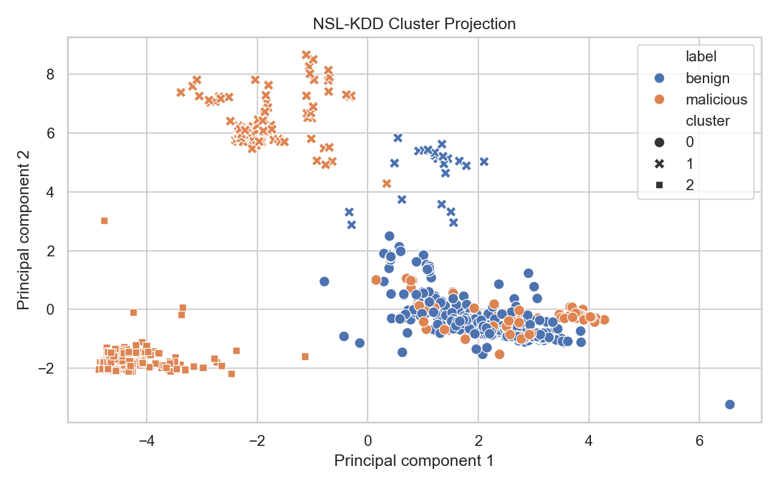
Figure 1. PCA projection of NSL-KDD records colored by label.
Cluster 0 is primarily benign and acts as the most normal-like cluster in the baseline run. Cluster 1 is mixed but malicious-heavy, suggesting overlapping suspicious patterns. Cluster 2 is fully malicious in this sample and is dominated by neptune records.
These findings are useful because they show both the strengths and the limits of clustering. The strongest malicious pattern becomes clearly separated, but another cluster remains mixed, which reflects the ambiguity analysts often face in real investigations.
The results therefore suggest that malicious traffic in the sample is not behaviorally uniform. One group is strongly concentrated around repeated attack-like behavior, while another overlaps more with traffic that is closer to normal in some dimensions.
This is important because mixed clusters are not failures to be ignored. In many security settings, those mixed regions are exactly where analysts need more context, enrichment, and careful review.
The attack-type distribution reinforces this interpretation. Neptune records dominate the most malicious cluster, while portsweep, ipsweep, satan, and smaller attack categories appear more often in mixed groupings. That suggests some malicious behaviors are much more concentrated than others in the feature space.
The benign records are also informative. Most benign traffic appears in Cluster 0, which creates a useful normal-like reference point. A smaller number of benign records appear in a malicious-heavy cluster, showing that overlap and ambiguity remain part of the analysis.

Implications
The results support the larger project claim that clustering can help organize traffic for analyst review. Even without using labels to fit the model, the workflow produced one mostly benign cluster, one mixed suspicious cluster, and one clearly malicious cluster.
This matters because cybersecurity analysis often depends on triage and prioritization. A cluster-oriented view can help direct attention toward groups that deserve deeper review, additional indicators, or manual analyst validation.
The project also has educational implications. It demonstrates that a relatively compact Python repository can still cover the full workflow of a cybersecurity analytics project: data preparation, model application, interpretation, documentation, and packaging.
More broadly, the project argues that interpretation is the bridge between data science and operational usefulness. A cluster assignment by itself is not enough; the value comes from understanding why that group looks suspicious and what an analyst should do next.
For that reason, CyberTrace contributes not only a set of outputs but also a reusable workflow pattern: prepare safe data, cluster similar records, compare discovered groups with labels after the fact, and translate the result into plain-language cybersecurity insights.

Group Members
- Victor Andrade
- Set up the Python project structure and CLI workflow.
- Implemented dataset preparation, clustering, tests, and packaging scripts.
- Integrated the real dataset analysis outputs, figures, and submission materials.
- Ben Miller
- Helped shape the project direction around cybersecurity investigation.
- Contributed to the problem framing, motivation, and interpretation goals.
- Supported the final narrative about findings, implications, and future work.
This section is included to make individual effort visible in the final submission instead of treating the entire project as a single anonymous artifact.

Limitations
- NSL-KDD is older than current enterprise network environments.
- The baseline run uses a fixed cluster count of three.
- The workflow currently emphasizes benchmark records over richer live packet parsing.
- Interpretation is supported by labels after clustering, so deeper feature analysis is still needed.
Another limitation is that this report emphasizes one baseline clustering result rather than a large comparison across many parameter settings. A more exhaustive study would compare multiple choices of k and alternative clustering methods.

Future Work
- Compare additional clustering methods such as hierarchical clustering or DBSCAN.
- Use newer flow-based datasets to better reflect modern traffic patterns.
- Add more analyst-facing outputs, such as per-cluster feature summaries and scoring.
- Expand preparation to other safe artifacts such as Zeek or Suricata logs.
These improvements would make the project stronger both as a cybersecurity investigation tool and as a more rigorous data-analysis comparison.
A strong next step would be to connect cluster outputs directly to analyst actions such as triage recommendations, escalation flags, or suggested follow-up evidence. That would push the project beyond exploration into more operational decision support.

Reproducibility and Practical Value
A major strength of the final project is that the entire workflow can be rerun directly from the repository. The raw dataset, preparation code, clustering command, notebooks, figures, tests, report, presentation, and submission zip are all generated from the same project.
This reproducibility matters in cybersecurity because results are more trustworthy when the path from input data to analyst-facing output is visible. A reviewer can inspect how records were prepared, how clustering was applied, and how the results were interpreted.
The project is also practically reusable. Although the final implementation focuses on NSL-KDD, the repository structure can be extended to other safe datasets such as flow logs, packet-derived features, Zeek outputs, or Suricata alerts.

Conclusion
CyberTrace fulfills the project goal by delivering a reproducible Python workflow for preparing safe cybersecurity data, clustering artifacts, and interpreting the results through a cybersecurity lens.

