PORTFOLIO EXPERIMENT SYSTEM

Andre Portfolio Concept Experiment Playbook
  - Reusable specifications and staged Figma Make prompts
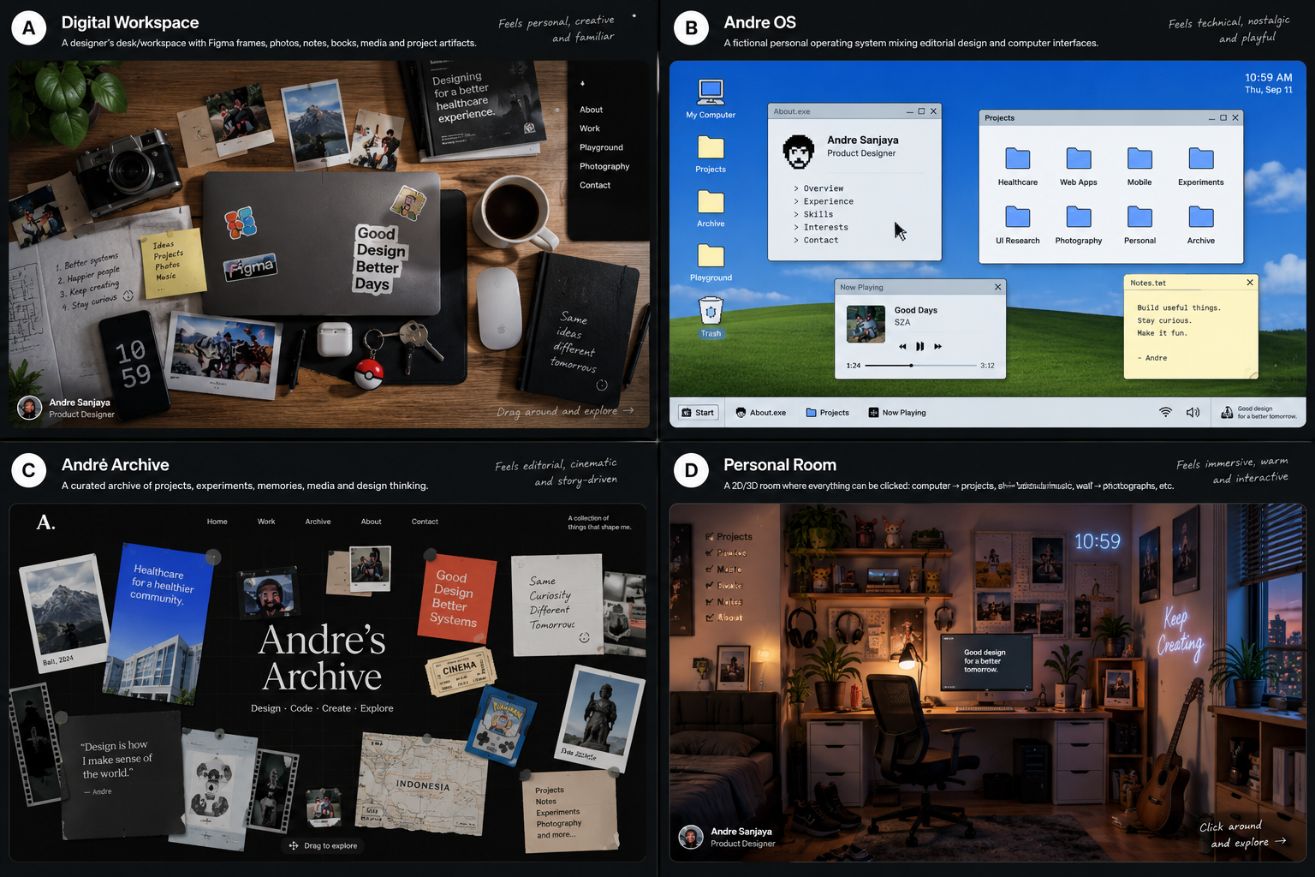
Four concept directions prepared for systematic experimentation
This playbook lets Andre test four distinct portfolio worlds without rebuilding the strategy from zero each time. Every concept uses the same audience, project content, recruiter goals, and quality standards. Only the metaphor, spatial behavior, and visual storytelling change.
The recommended workflow is to choose one concept, paste its New Chat Starter into a fresh conversation, attach the relevant reference image and real project assets, then run the numbered implementation prompts one at a time. Treat every generated version as an experiment that must be evaluated, not as a final design.

NAVIGATION

Contents
Section | What it contains
1 How to use this playbook | Experiment workflow, prompt discipline, and asset preparation
2 Shared portfolio source of truth | Audience, content, design rules, interaction guardrails, and success criteria
3 Compare the four concepts | Strengths, risks, effort, mobile fit, and recommended test order
A Digital Workspace | A tangible designer desk where every object reveals part of Andre
B Andre OS | A fictional personal operating system for projects, profile, media, and experiments
C Andre Archive | An editorial collection of case files, notes, memories, and design thinking
D Personal Room | An explorable room with hotspots mapped to work and personal interests
Appendix | Reusable evaluation prompt, scorecard, asset checklist, and official prompting references

1 How to use this playbook
Do not paste an entire concept chapter into Figma Make in one message. Large one-shot requests are difficult to inspect and tend to produce generic layouts, incomplete behavior, and accidental regressions. Build the world in controlled layers.
1. Duplicate your Figma Make project before starting a new concept experiment.
2. Attach the four-concept image for direction and your real portfolio screenshots for content.
3. Paste the concept New Chat Starter. Ask the assistant to restate the intended hierarchy before it builds.
4. Run the Foundation prompt and inspect only the overall world, composition, and primary navigation.
5. Run the remaining prompts sequentially. After each result, test what changed before continuing.
6. When refining one component, explicitly tell the builder not to redesign unrelated parts.
7. Replace placeholder content with public-safe project assets before evaluating visual quality.
8. Run the final QA prompt, then score the experiment with the same criteria used for the other concepts.

Prompt operating rules
- One prompt should have one dominant objective. Related subrequirements are acceptable; unrelated redesign work is not.
- Name the target area precisely, for example Projects window, center archive cluster, or room computer hotspot.
- State what must remain unchanged so the builder does not regenerate the whole experience.
- Describe behavior through trigger, state change, feedback, and exit. Example: single click selects, Space opens Quick Look, Escape closes it.
- Use real copy, project names, years, roles, and sanitized screenshots as early as possible.
- Ask for desktop behavior and mobile behavior separately. Do not shrink a desktop metaphor into an unusable miniature.
- Whenever the metaphor conflicts with usability, protect direct access to Work, About, Resume, and Contact.

Asset preparation before each experiment
Asset group | Minimum useful set | Notes
Identity | Portrait, name, role, short bio, location, availability | Use final copy; avoid lorem ipsum
Selected work | 3 hero images plus 3 to 6 supporting images for each case study | Remove confidential patient or client data
Personal layer | 5 to 12 photos or artifacts related to movies, music, photography, Pokemon, and Bali | Use personal material rather than stock filler
Career | Resume PDF, experience dates, education, selected capabilities | Make the resume reachable in one or two actions
Experiment references | Four-concept collage plus one concept-specific crop or mood board | Reference interaction grammar, not exact assets

2 Shared portfolio source of truth
PROJECT
Andre Sanjaya Product and UI UX Designer Portfolio
PRIMARY AUDIENCES
- Product design recruiters and hiring managers evaluating Andre for full-time roles.
- Design leads and cross-functional teammates looking for evidence of systems thinking and execution quality.
- Potential freelance clients who need confidence in Andre's process, reliability, and ability to handle complex products.
PRIMARY OUTCOMES
- Visitors understand who Andre is and what he designs within 10 to 15 seconds.
- Visitors can reach selected work, resume, about, and contact within one or two intentional actions.
- Case studies demonstrate problem framing, workflow reasoning, design decisions, implementation awareness, and outcomes.
- Exploration communicates personality without hiding professional evidence.
- The experience feels editorial, technical, playful, and cinematic rather than like a generic AI-generated portfolio.

Content architecture shared by all concepts
Destination | Purpose | Recommended content
Home or World | Immediate identity and orientation | Name, role, concise positioning, selected work route, visible direct navigation
Selected Work | Recruiter evidence | Badung Sehat, SIMRS or EMR, NurTani, Sanata CMS, and one focused healthcare case
Playground | Creative range | JARVIS voice UI, Body Drummer, Teach the Machine, Figma Make experiments
Research Notes | Show design judgment | Table actions, label and value hierarchy, spacing, date format, form behavior
Photography and Media | Personal perspective | Curated photographs, movie and music notes, current rotation
About | Identity and trajectory | Bio, experience, education, capabilities, values, interests
Resume | Fast evaluation | Download or open resume without requiring exploration
Contact | Conversion | Email, LinkedIn, availability for full-time and freelance work

Shared visual and interaction rules
- Use a restrained palette with deep black, warm off-white, cool blue, and a few small functional accents.
- Use one modern sans-serif for interface text, one optional serif for editorial moments, and one monospace for metadata or technical labels.
- Prefer compact controls, 1 px borders, intentional spacing, limited radii, subtle depth, and believable object hierarchy.
- Use controlled asymmetry: objects may rotate, overlap, or vary in form, but alignment, spacing, and interaction rules remain systematic.
- Keep a direct navigation layer visible or quickly accessible. Exploration is an optional path, never a prerequisite.
- Provide keyboard focus, useful labels, readable contrast, and reduced motion behavior.
- On mobile, reinterpret the metaphor for the device instead of scaling the desktop scene down.
- Avoid huge rounded cards, excessive gradients, glassmorphism, random blobs, fake testimonials, empty skill percentages, and generic startup copy.

Shared project content map
Content | Portfolio role | Possible artifact treatment
Badung Sehat | Flagship healthcare platform case study | Project file, hospital folder, case file, or monitor application
SIMRS EMR Giri Asih | Complex workflow and clinical interface evidence | Clinical blueprint, active application, research dossier, or desk screen
Hemodialysis EMR | Specialized product design evidence | Procedure record, project module, technical case file, or secondary monitor
NurTani | Freelance marketplace and responsive design | Marketplace folder, receipt and product cards, archive folio, or parcel object
Sanata CMS thesis | Design to implementation and Laravel capability | CMS file, source folder, bound thesis, or laptop project
UI UX research notes | Evidence-based decision making | Sticky notes, text documents, field notes, or wall pinboard
Makeathon experiments | Playful interactive thinking | Prototype files, lab folder, experimental artifacts, or shelf devices
Photography, movies, music, Pokemon | Personality and creative perspective | Polaroids, media player, ticket stubs, collectible object, or wall gallery

3 Compare the four concepts
The four directions are not merely visual skins. Each one changes what visitors notice first, how they navigate, and how much engineering is required. Test them against the same content and tasks.
Criterion | A Workspace | B OS | C Archive | D Room
Recruiter speed | Strong | Very strong | Strong | Moderate
Personal warmth | Very strong | Moderate | Strong | Very strong
Technical character | Moderate | Very strong | Strong | Moderate
Editorial storytelling | Strong | Moderate | Very strong | Strong
Cinematic potential | Strong | Moderate | Very strong | Very strong
Mobile adaptation | Moderate | Very strong | Strong | Moderate
Content scalability | Strong | Very strong | Very strong | Moderate
Build complexity | Medium | High | Medium | Very high
Main risk | Can look staged | Can become a gimmick | Can hide hierarchy | Can become slow or confusing

Recommended experiment order
1. Andre OS first, because its navigation model is explicit and it establishes reusable content structure quickly.
2. Andre Archive second, because it tests the strongest editorial and storytelling direction using similar content.
3. Digital Workspace third, because it tests warmth and physical object interaction without the full cost of a room.
4. Personal Room last, because it needs the most asset production, hotspot logic, responsive reinterpretation, and performance work.
Do not treat the first finished concept as the winner. Use the evaluation scorecard in the appendix after completing the same recruiter tasks in every version.
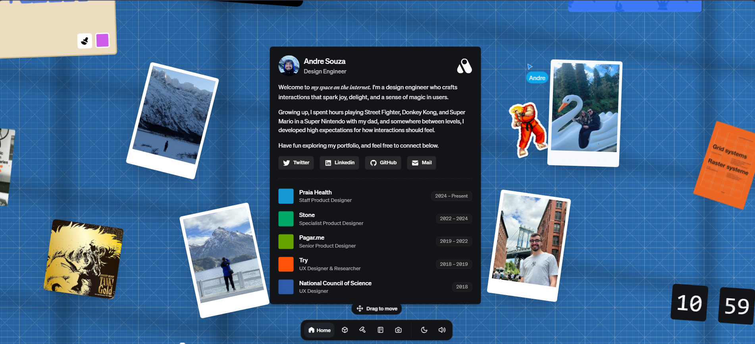
Reference interaction model showing a draggable spatial canvas with direct navigation

CONCEPT A

Digital Workspace
A designer desk where physical and digital artifacts reveal Andre's work and personality
The visitor arrives at a top-down or shallow-perspective creative desk. The desk feels used, not staged: project printouts, a closed laptop, camera, notes, photographs, headphones, a notebook, and small personal artifacts are arranged with controlled imperfection. Each meaningful object has a clear role in the information architecture.

Strategic fit
- Best for communicating warmth, craft, photography, and a personal creative practice.
- Lets healthcare work feel tangible through printed flows, annotated screens, ID cards, and project documents.
- Works well as a spatial homepage while case studies open in clean reading panels.
- Main risk: too many photorealistic props can obscure navigation or look like decorative AI imagery.

Workspace object map
Object | Meaning | Interaction and destination
Laptop | Selected professional work | Click to open Projects; screen can preview the featured case study
Printed clinical flow | Healthcare product expertise | Hover reveals context; click opens Badung Sehat or SIMRS case study
Notebook | Process and design principles | Pages turn or open into research notes and decision records
Camera | Photography | Opens a contact sheet or lightweight photo viewer
Headphones or cassette | Music | Expands a simulated now-playing widget
Movie ticket | Film interest | Opens a compact watched list or cinematic inspirations
Pokemon object | Playful identity | Optional easter egg; never contains critical information
Sticky note | Current status | Shows current work, availability, or a short principle
Resume sheet | Career evaluation | Opens or downloads resume in one action
Desk phone or contact card | Conversion | Opens email and LinkedIn actions

Visual and motion direction
- Warm walnut or dark neutral desk, soft directional light, restrained film grain, and realistic contact shadows.
- Combine real project screenshots with photographed or rendered objects. Avoid perfectly centered showroom composition.
- Interactive objects lift 2 to 6 px, gain a stronger shadow, and show a concise label on hover or focus.
- Canvas panning should be subtle and bounded. A persistent compact dock protects direct navigation.
- Case studies should open in a stable full-height panel or focused document view, not remain scattered on the desk.
- Reduced motion removes parallax and object drift while preserving all state changes.

Copy ready prompt sequence

Prompt 01 New Chat Starter
Use when starting this experiment in a new conversation
I am building an interactive portfolio for Andre Sanjaya, a Product and UI UX Designer based in Bali. The audience is product design recruiters, design leads, and potential freelance clients. The portfolio must communicate editorial, technical, playful, and cinematic qualities while keeping professional work easy to reach.
Use Concept A: Digital Workspace. The homepage is a believable designer desk made from meaningful physical and digital artifacts. It is not a conventional vertical landing page and it is not a decorative collage. Every important object must map to portfolio content.
Core content: Badung Sehat, SIMRS EMR Giri Asih, Hemodialysis EMR, NurTani, Sanata CMS, UI UX research notes, Makeathon experiments, photography, movies, music, Pokemon, about, resume, and contact.
Protect recruiter usability. Work, About, Resume, and Contact must be reachable within one or two actions through a fixed navigation dock as well as through objects. Desktop may use a bounded pannable workspace. Mobile must become a curated vertical desk inventory rather than a tiny scaled desktop.
Use the attached images only for spatial composition, materiality, and exploratory behavior. Do not copy their exact layout, assets, colors, text, or identity. Before proposing code or screens, restate the scene hierarchy, direct navigation, and the role of each major object.

Prompt 02 Foundation Scene
Use when creating the first build only
Create only the desktop foundation for Digital Workspace.
Build a full-screen top-down or shallow-perspective desk scene with a clear visual center, meaningful empty space, and 8 to 12 placeholder objects. Include a closed or partially open laptop, one clinical project printout, notebook, camera, headphones, two photographs, sticky note, resume sheet, and contact card. Add a compact fixed navigation dock with Home, Work, Playground, About, and Contact.
The desk should feel personal, crafted, and believable. Use warm dark materials, off-white paper, cool blue accents, subtle grain, limited rotation, and realistic contact shadows. Do not use generic SaaS cards, floating glass panels, excessive gradients, random stickers, or stock office props without meaning.
Implement bounded drag-to-pan on desktop with an obvious Drag to explore cue that disappears after first use. The fixed dock must remain available. Add hover and keyboard-focus labels for every interactive object.
Do not build full case studies yet. Explain the object hierarchy before implementing, then create the scene and basic object states.

Prompt 03 Object Navigation
Use when turning the desk into a usable information architecture
Improve only object navigation and direct navigation in the existing Digital Workspace. Keep the current art direction and composition.
Map the laptop to Selected Work, the clinical printout to Healthcare Projects, the notebook to Process and Research Notes, the camera to Photography, the headphones to Music, the resume sheet to Resume, and the contact card to Contact. Add a small visible label when an object is hovered, focused, or selected. The label must show object name, destination, and one short action phrase.
Single click selects an object. Double click or Enter opens it. Escape closes the active view. The fixed navigation dock must open the same destinations without requiring object discovery. Add a short first-visit orientation that teaches pan, select, and open, then remains dismissible.
Do not add new decorative objects. Do not redesign typography, lighting, or the desk surface.

Prompt 04 Projects on the Laptop
Use when building the professional work browser
Focus only on the laptop and Selected Work experience.
When the laptop opens, show a compact portfolio project browser inside the screen. Include Badung Sehat, SIMRS EMR Giri Asih, Hemodialysis EMR, NurTani, and Sanata CMS. Each project shows title, year, Andre's role, category, one-line outcome, and a real or placeholder thumbnail.
Support quick scanning with Featured, Healthcare, Web, Mobile, and Freelance filters. A selected project opens a Quick Look layer with hero image, concise problem, role, duration, three tags, and Open Case Study. The interface should feel like a designer's working computer, not a generic ecommerce grid.
Keep all project text legible and keep the laptop interaction independent from canvas panning. Do not change the surrounding desk or other objects.

Prompt 05 Case Study Reading View
Use when making evidence easy to evaluate
Create the full case study reading experience opened from a project Quick Look.
Use a focused full-height document panel that temporarily reduces or blurs the desk behind it. Include Overview, Context, Problem, Role and Team, Constraints, Process, Key Decisions, Final Design, Outcome, and Reflection. Use real project screenshots as the dominant evidence. Keep paragraphs short and add a sticky section index for long content.
For Badung Sehat, emphasize complex healthcare services, role-based workflows, status design, and public versus operational clarity. Include a confidentiality rule: never display patient data, private client data, or unapproved internal information.
Provide Previous Project, Next Project, Back to Desk, Resume, and Contact actions. Escape closes the panel and returns focus to the originating project. Do not force the case study itself to look like paper scattered on a desk; readability takes priority.

Prompt 06 Personal Objects
Use when adding personality after the professional core works
Improve only the personal objects in Digital Workspace.
The camera opens a curated photography contact sheet. The headphones open a simulated Now Playing panel. The movie ticket opens a concise list of cinematic references. A small Pokemon-inspired collectible triggers a playful original easter egg reading A wild idea appeared, with Explore and Save for later actions.
Keep these experiences lightweight and secondary. They should reveal Andre's perspective without competing with Selected Work. Use personal photos and specific copy instead of stock content. Critical portfolio information must never be hidden inside an easter egg.
Do not add more than three new objects. Preserve visual breathing room and the existing project hierarchy.

Prompt 07 Motion and Material Feedback
Use when polishing interaction without creating distraction
Refine only motion, hover, focus, and material feedback.
Interactive paper may lift 3 px and rotate no more than 1 degree. The laptop may open with a restrained hinge animation. Photographs may slide or flip with clear controls. Shadows should respond subtly to elevation. Pointer parallax must remain under 8 px and stop while a reading panel is open.
Use transitions between 160 and 320 ms for interface states. Longer cinematic transitions may be used only when opening or closing the main workspace once. Add reduced-motion behavior that removes parallax, physical drift, and large transforms while retaining opacity and instant state feedback.
Do not add looping animation to every object and do not move noninteractive objects in ways that suggest they are clickable.

Prompt 08 Responsive Adaptation
Use when designing tablet and mobile intentionally
Create responsive behavior for Digital Workspace without changing the desktop design.
Tablet uses a smaller bounded workspace with fewer visible objects and a persistent bottom dock. Mobile becomes a curated vertical Desk Inventory. Show a compact identity header, Selected Work first, then Process Notes, Playground, Photography and Media, About, Resume, and Contact. Represent objects as editorial rows or tiles using the same materials and imagery, not as a miniature pannable desk.
Every mobile destination must work with tap and standard scrolling. Avoid drag-only navigation, tiny rotated text, hover-dependent labels, and overlapping objects. Keep the metaphor recognizable through object photography, paper textures, and naming.

Prompt 09 Accessibility and Performance
Use when making the experiment robust
Audit and improve only accessibility and performance.
Make every interactive object a semantic button or link with a useful accessible name. Provide visible keyboard focus, logical tab order, Enter and Space activation, Escape to close overlays, and focus restoration. Ensure text contrast meets WCAG AA. Provide reduced-motion and mute controls. Do not communicate project categories or state through color alone.
Optimize large images, lazy-load content outside the initial viewport, use responsive image sources, and avoid continuous animation work when the tab is inactive. Keep initial interaction responsive on ordinary laptops and mobile devices.
Return a concise list of changes and any limitations that still require manual review.

Prompt 10 Remove Generic AI Styling
Use when performing final art direction
Polish the existing Digital Workspace so it feels authored by Andre.
Replace generic copy with concise first-person content. Remove repeated card shapes, identical radii, random decorative stickers, excessive shadows, broad gradients, and empty filler objects. Vary artifact form intentionally: printout, notebook, screen, photograph, ticket, note, and document. Keep one spacing system, one depth system, and a restrained rotation range from minus 6 to plus 6 degrees.
Preserve the scene hierarchy, direct navigation, responsive behavior, and working interactions. Do not regenerate the entire layout. Show which elements were removed, simplified, or made more specific.

Prompt 11 Final Product QA
Use when testing before comparing the concept
Act as a senior product designer and front-end QA reviewer. Test the completed Digital Workspace as a recruiter, keyboard user, mobile visitor, and returning visitor.
Complete these tasks: identify Andre within 15 seconds; open Badung Sehat; scan role and outcome; return to the desk; open Resume; reach Contact; use keyboard only; enable reduced motion; test narrow mobile width; test slow image loading.
Report issues by severity with location, expected behavior, observed behavior, and recommended fix. Prioritize blocked navigation, unreadable content, focus loss, pan conflicts, performance problems, and metaphor elements that do not help understanding. Do not propose new decorative features until critical and major issues are resolved.

CONCEPT B

Andre OS
A fictional personal operating system where work and identity live as applications files and utilities
Andre OS turns the portfolio into a usable desktop environment. Professional work appears in a project explorer, case studies open as readable documents, career history becomes release history, and personal interests become media applications or small utilities. The metaphor should improve scanning and discovery rather than imitate a real operating system for novelty.

Strategic fit
- Strongest concept for technical character, fast direct navigation, scalable content, and mobile reinterpretation.
- Useful OS behaviors such as search, Quick Look, recent files, and taskbar state can improve portfolio usability.
- Provides a clear home for experiments, research notes, photography, resume, and career history.
- Main risk: visual nostalgia can overpower case-study quality or become a Windows or macOS imitation.

Application and file map
Application or file | Purpose | Core behavior
About.exe | Profile, capabilities, interests, and contact | Draggable window with internal sections
Projects | Selected professional work | Explorer with grid and list views, filters, and Quick Look
Playground | Creative experiments | Experimental file types with short demos
Archive | Older projects and personal references | Year and topic folders with search
Photos | Photography | Contact sheet and focused viewer
Resume.pdf | Recruiter evaluation | Single action preview and download
Notes.txt | Design principles and current thoughts | Small editable-looking but read-only document
Now Playing | Music and mood | Compact simulated player
System Update | Career timeline | Andre OS release history
Search | Fast universal access | Ctrl or Command K with instant results

Visual and interaction direction
- Create an original desktop language with compact title bars, 1 px borders, limited radii, crisp icons, and editorial typography.
- Use nostalgic cues sparingly. Do not reproduce a proprietary operating system wallpaper, icon set, or exact chrome.
- Support single-click select, double-click or Enter open, Space Quick Look, Escape close, window focus, minimize, maximize, and close.
- Use global search and a Start menu to guarantee direct access to essential content.
- Mobile becomes an original mobile OS with app icons and full-screen apps, not a shrunken desktop.

Copy ready prompt sequence

Prompt 01 New Chat Starter
Use when starting Andre OS in a new conversation
I am building Andre OS, an interactive portfolio for Andre Sanjaya, a Product and UI UX Designer based in Bali. The audience is product design recruiters, design leads, and potential freelance clients.
Andre OS is a fictional personal operating system where projects, experience, research notes, photography, music, and experiments exist as applications, files, folders, widgets, and system utilities. It must feel editorial, technical, playful, cinematic, personal, and subtly nostalgic.
Do not build a Windows, macOS, Linux, cyberpunk, or hacker clone. Create an original visual language. Avoid excessive glassmorphism, neon gradients, fake terminal decoration, huge rounded cards, and generic startup copy.
Core content: Badung Sehat, SIMRS EMR Giri Asih, Hemodialysis EMR, NurTani, Sanata CMS, UI UX research notes, JARVIS, Body Drummer, Teach the Machine, photography, movies, music, Pokemon, About, Resume, and Contact.
Protect recruiter usability. Projects, Resume, About, and Contact must be reachable within one or two actions through the desktop, Start menu, taskbar, and global search. Before building, explain the desktop hierarchy, window model, file organization, and mobile reinterpretation.

Prompt 02 Desktop Foundation
Use when creating the initial operating system shell
Create only the Andre OS foundation.
Build a full-screen original desktop environment with a restrained custom wallpaper, desktop icons, persistent taskbar, Start menu, system tray, clock and date, and a basic draggable window system. Add About.exe, Projects, Playground, Archive, Photos, Notes.txt, Resume.pdf, Trash, Now Playing, and System Status.
Single click selects. Double click or Enter opens. Clicking a window brings it forward. Windows support drag, minimize, maximize, close, active and inactive states, and session position memory. The taskbar shows open applications and remains available when windows overlap.
Use compact UI, crisp original icons, 1 px borders, subtle shadows, limited radii, modern sans-serif interface type, monospace metadata, and selective serif editorial moments. Do not fully build every application yet. Explain the window state model before implementing.

Prompt 03 Start Menu and Search
Use when protecting direct access and orientation
Improve only the Start menu, taskbar navigation, and global search.
The Start menu should show Andre Sanjaya, Product and UI UX Designer, and direct links to Projects, About, Experience, Playground, Photos, Resume, and Contact. Add Settings, Now Playing, About Andre OS, and a playful Shutdown action. Shutdown fades to Thanks for visiting Andre OS and offers Restart.
Add global search opened by Ctrl or Command K. Search across projects, categories, resume, research notes, photography, and contact. Results must be keyboard navigable and show type, title, and short context. Selecting a result opens the correct application and restores focus correctly when closed.
Do not change the wallpaper, window chrome, or application content.

Prompt 04 Projects Explorer
Use when building the main recruiter workflow
Focus only on the Projects application.
Create a believable file explorer for Andre's work with Favorites, All Projects, Healthcare, Web, Mobile, UI UX Research, Freelance, and Experiments in the sidebar. Include Badung Sehat, SIMRS EMR Giri Asih, Hemodialysis EMR, NurTani, and Sanata CMS in the main area.
Support grid and list views, sorting by year and category, and visible selected states. Project files show title, year, role, category, and thumbnail. Double click or Enter opens a project. Single click plus Space opens Quick Look with hero image, short problem, role, duration, outcome, tags, and Open Case Study.
Keep recruiter scanning fast. Avoid ecommerce cards, skill percentages, or decorative file names that hide the actual project title.

Prompt 05 Project File and Case Study
Use when turning a selected project into strong evidence
Create the project file and full case study behavior.
A project opens in a dedicated document window with Overview, Context, Problem, Role and Team, Constraints, Process, Key Decisions, Final Design, Outcome, and Reflection. Use a sticky internal index, large real screenshots, captions, and clear previous and next project actions.
Use BadungSehat.project as the model. Emphasize the multi-service healthcare context, role-specific workflows, operational statuses, public status simplification, notification logic, and design decisions. Never expose patient data or confidential internal data.
Allow maximize for comfortable reading. The surrounding OS may remain visible in normal mode, but maximize must produce a distraction-free reading view. Preserve window history and return focus to the project file when the case study closes.

Prompt 06 About and Release History
Use when integrating career story into the metaphor
Improve only About.exe and create System Update History.
About.exe includes portrait, Andre Sanjaya, Product and UI UX Designer, a short first-person introduction, location in Bali, availability, capabilities, interests, and contact. Use internal sections for Overview, Experience, Skills, Interests, and Contact. Avoid a corporate biography and avoid rating skills with arbitrary percentages.
Represent career development as Andre OS Release History. Include a clear chronological sequence beginning with System Implementor and progressing into UI UX and Product Design work. Each version contains year, role, focus, selected projects, and what changed. Keep the real resume available separately for conventional evaluation.
Do not redesign Projects or the global desktop.

Prompt 07 Playground Media and Easter Eggs
Use when adding creative range without harming usability
Build only Playground, Photos, Now Playing, and two restrained easter eggs.
Playground contains jarvis.ai, body-drummer.exp, teach-machine.lab, interactive-room.scene, and prototype-01.fig. Each file opens a concise preview with idea, interaction, status, and what Andre learned.
Photos opens a contact sheet and focused viewer with previous, next, zoom, and subtle metadata. Now Playing remains simulated unless real licensed audio is supplied.
Add one original collectible icon that triggers A wild idea appeared, and one optional Developer Mode keyboard sequence that reveals design annotations. Neither may contain required information. Do not add more easter eggs or clutter the desktop.

Prompt 08 Window Interaction Polish
Use when making the OS feel coherent and reliable
Refine only window management and system feedback.
Ensure active windows receive the highest layer and a clear active title bar. Minimized windows appear in the taskbar. Maximized windows respect the taskbar. Closing a window updates taskbar state. Dragging is constrained so title bars cannot become unreachable. Remember positions during the session and cascade newly opened windows so they do not fully overlap.
Add tooltips for unfamiliar icons, subtle opening and minimizing transitions, context menus for relevant files, and clear loading, empty, and error states. Avoid excessive bounce, elastic motion, and arbitrary sound. Do not redesign application content.

Prompt 09 Mobile Andre OS
Use when translating the concept to smaller screens
Create the mobile and tablet adaptation of Andre OS.
Tablet supports one primary window plus a simplified taskbar. Mobile becomes an original mobile OS home screen with app icons and a bottom dock. Apps are About, Projects, Playground, Photos, Resume, and Contact. Opening an app uses full-screen mobile navigation with a visible back action and standard scrolling.
Preserve the same content hierarchy and visual DNA, but remove desktop window dragging, tiny taskbar controls, hover-only behavior, and double-click requirements. Projects must open in one tap and case studies must read like responsive editorial pages. Do not scale the desktop down.

Prompt 10 Accessibility and Performance
Use when making the OS usable beyond the visual metaphor
Audit and improve accessibility and performance without changing the concept.
Add semantic roles and labels to desktop icons, taskbar items, menu items, window controls, search results, and files. Support logical keyboard navigation, visible focus, Enter and Space activation, Escape close, focus trapping inside modal layers, and focus restoration. Provide reduced motion, mute, and high-contrast-friendly states.
Use responsive images, lazy-load nonessential previews, suspend hidden window animations, and prevent expensive pointer effects from running continuously. Ensure readable zoom and text reflow. Return a short list of remaining browser or prototype limitations.

Prompt 11 Final Art Direction and QA
Use when removing imitation and validating the product
First polish Andre OS so it feels original and authored. Remove exact proprietary OS motifs, repeated generic cards, unnecessary widgets, filler files, fake terminal styling, neon gradients, and empty decorative complexity. Keep compact chrome, consistent spacing, clear iconography, and Andre-specific content.
Then test these tasks: identify Andre; open Badung Sehat through Projects; use Quick Look; maximize the case study; return to desktop; find Resume through search; open Contact from Start; navigate by keyboard; use mobile; enable reduced motion.
Report issues by severity with location, expected behavior, observed behavior, and recommended fix. Fix critical and major issues before suggesting new features.

CONCEPT C

Andre Archive
An editorial collection of projects research notes experiments memories and cultural references
Andre Archive frames the portfolio as a curated body of evidence rather than a software shell. Visitors browse case files, field notes, photographs, tickets, maps, annotations, and experiment records on a spatial canvas, then open them in disciplined editorial reading views. It is the strongest concept for storytelling and design thinking.

Strategic fit
- Best for presenting mature editorial taste, process evidence, research notes, and a coherent personal point of view.
- Can connect healthcare projects, interface decisions, experiments, photography, movies, and music as one evolving practice.
- Supports both spatial exploration and conventional filters or index navigation.
- Main risk: an artful collage can make project priority ambiguous if hierarchy and labels are weak.

Archive collection map
Collection type | Example content | Presentation
Case Files | Badung Sehat, SIMRS, Hemodialysis, NurTani, Sanata CMS | Numbered folios with cover, metadata, and full case study
Field Notes | Research on table actions, typography, spacing, dates, and forms | Annotated note cards linked to relevant projects
Experiments | JARVIS, Body Drummer, Teach the Machine | Lab records with demo, premise, and learning
Contact Sheets | Photography from Bali and personal moments | Curated sheets with focused viewer
Cultural Index | Movies, music, Pokemon, books, and interfaces | Tickets, lists, covers, and short annotations
Timeline | Experience and education | Dated archive entries linked to projects
Index | All content | Searchable conventional list by type, year, and theme

Visual and interaction direction
- Use black, warm off-white, electric blue, restrained red or orange, paper grain, crop marks, tape, pins, and subtle editorial grids.
- Mix serif display type with modern sans-serif body copy and monospace metadata.
- Use spatial panning only on desktop. A fixed index and direct navigation protect orientation.
- Hover or focus should clarify title, type, year, and action without requiring visitors to decode the artifact.
- Open content in clean editorial sheets; the archive canvas is for discovery, not long-form reading.

Copy ready prompt sequence

Prompt 01 New Chat Starter
Use when starting the archive in a fresh conversation
I am building Andre Archive, an interactive portfolio for Andre Sanjaya, a Product and UI UX Designer based in Bali. It is a curated collection of projects, experiments, research notes, photographs, memories, and cultural references.
The audience is product design recruiters, design leads, and potential freelance clients. The experience should feel editorial, technical, playful, cinematic, and story-driven. It should not be a conventional vertical portfolio, scrapbook template, or random collage.
Core professional content: Badung Sehat, SIMRS EMR Giri Asih, Hemodialysis EMR, NurTani, Sanata CMS, and UI UX research notes. Creative content: JARVIS, Body Drummer, Teach the Machine, photography, movies, music, and Pokemon.
Organize content into Case Files, Field Notes, Experiments, Contact Sheets, Cultural Index, Timeline, and a conventional searchable Index. Work, About, Resume, and Contact must remain reachable within one or two actions. Desktop may use a bounded spatial canvas; mobile becomes an editorial feed and index.
Use attached references only for materiality, spatial composition, and exploratory behavior. Do not copy exact assets or identity. Before building, explain the collection hierarchy, featured path, index path, and content-opening behavior.

Prompt 02 Archive Foundation
Use when creating the first spatial collection
Create only the Andre Archive foundation.
Build a dark full-screen editorial canvas with a clear central title artifact reading Andre's Archive and the line Design Code Create Explore. Arrange 10 to 14 meaningful placeholder artifacts around it: two Case Files, two Field Notes, one Experiment record, three photographs, one cinema ticket, one map or location fragment, and one index card.
Use controlled overlap, limited rotation, paper and print textures, strong typography, crop marks, tape or pins, and restrained blue and orange accents. Maintain an underlying grid and clear hierarchy. Add fixed navigation for Home, Work, Archive, About, Resume, and Contact plus a visible Index action.
Implement bounded drag-to-pan, hover or focus metadata, and a first-visit orientation. Do not build full case studies yet and do not fill the canvas with random decoration.

Prompt 03 Archive Index and Filters
Use when making the collection easy to search and scan
Build the conventional Archive Index without changing the spatial canvas.
The Index opens as a clean editorial panel listing all items. Add filters for All, Case Files, Field Notes, Experiments, Photography, Culture, and Timeline; sorting by Featured, Newest, Oldest, and A to Z; and search across title, project, year, and theme.
Every result shows a visible type, title, year, one-line description, and related collection. Selecting a result opens the same content as its spatial artifact. Preserve browser back behavior, close with Escape, and restore focus to the triggering item.
This index is the safety route for recruiters and keyboard users. Do not hide it behind an ambiguous icon.

Prompt 04 Case File System
Use when building consistent project artifacts
Focus only on the Case File system.
Create numbered project folios for Badung Sehat, SIMRS EMR Giri Asih, Hemodialysis EMR, NurTani, and Sanata CMS. Each cover shows Case File number, title, year, role, category, one-line problem, and a distinct real screenshot crop. Use a consistent metadata system while allowing each cover to have its own composition.
Hover or focus reveals View Case File. Opening a folio uses a clean editorial reading sheet with Overview, Context, Problem, Role and Team, Constraints, Process, Key Decisions, Final Design, Outcome, and Reflection. Add a sticky section index and related Field Notes.
Do not present projects as identical rounded cards. Do not sacrifice text readability for collage aesthetics.

Prompt 05 Field Notes and Cross Links
Use when showing evidence based design judgment
Create Field Notes and connect them to relevant case files.
Include notes on table action placement, label and value typography, button spacing, date formats, filter behavior, error prevention, and feedback messages. Each note should contain a concise question, observed problem, evidence or standard, Andre's inference, recommendation, and linked project context.
Display notes as distinct annotated artifacts on the canvas and as readable articles when opened. Add Related Case File and Related Notes links. Clearly distinguish external evidence, observed professional pattern, and Andre's context-specific judgment.
Do not fabricate research findings or citations. Use placeholders where a verified source is still needed.

Prompt 06 Experiments Photography and Culture
Use when adding personal and creative layers
Build only the Experiments, Contact Sheets, and Cultural Index collections.
Experiments includes JARVIS voice UI, Body Drummer, Teach the Machine, and other Figma Make prototypes. Each record explains the premise, interaction, tools, current status, and learning.
Photography uses curated contact sheets with location, year, and short captions. The Cultural Index includes selected movies, music, Pokemon, books, and interfaces with one-sentence annotations explaining why they matter to Andre's creative perspective.
Keep the personal layer specific and edited. Do not create long generic lists or use stock imagery. Professional work remains visually dominant.

Prompt 07 Archive Motion and Discovery
Use when polishing spatial exploration
Refine only spatial navigation, artifact feedback, and opening transitions.
Canvas panning must be bounded and must not interfere with clicking or text selection. Interactive artifacts lift slightly, sharpen, and reveal metadata on hover or focus. Selected artifacts move forward in depth. Opening an artifact should feel like bringing a document closer, then settle into a stable reading panel. Closing reverses the relationship and restores focus.
Keep interaction transitions between 160 and 360 ms. Use one longer cinematic entrance only for the initial archive reveal. Reduced motion removes parallax, depth transforms, and long transitions. Do not make every paper float continuously.

Prompt 08 Responsive Archive
Use when adapting editorial hierarchy to tablet and mobile
Create responsive behavior for Andre Archive.
Tablet uses a reduced spatial canvas plus visible Index. Mobile becomes a curated editorial archive with Featured Case Files first, followed by Field Notes, Experiments, Photography and Culture, Timeline, About, Resume, and Contact. Use horizontal media only where touch targets and labels remain clear; otherwise use vertical lists and full-width folios.
Preserve the editorial typography, material cues, and collection labels. Remove drag-to-pan, hover-only information, overlapping artifacts, and rotated body text on mobile. Standard scrolling and back navigation must work naturally.

Prompt 09 Accessibility and Content Integrity
Use when protecting readability trust and privacy
Audit and improve Andre Archive for accessibility and content integrity.
Use semantic headings, landmarks, links, and buttons. Provide visible focus, logical reading order independent from visual artifact position, keyboard access to canvas items and Index, Escape close, focus restoration, reduced motion, and sufficient contrast. Ensure zoom and text reflow do not break reading panels.
Clearly mark draft or placeholder evidence. Never display patient data, confidential internal information, or unapproved client assets. Provide alt text for meaningful images and empty alt text for purely decorative texture.
Return remaining issues and the content that still needs real evidence or approved assets.

Prompt 10 Editorial Polish
Use when removing random collage behavior and generic AI output
Polish the existing Andre Archive without changing its information architecture.
Remove random stickers, repeated paper shapes, meaningless tape, generic quotes, overly distressed textures, broad gradients, and identical artifact treatments. Strengthen the editorial grid, hierarchy, type roles, metadata format, spacing system, depth levels, and restrained rotation range.
Make every visible artifact answer one question: what does this reveal about Andre's work, thinking, or perspective? Remove anything that has no answer. Replace placeholder copy with specific concise content. Preserve direct navigation, Index, responsive design, and working interactions.

Prompt 11 Final Archive QA
Use when testing discovery and recruiter comprehension
Act as a senior product designer and content strategist. Test Andre Archive using these tasks: identify Andre and his role; find the featured project; open Badung Sehat; locate its related Field Note; return to Index; filter Experiments; open Resume; reach Contact; use keyboard only; enable reduced motion; test mobile reading.
Report issues by severity with location, expected behavior, observed behavior, and fix. Pay special attention to unclear hierarchy, artifacts that look clickable but are not, illegible rotated text, pan conflicts, reading-panel width, focus order, missing context, and visual decoration that does not support meaning. Fix critical and major issues before adding new content.
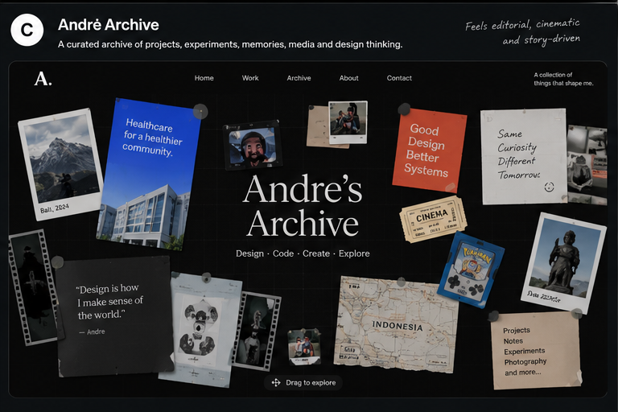
Concept C visual anchor for the completed archive experiment

CONCEPT D

Personal Room
An explorable room where furniture screens shelves and wall objects map to Andre's portfolio
Personal Room is the most immersive direction. Visitors enter a warm evening room belonging to a working designer. The computer opens projects, wall prints open case studies, the camera opens photography, speakers or headphones reveal music, shelves hold experiments and references, and the door or phone leads to contact. The room must operate as an interface rather than a static illustration with hidden hotspots.

Strategic fit
- Highest emotional and cinematic potential, with a strong sense of place and personality.
- Can connect work, routine, hobbies, and Bali identity within one memorable environment.
- Works best when important hotspots are visibly labeled and paired with a direct menu.
- Main risk: asset cost, slow loading, unclear hotspots, motion sickness, and poor mobile translation.

Room hotspot map
Room object | Destination | Behavior
Main computer | Selected Work | Screen wakes on hover or focus; click opens project browser
Clinical print or second monitor | Healthcare case study | Direct route to Badung Sehat or SIMRS
Desk notebook | Process and research notes | Opens pages or a readable note panel
Camera on shelf | Photography | Opens contact sheet viewer
Headphones or speakers | Music | Opens simulated now-playing controls
Movie posters or ticket board | Film references | Opens curated cinematic inspirations
Collectible shelf | Pokemon and playful interests | Small optional easter egg
Books or prototype devices | Playground | Opens experiments and learning
Pinned resume | Resume | Preview and download
Phone or door | Contact | Opens email, LinkedIn, and availability

Visual and interaction direction
- Use a warm dusk or evening scene with practical lamps, cool exterior window light, realistic depth, and readable interface overlays.
- Prefer a 2.5D layered illustration or optimized WebGL scene over photorealistic complexity unless production resources support it.
- Interactive objects receive visible hotspot labels, focus rings, and gentle light or outline feedback.
- Use modest camera movement and bounded zoom. Provide a fixed room map or menu for direct navigation.
- Open long content in flat readable panels. Do not force visitors to read text inside perspective-distorted room surfaces.
- On mobile, use guided room scenes or a vertical object tour rather than free 3D navigation.

Copy ready prompt sequence

Prompt 01 New Chat Starter
Use when starting Personal Room in a fresh conversation
I am building Personal Room, an immersive interactive portfolio for Andre Sanjaya, a Product and UI UX Designer based in Bali. The room represents Andre's real creative world. Every meaningful object maps to work, design thinking, or a personal interest.
The audience is product design recruiters, design leads, and potential freelance clients. The mood is warm, cinematic, personal, playful, and technically controlled. The scene may be 2.5D or lightweight 3D, but usability, performance, and readable case studies take priority over realism.
Core content: Badung Sehat, SIMRS EMR Giri Asih, Hemodialysis EMR, NurTani, Sanata CMS, UI UX research notes, JARVIS, Body Drummer, Teach the Machine, photography, movies, music, Pokemon, About, Resume, and Contact.
Map the computer to Projects; a clinical print or second monitor to Healthcare Work; notebook to Process; camera to Photography; headphones or speakers to Music; wall tickets or posters to Movies; shelf prototypes to Playground; pinned document to Resume; phone or door to Contact.
Provide obvious hotspots and a fixed direct menu. Important information must not depend on hunting through the room. Mobile must use a guided object tour or vertical inventory, not a shrunken free-roam room. Before building, recommend 2.5D or 3D based on the desired behavior, then explain scene hierarchy, camera rules, hotspot system, and fallback navigation.

Prompt 02 Room Foundation
Use when building the first scene only
Create only the Personal Room foundation.
Build a warm dusk designer bedroom or studio with a desk as the visual center, computer, second monitor, task chair, notebook, camera, headphones, practical lamp, shelving, a few plants, wall prints, window, resume document, and phone. Use original assets and a composition that feels lived in rather than showroom-perfect.
Implement either an optimized layered 2.5D scene or a lightweight 3D scene. Add a small fixed menu with Home, Work, Playground, About, Resume, and Contact. Mark 6 to 8 primary hotspots with subtle but visible focusable indicators. Add a short first-visit instruction: Click an object or use the menu.
Do not build full destinations yet. Do not add dense decorative clutter, uncontrolled camera movement, or tiny unreadable interface screens.

Prompt 03 Camera and Hotspot System
Use when making exploration understandable and safe
Improve only camera behavior, hotspot discovery, and direct navigation.
Use bounded camera pan with gentle depth movement. If zoom is included, constrain it to a narrow comfortable range and provide Reset View. Interactive objects show a concise label on hover, focus, or tap: object name, destination, and action. Add a Room Map or Object List that exposes all destinations without exploration.
Keyboard users must be able to move through hotspots in a logical sequence. Enter opens, Escape returns to room, and focus returns to the source object. Do not rely on color alone. Avoid motion triggered by scrolling that removes user control.
Keep the scene composition and lighting unchanged.

Prompt 04 Computer Projects Experience
Use when building the primary professional path
Focus only on the computer hotspot and project experience.
When activated, the camera moves gently toward the desk and the computer interface becomes a flat readable overlay. Show Selected Work with Badung Sehat, SIMRS EMR Giri Asih, Hemodialysis EMR, NurTani, and Sanata CMS. Each project displays title, year, role, category, one-line outcome, and thumbnail.
Support filters for Featured, Healthcare, Web, Mobile, and Freelance. Selecting a project opens Quick Look with problem, role, duration, outcome, and Open Case Study. The full case study uses a distraction-free responsive panel with Overview, Context, Problem, Role and Team, Constraints, Process, Key Decisions, Final Design, Outcome, and Reflection.
Do not make visitors read the case study on a perspective-distorted monitor. Preserve Back to Room and direct Contact actions.

Prompt 05 Secondary Work Hotspots
Use when turning the room into a meaningful content map
Build only the secondary professional hotspots.
The clinical print or second monitor opens Healthcare Work and highlights Badung Sehat, SIMRS, and Hemodialysis. The desk notebook opens Process and UI UX Research Notes. Shelf prototype devices open Playground with JARVIS, Body Drummer, and Teach the Machine. The pinned resume opens a readable preview and download action.
Each hotspot should have a distinct visual cue and a short explanation of why that object represents the destination. Keep content panels flat, accessible, and easy to close. Do not add new decorative room zones.

Prompt 06 Personal Layer
Use when adding interests and sense of place
Build only the personal room objects.
The camera opens a curated photography contact sheet with Bali locations and personal captions. Headphones or speakers open a simulated music player with Focus, Late Night Design, Movies, Throwbacks, and Current Rotation. A small ticket board opens selected films and cinematic inspirations. A collectible shelf may contain one original Pokemon-inspired easter egg reading A wild idea appeared.
The personal layer should feel specific and edited, not like a list of hobbies. It remains secondary to work and must not introduce autoplay audio. Preserve performance and room breathing space.

Prompt 07 Lighting and Cinematic Motion
Use when polishing atmosphere while preserving comfort
Refine only lighting, transitions, and ambient motion.
Use warm practical lamp light, subtle cool window light, restrained bloom, and readable contrast around hotspots. Add minimal ambient movement such as curtain drift, plant movement, or monitor glow, but no more than two looping effects at once. Camera transitions to hotspots should be short, predictable, and cancelable.
Provide reduced motion that removes camera travel, parallax, ambient loops, and depth transforms. In reduced motion, destinations open immediately as flat panels. Do not use rapid zooms, head-bob, motion blur, flashing light, or forced cinematic sequences.

Prompt 08 Responsive and Fallback Experience
Use when making the room usable across devices and capabilities
Create tablet, mobile, and low-performance fallbacks.
Tablet uses a guided room with a limited set of camera positions. Mobile becomes a vertical Object Tour: identity header, Selected Work computer, Healthcare print, Process notebook, Playground shelf, Photography camera, Media corner, About, Resume, and Contact. Each object appears as a clear editorial section with standard scrolling and tap behavior.
Provide a static illustrated fallback when WebGL or advanced motion is unavailable. Preserve the same destinations and content. Avoid drag-only interaction, tiny hotspots, landscape-only layouts, and horizontal overflow.

Prompt 09 Accessibility and Performance
Use when making the immersive concept production ready
Audit and improve accessibility and performance for Personal Room.
Every hotspot must be a semantic control with an accessible name and visible focus state. Provide a skip link to the direct menu, logical focus order, keyboard activation, Escape close, focus restoration, reduced motion, mute, sufficient contrast, and text alternatives for meaningful room imagery.
Optimize textures and images, lazy-load secondary zones, pause rendering when hidden, cap device pixel ratio where appropriate, avoid loading full case-study media on initial scene load, and provide the static fallback automatically for constrained devices. State measurable performance risks and what still requires browser testing.

Prompt 10 Remove Decorative Noise
Use when strengthening meaning and authored character
Polish the existing Personal Room without adding new zones.
Remove props that do not reveal work, process, personality, or navigation. Reduce repeated posters, plants, collectibles, neon signs, and generic desk accessories. Replace generic objects with Andre-specific artifacts and public-safe project imagery. Strengthen the hierarchy from main computer to secondary work objects to personal objects.
Keep the lighting cinematic but readable. Keep hotspot indicators consistent. Preserve direct navigation, responsive fallback, and all working behaviors. Show which objects were removed, merged, or given a clearer purpose.

Prompt 11 Final Immersive QA
Use when testing usability comfort and performance
Act as a senior product designer, accessibility reviewer, and performance QA reviewer. Test these tasks: identify Andre; find Selected Work without instructions; open Badung Sehat; scan role and outcome; return to room; open Resume; reach Contact; use keyboard only; enable reduced motion; use the static fallback; test mobile; test slow loading.
Report issues by severity with location, expected behavior, observed behavior, and fix. Prioritize hidden hotspots, camera discomfort, focus loss, unreadable overlays, slow initial load, accidental clicks during pan, weak fallbacks, and decoration that competes with work. Fix critical and major issues before proposing additional immersion.
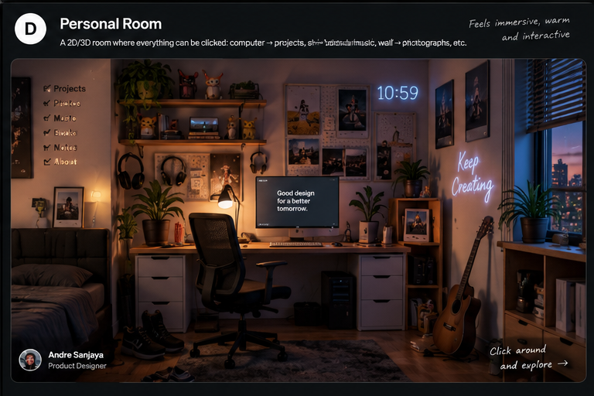
Concept D visual anchor for the completed room experiment

APPENDIX

Reusable experiment evaluation
Use the same tasks, device widths, content, and success measures for every concept. This prevents visual novelty from being mistaken for stronger portfolio performance.

Standard evaluation prompt

Prompt A1 Cross Concept Evaluation
Use when comparing a finished experiment against the others
Evaluate this interactive portfolio concept as a senior product design recruiter, UX researcher, accessibility reviewer, and front-end lead.
Do not judge only visual novelty. Test whether a visitor can: identify Andre and his role within 15 seconds; find selected work; open Badung Sehat; understand the problem, role, and outcome; find another project; open Resume; reach Contact; use keyboard only; use reduced motion; complete the same tasks on mobile.
Score each criterion from 1 to 5 and explain the evidence: first-impression clarity, recruiter speed, project discoverability, case-study readability, credibility, personality, originality, metaphor coherence, navigation clarity, accessibility, mobile adaptation, performance risk, content scalability, and implementation complexity.
Separate observed behavior from inference. List critical, major, and minor issues. End with Keep, Change, Remove, and Next Experiment recommendations. Do not recommend new decorative features until core task failures are addressed.

Experiment scorecard
Criterion | A | B | C | D | Evidence or note
Identity clear in 15 seconds
Selected work reached quickly
Case study easy to scan
Resume and contact direct
Personality feels specific
Metaphor improves understanding
Keyboard and reduced motion
Mobile experience works
Performance feels responsive
Content can scale

Decision rule
Choose the concept that best balances fast professional evaluation with memorable personality. A strong result should not need an explanation from Andre before a recruiter can use it. If two concepts score similarly, prefer the one that makes case studies easier to maintain and publish.

Reusable asset checklist
- Final portrait and short first-person bio.
- Public-safe resume PDF and contact links.
- Three to five selected project summaries with role, duration, problem, contribution, outcome, and approved screenshots.
- One flagship Badung Sehat case study with sanitized workflow evidence.
- Three to six short UI UX research notes with verified sources where claims require evidence.
- Three to five experiment summaries with prototype media and learning.
- Curated photography and personal media with captions.
- Original icons, object assets, wallpapers, or room illustrations with known usage rights.
- Mobile content priority and reduced-motion decisions.
- Analytics plan for project opens, resume opens, contact actions, and navigation paths.

Official prompting references
- Figma Visual Prompt Engineering
- Figma Explore Figma Make
- Figma Add Guidelines to Figma Make
- Lovable Prompting Guide
- Replit Build Your First App

Final recommendation
Start with Andre OS for the clearest reusable content architecture, then test Andre Archive for the strongest storytelling direction. Use the same project assets and evaluation scorecard in both. If neither feels personal enough, test Digital Workspace. Build Personal Room only after the content and recruiter paths already work, because it has the highest production and performance cost.

