Step 3: Evaluation
A screenshot of the confusion matrix can be seen below:
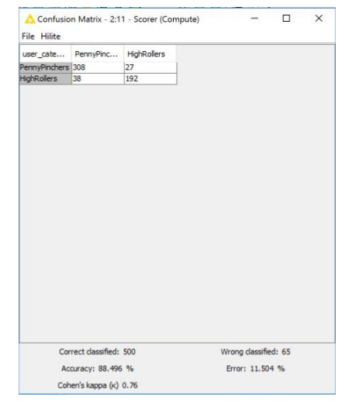

As seen in the screenshot above, the overall accuracy of the model is 88.496%.
• “308” & “38”: according to the model, we predict that 348(308+38) users are PennyPinchers, but among them 308 users are truly predicted, which means among these 348 users, 308 users are exactly PennyPinchers, 38 HighRollers are incorrectly predicted as PennyPinchers.
• “192” & “27”: according to the model, we predict that 219(192+27) users are HighRollers, but among them 192 users are truly predicted, which means among these 219 users, 192 users are exactly HighRollers, 27 PennyPinchers are incorrectly predicted as HighRollers.

