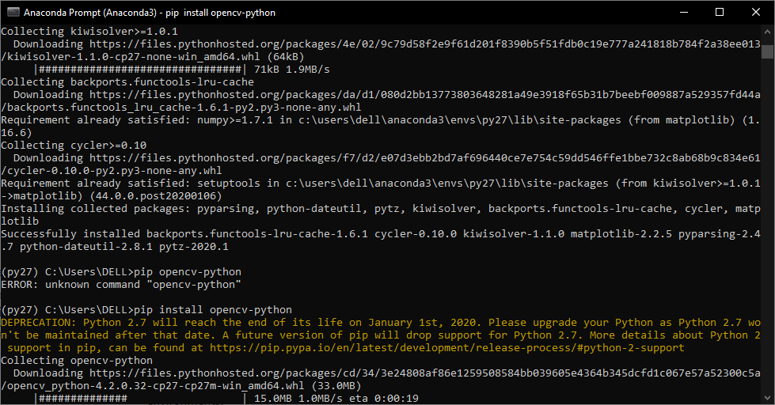

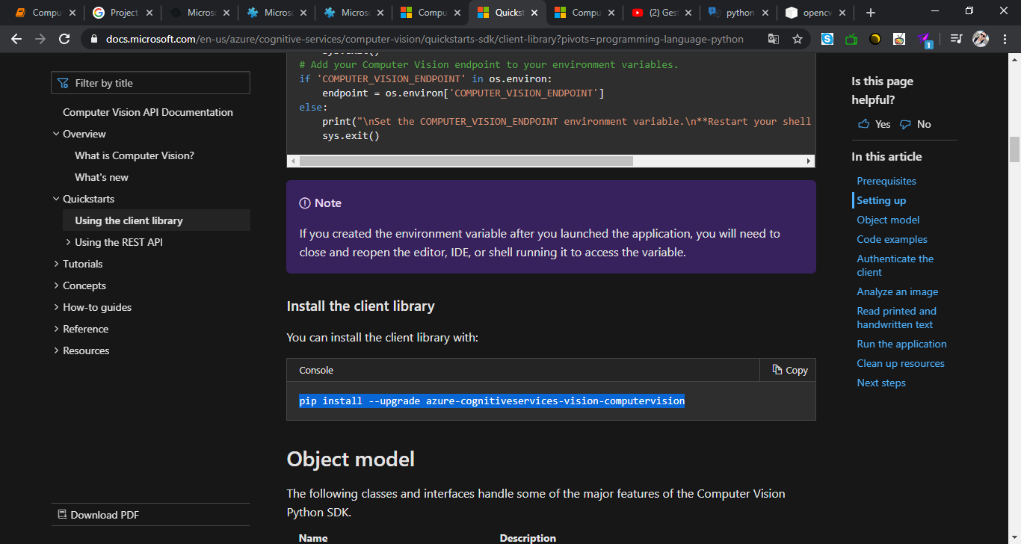

pip install --upgrade requests

pip install --upgrade azure-cognitiveservices-vision-computervision

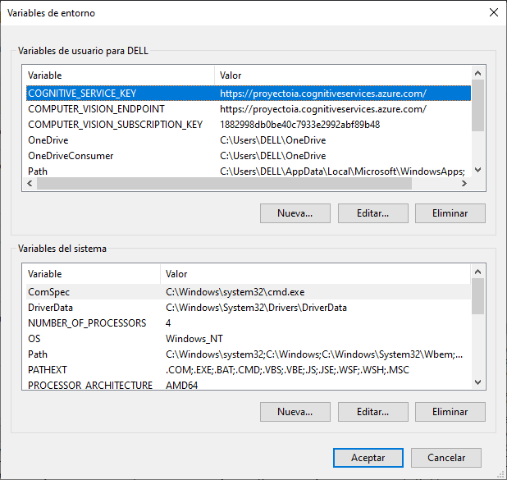

<https://proyectoia.cognitiveservices.azure.com/>

1882998db0be40c7933e2992abf89b48