Análisis Multivariante

PCA, permanova and more…

22/9/2022

CORRELATION BETWEEN FLOWER METRICS 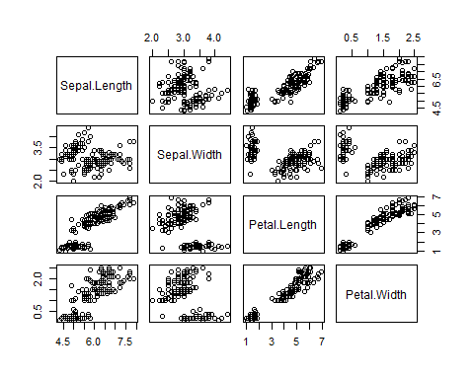

## Sepal.Length Sepal.Width Petal.Length Petal.Width  
## Sepal.Length 1.0000000 -0.1175698 0.8717538 0.8179411  
## Sepal.Width -0.1175698 1.0000000 -0.4284401 -0.3661259  
## Petal.Length 0.8717538 -0.4284401 1.0000000 0.9628654  
## Petal.Width 0.8179411 -0.3661259 0.9628654 1.0000000

#PCA analysis

## Standard deviations (1, .., p=4):  
## [1] 1.7083611 0.9560494 0.3830886 0.1439265  
##   
## Rotation (n x k) = (4 x 4):  
## PC1 PC2 PC3 PC4  
## Sepal.Length 0.5210659 -0.37741762 0.7195664 0.2612863  
## Sepal.Width -0.2693474 -0.92329566 -0.2443818 -0.1235096  
## Petal.Length 0.5804131 -0.02449161 -0.1421264 -0.8014492  
## Petal.Width 0.5648565 -0.06694199 -0.6342727 0.5235971

## Importance of components:  
## PC1 PC2 PC3 PC4  
## Standard deviation 1.7084 0.9560 0.38309 0.14393  
## Proportion of Variance 0.7296 0.2285 0.03669 0.00518  
## Cumulative Proportion 0.7296 0.9581 0.99482 1.00000

PLOTTING PCA

biplot(iris.pca)

