proyecto

Lidia y Andrés

21/09/2022

## Fixed term is "(Intercept)"

## Global model call: lm(formula = def ~ DBH + DBH2 + mycrhz + NO3 + comp, data = DIVERSIFICA.plot,   
## na.action = na.fail)  
## ---  
## Model selection table   
## (Intrc) comp DBH DBH2 mycrh df logLik AICc delta weight  
## 15 29.88 -7.218 6.592 -12.30 5 -111.079 234.7 0.00 0.724  
## 16 30.09 2.382 -6.739 6.115 -11.28 6 -110.469 236.6 1.93 0.276  
## Models ranked by AICc(x)

##   
## Call:  
## model.avg(object = res, subset = delta < 2, revised.var = FALSE)  
##   
## Component model call:   
## lm(formula = def ~ <2 unique rhs>, data = DIVERSIFICA.plot, na.action =   
## na.fail)  
##   
## Component models:   
## df logLik AICc delta weight  
## 234 5 -111.08 234.66 0.00 0.72  
## 1234 6 -110.47 236.59 1.93 0.28  
##   
## Term codes:   
## comp DBH DBH2 mycrhz   
## 1 2 3 4   
##   
## Model-averaged coefficients:   
## (full average)   
## Estimate Std. Error Adjusted SE z value Pr(>|z|)   
## (Intercept) 29.9414 2.4287 2.5484 11.749 < 2e-16 ***  
## DBH -7.0862 2.8530 2.9929 2.368 0.017902 *   
## DBH2 6.4608 2.9627 3.1081 2.079 0.037643 *   
## mycrhz -12.0185 3.2214 3.3773 3.559 0.000373 ***  
## comp 0.6564 1.2764 1.3030 0.504 0.614423   
##   
## (conditional average)   
## Estimate Std. Error Adjusted SE z value Pr(>|z|)   
## (Intercept) 29.941 2.429 2.548 11.749 < 2e-16 ***  
## DBH -7.086 2.853 2.993 2.368 0.017902 *   
## DBH2 6.461 2.963 3.108 2.079 0.037643 *   
## mycrhz -12.019 3.221 3.377 3.559 0.000373 ***  
## comp 2.382 2.338 2.457 0.969 0.332435   
## ---  
## Signif. codes: 0 '***' 0.001 '**' 0.01 '*' 0.05 '.' 0.1 ' ' 1

## DBH DBH2 mycrhz comp  
## Sum of weights: 1.00 1.00 1.00 0.28  
## N containing models: 2 2 2 1

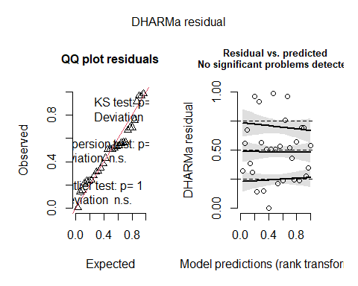

## Object of Class DHARMa with simulated residuals based on 250 simulations with refit = FALSE . See ?DHARMa::simulateResiduals for help.   
##   
## Scaled residual values: 0.984 0.536 0.384 0.964 0.236 0.692 0.756 0.28 0.56 0.916 0.216 0.564 0.52 0.508 0.236 0.144 0.432 0.348 0.32 0.504 ...

visreg(plotModel)

