The rapid spread of COVID-19 around the world during the first quarter of 2020 spurred a massive response across the technological base, not least in computer and data science. Scientists and technologists both inside and outside healthcare snapped into action as the scale of the outbreak became clear, some providing techniques they had been working on for years, others proposing new projects all aimed at arresting the virus' progress.

The European Molecular Biology Laboratory's Bioinformatics Institute (EMBL-EBI), for example, already had a multiyear project underway to build a portal for anonymized genetic data from patients. Rolf Apweiler, co-director of EMBL-EBI, says it became clear at an early stage in the pandemic that those who suffered the most serious symptoms were "not only old people with underlying health conditions, but relatively young and healthy people. It is unclear why they are vulnerable and it may be in their genetic makeup. Understanding that is pretty important because if we want to go back to normal life, we want to find people who are vulnerable and need more protection."

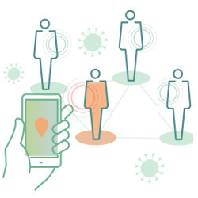

According to Apweiler, what would normally take several years was compressed to a matter of months. By mid-April 2020, the group had opened an early implementation of the portal.

Before the pandemic got underway, warnings about a new epidemic came from data mining systems already in place. Social media technology provided the earliest clues to scientists working outside China, when Canadian company BlueDot and two research groups independently registered online chatter about a pneumonia-like disease at the end of December 2019. In internal reports, Chinese authorities had noted the existence of a novel virus-borne disease only a few days beforehand.

As the first wave passed, suppressed in many developed nations by a broad-brush lockdown and social-distancing campaign, the loose coalition of technologists working on data-driven methods to combat the disease turned their attention to ways to build a smarter strategy for controlling the spread of SARS-CoV2, the virus that causes COVID-19.