|  |  |  |
| --- | --- | --- |
|  | **Introduction to Pyhon** | MSC |
| **FINAL EXAM – INTRODUCTION TO PYTHON** |

First name : Tiffany

Last name : PEREZ VICTORIA

---------------------------

**Question I. Choice of 3 entreprises, collect datas and plots (4 points/20)**

- You have to choose 3 companies

- You have to check that nobody has choose exactly the same 3 companies (2 students can have 1 or 2 companies in common but not the 3)

- To help you to check it you can the the google sheet [here](https://docs.google.com/spreadsheets/d/1lN6dIco7Kxx_atyXty3J6tVtfthwT-3GWk-F26GAZZM/edit?usp=sharing)   
**⚠️ Otherwise the grade is divided by 2 !**

- Use Python to make 3 plots of the ajust close value for each company depending on time and with a title and label

Stocks = ["AAPL", "GOOGL", "KO"]

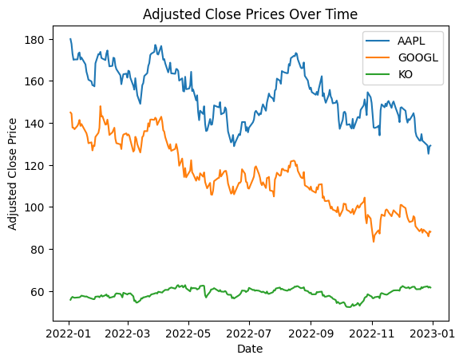

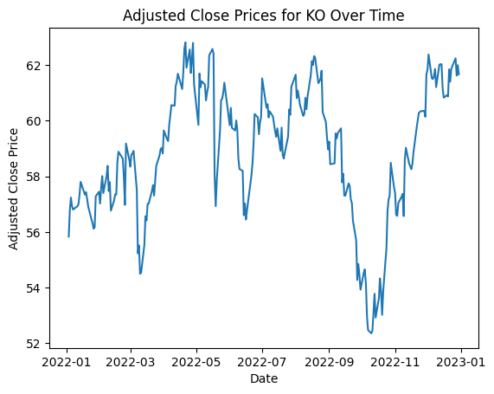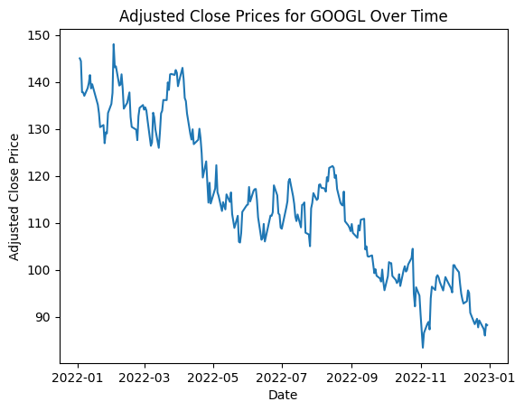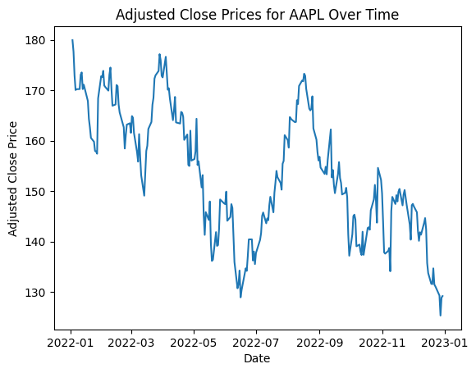

* Give the code, the results and the chat GPT prompt (if you use chat GPT)

**Question 2 . Calculate the average daily return with Pandas (4 points/20)**

* Collect the datas with Yahoo finance : you must have an Excel file like the given yahooFinancialDatasExample.xlsx with the information :   
  One column for the date (use value from Year 2022), 3 columns which contains the adjust close values for each company (like SANO column)
* You have to write code to calculate the average daily return for each company. In order to do that you can use the method pct_change from Pandas library.

def calculate_average_daily_return(adj_close_data):

    daily_returns = adj_close_data.pct_change()

    average_daily_return = daily_returns.mean()

    return average_daily_return

calculate_average_daily_return(stock_data)

AAPL -0.001074

GOOGL -0.001689

KO 0.000475

* Give the code, the results and the chat GPT prompt (if you use chat GPT)

**Question 3. Calculus of the average daily return without pct_change method (5 points /20)**

* How calculate for each company he average daily return without using the method pct_change ? (look at the Annex on the ppt Fin exam.ppt).
* Write a code to do that. Pay attention to add some comment in your codes to explain it at the best. Use function in order to increase your code visibility.
* Test your code in order to see whether you have the same results as question 2.

def calculate_average_daily_return_manual(adj_close_data):

    # Calculate daily returns without using pct_change

    daily_returns = (adj_close_data / adj_close_data.shift(1)) - 1

    average_daily_return = daily_returns.mean()

    return average_daily_return

calculate_average_daily_return_manual(stock_data)

AAPL -0.001074

GOOGL -0.001689

KO 0.000475

**Question 4. Correlation between adjust close values (3 points/20)**

* Use Python to calculate the correlation between adjust close values of your 3 companies. Determines whether a portfolio of stocks from these three companies is risky or not. Otherwise, if the correlation is low, there is little risk; if the correlation is greater than 0.6, the risk is high.
* Give the code, the results and your interpretation.

def calculate_correlation(adj_close_data):

    correlation_matrix = adj_close_data.corr()

    return correlation_matrix

calculate_correlation(stock_data)

         |  AAPL  |  GOOGL |  KO

--------------------------------

AAPL     | 1.0000 | 0.8182 | 0.0520

GOOGL    | 0.8182 | 1.0000 | -0.0365

KO       | 0.0520 | -0.0365| 1.0000

The correlation values between the companies are as follows:

AAPL and GOOGL: 0.8182

AAPL and KO: 0.0520

GOOGL and KO: -0.0365

A correlation close to 1 indicates a strong positive correlation,

while a correlation close to -1 indicates a strong negative correlation.

A correlation close to 0 suggests a weak or no linear correlation.

In this case:

AAPL and GOOGL have a relatively high positive correlation (0.8182).

AAPL and KO have a very low positive correlation (0.0520).

GOOGL and KO have a very low negative correlation (-0.0365).

**Question 5. Matplotlib and heatmap (4 points/20)**

* Use matplotlib to plot an heatmap of the correlations : give the codes and the result  
  You can look at the page <https://matplotlib.org/stable/gallery/images_contours_and_fields/image_annotated_heatmap.html> to help you and/or you can use chat GPT to help you too write the code
* Give the code, the results and the chat GPT prompt (if you use chat GPT)

***Promt*** : based on dataframe with 3 stocks, graph a correlation matrix and show the labels

def plot_correlation_heatmap(correlation_matrix, symbols):

    plt.imshow(correlation_matrix, cmap='coolwarm', interpolation='none')

    for i in range(len(symbols)):

        for j in range(len(symbols)):

            plt.text(j, i, f'{correlation_matrix.iloc[i, j]:.3f}', ha='center', va='center', color='black')

    plt.colorbar(label='Correlation')

    plt.xticks(range(len(symbols)), symbols)

    plt.yticks(range(len(symbols)), symbols)

    plt.title('Correlation Heatmap of Stock Prices')

    plt.show()

plot_correlation_heatmap(calculate_correlation(stock_data), stocks)

