**Exercises week 2 (16-19 January)**

**Name:** _________________________

During last week’s exercises we investigated fish that had a common goal. This week we will look at a scenario where people (pedestrians and cars) have their own goals or preferences and are tasked to follow a social system to regulate the junction of two roads. Read carefully and report your results in a concise manner as requested in the exercise below. Submit this document and all additional files to canvas before **January 19th 12:00**.

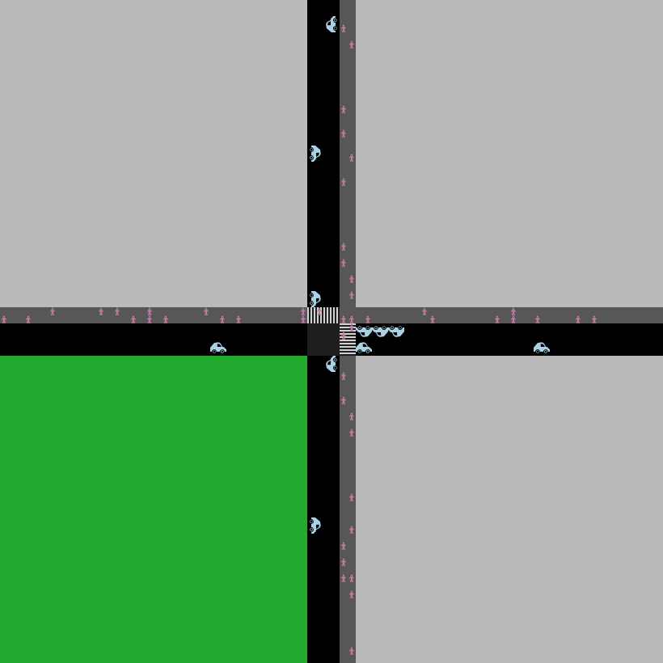

**Fig. 1** The base model without traffic regulation.

# Traffic regulation

Travelling in a city is inherently a complex and social activity. To avoid accidents and enable everyone to reach their goal within a reasonable time, requires people to adapt their behaviour via attention to the behaviour of others, communication, and adherence to social rules. To practice with many of the skills necessary to perform the final project, in this exercise you will study a highly simplified scenario where pedestrians and cars try to cross an intersection. For this, imagine a municipality that maintains an intersection for which it has decided to place traffic lights, because the current situation frequently leads to large traffic jams. Since traffic lights can be switched on and off, their question for you is at what levels of traffic the lights should be activated to produce the best traffic flow for all travellers?

Start by downloading the base model, *traffic_basic.nlogo*, from Canvas. In this model pedestrians walk toward an intersection and use the crosswalk to pass. To keep the model simple, pedestrians do not change direction. At the same time cars drive toward the intersection and would like to cross it with a preferred direction (left, straight, right). The movement of the cars and pedestrians is simple; if the patch before them is free they will advance one patch, otherwise they will stop completely. In other words, acceleration and variation in speed are not considered in this model. And, aside from always avoiding collisions, there are no traffic rules either. Make sure to play with the model and study the code to understand what is happening.

Your task is to perform an experiment by 1) implementing regulation in the form of traffic lights, 2) implementing a way to measure the traffic flow, and 3) use behaviour space and RStudio to collect data with and without the traffic lights for different amounts of traffic and analyse the impact on traffic flow. Below are some pointers per step.

There are many ways traffic lights could be implemented (e.g. via global parameters, patch properties or as turtles). To practice your computational problem solving, it is up to you to decide how to do this. What is key is that traffic stops before a light if it is red, and move across it when it is green. For this exercise you should implement a 5-step circulation scheme for the green light (one per car direction and one for all pedestrians). The lights should change over with a fixed duration, that is set using a slider. Add a switch that can turn the lights on and off, so we can compare the added regulation to the original model later.

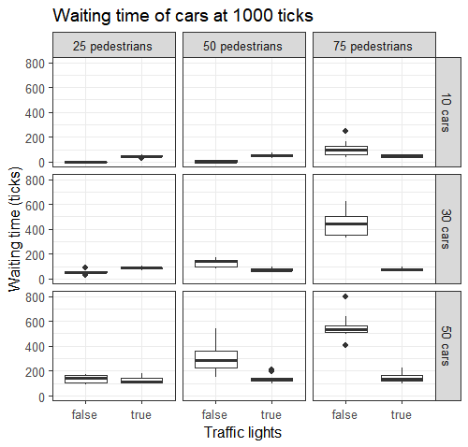

**Fig. 2** Example of figure generated using ggplot2.

Next, to measure the “effectiveness” of the new traffic lights, we would like to know the average time an agent has to wait (not move) before it passes the intersection. Keep track of the waiting time per traveller and implement two *to-report* functions (one for cars and one for pedestrians) that return the average waiting time. Also include a plot in de NetLogo model that shows the waiting time for cars and pedestrians separately.

For the last step, collect data using behaviour space. Measure at the end of a run of 1000 ticks. Vary three parameters in the experiment: 1) lights turned on/off, 2) 25/50/75 pedestrians, 3) 10/30/50 cars. Run 10 repetitions per condition. Next, analyse the collected data in RStudio. Make two plots that show the mean/median and the variation of the effect of turning on the traffic lights on the average waiting time for different combinations of pedestrians and car traffic. We recommend using the package *ggplot2* for this. [**Here**](http://www.sthda.com/english/wiki/ggplot2-box-plot-quick-start-guide-r-software-and-data-visualization) you can find a tutorial for summarizing the data in the form of *boxplots*, and [**here**](http://www.sthda.com/english/articles/32-r-graphics-essentials/127-ggplot-facet-quick-reference) is a tutorial on using *facet_grid* to easily generate a grid of subplots for each combination of pedestrian and car traffic flow. This should give you figures similar to Fig. 2. Other graph types, like violin plots or dots with error bars, are allowed as well, as long as they give clear insights in the mean differences between conditions and variation within a condition.

Discuss your findings and formulate an advice for the municipality in this document using the figures made with RStudio to support your conclusions. Besides this document with your answer, upload your NetLogo model provided with clear comments, any collected data (.csv) and R scripts (.r) used in the analysis to Canvas as a compressed file (.zip).

<type your answer here>