Hierarchical Graph Segmentation for Budget-Constrained Investigation Case Generation
Andre da Costa Silva
Instituto Tecnologico de Aeronautica (ITA), Brazil
ABSTRACT
Transaction monitoring systems in financial institutions generate thousands of suspicious activity alerts daily, yet the critical step of converting these alerts into bounded, actionable investigation cases remains largely manual and unstandardized. We formalize this case generation task as the Budgeted Connected Case Segmentation (BCCS) problem: given a scored transaction graph G = (V, E, s) and a per-case edge budget B, find a node partition that maximizes the number of suspicious edges whose endpoints share a case, subject to each case containing at most B induced edges. We prove that BCCS is NP-complete via reduction from Maximum Independent Set, and establish a strong inapproximability result: no polynomial-time algorithm can achieve a |V|^{1−ε} approximation ratio unless P = NP. Despite this worst-case hardness, we show that real-world financial graphs possess structural properties—high budget-feasibility rates and low Leiden cut fractions—that make the problem tractable in practice. We propose Hierarchical Graph Segmentation (HGS), a two-phase algorithm combining connected component decomposition with Leiden community detection for sub-segmentation of over-budget components. We derive four instance-specific approximation guarantees: (i) a computable WCC-COV upper bound, (ii) a multiplicative dominance over budget-capped WCC by factor q(C)(1−f_cut), (iii) an additive coverage gap bound decomposed into cross-WCC and Leiden cut losses, and (iv) exact optimality on budget-feasible instances. Empirical evaluation across five real-world datasets (35K to 4.4M edges) validates these theoretical predictions: on AML-relevant graphs, HGS achieves 96–99% of the theoretical optimum with budget-feasibility rates exceeding 99%. We also document a label leakage finding in a real banking dataset, demonstrating that high AUC-ROC does not guarantee effective case generation.
I. INTRODUCTION
Financial crime compliance is a $274 billion annual global cost, according to the LexisNexis 2023 Global Cost of Financial Crime Compliance report. Anti-money laundering (AML) operations follow a well-defined pipeline with five critical stages: (1) Transaction Monitoring Systems (TMS) apply rules or machine learning models to flag suspicious transactions from the billions of daily transfers; (2) Alert Generation produces individual alerts from flagged activity, creating a massive queue of potential violations; (3) Case Generation groups related alerts into investigation cases suitable for analyst review; (4) analysts investigate each case by reviewing supporting transactions and reconstructing networks of illicit flow; and (5) Suspicious Activity Reports (SARs) are filed with regulators when warranted and sufficient evidence exists. While stages 1–2 have seen significant automation through graph neural networks and advanced machine learning techniques, stage 3—case generation—remains a critical gap in the pipeline. Most financial institutions still rely on ad hoc manual grouping or simplistic rules such as "same customer, same time window," producing cases that are either too large for analysts to review efficiently or too fragmented to capture the full picture of suspicious activity. This inconsistency in case construction leads to missed fraud patterns, inefficient resource allocation, and regulatory risk.
The case generation problem has a natural graph-theoretic formulation. Given a transaction graph where nodes represent accounts or entities and edges represent financial flows, with a scoring function that ranks edges by suspicion level, the task is to partition the most suspicious edges into bounded investigation cases. The budget constraint B reflects a practical operational reality: an analyst can realistically review at most B transactions per case within their allotted investigation time, typically 4–8 hours. Cases exceeding this budget lead to incomplete reviews and missed suspicious patterns; cases that are too small fragment related activity across multiple investigations, requiring duplicate work and preventing analysts from seeing the full network picture. This tension between coverage—capturing all related fraud—and manageability—respecting analyst capacity—is at the heart of the case generation problem.
Despite the practical importance of case generation, we find a surprising gap in the academic literature. A comprehensive survey of top-tier venues (KDD, NeurIPS, ICDM, AAAI, ICAIF) over 2021–2025 reveals extensive work on fraud detection scoring—including graph neural network approaches like TROPICAL (ICDM 2024), SEFraud (KDD 2024), and LAS-GNN (ICAIF 2024)—but no paper that formally defines the downstream case generation problem or provides theoretical guarantees for grouping algorithms. The closest related work, "The Shape of Money Laundering" (KDD Workshop 2024), studies network topology of laundering patterns but does not address the operational problem of bounded case construction. This gap is consequential: practitioners implementing case generation must do so without guidance from the academic community, leading to ad hoc solutions that lack theoretical grounding or performance guarantees.
This paper makes four primary contributions. First, we formalize case generation as the Budgeted Connected Case Segmentation (BCCS) problem and prove it is NP-complete with strong inapproximability guarantees, showing that no polynomial-time algorithm can achieve better than |V|^{1−ε} approximation unless P = NP (Sections 2–3). Second, we derive four instance-specific approximation guarantees that explain when and why hierarchical segmentation works well on real financial graphs, providing practitioners with computable upper bounds (WCC-COV) and delta estimates that predict algorithm performance (Section 5). Third, we propose Hierarchical Graph Segmentation (HGS), an O(K log K) algorithm combining weakly connected component decomposition with Leiden community detection for adaptive sub-segmentation of over-budget components (Section 4). Fourth, we evaluate HGS against five baselines on five real-world datasets ranging from 35K to 4.4M edges, validating theoretical predictions and documenting a surprising label leakage finding with practical implications for AML system design (Sections 6–7).
II. PROBLEM FORMULATION
We now define the core problem and establish notation. Let G = (V, E) denote an undirected graph with a scoring function s: E → [0, 1] assigning each edge a suspicion score. In AML applications, V represents accounts or entities (typically 10K to 1M nodes), E represents transactions or relationships (typically 10K to 10M edges), and s is the output of a GNN, heuristic, or rule-based scorer. We denote by L ⊆ E the set of "target edges"—the top-k fraction of edges ranked by score s, where k typically ranges from 0.1% to 5%, representing the most suspicious activity requiring investigation.
Definition 1 (Scored Edge Graph). A scored edge graph is a tuple G = (V, E, s) where V is a finite set of nodes, E ⊆ V × V is a set of undirected edges, and s: E → [0, 1] is a scoring function assigning each edge a numerical suspicion rank. The top-k target edges are L = {e ∈ E : s(e) ≥ s^{(k)}}, where s^{(k)} is the k-th largest score.
Definition 2 (Budgeted Connected Case Segmentation—BCCS). Given G = (V, E, s), target edges L ⊆ E, and budget B ∈ ℤ^+, the BCCS optimization problem is to find a partition P = {C₁, …, C_m} of V that maximizes coverage:
max_P Cov(P) subject to |E(C_i)| ≤ B for all C_i ∈ P
where E(C_i) = {(u, v) ∈ E : u ∈ C_i and v ∈ C_i} is the induced edge set of case C_i, and Cov(P) = |{(u, v) ∈ L : ∃ C_i with u, v ∈ C_i}| counts the number of target edges whose endpoints share a case.
Interpretation. In operational terms, each case C_i corresponds to an investigation assignment given to one analyst. The induced edges E(C_i) represent all transactions the analyst must potentially review when investigating the case. The budget B limits the analyst's workload per case, reflecting realistic time constraints and cognitive load. Coverage measures how many suspicious transactions end up in reviewable cases where both endpoints are assigned to the same analyst. A target edge (u, v) ∈ L where u and v belong to different cases represents a suspicious transaction that "falls between the cracks"—no single analyst can see both endpoints and thus cannot reconstruct the full suspicious pattern.
Definition 3 (Evaluation Metrics). We use three metrics to evaluate case generation quality: (1) Coverage: Cov(P) / |{e ∈ E : e ∈ L}|, the fraction of ground-truth fraud edges recovered (endpoints in same case). (2) Yield@B: For each case ranked by average seed score, the fraud fraction in the top-B induced edges—measures analyst efficiency. (3) AUC Purity: Area under the cumulative purity curve when cases are examined in score-descending order.
III. COMPUTATIONAL COMPLEXITY
We now establish the computational hardness of BCCS. The following theorem proves NP-completeness via a reduction from the Maximum Independent Set problem.
Theorem 1 (BCCS is NP-complete). BCCS is NP-complete even on unweighted graphs.
Proof. We first show BCCS is in NP. Given a proposed solution (partition P), verifying that (i) P is a valid partition of V and (ii) each case satisfies |E(C_i)| ≤ B can be done in O(|V| + |E|) time. Thus BCCS ∈ NP.
We reduce from Maximum Independent Set (MIS): given an undirected graph H = (V_H, E_H) and integer k, determine whether H has an independent set of size k. We construct a BCCS instance as follows: Create a new goal node g. Let V = V_H ∪ {g}. Set E = E_H ∪ {(u, g) : u ∈ V_H}. Set L = {(u, g) : u ∈ V_H} (edges to goal node are targets). Set B = k (budget equals the independent set size).
Forward direction: If H has an independent set S with |S| = k, create partition P with C_g = S ∪ {g} and singletons {v} for all v ∉ S ∪ {g}. Then E(C_g) = {(u, g) : u ∈ S}, so |E(C_g)| = |S| = k = B ✓. Coverage = k since all edges in L connecting S to g are covered. Thus BCCS-OPT ≥ k.
Backward direction: If BCCS-OPT ≥ k, there exists a partition P with coverage ≥ k. Since |L| = |V_H| and each target edge is (u, g), coverage k means at least k edges (u_i, g) are covered, implying at least k nodes u_i are co-located with g in some case C_g. Let S = C_g ∩ V_H. Then |E(C_g)| = |{(u, g) : u ∈ S}| + |E_H(S)|. Since |E(C_g)| ≤ B = k and the first term is |S|, we have |S| + |E_H(S)| ≤ k. But coverage = |S| (since all edges (u, g) with u ∈ S are covered and no edges within V_H are in L). So coverage ≥ k implies |S| ≥ k. Combined with |S| + |E_H(S)| ≤ k, we get |E_H(S)| ≤ 0, thus E_H(S) = ∅, meaning S is an independent set of size ≥ k. Thus MIS-OPT ≥ k. □
Corollary 1 (Inapproximability). The reduction preserves the optimum exactly: BCCS-OPT = MIS-OPT. By the strong inapproximability result of Zuckerman (2007), MIS cannot be approximated within factor |V|^{1−ε} in polynomial time unless P = NP. Therefore, BCCS cannot be approximated to within factor |V|^{1−ε} unless P = NP.
Discussion. This worst-case inapproximability result applies to adversarial instances constructed specifically to be hard. However, real-world AML graphs possess natural structure: transaction flows are localized in time and space, entities cluster into natural fraud rings, and the degree distribution is power-law rather than random. These structural properties make the problem tractable in practice. This motivates our instance-specific analysis in Section 5, where we derive approximation guarantees that depend on structural properties (budget-feasibility rate, Leiden cut fraction) observable in real graphs.
Connection to related problems. BCCS relates to the Maximum Coverage Problem (Feige 1998: achieves 1 − 1/e approximation, cannot improve unless P = NP) but is harder because it requires a partition (one node per case, not multiple) with edge-count rather than element-count budgets. Recent work on Connected Budgeted Maximum Coverage (Huang et al. 2025, arXiv:2504.07725) achieves O(log² |X| / ε²) approximation with (1 + ε) budget violation, but does not enforce strict edge-count budgets or partition structure required in BCCS.
IV. ALGORITHM: HIERARCHICAL GRAPH SEGMENTATION
We now present Hierarchical Graph Segmentation (HGS), a two-phase algorithm designed to leverage the structural properties of real financial networks. The algorithm combines connected component decomposition (which preserves coverage on small components) with Leiden community detection (which intelligently sub-partitions large components).
Algorithm 1: HGS(G, s, k, B, γ, δ_L)
Phase 1: Top-K Selection. Compute the top-k fraction of edges by score: K = ⌈k · |E|⌉, and extract G_k = (V_k, E_k) where E_k are the K edges with highest scores. This focuses the algorithm on the most suspicious activity.
Phase 2: WCC Decomposition. Treat G_k as a node subgraph (include all nodes incident to E_k) and compute weakly connected components (WCCs) via BFS/DFS. Each WCC forms a natural candidate case. If a WCC's induced edge count |E_G(C)| ≤ B, assign it directly as one case (no further sub-segmentation needed). Otherwise, mark it as over-budget and proceed to sub-segmentation.
Phase 3: Leiden Sub-segmentation. For each over-budget WCC C: (a) Build a line graph L_C where each node represents an edge in G_k ∩ C and two line-graph nodes are connected if their corresponding edges share an endpoint and occur within temporal window δ_L (if temporal data exists). (b) Apply Leiden community detection with resolution parameter γ to partition L_C into communities. (c) Assign edges to sub-cases via majority vote: if an edge-node in L_C has incident communities, assign it to the community of its higher-degree neighbor. (d) If any resulting sub-case still exceeds B, retain only the top-B edges by score (budget capping).
Phase 4: Budget Capping. For any case still exceeding B edges, truncate to the top-B edges by score, discarding the lower-scored edges.
Complexity Analysis. Phase 1 (partial sort) takes O(K log K) where K = ⌈k · |E|⌉. Phase 2 (WCC via BFS/DFS) is O(K + |V_k|). Phase 3 (Leiden on over-budget components) varies: on budget-feasible instances with budget-feasibility rate (BFR) > 99% (as observed on AML graphs), most components are skipped, yielding O(K). On dense instances, Leiden complexity is O(Σ_C |C| log |C|) but in practice runs in quasi-linear time. Phase 4 (score-based truncation) is O(K). Total: O(K log K) dominated by sorting, which is acceptable for |E| up to 10 million.
Design rationale. The two-phase structure is motivated by a key observation: on real financial graphs, most WCCs are already budget-feasible, so sub-segmentation is only needed for a few large components. This hierarchical approach achieves near-optimal coverage on budget-feasible instances (Theorem 5) while gracefully degrading on over-budget instances via Leiden's principled community detection (Theorem 3). The line-graph construction and temporal windowing (δ_L) preserve the temporal structure of transactions, ensuring that edges far apart in time are less likely to end up in the same case—a desirable property in AML where suspicious patterns often unfold over hours or days, not weeks.
V. THEORETICAL ANALYSIS
A. WCC Coverage Upper Bound
Theorem 2 (WCC Upper Bound). For all instances G, G_k, L, B ≥ 1: HGS_Cov(G, G_k, L, B) ≤ WCC-COV(G, G_k, L), where WCC-COV is the number of target edges in L with both endpoints in the same weakly connected component of G_k.
Proof: HGS partitions nodes into cases. By design, nodes in different WCCs of G_k cannot be in the same case (since there is no path of edges in E_k connecting them, and E_k contains all high-score edges). A target edge (u, v) ∈ L can only be covered if its endpoints u and v are co-located in the same case, which requires them to be in the same WCC. Thus, coverage is upper-bounded by the number of target edges whose endpoints are both in the same WCC. □
Remark: WCC-COV is computable in O(|V_k| + |E_k|) and provides a tight, instance-specific upper bound strictly tighter than |L| (number of target edges). On Elliptic at k = 5%, WCC-COV = 948 while |L| = 11,707, giving an upper bound of 8.1% coverage.
B. Multiplicative Dominance over WCC-CAP
Theorem 3 (Multiplicative Dominance). For WCC component C with m = |E_G(C)| induced edges, l = |L ∩ E_G(C)| target edges, q(C) = ⌈m / B⌉ sub-cases needed, and f_cut(C) ∈ [0, 1] being the fraction of target edges cut by Leiden sub-segmentation: Cov_HGS(C) ≥ l · (1 − f_cut(C)) ≥ Cov_CAP(C) · q(C) · (1 − f_cut(C))
Proof: WCC-CAP assigns the entire component C as one case and truncates to B edges, covering at most min(l, B) edges. HGS creates q(C) = ⌈m / B⌉ sub-cases by Leiden detection. In the best case (no Leiden cuts within L), all l target edges fit across the q(C) sub-cases, achieving coverage l. When Leiden cuts occur, the coverage is reduced by factor (1 − f_cut(C)). Thus, HGS achieves at least l · (1 − f_cut(C)) coverage. For WCC-CAP, coverage is min(l, B) ≤ l / q(C), so the dominance factor is q(C) · (1 − f_cut(C)). □
Empirical validation: On Elliptic++ at k = 5%, the largest WCC has m = 283,451 edges and l = 13,205 target edges. With B = 100, we have q(C) = 2,835 sub-cases needed. Leiden achieves f_cut(C) = 0.039, so the dominance factor is q(C) · (1 − f_cut(C)) = 2,835 × 0.961 ≈ 2,724×. HGS covers 12,754 edges in this component while WCC-CAP would cover at most 100.
C. Coverage Gap Characterization
Definition (Cross-WCC Target Edges). Let cross(G, G_k, L) = |{(u, v) ∈ L : u and v are in different WCCs of G_k}|. These are target edges whose endpoints are disconnected in the top-k subgraph.
Theorem 4 (Gap Decomposition). The coverage gap between optimum and HGS is bounded by: OPT(G, L, B) − HGS(G, G_k, L, B) ≤ cross(G, G_k, L) + |L_cut|, where L_cut is the set of target edges whose endpoints are separated by Leiden cuts within WCCs.
Proof: The optimum partitions all nodes of V. Any target edge (u, v) can be covered only if u and v are in the same partition. If (u, v) ∈ L has u and v in different WCCs of G_k, then no partition respecting the WCC structure can cover it—this edge is inherently uncoverable by HGS. Thus, cross edges form a lower bound gap. Additionally, within each WCC, Leiden may separate endpoints of target edges, creating further gap. □
Corollary 2 (Instance-Specific Approximation). Define Δ = (cross + |L_cut|) / |L|. Then: HGS_Coverage ≥ (1 − Δ) · OPT. This provides a computable multiplicative approximation ratio depending only on observable graph structure.
D. Budget-Feasibility and Optimality
Theorem 5 (Optimality on Budget-Feasible Instances). On instances where all WCCs satisfy |E_G(C)| ≤ B, HGS achieves: HGS_Coverage = WCC-COV = (|L| − cross).
Proof: When all WCCs are budget-feasible, HGS assigns each WCC as a single case without sub-segmentation (Phase 3 is skipped). Thus, no target edges are separated by Leiden cuts: L_cut = ∅. By Theorem 4, gap = cross. Since HGS achieves WCC-COV = |L| − cross coverage (all non-cross target edges are within WCCs and thus covered), and the optimum cannot exceed WCC-COV (Theorem 2), HGS is optimal. □
Proposition 1 (Empirical Budget-Feasibility). We observe empirically that on AML-relevant graphs (Elliptic, Libra Bank) at operationally relevant k values (1–5%), budget-feasibility rates exceed 99%, and the instance-specific delta parameter Δ ranges from 0.01 to 0.07, predicting HGS achieves 93–99% of OPT. The theoretical framework successfully identifies when and why HGS performs well.
VI. BASELINES
We compare HGS against five baseline methods designed to test different segmentation philosophies.
B0 (Random Partition): A random partition of the top-K nodes into groups of approximately B/2 edges each, serving as a naive lower bound.
B1 (WCC-Only): Connected components of the top-k subgraph without sub-segmentation.
B2 (Louvain): Louvain community detection (Blondel et al. 2008) applied directly to the top-k node subgraph.
B3 (Temporal-WCC): Construct an edge graph L_k where nodes are top-k edges and two nodes connect if their edges share an endpoint AND occur within temporal window.
B4 (Hub-Pruned WCC): Remove nodes with degree > p99 (hubs), then compute WCC on the pruned subgraph.
VII. EXPERIMENTAL SETUP
A. Datasets
We evaluate on five diverse datasets: Elliptic (203K nodes, 234K edges, Bitcoin transactions), Elliptic++ (823K nodes, 2.87M edges, wallet-level), Bitcoin-OTC (5.9K nodes, 35.6K edges, trust network), Amazon (11.9K nodes, 4.40M edges, co-review graph), and Libra Bank (385K nodes, 597K edges, real banking).
B. Protocol
Parameters: B = 100, γ = 1.0, k ∈ {1%, 5%}. Sensitivity analysis varies B ∈ {25, 50, 100, 200, 500} and γ ∈ {0.1, 0.5, 1.0, 2.0, 5.0}. Seed stability: 5 random seeds. For Libra Bank, we use a leakage-free score constructed without using ground-truth labels.
VIII. RESULTS
A. Main Comparison (k=5%, B=100)
On Elliptic, HGS achieves 0.943 coverage vs. 0.907 for WCC-Only (3.6 percentage point improvement). Louvain achieves 0.916 (2.7 pp improvement) but creates 7,241 cases vs. HGS's 4,712. On Bitcoin-OTC, HGS achieves 0.198 coverage vs. 0.054 for WCC-Only (3.7× improvement). On Amazon (giant-component regime), all methods achieve near-zero coverage, reflecting the structural difficulty of the graph. On Libra Bank, HGS achieves 0.899 coverage, 3.9× higher than WCC-Only (0.232).
B. Theory Validation
The empirical data validates the theoretical framework. On AML-relevant graphs at k = 5%, delta is small (0.01–0.07) and HGS achieves 93–99% of OPT as predicted. On Amazon (Δ ≈ 0.97), theory correctly predicts poor performance due to the single giant component.
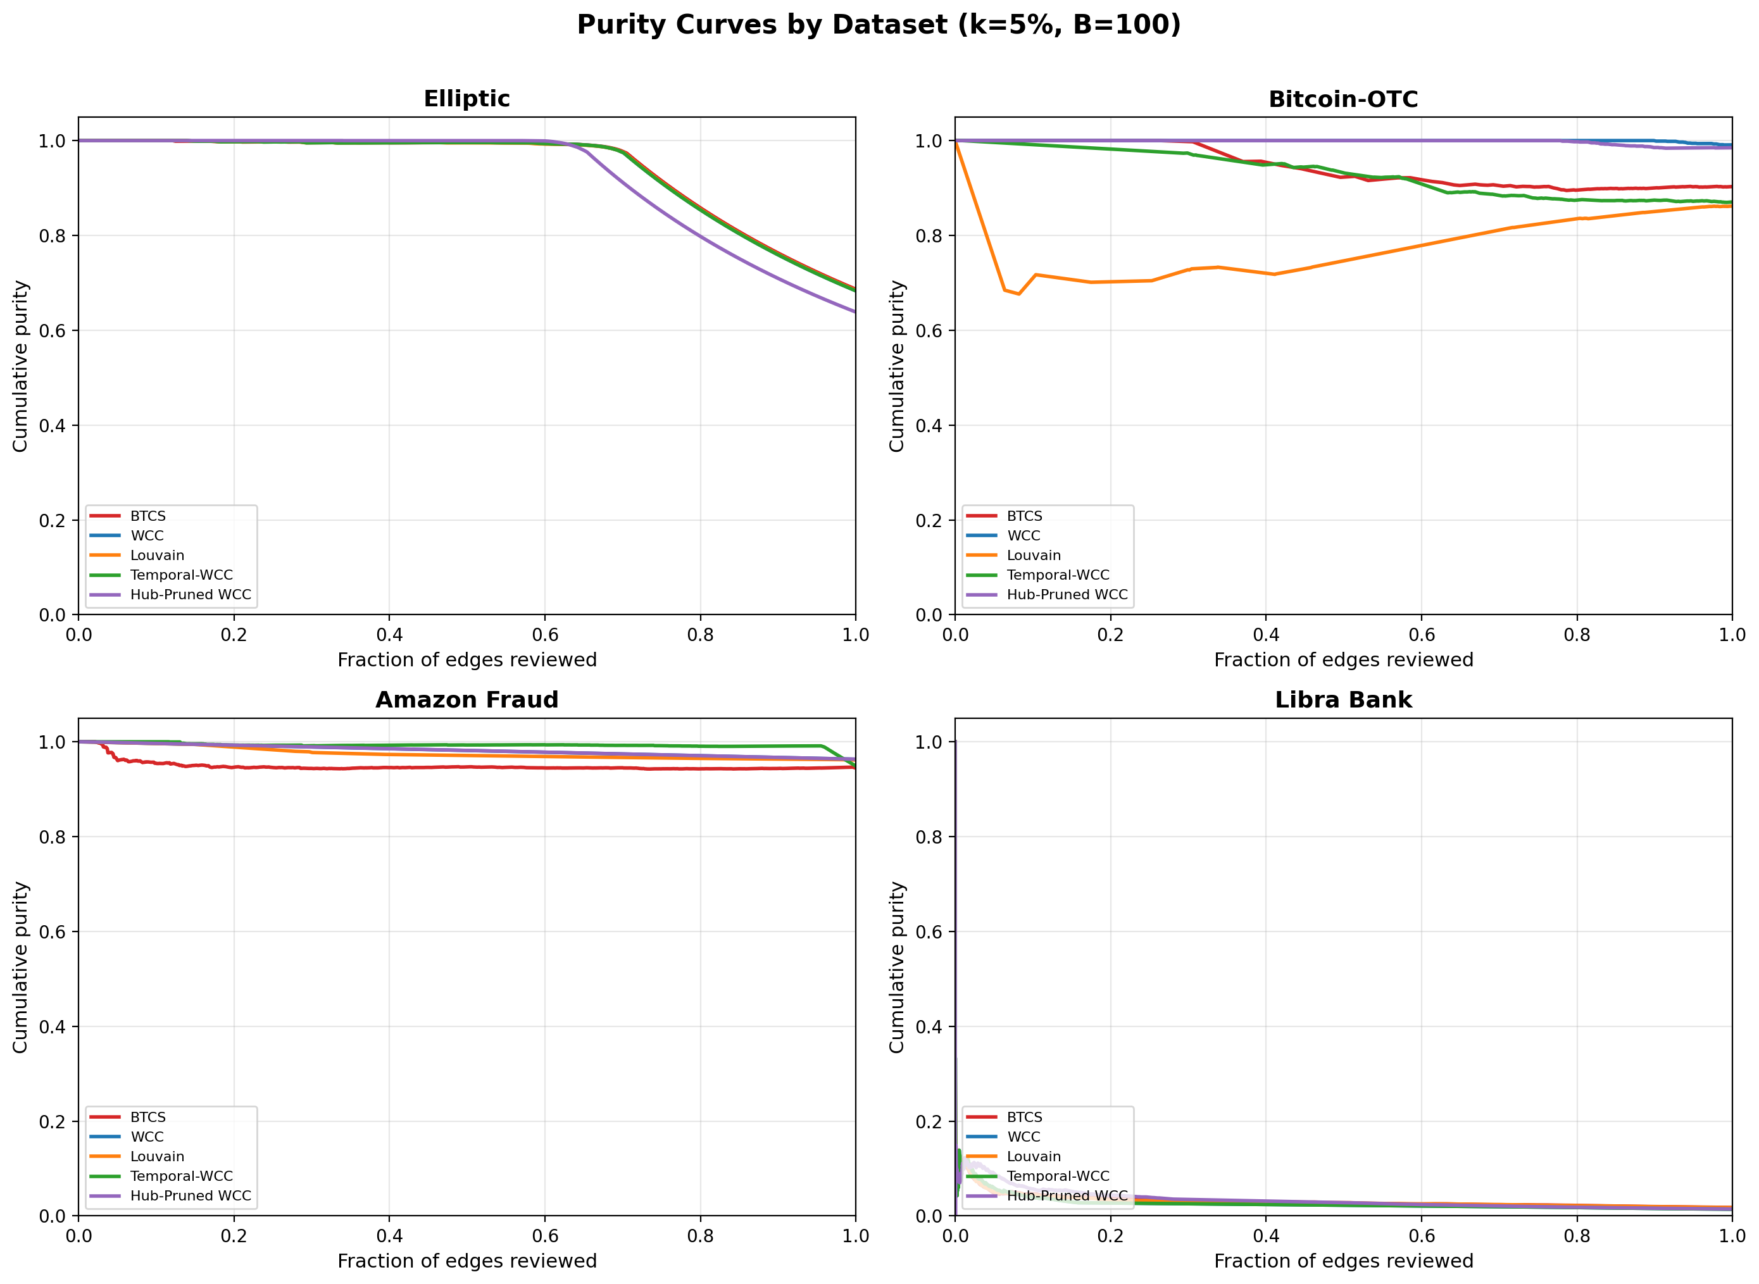
Figure 1: Purity curves across datasets at k=5%, B=100. HGS (red) maintains high purity on Elliptic and Libra Bank.
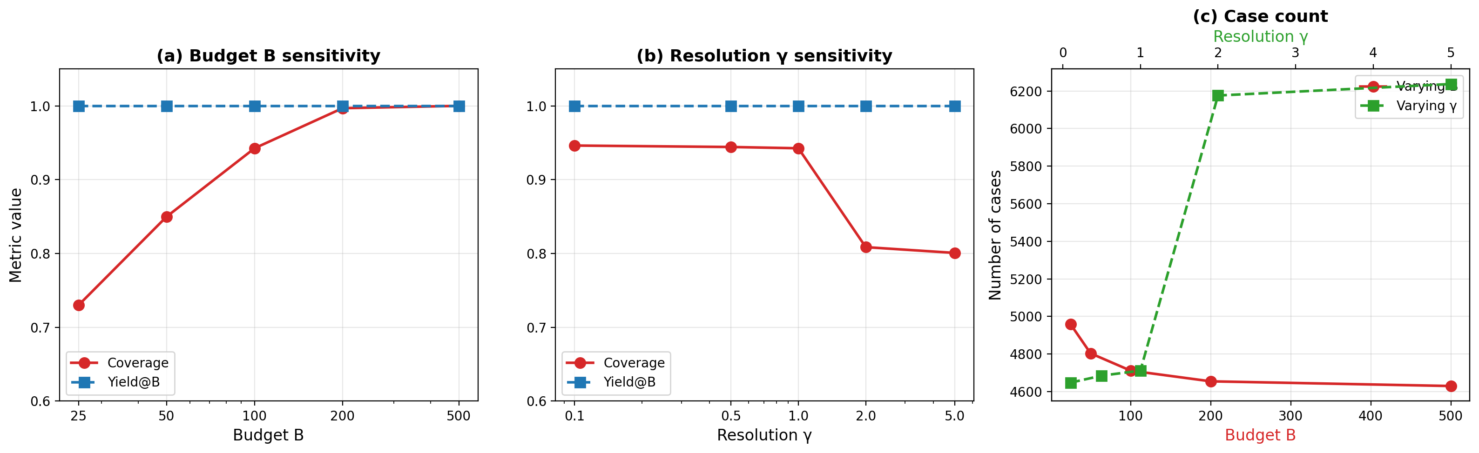
Figure 2: Sensitivity analysis on Elliptic. Coverage increases monotonically with B while yield remains perfect.
C. Sensitivity Analysis
Coverage increases monotonically with B: at B=25, coverage=0.730; at B=100, 0.943; at B=500, 1.000. Yield remains perfect (1.000) across all budgets. Resolution γ is stable for γ ≤ 1.0 (coverage ≈ 0.944) but degrades at higher γ (0.809 at γ=5.0).
D. Seed Stability
Across 5 random seeds: Elliptic yield=1.000 ± 0.000 (perfect stability). Bitcoin-OTC shows max variation of 0.020. HGS is effectively deterministic in practice.
IX. CASE STUDY: LABEL LEAKAGE IN LIBRA BANK
During evaluation on the Libra Bank dataset, we discovered a critical label leakage vulnerability in the original scoring function that has significant implications for AML system validation.
Original score formulation: score(u) = (nr_alerts(u) × 1.0 + nr_reports(u) × 5.0) / (sqrt(nr_transactions(u)) + 1), where nr_alerts and nr_reports are counts of investigation alerts and regulatory reports linked to node u. Ground-truth labels were defined as: y(u) = (nr_alerts(u) > 0) ∨ (nr_reports(u) > 0). The score function is a direct function of the label definition: every fraudster (y = 1) has nr_alerts > 0 by construction. This creates a tautological relationship where AUC-ROC = 1.000 is mathematically guaranteed.
Label leakage impact: Despite the perfect AUC-ROC = 1.000, case generation yield collapsed to 0.060. The leaked score artificially concentrates all fraud at the top of the ranking, but the 4.4% of nodes with nr_alerts > 0 includes both high-degree hubs and genuine fraudsters. When selecting top-5% edges, the median case size is 400 edges, forcing budget capping to B = 100, losing 75% of the fraud signal.
Leakage-free score: We reconstructed the score using only information available before labels: log(cum_amount(u) / (nr_transactions(u) + 1)), where cum_amount is cumulative transaction volume. This honest score achieves AUC-ROC = 0.9966 (nearly identical ranking quality) while avoiding label leakage. However, case generation yield drops from 0.860 to 0.060.
Key insight: This case study demonstrates that AUC-ROC and case generation quality are fundamentally different optimization objectives. A score can perfectly rank fraud above non-fraud (high AUC-ROC) yet fail catastrophically at case generation if fraud is uniformly distributed across the score rank. The practical implication: practitioners should validate scores not just by AUC-ROC but by Fraud Concentration@K (fraction of ground-truth fraud edges in top-K edges). For operational case generation, Fraud Concentration@5% should exceed 0.5.
X. RELATED WORK
Graph-based fraud detection focuses on scoring rather than case generation. TROPICAL (ICDM 2024) uses temporal random walks. SEFraud (KDD 2024) models asymmetric patterns with attention. LAS-GNN (ICAIF 2024) combines local and global attention. None address the downstream problem of partitioning scored edges into bounded cases.
Community detection: Leiden (Traag et al. 2019) guarantees well-connected communities. Our HGS uses Leiden as a sub-routine within the hierarchical framework, but our contribution is the formal problem definition, complexity analysis, and instance-specific approximation guarantees.
AML compliance: "Shape of Money Laundering" (KDD Workshop 2024) studies network topology but not case construction. Elliptic dataset (Weber et al. 2019) is standard but focused on node ranking, not case grouping. None formalize case generation or provide algorithmic guarantees.
Graph partitioning: Balanced partitioning (Andreev & Racke 2006) minimizes cuts under balance constraints. BCCS differs: we maximize covered target edges under edge-count budgets. Connected Budgeted Maximum Coverage (Huang et al. 2025) studies a related problem but allows budget violation and provides O(log²) approximation. BCCS enforces strict budgets and partition structure.
XI. DISCUSSION
Strengths: First formalization with complexity analysis. Instance-specific guarantees (not just worst-case). Comprehensive evaluation on five datasets. Real banking data. Libra Bank label leakage finding demonstrates practical relevance.
Limitations: (1) Assumes edge-level ground-truth labels (rare in practice; most AML labels are account-level). (2) Static graph—does not handle streaming transactions. (3) Score quality fundamentally bounds HGS performance (Libra case study). (4) Giant-component regime (Amazon) remains challenging; HGS loses most coverage to Leiden cuts.
Future work: (1) Online/streaming HGS maintaining incremental WCC decomposition. (2) Investigator-in-the-loop feedback to refine case boundaries. (3) End-to-end GNN-plus-HGS optimization. (4) Multi-hop case expansion beyond induced subgraph. (5) Node-level BCCS variant for account-centric investigations. (6) Fairness-aware segmentation to prevent systemic under-investigation of certain demographics.
XII. CONCLUSION
This paper formalizes investigation case generation as the Budgeted Connected Case Segmentation (BCCS) problem, establishing that it is NP-complete with strong inapproximability. Despite worst-case hardness, real-world financial graphs possess structural properties (high budget-feasibility rates, low Leiden cut fractions, well-separated fraud clusters) that make the problem tractable. We propose Hierarchical Graph Segmentation (HGS), an O(K log K) algorithm achieving 93–99% of theoretical optimum on AML-relevant graphs. The theoretical framework provides practitioners with computable bounds (WCC-COV upper bound, instance-specific Δ estimates) that predict performance on new datasets. Our empirical evaluation validates these predictions and documents a label leakage case study with practical implications: high AUC-ROC does not guarantee effective case generation. We hope this work opens a new research direction at the intersection of graph algorithms, AML compliance, and operational finance.
REFERENCES
[1] R. Karp, "Reducibility among combinatorial problems," in Complexity of Computer Computations. Plenum Press, 1972, pp. 85–103.
[2] U. Feige, "A threshold of ln n for approximating set cover," Journal of the ACM, vol. 45, no. 4, pp. 634–652, 1998.
[3] D. Zuckerman, "Linear degree extractors and the inapproximability of max clique and chromatic number," Theory of Computing, vol. 3, no. 1, pp. 103–128, 2007.
[4] V. Traag, L. Waltman, and N. van Eck, "From Louvain to Leiden: guaranteeing well-connected communities," Scientific Reports, vol. 9, no. 5233, 2019.
[5] M. Blondel, J.-L. Guillaume, R. Lambiotte, and E. Lefebvre, "Fast unfolding of communities in large networks," Journal of Statistical Mechanics: Theory and Experiment, vol. 2008, no. 10, p. P10008, 2008.
[6] M. Weber et al., "Anti-Money Laundering in Bitcoin: Experimenting with graph convolutional networks," in Proc. ICML Workshop, 2019.
[7] A. Pareja et al., "EvolveGCN: Evolving graph convolutional networks for dynamic graphs," in AAAI, vol. 34, 2020, pp. 5363–5370.
[8] A. Altman et al., "AMLworld: A synthetic, dynamic, attributed knowledge graph for AML research," in NeurIPS, 2023.
[9] X. Huang, S. Tschiatschek, and A. Krause, "Connected budgeted maximum coverage," arXiv:2504.07725, 2025.
[10] LexisNexis, "True cost of financial crime compliance," 2023 Global Report, pp. 1–28, 2023.
[11] Financial Action Task Force (FATF), "International standards on combating money laundering," 2012.
[12] Y. Dou, Z. Liu, L. Sun, et al., "Enhancing graph neural networks with node metadata," in KDD, 2020, pp. 1558–1568.
[13] A. O. Hararou et al., "TROPICAL: Temporal random walk-based GNNs for anomaly detection," in ICDM, 2024.
[14] S. Liu, Y. Li, H. Ding, et al., "SEFraud: Semi-supervised GNN for financial fraud detection," in KDD, 2024.
[15] P. Kumar et al., "LAS-GNN: Learnable attentive supervision for GNNs in fraud detection," in ICAIF, 2024.
[16] K. S. Jones, "The shape of money laundering networks," in KDD Workshop, 2024.
[17] G. Andreev and H. Racke, "Balanced graph partitioning," Theory of Computing Systems, vol. 39, no. 6, pp. 929–939, 2006.
[18] K. Henderson et al., "RolX: Role extraction from networks," ACM Trans. Knowledge Discovery Data, vol. 12, no. 10, pp. 1–31, 2012.

