Post-Hoc Sensitivity Analysis
As noted by the reviewers, this study included 777 eyes from 638 subjects, meaning that some participants contributed data from both eyes. This raises an important methodological consideration, as most statistical approaches assume independence of observations. Studies that include both eyes without explicitly accounting for inter-eye correlation may underestimate the true variance of their measurements (1). This occurs because the variability between two eyes from the same individual is inherently smaller than that between eyes from different individuals, reflecting shared physiological, genetic, and structural determinants of vision (1).
As a consequence, failure to account for this correlation can lead to artificially narrow confidence intervals (1). Moreover, it artificially inflates the sample size, as a study contributing 200 eyes from 100 participants does not provide the same amount of effective information as 200 observations from distinct individuals, due to clustering at the subject level (1).
To address this issue, we reviewed the primary studies included in our analysis, quantified the proportion of data derived from studies reporting one eye per participant versus both eyes, and examined the methods used for eye selection in studies reporting a single eye. These findings are summarized in the table below.

Approximately 60% of the information for this work was derived from studies reporting one eye per participant, while approximately 40% derived from studies reporting both eyes.

Quantifying the inter-eye correlation is disease-dependent and varies across conditions. For glaucoma specifically, the inter-eye correlation for the perimetric Mean Deviation varies; however, evidence drawn from publications places this value at ∼0.7 (2).

To evaluate the robustness of our findings, we performed a sensitivity analysis on the pooled estimates for mean difference in testing time, MD, and PSD. We recalculated these effect sizes by applying an effective sample size correction to studies reporting bilateral data, testing a range of scenarios to account for varying degrees of possible inter-eye correlation.

Scenario 1 serves as the unadjusted reference, assuming an inter-eye correlation of zero and treating all eyes as fully independent observations. Under this assumption, no statistical penalty is applied to studies reporting both eyes, and their reported sample sizes and standard errors are retained without modification (the same way the meta-analysis was conducted). Scenario 2 assumes a mild inter-eye correlation of 0.3, corresponding to a standard error multiplier of 1.14 and a retention of approximately 77% of the nominal sample size, representing a small penalty to studies reporting both eyes. Scenario 3 assumes a moderate inter-eye correlation of 0.5, with a standard error multiplier of 1.22 and retaining approximately 67% of the nominal sample size. Scenario 4 assumes a strong inter-eye correlation of 0.7, producing a standard error multiplier of 1.30 and retaining approximately 59% of the nominal sample size, representing an adjustment appropriate for conditions with high bilateral symmetry, among which glaucoma could be included. Finally, Scenario 6 represents the theoretical upper bound, assuming perfect inter-eye correlation of 1.0, under which the two eyes of a single participant carry no more independent statistical information than a single eye alone. This yields a standard error multiplier of 1.41, retains 50% of the nominal sample size, and is mathematically equivalent to analysing only one eye per participant. We believe this approach allows the committee to appreciate the potential magnitude of bias introduced by treating clustered ocular data as independent, and the robustness of the pooled estimates across the spectrum of plausible inter-eye correlations.

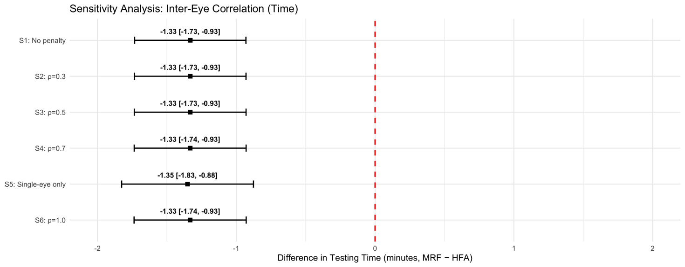

Sensitiviy Analysis 1: Pooled absolute mean difference in testing time (minutes) between Melbourne Rapid Fields (MRF) and Humphrey Field Analyzer (HFA) across varying assumptions of inter-eye correlation (ρ). The pooled estimate remains consistent, at approximately -1.33 minutes (95% CI: -1.74 to -0.93).

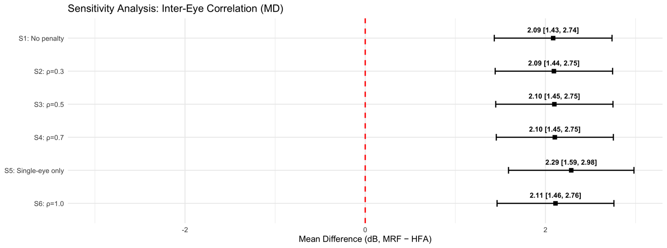

Sensitivity analysis 2: Pooled absolute mean difference in MD (dB) between Melbourne Rapid Fields (MRF) and Humphrey Field Analyzer (HFA) with varying assumptions of inter-eye correlation (ρ). The pooled estimate remains consistent at 2.09-2.11 dB. Scenario 5, utilizes only single-eye studies (60% of data, with an estimate of 2.29 dB (95% CI: 1.59 to 2.98).

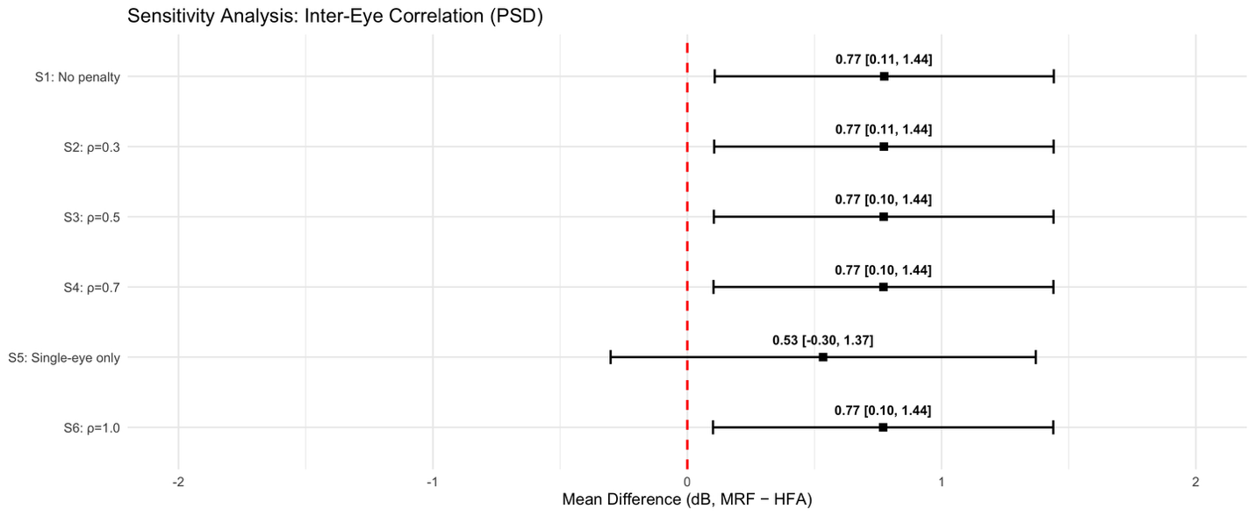

Sensitivity analysis 3. Pooled mean difference in PSD (dB) between Melbourne Rapid Fields (MRF) and Humphrey Field Analyzer (HFA) across varying assumptions of inter-eye correlation (ρ). The pooled estimate was consistently around 0.77 dB (95% CI: 0.10 to 1.44) across all correlation scenarios, except for Scenario 5, which included only studies reporting a single eye per participant (losing approximately 40% of the total data).

Results of this post-hoc sensitivity analysis, conducted in response to the reviewers’ comments, indicate with a reasonable degree of certainty that the pooled effect sizes remain consistent in direction and magnitude. This suggests that the primary findings described in the original manuscript are robust and consistent, despite the potential for variance shrinkage introduced by bilateral data without appropriate clustering adjustments.

References:
1. Armstrong RA. Statistical guidelines for the analysis of data obtained from one or both eyes. Ophthalmic Physiol Opt. 2013 Jan;33(1):7–14. doi:10.1111/opo.12009 PubMed PMID: 23252852.
2. Teng B, Li D, Choi EY, Shen LQ, Pasquale LR, Boland MV, et al. Inter-Eye Association of Visual Field Defects in Glaucoma and Its Clinical Utility. Transl Vis Sci Technol. 2020 Nov 17;9(12):22. doi:10.1167/tvst.9.12.22 PubMed PMID: 33244442; PubMed Central PMCID: PMC7683854.

