Date :

Quotation Num:
26/11/2019
O_19_149_PRFV_RECT_
Customer:
JD INGENIEROS

OFICINAS VALENCIA

RONDA DE GUGLIELMO MARCONI 11 46980 PATERNA –VALENCIA - SPAIN
Tel. 00 34 96 332 51 34
Fax 00 34 96 160 42 56
www.artein-ingenieria.com jclozano@artein-ingenieria.com

OFICINAS MADRID

C/NAVALES 76 28923 ALCORCON MADRID SPAIN
Tel+34 91 145 26 51
www.artein-ingenieria.com jlisidro@artein-ingenieria.com
PROPUESTA NUMERO:19_077_JD

Cliente Fecha:16/05/2019

Borja Rejano
Técnico Estudios y Valoraciones

T. (00 34) 91 159 16 16
F. (00 34) 91 159 16 17
M. (00 34) 664 396 449
C/ Quintanavides, 13 - Edificio 1 - Planta 4ª
28050 Madrid www.construciainstalaciones.com

INDICE
- Requerimientos del cliente.
- Caracteristicas generales de la solucion.
- Propuesta economica.
- Planos comerciales.
- Condiciones comerciales

1.- REQUERIMIENTOS DEL CLIENTE

2.CARACTERISTICAS GENERALES DE LA SOLUCION

General 3 St eelwork

  - The manu fact,ure and design of Balmoral ( H'ot Press Mo11!ded GRP Secti onal W.ater Storage Tanks) shall be to the ,qu ali ty standard r,equirements. of
{B'S EN ISO 9001) and shaU oomply with
(BSEN1 3280:2001} g!assfi br e r einforced plastic d,st e rns. f,or rn ld water storage .

Process Requirements

  - Ciste rns shall be manufactured by the Hot Pr,ess. Moulded methoo, g!ass rei nforced plasti c, moukled at tem¡perntures up to 150•e using
po!ye st,er resins whid1 conform to ISO 472, UV
st abili:sed and ' E' gla:ss ibre rei11fomement, coLaur gr<'fy'( RAL7 004:l .

.2.. 2 The cistem design sha l! inoorporate 1x1m pillow panels to th,e wa Us of cistems wit.n pmvis i on for flat panels far ronnections. .and fitti11gs.. P u rpose malle oover pa nels 1x1m and 1 x0. 5m flat pa, nel s po:siti oned to give free dra·ini ng charn1els.

2.) Base pam l5. av ailable int@rn ally fl anged (IFB} with 1x1m flat pane ls, fasteners inte mal (staínless steel Grade 1A 4D1 }, or externally flanged (EFB! with 1x 1m flat pane !s. and om piUow sump pane l, faste ner s extem al (Galvanisedj. Alte rnetively stainless steel fastners throughout can be requested..
  - Panels to be rigid!y supported by a combination of stainless stee l tia mds. inte rna!ly and galvaní;,ed box sec tion ext,ernally.

  - Steelworlk designed t o EN 1 0088-3;1'99 5. lntemal staiílless stee l 1 .4401 (316/ A4), g r ade and. ,externa! mild steel galva,nised to BSEN ISO 1461:2 009. Cistems to inco rporate exte ma l wal! bracing on depths 1 . 5m and greater and ti e rods 2m and

great er:.

- lnsu lati on (Encap sulated)

  - Pamels snall be factory insula t,e, d e ithe r on tne t,op, sicies ,md base as req uired , usiílg 40mm thklk CFC/ HiFC expa nded polysty rene.

4...2 Pame ls to be im;ul atecl wi tlilin a profile d face covering tne maximum s11rfaae arna and, to be encapsul a tecl with an extemal weather s.kin made
    - from ultraviolet stabilised mat,erial provi di ng p,ro, t ect íon against weathe rin g.

4.3 Conn ectioris. to be site fitted on flat insulated panels,
, and ali, holes sha ll be 5@a!ed with a rec.essed p!astic sectían from the ou te r surfac:e of too insulation skin to tlhe d ste m panel.

Foundation

2.4 AII sur faces oí the p,mels shaU be smooth and
5.1 AH cisterns to be htstalled,

on either flat co11tin u o u s

crevice fr,ee to provide hygienic finisn a11d b e dime nsim1ally ac cur ate witlh sha rply defined profiles.

.2..5 F!oat valve ctlambers can be provided with central hinged or líft off lockabLe ABS lid, witn opti ons of 180mm , 300mm and 500mm depth, where appmpriate pmvision for Type AB air gap in complia nae with BSEN1 30 77:2008.

  - 6 Man am ess. 600mm diameter scre>Hed , hhlgtid or li f t off lockable ABS li d available.

  - All tanks deeper than 1. 5m shall be füted to client r@<lLii re ments witn ínt.ernal stainless. or GRP an d externa! standard duty alumi hium ac.oess

l adders: to BS42 1 1 witn, hooped safety cage.

  - Handr:ail í:s offered as an option and s noold b e

consi dered to meet partic!.llar oontract needs.
foun da ti,on, clase centre beams, pier waUs or hearer beams conforming to marrnf-acturer's specification o f flatness and deflection and to be provided by the die nt. Refer, to BSTL 1693-004 to BSTL-1693-012.

Partitions
6.. 1 Wh,ere part itio ns are reqtiired, they wm be ful! n,eight using st andard paM ls. Eacn comp,,ut ment will be capable of s.upportíng water 011 either side witil on,e side emp,ty .

6.2 Wh,ere tan!< waUs req uim ,external rei nforce-ment, then part it i,on walls shaU be similarly reinforced i n grade 3:16 st ai nless steel.

Connections

7..1 Al! ,con nections ;;upp!ied to be site inst.all ed.

  - 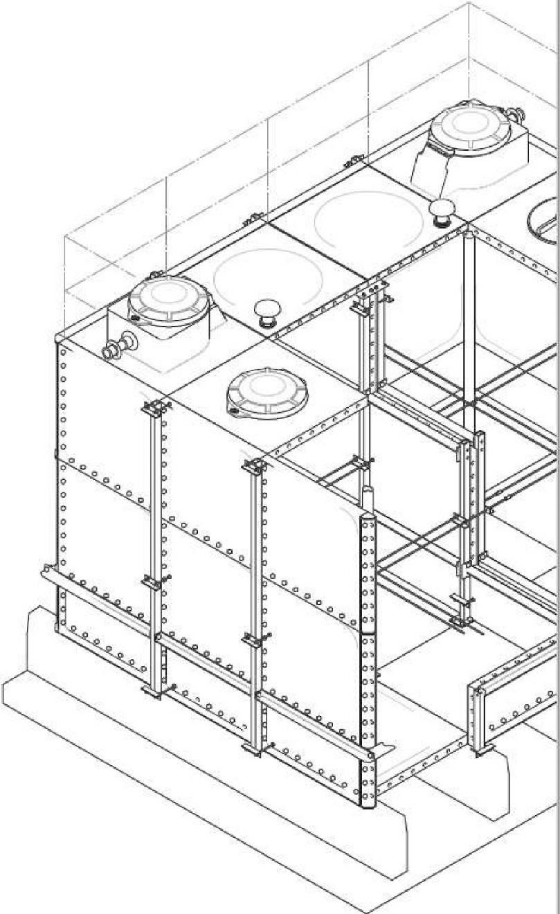Connect i,ons S4mm anci be low, plain/ BSP thread ed, 67mm and above flanged t o PN16 1.mle ss otherwise stated.

  - Standard flangoo connections as Balmoral 'BSTL' range spool piece with intemal support fl ange , external stub flange with loase galvani sed ring.

  - A,li c:on nection s to be instalted in accordance with WRAS/currnnt water byelaws. Tank mam.1f act urnr has WRAS approval for compliance with BS El'il 13077 i nstallatio ns.

- lnstallation

  - To be carrie,d aLJt by Balmoral approvec! i nstaller:s,
for warranty to be valid.

  - BALSEAL high densit y foam/butyl sealing strip ta be used covering full width of panel flange providing a water ti ght seal.

- Commissioning and Testing

  - Te-sting shall be carried out on campletion of installa tion by a mechanical contractor an<i sl10ulc:l be compieted within ten working days of assembly. This shaU incl ude the final se t tin g of float val ves
Le, v el swit ch,e s al1d ,any ot, her connection which requires se tti ng.

  - TiH! t.esting and comp li an,ce of p anels, sealant , conections ancl fixings shall be as Ust ed in WRAS Water Fit.tings and Mat,erials Directory and cl.lrrent water regulations.

- Mechanical properties
Method of manuJactLJl'e |  | Hot Pre-S-s Moulde-d
Sp€dtic gravity |  | 1. 84 :!: o.2 g/c mu
lrnsile strength |  | ,1!i0Mpa
l'lexural. strength |  | >2.00Mpa
Flexura! modul us |  | >115 00 Mpa
lmpact strength |  | 90 Kj / m
Shore hard-ies,s |  | Barcol:54
She-ar strengt h |  | 94.1 Mpa
(il.a'l'l 0011tent )1, |  | JO% ± 2
li:he.rrnal e-xpaílsion |  | 16. 10' (-6)m/ (m.k)
Therma l conductiv ity |  | O. JW/( m.k)
Overall heat lransmhsion |  | 0.6 W/ m2 K
Water ab50l'ption % |  | -síl. 3%
Light trnnsmission |  | ü.2 % Transmi.-.sion
lnsulati on thicknes:s |  | 40mm Eiqlil nded l)l'Styrene
lnsulation cate-r |  | Al!S

,

M100 WRc approv ed, capaci ti es to 4.00m deep • Listing 0706068.
M1 00-B30 WRc approved, capaciUe s to 4.00m
d,eep - Listing 0706067.

3. PROPUESTA ECONOMICA

SUPPLY
Item | Reference | Qty | Details | Price (EUR)
1 | 9m x 6m x 3m high | 2 | Internally Flanged Base 9000 x 6000 x 3000 Sectional Tank | 66.513.00
2 | 8m x 4m x 3m high | 2 | Internally Flanged Base 8000 x 4000 x 3000 Sectional Tank | 50.053.00
Total excluding VAT (EUR) |  |  |  | 116.566.00
INSTALLATION
Item | Reference | Qty | Details | Price (EUR)
1 | Installation and Start up | 4 | Installation, comissioning and Start up of the all tanks | 21.995,00
Total excluding VAT (EUR) |  |  |  | 21.995,00
In this prices are not included the foundation required to support the tanks. ARTEIN can desing and supply that system if the customer request it.

4.- PLANOS COMERCIALES.

5.- CONDICIONES COMERCIALES

Payment conditions
- 30% at the sign of the order
- 70% Aganist shippind documents
- 10% at finalization of the installation
The proposal is valid for 3 months

Delivery time
7 to 8 week from the approval of the engineering drawing.

Guarantee Period
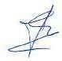
12 Meses

Fdo. Jose Luis Isidro
Director General

Page 2 of 7

Quotation Notes
1 | Our Standard public liability insurance is limited to EUR10,000,000. Any insurance requirements beyond this value will be charged as an extra.
2 | Our tender is open for acceptance for 30 days.
3 | Offloading and positioning of materials will be the responsibility of yourselves unless stated otherwise within each tanks specific notes
4 | Any lighting, power and facilities which may be required would be the responsibility of the client
5 | Any scaffolding that may be required will be supplied by the contractor unless stated otherwise within each tanks specific notes
6 | Sub-contract orders will not be accepted on values less than EUR10,000 without prior agreement. Where a sub-contract has been agreed, the retentions are only applicable to 10% of the quotation value.
7 | ARTEIN standard terms and conditions apply.
8 | As standard our deliveries will be made by FORS Bronze 40ft articulated lorry unless agreed stated otherwise within each tanks specific notes
9 | Testing & commissioning is not included as standard but can be offered if required at an extra cost
10 | Secure site storage of all materials from delivery date to install completion date and then protection from our handover to be provided by yourselves
11 | Our deliveries are made between the hours of 10.00am and 5.00pm unless stated otherwise within each tanks specific notes .
12 | BTL hold a range of HSEQ approvals inc ISO9001, ISO14001, Achilles, SSIP, Safecontractor & Constructionline. These include RAM documentation supplied in our format. Should RAMS be required in a non-standard format a charge will be applied
13 | Our couriers require all offloading of the tank materials to have commenced within 20mins of the arrival of the vehicle. Failure to do this could result in the vehicle leaving and an aborted delivery charge being applied
14 | To further improve our service levels we will forward you a very brief satisfaction survey at the end of the project and for every response we receive we will make a small donation to charity
15 | Balmoral withholds the right to charge for any aborted installations within 48 hours of the agreed upon installation start date
16 | Induction - We have included for a standard one hour induction. If we are required to attend longer than this then this will be charged for at an hourly rate.
17 | Waste materials and packaging to be placed by ARTEIN erectors in skips or waste removal system supplied by others. If we are required to remove this from site, there would be an extra cost
18 | The structural integrity of the foundation remains the customer's responsibility at all times.
19 | Welfare facilities should be provided by others. If this is impractical, Balmoral Tanks must be advised at the time of order placement.
20 | Overflow and warning pipes MUST be connected to a safe and adequate point of discharge so that, in the event of activation, there is no possibility of water damage to the surrounding area. Warning pipes must also be run to a visible but safe location
21 | No additional fixtures or fixings should be attached to the tank without prior agreement from ARTEIN Doing so could invalidate the warranty.
22 | Fair and reasonable time should be allowed between filling the tank and handover of the project, to allow for remedial works, if required.
23 | Upon receipt of the Project Confirmation pack from our Contracts department, it is essential that all documentation (especially Customer Responsibilities & Foundation details) are read and understood.
24 | Our standard work hours are 8am till 5pm on weekdays. Anything outside this would require additional cost
25 | This tank should not be left unattended during initial filling. If commissioning services are required please contact us to provide you with a quotation if not already done
26 | ARTEIN will not be liable for consequential costs incurred caused by failure to meet any of the instructions stated within this quotation

Page 3 of 7

Item 1 - Detail
9m x 6m x 3m high
Tank Type | Internally Flanged Base
Quantity | 1
Description | GRP hot press moulded sectional tank. Manufactured to BS EN 13280:2001
Int. Dims (LxWxH) | 9000mm x 6000mm x 3000mm
Ext. Dims (LxWxH) | 9330mm x 6330mm x 3040mm
Nominal capacity | 162,000 litres / 35,640 gallons
Min. Spatial Dims (LxWxH) | 10930mm x 7330mm x 3840mm
Cover | Manufactured to BS6399 Part 1 1984.
Insulation | 40mm Polystyrene Encapsulated (0.6W/m2K) to the cover and sides
Panel Type | Cover: 1000 x 1000 mm. Side 1000 x 1000 mm. Base 1000 x 1000 mm.
Fixings | Grade 316 stainless steel bolt fasteners where internal, GMS external

Item 1 - Ancillaries (Included)
Item | Part Code | Description | Qty
Drain | DRV-200- BSP | 2" Threaded Drain c/w Brass Gate Valve & S/S Barrel Nipple | 2
Float Valve Chamber | FVC-400 | 1mx1mx400mm high clipped float valve chamber | 2
Inlet | EQU-200- CF-DA-FLG | 2" BSP Equilibrium Ballvalve suitable up to 5 Bar c/w copper ball & drop arm - Flanged | 2
External Ladders | FAC-3.0 | 3050mm IFB Caged 13 Rung Ladder c/w Brackets - Alu | 2
Manways | MWC-1X1 | Clipped lid 1x1m cover access panel | 2
Outlet | FSP-SPF- 150 | 150mm PN10 Flange c/w Spool Piece & PVC Backing Ring | 2
Overflow | UOF-100 | 100mm PN10 Flange c/w Screened Overflow & Dip Pipe | 2
Vent | SCV-2-MW | 2" Screened Air Vent Tank Connector - Type ZWLFBR | 2
Warning Pipe | TOF-1 | 1" Pushfit Screened Fitting - Type R30E | 2
Base Steel | ST-BX3-6200  -KIT | 100X50X3MM RHS BASE STEEL GALV KIT - 6200mm | 38
Internal Ladders | IGL-3 | 2765mm Int' 11 Rung Ladder - GRP needs 4 x BKT-867 | 2

Item 1 - Logistics and Price
Lead Time | To Be Agreed
Delivery | Delivery included , DDP ON SITE
Installation | Installation excluded
Price (Total) excluding VAT (EUR) |  | 66.513,00

Page 4 of 7

Item 1 - Notes
Tank Base: Important Information Steels are Included.
19 no. 6200mm long 100X50X3MM RHS BASE STEEL GALV KIT - 6200mm steels placed at 500mm centres to run parallel to width.

Orientation of Pier Walls/Supporting Steel and divider location (if applicable) are criticaland should match provided specifications as the tank is specifically designed.

The top surface should be level to a tolerance of no more than 2mm in any 1m or a total of 6mm in any 6m measured laterally or diagonally.

To avoid delay to the installation of your tank, and possibly additional costs, please ensure you review and adhere to the technical details & information in relation to the tank base specification. It is also the customer's responsibility to ensure the base is of the necessary structural integrity. Please call us immediately if you have any questions or concerns on tank base specification.
1

Page 5 of 7

Item 2 - Detail
8m x 4m x 3m high
Tank Type | Internally Flanged Base
Quantity | 2
Description | GRP hot press moulded sectional tank. Manufactured to BS EN 13280:2001
Int. Dims (LxWxH) | 8000mm x 4000mm x 3000mm
Ext. Dims (LxWxH) | 8330mm x 4330mm x 3040mm
Nominal capacity | 96,000 litres / 21,120 gallons
Min. Spatial Dims (LxWxH) | 9930mm x 5330mm x 3840mm
Cover | Manufactured to BS6399 Part 1 1984.
Insulation | 40mm Polystyrene Encapsulated (0.6W/m2K) to the cover and sides
Panel Type | Cover: 1000 x 1000 mm. Side 1000 x 1000 mm. Base 1000 x 1000 mm.
Fixings | Grade 316 stainless steel bolt fasteners where internal, GMS external

Item 2 - Ancillaries (Included)
Item | Part Code | Description | Qty
Drain | DRV-200- BSP | 2" Threaded Drain c/w Brass Gate Valve & S/S Barrel Nipple | 2
Float Valve Chamber | FVC-400 | 1mx1mx400mm high clipped float valve chamber | 2
Inlet | EQU-200- CF-DA-FLG | 2" BSP Equilibrium Ballvalve suitable up to 5 Bar c/w copper ball & drop arm - Flanged | 2
External Ladders | FAC-3.0 | 3050mm IFB Caged 13 Rung Ladder c/w Brackets - Alu | 2
Manways | MWC-1X1 | Clipped lid 1x1m cover access panel | 2
Outlet | FSP-SPF- 150 | 150mm PN10 Flange c/w Spool Piece & PVC Backing Ring | 2
Overflow | UOF-100 | 100mm PN10 Flange c/w Screened Overflow & Dip Pipe | 2
Vent | SCV-2-MW | 2" Screened Air Vent Tank Connector - Type ZWLFBR | 2
Warning Pipe | TOF-1 | 1" Pushfit Screened Fitting - Type R30E | 2
Base Steel | ST-BX3-4200  -KIT | 100X50X3MM RHS BASE STEEL GALV KIT - 4200mm | 34
Internal Ladders | IGL-3 | 2765mm Int' 11 Rung Ladder - GRP needs 4 x BKT-867 | 2

Item 2 - Logistics and Price
Lead Time | To Be Agreed
Delivery | Delivery included
Installation | Installation excluded
Price (Each) excluding VAT (GBP) |  | 25.027.00
Price (Total) excluding VAT (GBP) |  | 50.055.00

Page 6 of 7

Item 2 - Notes
Tank Base: Important Information Steels are Included.
17 no. 4200mm long 100X50X3MM RHS BASE STEEL GALV KIT - 4200mm steels placed at 500mm centres to run parallel to width.

Orientation of Pier Walls/Supporting Steel and divider location (if applicable) are criticaland should match provided specifications as the tank is specifically designed.

The top surface should be level to a tolerance of no more than 2mm in any 1m or a total of 6mm in any 6m measured laterally or diagonally.

To avoid delay to the installation of your tank, and possibly additional costs, please ensure you review and adhere to the technical details & information in relation to the tank base specification. It is also the customer's responsibility to ensure the base is of the necessary structural integrity. Please call us immediately if you have any questions or concerns on tank base specification.
1

Page 7 of 7

Dimensions | L (mm) |  | W(mm) | H (mm)
Interna! (Actual) |  | 8000 | 4000 |  | 3000
Externa! |  | 8330 | 4330 |  | 3040
Total Min Spatial |  | 9930 | 5330 |  | 3840

Capacity: 96000 litres

> 1 Externall Lac

FAC-3.0

3( 1,00( Front 1,006mn 0mm

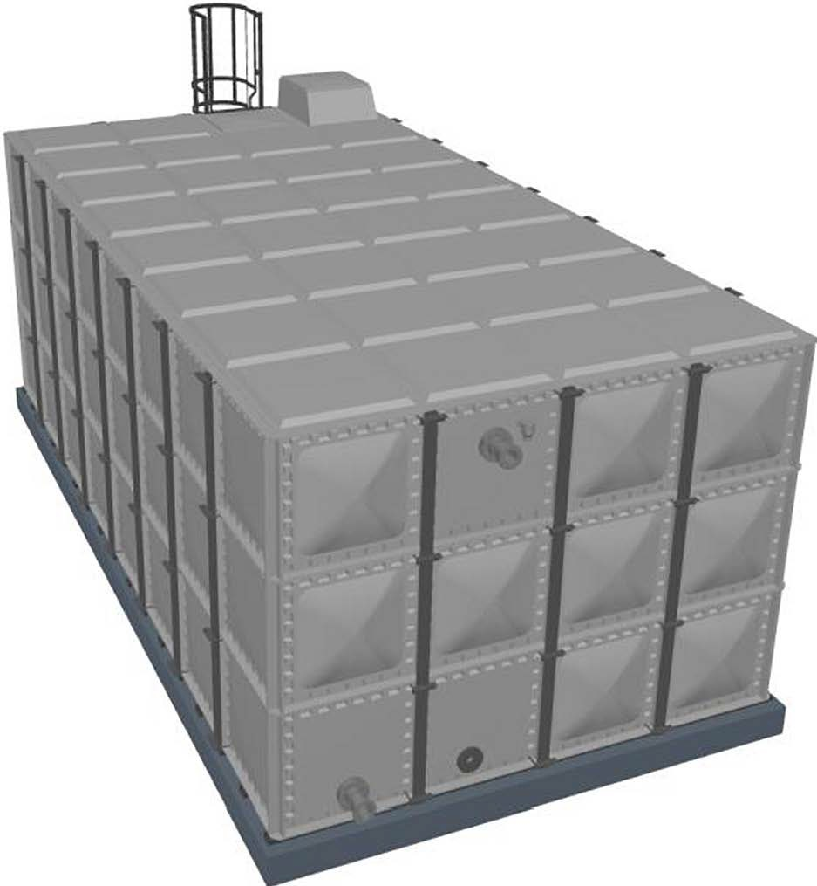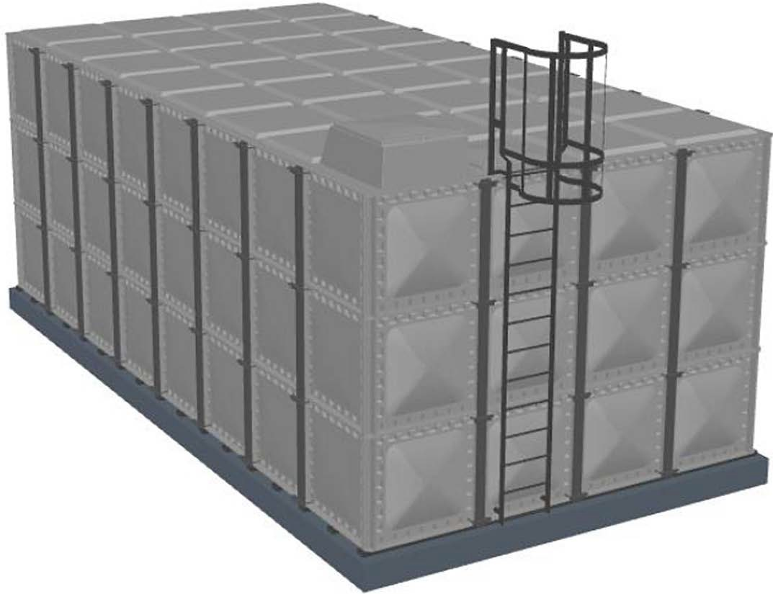
Interna! Lac | IGL-3 | Ti | 1,00( | Nlone
lnlet | EQU-200-C | 2" | 1,00( | FVC
Float Valve | FVC-400 | 1r | 1,00( | Cover
Manways | MWC-1X1 | CI | 1,00( | Cover
Vent | SCV-2-MW | 2" | 1,00( | Nlone
Outlet | FSP-SPF-15 | 1� | 1,00( | Back | 514mm | 200mm
Overfllow | UOF-100 | 1( | 1,00( | Back | 1,497mn | 2,665mn
Warning Pi¡ | TOF-1 | 1" | 1,00( | Back | 1,696mn | 2,775mn
Drain | DRV-200-B | 2" | 1,00( | Back | 1,424mn | 200mm

Dimensions | L (mm) | W (mm) | H (mm)
Interna! (Actual) | 9000 | 6000 |  | 3000
Externa( | 9330 | 6330 |  | 3040
Total Min Spatial | 10930 | 7330 |  | 3840
Capacity: 162000 litres

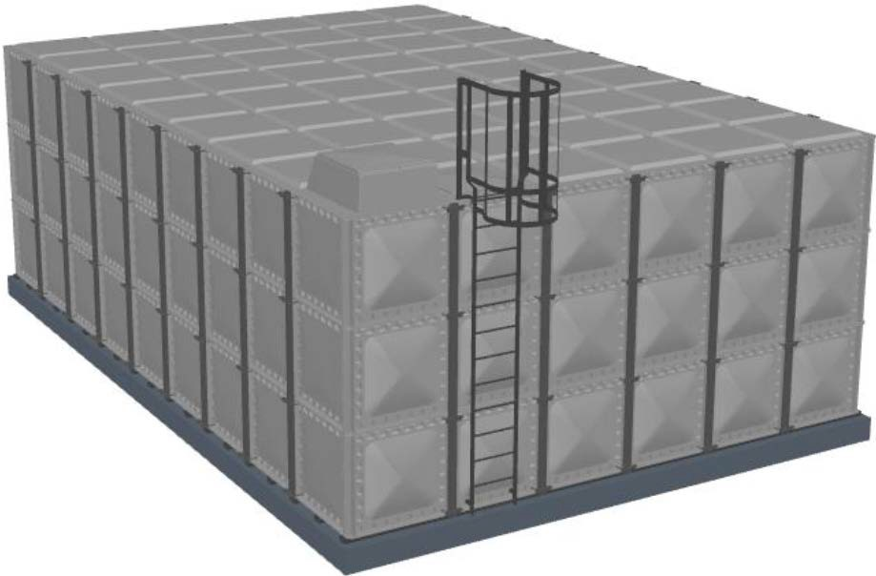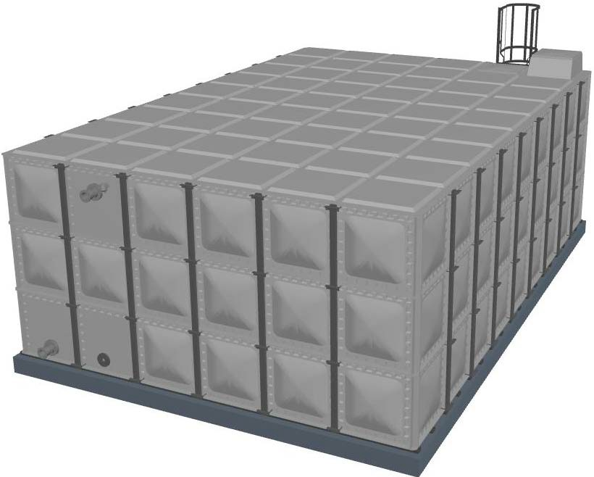,1 Externa! La<
Interna! Lac | IGL-3 | 2, | 1,00( | None
lnlet | EQU-200-C | 2" | 1,00( | FVC
Float Valve | FVC-400 | 1 r | 1,00( | Cover
Manways | MWC-1X1 | CI | 1,00( | Cover
Vent | SCV-2-MW | 2" | 1,00( | None
Outlet | FSP-SPF-15 | E | 1,00( | Back | 514mm | 200mm
Overflow | UOF-100 | 1( | 1,00( | Back | 1,497mn | 2,665mn
Warning Pi¡ | TOF-1 | 1" | 1,00( | Back | 1,696mn | 2,775mn
Drain | DRV-200-B | 2" | 1,00( | Back | 1,424mn | 200mm

FAC-3.0
3( 1,00( Front 1,006mn
0mm

1 2 3 4 5 6 7 8
A
9 10 11 12
THE CONNECTION POSITION DIMENSIONS ARE AJ..WAYS TAKEN FROM THE BOTTOM LEFT OF THE PANEL THAT IT IS PLACED ON. THE HORIZONTAL ANO VERTICAL DIMENSIONS REFERENCE A POINT IN THE CENTRE OF THE

ITEM ELEV CATEGORY

º"""
'"' Warning Pipe
---

FAC-3.0
COOE
QTY
SHORT OESCRIPTION
AlumlnlumCsgedladder
150mm PN10 Flange cJwSpool Pillee
100mm PN10 Flange clw Scteened 0/F&Dip Pipe
1'PushfltScreenedFlttln11
DIM-H DIM-V

""" c..,
"""' FloatVeMIChsmber
FVC ''"'
....
e-
BaseSteel lntemal lntemalladder$
B

DRV-200-BSP
,VC,00
EQU-200-CF-OA-FLG M'NC-1X1
ST-8X3-6200-KfT IGL-3

2"ThreadedDrakldwBrauGllt9VBlve&Plug 1rnx1mx400mm high dipped float velve dlamber 2" BSP Equilibrium • Aenged Clippedlid1x1mCOVfllf�penel

B

e
ra

D r7

BASE
1. Tank Base: lmportant lnformation Steels are lncluded.
19 no. 6200mm long 100XSOX3MM RHS BASE STEEL GALV KIT - 6200mm
steels placed at 500mm centres to run parallel to width.
e
Orientation of Pier Walls/Supporting Steel and divider location (if applicable) are criticaland should match provided specifications as the tank is specifically designad.
The top surface should be level to a tolerance of no more than 2mm in any 1m or a total of 6mm in any 6m measured laterally or diagonally.
To avoid delay to the installation of your tank, and possibly additional costs, please ensure you review and adhere to the technical details & information in relation to the tank base specification. lt is also the customer's responsibility to ensure the base is of the necessary structural integrity. Please call us immediately
if you have any questions or concems on tank base specification. D

RIGHT ELEVATION FRONT ELEVATION LEFT ELEVATION BACK ELEVATION

E

F

E

F

Far lnformation
THIS DRAWING 1$ COPYRIGHT ANO 1$ ISSUED ON CONDITION THAT IT 1$ NOT COPIED, REPRODUCED OR DISCLOSED TO A THIRD PARTY WITHOUT CONSENT IN WRITING OF BALMORAL TANKS LTD.

G

PLAN
JOBTITLE

CLIENT
JGINGENIEROS
ESTIMATE TITLE
9m x 6m x 3m high
JOBNo.
410077 G
QUOTE No.
O_1 9_1 49 ESTIMATE No.

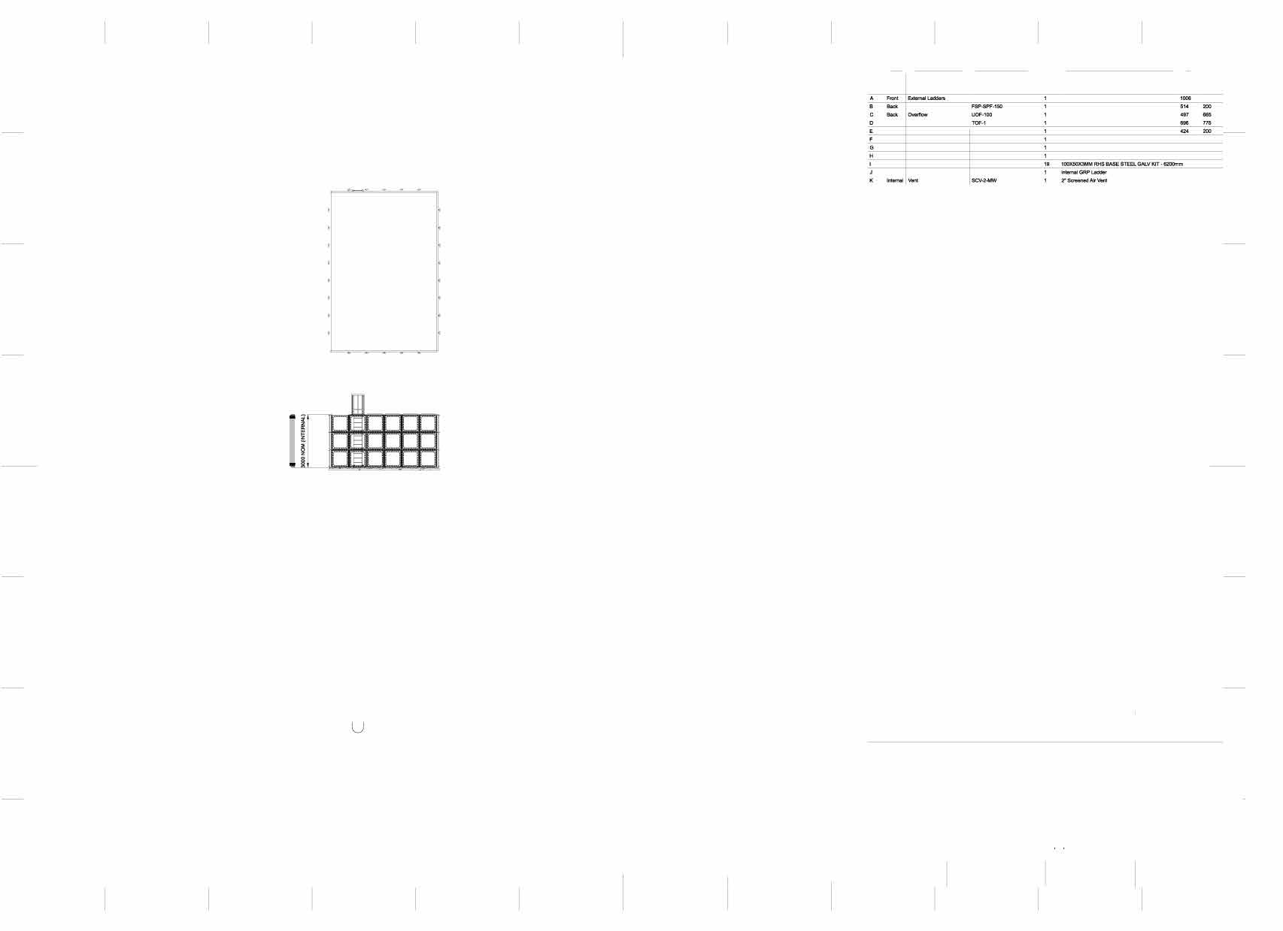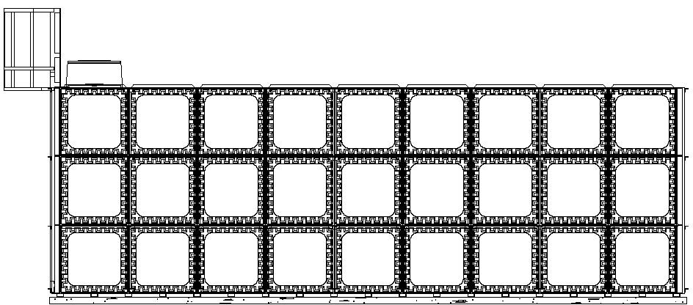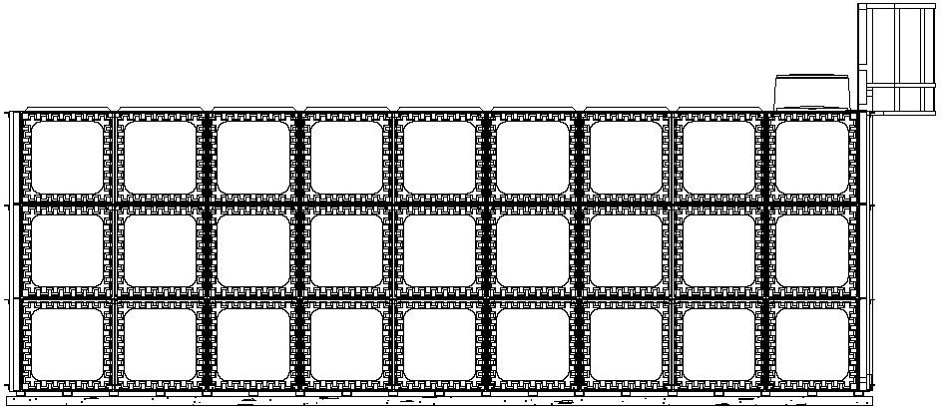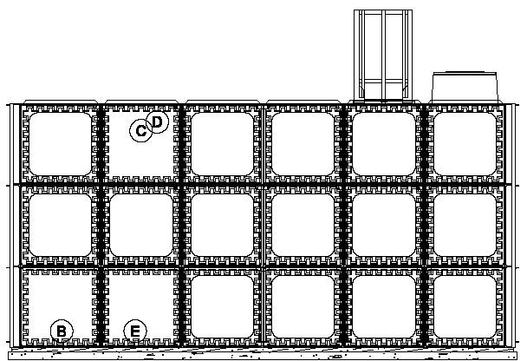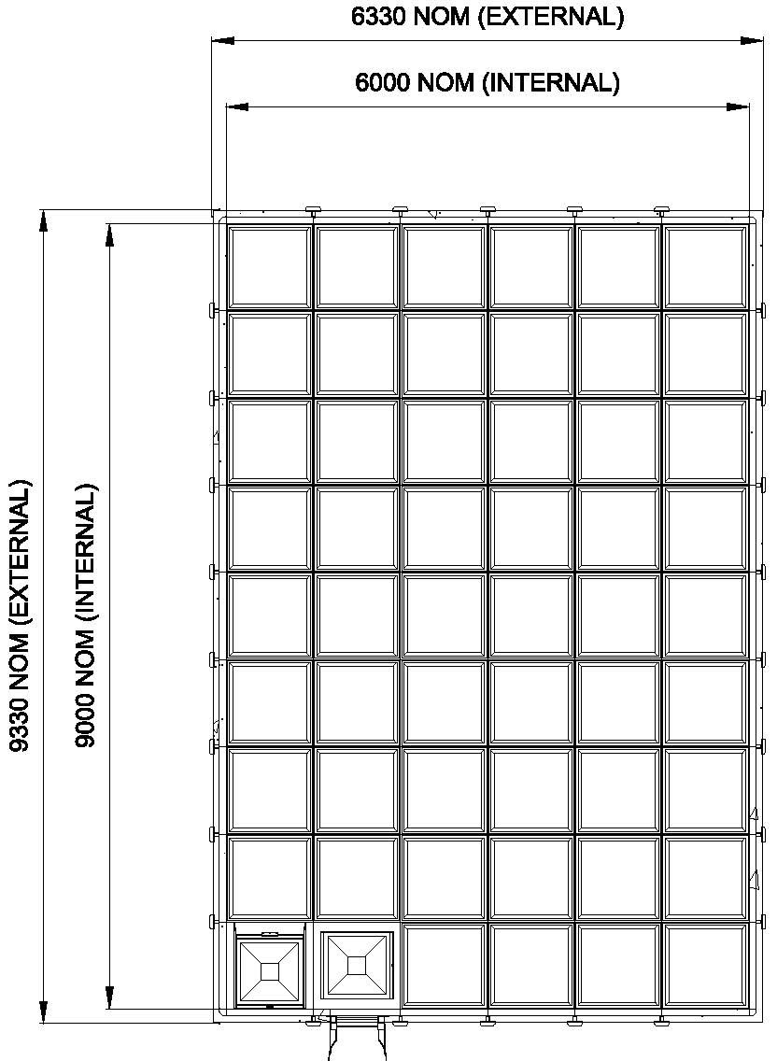

H

1 2 3 4 5 6 7 8

H
DATE TANKTYPE SCALE
El$
21/1112019 9X6X3 IFB NOT TOSCALE

9 10 11 12

1 2 3 4 5 6 7 8
A
9 10 11 12
THE CONNECTION POSITION DIMENSIONS ARE AJ..WAYS TAKEN FROM THE BOTTOM LEFT OF THE PANEL THAT IT IS PLACED ON. THE HORIZONTAL ANO VERTICAL DIMENSIONS REFERENCE A POINT IN THE CENTRE OF THE

ITEM ELEV CATEGORY

º"""
'"' Warning Pipe
---

FAC-3.0
COOE
QTY
SHORT OESCRIPTION
AlumlnlumCsgedladder
150mm PN10 Flange cJwSpool Pillee
100mm PN10 Flange clw Scteened 0/F&Dip Pipe
1'PushfltScreenedFlttln11
DIM-H DIM-V

""" c..,
"""' FloatVeMIChsmber
FVC ''"'
....
n
e-
BaseSteel lntemal lntemalladder$
B

DRV-200-BSP
,VC,00
EQU-200-CF-OA-FLG M'NC-1X1
ST-8X3-4200-KfT IGL-3

2"ThreadedDrakldwBrauGllt9VBlve&Plug 1rnx1mx400mm high dipped float velve dlamber 2" BSP Equilibrium • Aenged Clippedlid1x1mCOVfllf�penel

B

e

BASE
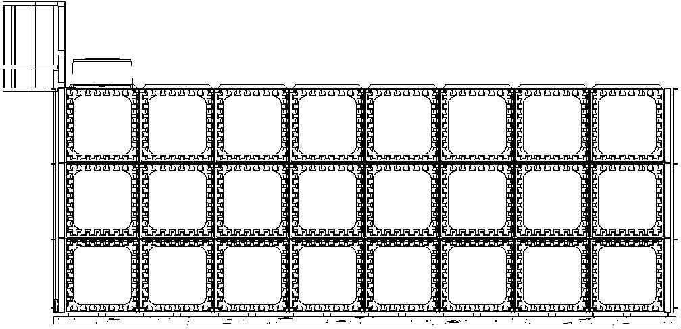
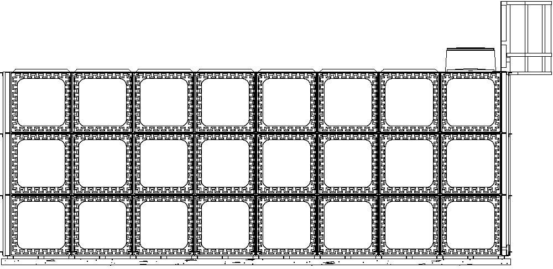
D 11 ]
1. Tank Base: lmportant lnformation Steels are lncluded.
17 no. 4200mm long 100XSOX3MM RHS BASE STEEL GALV KIT -4200mm
steels placed at 500mm centres to run parallel to width.
e
Orientation of Pier Walls/Supporting Steel and divider location (if applicable) are criticaland should match provided specifications as the tank is specifically designad.
The top surface should be level to a tolerance of no more than 2mm in any 1m or a total of 6mm in any 6m measured laterally or diagonally.
To avoid delay to the installation of your tank, and possibly additional costs, please ensure you review and adhere to the technical details & information in relation to the tank base specification. lt is also the customer's responsibility to ensure the base is of the necessary structural integrity. Please call us immediately
if you have any questions or concems on tank base specification. D


� i>>--
i
::::
::::
§ÍJ1

RIGHT ELEVATION FRONT ELEVATION LEFT ELEVATION BACK ELEVATION

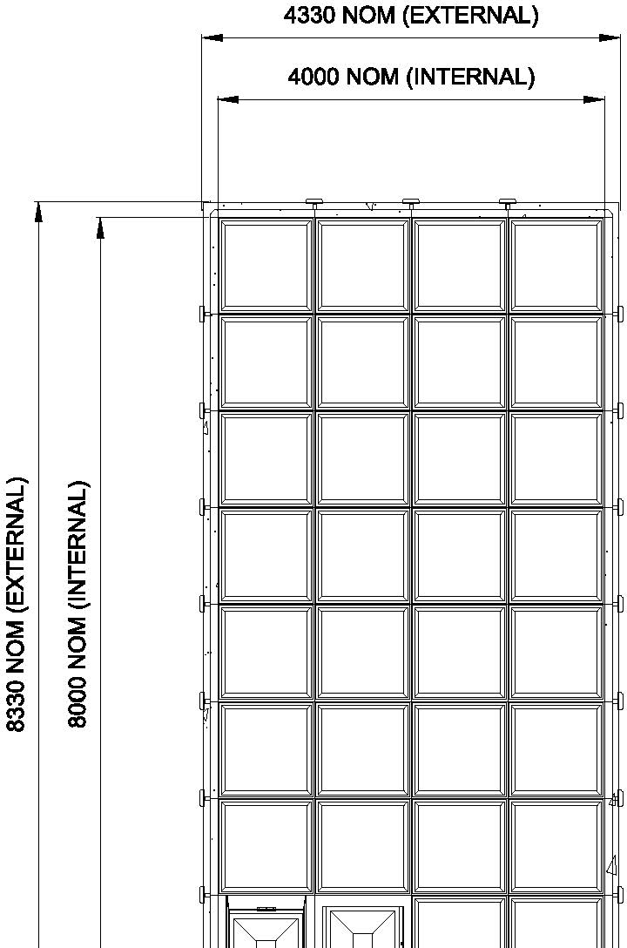
E

F
E

F

Far lnformation
THIS DRAWING 1$ COPYRIGHT ANO 1$ ISSUED ON CONDITION THAT IT 1$ NOT COPIED, REPRODUCED OR DISCLOSED TO A THIRD PARTY WITHOUT CONSENT IN WRITING OF BALMORAL TANKS LTD.


G

PLAN
JOBTITLE

CLIENT
JGINGENIEROS
ESTIMATE TITLE
8m x 4m x 3m high
JOBNo.
410077 G
QUOTE No.
O_1 9.149 ESTIMATE No.

H

1 2 3 4 5 6 7 8

H
DATE TANKTYPE SCALE
El$
21/1112019 8X4X3 IFB NOT TOSCALE

9 10 11 12

