Slim Table Generator
(tablegenerator.py)
User Guide

Andrés Megías Toledano | Version 1.7
Center for Astrobiology (CAB), Madrid | September 2022

Index
1. Introduction 1
2. Input files 2
3. Output files 2
4. Configuration file 3
5. Example case 7
5.1. Input files 7
5.2. Configuration file 8
5.3. Output tables 10
5.4. Output abundances list 11
Useful links 12
Credits 13
License 13

Introduction
The Slim Table Generator is a Python 3 script, tablegenerator.py, that creates tables in LaTeX format (.tex) out of the results of the Slim tool from the Madcuba package. It can create a table of the transition lines studied and a table of the abundances of the corresponding species with respect to a reference molecule.
The script requires the modules os, re, sys, copy, and platform, from the Python’s standard library, and also the libraries PyYaml, NumPy, Pandas, and RichValues. In order to run the code, it is necessary to specify some options in a configuration file. For running the code we have to write the following command line in the terminal, being in the folder of the file tablegenerator.py:
python3 tablegenerator.py <path> .
The argument <path> is the path of the configuration file. If we do not specify it, the script will search in the current folder (./) for the configuration file specified inside the script in the variable config_file, at the beginning of the code; we can use this variable to run the script in a programming environment like Spyder. If the script tablegenerator.py is not in the current folder, but in a folder with path <folder>, we should write <folder>/tablegenerator.py instead of tablegenerator.py. Moreover, if the script is included in a folder of executable files, the term python3 can be removed from the command line, and the script will be run from any path.

Input files
Apart from the configuration file, we need at least two files in order to run this script. They are described below, using the same name used in the configuration file:
  - Madcuba table. Transition lines table in .csv format generated by Madcuba. To generate it in Slim, select one of the species in the SimFit tab to open the transition table window, check the Spectral, Fit, and Phys. options, and click the save icon to export the table in .csv format.
  - processing table. Table in .csv format with information of the RMS noise and resolution of the spectra used in Madcuba. Each row, which corresponds to one spectral range, must have the following columns: min. frequency (MHz) (minimum frequency), max. frequency (MHz) (maximum frequency), rms noise (mK) (RMS noise), and resolution (MHz) (frequency resolution). This file can be generated by the Python Reduction Pipeline for Class (script processing.py) once we have run the steps --selection, --line_search, and --reduction, adding the argument --spectra_tables (for example: python3 processing.py config.yaml --spectra_table). If there are multiple sources, this variable should be a list.
  - LaTeX template (optional). Template with the structure of the tables in .tex format. Each of the two possible tables must contain only one row with a specific keyword; in the case of the transitions table, it is --tablelines--, and for the abundances table, it is --tableabunds--. It can be easily done with a graphical LaTeX editor like Lyx. If we do not supply this file, a generic simple template will be automatically generated according to the parameters set in the configuration file.
  - non-LTE lines table (optional). In case that we want to manually set the parameters of the transitions of some species (usually because they are not studied with a local thermodynamical equilibrium (LTE) model), this table in .tex format should contain the information of those transitions. It can be easily done with a graphical LaTeX editor like Lyx. This is a nested variable that should contain another variable with the name of the table in .tex format, and then a list containing the Madcuba names of the molecules included in the table.

Output files
The main output file that will be generated with this script is a .tex file containing two tables (or only one of them, depending on what we write in the configuration file):
- The transition table. It contains information about the specified transitions in the configuration file. The possible columns for each row are:
  - The species name.
  - The quantum numbers of the transition.
  - The frequency of the transition, in MHz.
  - The integrated area of the line, in mK·km/s.
  - The line width of the transition, in km/s.
  - The local sidereal rest (LSR) velocity of the line, in km/s.
  - The signal-to-noise (S/N) value for the integrated area of the line.
- The abundances table. It contains information about the abundance of each detected molecule. The possible columns for each row are:
  - The species name.
  - The temperature of the species (in case of LTE, excitation temperature).
  - The column density of the species.
  - The abundance of the species relative to the reference molecule.
Additionaly, there is a plain text file in .csv format that can be created containing the abundances of the observed species, for each observed source. This file can be used as an input for the Molecular Abundances Bar Plotter (abundancesbarplot.py).

Configuration file
The configuration file is a plain text document with the Yaml formatting style. This way, we can specify the options of the script tablegenerator.py by defining different variables that can be nested.
In order to define the values of the variables, we have to write, in a single line, the name of the variable followed by a colon (:), and its value, separated with a space. For the logical variables, the possible values are yes/no. There are variables whose value can be a list of elements, in which case they can be written between brackets and separated by commas or in single lines preceded by a hyphen (–). Similarly, in the case of nested variables, which work like Python dictionaries, next level variables must be written in a different line and with an indent. Text variables can be written between simple quotation marks ('), but this is optional. If the definition of a variable is not written, its default value will be used (see Section 3).
Below is a list of all the variables with their meaning and possible values:
- create lines table. Logical variable that determines if the lines transitions table is created.
- create abundances table. Logical variable that determines if the abundances table is created.
- export abundances list. Logical variable that allows to export a plain text file with the abundances of the studied species.
- input files. Nested variable for specifying the names of the input files.
  - Madcuba table. Transition lines table in .csv format generated by Madcuba. To generate it in Slim, select one of the species in the SimFit tab to open the transition table window, check the Spectral, Fit, and Phys. options, and click the save icon to export the table in .csv format. If there are multiple sources, this variable should be a list.
  - processing table. Table in .csv format with information of the RMS noise and resolution of the spectra used in Madcuba. This file can be generated by the Python Reduction Pipeline for Class (script processing.py) once we have run the steps --selection, --line_search, and --reduction, adding the argument –spectra_tables. If there are multiple sources, this variable should be a list.
  - LaTeX template. Template with the structure of the tables in .tex format. Each of the two possible tables must contain only one row with a specific keyword; in the case of the transitions table, it is --tablelines--, and for the abundances table, it is --tableabunds--. It can be easily done with a graphical LaTeX editor like Lyx. If this variable is not specified, a generic simple template will be automatically generated with the rows specified in the variables abundances table and lines table (see next pages).
  - non-LTE lines table. In case we want to manually specify the values of the transition table for one or more species (usually because they have been studied with a non-LTE model, like Radex), we have to create that part of the table in a separated .tex file, which is the file this variable refers to. It can be easily done with a graphical LaTeX editor like Lyx.
- output files. Nested variable for specifying the names of the output files generated by the script.
  - abundances list. Plain text file in .csv format with the abundances of the studied species. If there are multiple sources, it should be a list. This file can be used as an input for the Molecular Abundances Bar Plotter (abundancesbarplot.py).
  - LaTeX file. Text file in .tex format containing the transitions and/or abundances tables.
- molecules. List of molecules studied with Slim. Each of the elements of the list contains a variable whose name is the one that will appear on the table, and whose value is the name which appears in Slim. For the name that will appear on the table, numbers will automatically be written as subscripts; if we want to write a superscript, we should preceed the number by a hat symbol (^). If we want to specify more than one thermodynamical variants of the molecule, the element of the molecule list should be also a list containing the corresponding names (the final name and the Slim name) for each variant.
If its value is set to 'auto', the script will search for all the transitions in the .csv file generated by Madcuba which where checked in the Slim transition table window (in the .csv file this corresponds to the column CHECK). For the name that will appear on the table, it will be used the one which appears in Slim (which in the .csv file corresponds to the column Formula) but formatted.
- non-LTE molecules. In case there are molecules that have been studied with a non-LTE model (like Radex, which can be used through the Radex Online Python Interface –script radexonline.py– or the Radex Python Interface –script radex.py–), this nested variable specifies their parameters for the abundances table. Each next level variable name must be the name of the molecule as it appears on the molecule list (variable molecules). These variables are also nested, with the following variables:
  - column density (/cm2). Value and uncertainty of the column density of the molecule, in /cm², written in a specific format. If the value has no uncertainty, just put the number. It it has uncertainty, you can join the central value and the uncertainty with +/-; for example: 5.2 +/- 0.4. It it has a lower and an upper uncertainty, you should write the lower uncertainty just after the central value preceded by -, and then write the upper uncertainty preceded by +; for example: 5.2-0.3+0.4. Finally, if you want to use scientific notation (exponential notation with decimal base), for the central value and the uncertainty (or uncertainties), you just have to write an e, separated by a space from the numbers and followed by the exponent argument; for example: 5.2-0.3+0.4 e-3. If there are multiple sources, this variable should be a list with a value for each source.
  - kinetic temperature (K). Value and uncertainty of the kinetic temperature of the molecule, in K. It should be specified in the same format as the column density. If there are multiple sources, it should be a list.
- reference column density (/cm²). Value and uncertainty of the column density of the reference molecule in the region of the observations, in /cm². It is used to calculate the abundances of the observed species. If there are multiple sources, it should be a list.
- lines (MHz). Nested variable which contains a list of the transition lines that will appear on the transitions table. Each next level variable name is the one that will appear on the table. This variable is also nested, and contain another variables with the name of the molecule which appears in Slim; in case there is more than one thermodynamical variant of the molecule, there should be a variable for each of them. Them, the value of these variables should be a list with the values of the studied transitions, in MHz. For the names that will appear on the table, numbers will automatically be written as subscripts; if we want to write a superscript, we should preced the number by a hat symbol (^).
- lines margin (MHz). Frequency range around the given value of the transition that will be used by the script to detect line, in MHz.
- frequency decimals. Number of decimals of the frequency shown in the transitions table.
- S/N threshold. Signal-to-noise value for line area used to determine if a line has been properly detected or not.
- recalculate area uncertainty. Logical variable that determines if the line area uncertainty is recalculated instead of using the value given by Madcuba; the expression used for the area uncertainty is ΔA = ΔT (Δv δv)^{½}, where ΔT is the RMS noise level in the surroundings of the line, Δv is the velocity line width, and δv is the velocity resolution of the spectra which contains the line.
- correct false detections. Logical variable that determines if, in case a line is detected below the current signal-to-noise threshold, the upper limit (that is, the detected area) will be increased by the area uncertainty times the difference between the signal-to-noise threshold and the current signal-to-noise value.
- abundances table. List which defines the rows of the abundances table. Each of the elements is a list with two elements. The first one is a natural number which refers to the source of the observations (in case there is only one source, that number should always be 1); the order of the sources is the one that has been used in the variables input files and output files. The second element is a list with row names; possible names are species (species name) temperature (in K), density (column density, in /cm²), and abundance (abundance relative to H₂). Then, the values for these rows will correspond to the data of the selected source. The rows defined in each element of the list abundances table will be concatenated in the same order in which they are written.
- lines table. List which defines the rows of the transitions table. Each of the elements is a list with two elements. The first one is a natural number which refers to the source of the observations (in case there is only one source, that number should always be 1); the order of the sources is the one that has been used in the variables input files and output files. The second element is a list with row names; possible names are species (species name) transition (transition quantum numbers), frequency (transition frequency, in MHz), intensity (line peak intensity, in K), area (line area, in mK·km/s), width (line width, in km/s), velocity (line radial velocity offset, in km/s), and sn_area (signal-to-noise of the line area). Then, the values for these rows will correspond to the data of the selected source. The rows defined in each element of the list abundances table will be concatenated in the same order in which they are written.
- tables scientific notation. Nested variable which determines if scientific notation is used to represent the values of some rows of the tables. For each table, a next level variable named lines table or abundances table should be used, and it should be a list containing the names of the desired rows. Moreover, there is an additional next level variable:
  - use crosses. Logical variable that determines if crosses are used in scientific notation for the products; if its value is negative, dots will be used instead.
- multiplying factors. Nested variable that can be used to define factors that divide the values of each row, for each table (so, to recover the actual value on the final table, we should multiply by those factors). The next level variables are abundances table and lines-table. Each of these variables should be dictionaries (or nested variables) with the next level variable names being the names of the desired row and the values being the desired factors.
Default variable values
Below are the default values of the variables of tablegenerator.py, that is, the values that they will take if they are not declared in the configuration file.
create lines table: no
create abundances table: no
export abundances list: no
input files:
MADCUBA table: ''
processing table: ''
LaTeX template: ''
non-LTE lines table: {}
output files:
abundances list: ''
LaTeX file: 'tables.tex'
reference column density (/cm2): 1
lines (MHz): 'auto'
lines margin (MHz): 0.2
frequency decimals: 3
S/N threshold: 3
recalculate area uncertainty: yes
correct false detections: yes
multiplying factors:
abundances table: {}
lines table: {}
Note that this default values will only be used if neither the variable name nor its value are written in the configuration file. If the variable name is written (and the colon) but its value is not, the corresponding Python variable will get the value None.

Example case
Here we show a brief example to see how to use the script tabbegenerator.py. We will use the observations of the starless core L1517B, using molecular hydrogen (H₂) as the reference molecular for calculating the abundances of the observed species.

Input files
For this example, we will use the following four files:
  - Madcuba table. Transition lines table in .csv format generated by Madcuba.
  - processing table. Table in .csv format with information of the RMS noise and resolution of the spectra used in Madcuba, generated by the Python Reduction Pipeline for Class (script processing.py) with the argument --spectra_tables.
  - LaTeX template. Template with the structure of the tables in .tex format, created with the LaTeX editor Lyx.
  - non-LTE lines table. Table in .tex format that contains the values of the methanol transitions, which we did not study with an LTE model. It was created with the LaTeX editor Lyx.

Configuration file
Below is an example of configuration file which produces the two possible tables using data from two sources, and making use of the results of Radex Online.
create lines table: yes
create abundances table: yes
export abundances list: yes
input files:
MADCUBA table:
- L1517B-madcuba.csv
- L1517BOFF1-madcuba.csv
processing table:
- L1517B-processing.csv
- L1517BOFF1-processing.csv
LaTeX template: tables-template.tex
non-LTE lines table:
table-extra.tex: [CH3OH]
output files:
abundances list:
- L1517B-center-all.csv
- L1517B-methanol-all.csv
LaTeX file: tables.tex
molecules:
- - CH3OH A: CH3OH-A,vt=0-2
- CH3OH E: CH3OH-E,vt=0-2
- CH3O: Methoxy
- CH3OCHO: CH3OCHO
- CH3OCH3: CH3OCH3
- CH3CHO: CH3CHO
- HCOOH: HCOOH
- c-C3H2O: Cyclopropenone
- CH2CO: CH2CO
- CCCO: CCCO
- HCCCHO: HCCCHO
- HCCNC: HCCNC
- CH2CHCN: C2H3CN
- CH3NC: CH3NC
- CH3CN: CH3CN
- HCCCN: HCCCN
non-LTE molecules:
CH3OH A:
column density (/cm2):
- 4.30+/-0.12 e12
- 4.96+/-0.13 e12
kinetic temperature (K): [10, 10]
CH3OH E:
column density (/cm2):
- 3.85+/-0.24 e12
- 4.51+/-0.20 e12
kinetic temperature (K): [10, 10]
reference column density (/cm2): [3.5e22, 0.957981e22]
lines (MHz):
CH3OH:
CH3OH-A,vt=0-2:
- 96741.371
- 95914.310
- 97582.798
CH3OH-E,vt=0-2:
- 96739.358
- 96744.545
- 96755.501
CH3O:
Methoxy:
- 82455.980
- 82458.252
- 82471.825
- 82524.180
CCCO:
CCCO:
- 96214.813
HCOOH:
HCOOH:
- 87926.863
CH2CO:
CH2CO:
- 81586.299
- 100094.510
- 80832.189
CH3OCHO:
CH3OCHO:
- 84454.754
CH3OCH3:
CH3OCH3:
- 82650.325
CH3CHO:
CH3CHO:
- 95963.465
c-C3H2O:
Cyclopropenone:
- 79483.520
HCCCHO:
HCCCHO:
- 83775.842
CH3CN:
CH3CN:
- 110383.500
- 110381.372
- 110374.989
CH3NC:
CH3NC:
- 100526.541
CH2CHCN:
C2H3CN:
- 84946.000
- 83207.505
- 87312.812
- 94276.636
- 96982.442
HCCCN:
HCCCN:
- 81881.468
- 100076.392
HCCNC:
HCCNC:
- 79484.131
- 99354.250
lines margin (MHz): 0.2
abundances table:
- [1, ['species']]
- [1, ['temperature', 'density', 'abundance']]
Table 1. Abundances table generated for the previous example configuration file.
Table. Excitation/kinetic temperatures (T), column densities (N_{obs}), and abundances (χ_{obs}) of COMs and COM precursors toward the dust and methanol peaks in L1517B.
Notes. Temperatures (T) refer to excitation temperatures (T_{ex}) for all the species except for methanol (CH₃OH), cyanoacetilene (HCCCN) and acetonitrile (CH₃CN), where they refer to kinetic temperatures (T_{kin}). We used Madcuba to derive the molecular parameters from the observations except for methanol (CH₃OH), cyanoacetilene (HCCCN) and acetonitrile (CH₃CN), where we used Radex. Molecular abundances were calculated using an H₂ column density of (3.5 ± 0.5) · 10²² /cm² for the dust continuum peak and of (9.6 ± 1.0) · 10²¹ /cm² for the position of the methanol peak. For the non-detections and also for some detections, we had to fix the excitation temperature (T_{ex}) so that Madcuba could fit the column density (N_{obs}).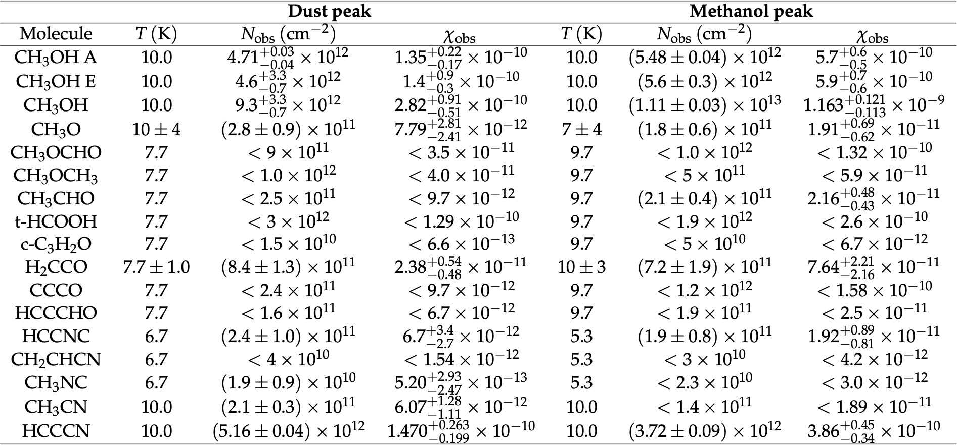
- [2, ['temperature', 'density', 'abundance']]
lines table:
- [1, ['species', 'transition', 'frequency']]
- [1, ['area', 'width', 'velocity', 'sn_area']]
- [2, ['area', 'width', 'velocity', 'sn_area']]
tables scientific notation:
lines table: []
abundances table: ['density', 'abundance']
use crosses: no
multiplying factors:
abundances table: {}
lines table: {}
S/N threshold: 3

Output tables
Tables 1 and 2 are the abundances and transitions tables, respectively, generated for the previous configuration file.
In order to copy the tables to a .tex file, you can copy the text between \begin{table} and \end{table} for the whole table including header and notes, or between \begin{tabular} and \end{tabular} for just the table frame, for each table.

Output abundances list
Below is the content of one of the output abundances list files for the previous configuration file (L1517B-methanol-all.dat), that is, for one of the sources.
molecule  Table 2. Transition lines table generated for the previous example configuration file.  Table. COMs and COM precursors transitions covered in our L1517B observations and their derived line parameters.  Notes. Line profiles were fitted using Madcuba, except for methanol (CH₃OH), cyanoacetilene (HCCCN) and acetonitrile (CH₃CN), where we used Class. (a) Uncertainties in the line area are calculated as ΔT (Δv δv)^{½}, with ΔT the RMS noise level, Δv the line width, and δv the velocity resolution of the spectrum. Similarly, upper limits are calculated as 3 ΔT (Δv δv)^{½}. (b) LSR stands for local sidereal rest. (c) This refers to the signal to noise ratio in integrated intensity area. If a certain value has no uncertainty, this means that it had to be fixed so that Madcuba could fit the line.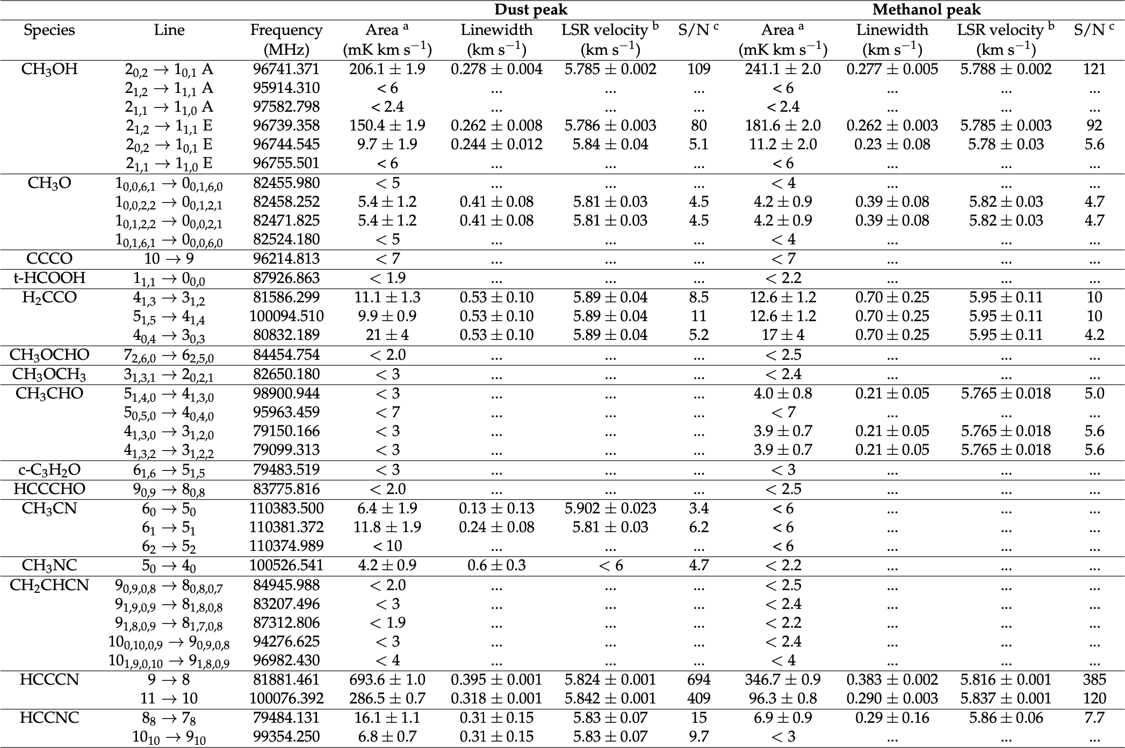 | abundance
CH3OH | 1.160-0.107+0.131 e-9
CH3O | 1.91-0.62+0.68 e-11
CH3OCHO | < 1.33 e-10
CH3OCH3 | < 6.3 e-11
CH3CHO | < 2.15-0.44+0.49 e-11
t-HCOOH | < 2.6 e-10
c-C3H2O | < 6.6 e-12
H2CCO | 7.55-2.08+2.23 e-11
CCCO | < 1.59 e-10
HCCCHO | < 2.6 e-11
HCCNC | 1.89-0.81+0.93 e-11
CH2CHCN | < 4.2 e-12
CH3NC | < 3.0 e-12
CH3CN | < 1.89 e-11
HCCCN | 3.88-0.34+0.43 e-10

As you can see, the file content of the file is quite auto-explicative, and the values of the abundance are displayed in an easily readable format.

Useful links
The following links may be of interest:
- Madcuba.
https://cab.inta-csic.es/madcuba/
- Python.
https://www.python.org/
- Python’s standard library.
https://docs.python.org/3/library/
- PyYaml.
https://pyyaml.org/wiki/PyYAMLDocumentation/
- NumPy.
https://numpy.org/
- Pandas.
https://pandas.pydata.org/
- Lyx.
https://www.lyx.org/

Credits
This software has been developed at the Center for Astrobiology (Centro de Astrobiología, CAB), in Madrid (Spain), within the subgroup of Astrochemistry and Chemical Complexity (Group of Interstellar and Circumstellar Medium, Department of Astrophysics).
Coding and testing
Andrés Megías Toledano
Supervising
Izaskun Jiménez Serra
Jesús Martín Pintado
Víctor M. Rivilla Rodríguez
Testing
Marina Centenera Merino
Álvaro López Gallifa
Fernando Rico Villas

License
The Slim Table Generator (tablegenerator.py) is published under a GNU General Public License (GPL) version 3.
Copyright © 2022 - Andrés Megías Toledano (https://www.github.com/andresmegias)
This program is free software: you can redistribute it and/or modify it under the terms of the GNU General Public License as published by the Free Software Foundation, either version 3 of the License, or (at your option) any later version.
This program is distributed in the hope that it will be useful, but without any warranty; without even the implied warranty of merchantability or fitness for a particular purpose. See the GNU General Public License for more details.
You should have received a copy of the GNU General Public License along with this program. If not, see https://www.gnu.org/licenses/.

https://cab.inta-csic.es/madcuba/
You can download this library from the following link: https://drive.google.com/drive/folders/1g5l3I2gowZ-s37z2w-eEDqUb12wj3dHN?usp=sharing. In order to install it, you have to copy the file richvalues.py to one of the Python system paths. To display the list of all these paths, you can run Python (for example, from the terminal, writing python3), and run the two following commands: import sys and sys.path. For example, for Mac, one of these paths would be: /Users/<user>/Library/Python/<3.x>/lib/python/site-packages, with <user> being your username and <3.x> your exact Python version.
Here, ‘not written’ means that neither the variable name nor its value are written in the configuration file. If the variable name is written (and the colon) but its value is not, the corresponding Python variable will get the value None.

