CV Programming Language: Java

Project #9 Hough Transform

Andres Quintero

Due Date:

Soft copy: 4/12/2020

Hard copy: 4/12/2020

*******************************************Main**********************************************

Step 0: inFile 🡨 open input file from args

outFile1, outFile2 🡨 open from args

numRows, numCols, minVal, maxVal 🡨- read from inFile

HoughAngle 🡨 180

HoughDist 🡨2 * (the diagonal of the input image)

imgAry 🡨 dynamically allocate

HoughAry 🡨 dynamically allocate HoughAry, size of

HoughDist by HoughAngle and initialize to zero

Step 1: loadImage(imgAry, inFile)

Step 2: buildHoughSpace (imageAry)

Step 3: prettyPrint(HoughAry, outFile1)

Step 4: determineMinMax (HoughAry)

Step 5: write HoughDist, HoughAngle, HoughMinVal, HoughMaxVal to outFile2

// as the header of Hough image

step 6: ary2File (HoughAry, outFile2) // output HoughAry to outFile2

Step 7: close all files

**Source code:**

import java.util.*;

import java.io.*;

import java.lang.Math;

public class Main{

public static void main(String args[]){

ImageProcessing image = new ImageProcessing();

HoughTransform hough = new HoughTransform();

Scanner inFile = null;

PrintWriter outFile1 = null;

PrintWriter outFile2 = null;

// 0

try {

inFile = new Scanner(new File(args[0]));

} catch (FileNotFoundException err) {

System.out.println("Error in opening input file from CLI: " + err);

}

try {

outFile1 = new PrintWriter(args[1]);

outFile2 = new PrintWriter(args[2]);

} catch (FileNotFoundException err) {

System.out.println("Error in opening output files from CLI: " + err);

}

image.numRows = inFile.nextInt();

image.numCols = inFile.nextInt();

image.minVal = inFile.nextInt();

image.maxVal = inFile.nextInt();

// dynamically allocating imgAry

image.imgAry = new int[image.numRows][image.numCols];

// HOUGH STUFF

// a^2 + b^2 = c^2

int diagonal = (int) Math.sqrt( Math.pow(image.numRows, 2) + Math.pow(image.numCols, 2) );

hough.HoughAngle = 180;

hough.HoughDist = 2 * diagonal;

hough.HoughAry = new int[hough.HoughDist][hough.HoughAngle];

// 1

image.loadImage(inFile);

// 2

hough.buildHoughSpace(image);

// 3

hough.prettyPrint(outFile1);

// 4

hough.determineMinMax();

// 5

outFile2.println(hough.HoughDist + " " + hough.HoughAngle + " " + hough.HoughMinVal + " " + hough.HoughMaxVal);

// 6

hough.ary2File(outFile2);

// 7

// Closing files

inFile.close();

outFile1.close();

outFile2.close();

}

}

public class ImageProcessing {

int numRows;

int numCols;

int minVal;

int maxVal;

int[][] imgAry;

ImageProcessing(){

numRows = 0;

numCols = 0;

minVal = 0;

maxVal = 0;

}

void loadImage(Scanner inFile){

for(int i = 0; i < numRows; i++){

for(int j = 0; j < numCols; j++){

imgAry[i][j] = inFile.nextInt();

}

}

}

}

public class xyCoord{

int x;

int y;

}

public class HoughTransform {

xyCoord point = new xyCoord();

int angleInDegree;

double angleInRadians;

int HoughDist;

int HoughAngle = 180;

int HoughMinVal;

int HoughMaxVal;

int[][] HoughAry;

// Functions

void buildHoughSpace(ImageProcessing image){

for(int r = 0; r < image.numRows; r++){

for(int c = 0; c < image.numCols; c++){

if(image.imgAry[r][c] > 0){

point.x = c;

point.y = r;

angleInDegree = 0;

while(angleInDegree <= 179){

angleInRadians = angleInDegree/180.00 * Math.PI;

double dist = computeDistance(point, angleInRadians);

int distInt = (int) dist;

HoughAry[distInt][angleInDegree]++;

angleInDegree++;

}

}

}

}

}

double computeDistance(xyCoord point, double angleInRadians){

double a = angleInRadians;

double x = point.x ;

double y = point.y ;

double c = Math.atan(y/x);

double t = a - c - (Math.PI/2);

double distance = ( Math.sqrt(Math.pow(x, 2)+Math.pow(y, 2)) ) * Math.cos(t) + (HoughDist/2);

// System.out.println(distance);

return distance;

}

void determineMinMax() {

int max = 0;

for(int i = 0; i < HoughDist; i++){

for(int j = 0; j < HoughAngle; j++){

if(HoughAry[i][j] > max){ max = HoughAry[i][j];}

}

}

HoughMaxVal = max;

int min = max;

for(int i = 0; i < HoughDist; i++){

for(int j = 0; j < HoughAngle; j++){

if(HoughAry[i][j] < min){ min = HoughAry[i][j];}

}

}

HoughMinVal = min;

}

void prettyPrint(PrintWriter outFile){

for(int i = 0; i < HoughDist; i++){

for(int j = 0; j < HoughAngle; j++){

if(HoughAry[i][j] > 0) {outFile.print(HoughAry[i][j] + " ");}

else {outFile.print(" ");}

}

outFile.println();

}

}

void ary2File(PrintWriter outFile){

for(int i = 0; i < HoughDist; i++){

for(int j = 0; j < HoughAngle; j++){

if(HoughAry[i][j] > 0) {outFile.print(HoughAry[i][j] + " ");}

else {outFile.print("0 ");}

}

outFile.println();

}

}

}

Outputs for 2pts

END OF 2pt OUTPUTS

Outputs for 2lines

END OF 2lines OUTPUTS

Outputs for 3pts

END OF 3pts OUTPUTS

Outputs for 3lines

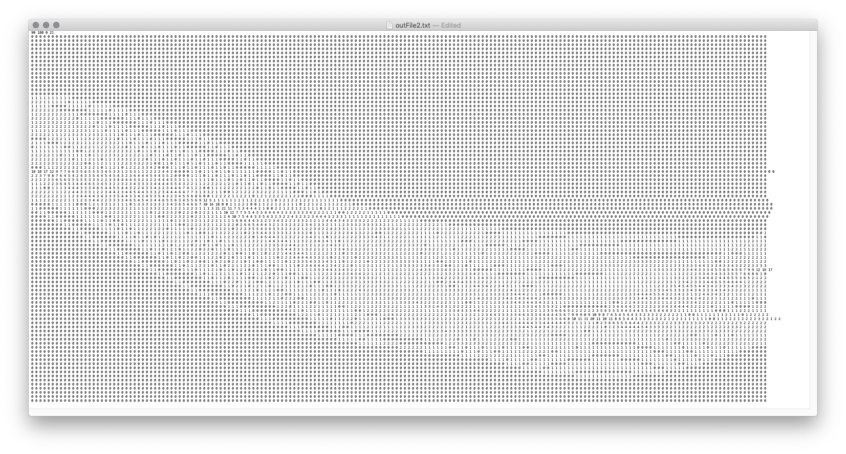

END OF 3lines OUTPUTS