w3af gtkUi User Guide

Document version: 0.1
Original author: Facundo Batista

September, 2008

Table of Contents
1.Introduction 3
1.1.Just the graphical interface 3
1.2.Running the program 3
2.General structure 3
3.Scanning 3
3.1.Configuring the scan 3
3.2.Using the Profiles 3
3.3.Running the scan 4
4.Analyzing the results 4
4.1.Browsing the Knowledge Base 4
4.2.Site structure 4
4.3.Requests and Responses 4
5.Exploitation 4
5.1.Executing an exploit 4
5.2.Using a shell 5
6.Other tools 5
6.1.Manual Requests 5
6.2.Fuzzy Requests 5
6.3.Encode and Decode 5
6.4.Comparing HTTP traffic 5
6.5.Using the Proxy 5
7.Configurations 5
7.1.HTTP Configuration 5
7.2.Miscellaneous Configuration 6
7.3.Advanced target 6
7.4.Proxy Configuration 6

Introduction
This document is a user guide for the 1.0 version of the Web Application Attack and Audit Framework ( w3af ), its goal is to provide a basic overview of how to use the application, how it works, and what you can do with it.

Just the graphical interface
w3af is a complete environment for auditing and attacking web applications. This environment provides a solid platform for auditing and penetration-testing.
The w3af is a framework that you can use in different ways. This document explains how to use it through the GTK Graphic User Interface, but you can also use w3af from command line, and even new user interfaces could be implemented in the future.
In any case, w3af is a core independent of the user interface, and it will be referred as the Core throughout this documentation. It's implemented in pure Python, as this graphic user interface.

Running the program
You can execute this program just doing double click in the icon, or selecting it from you operating system menu after installing it.
You can also run it from command line calling to the w3af_gui executable, and in this case you'll see any debug or warning message appear in the terminal. If you need to submit a bug or ask for a new feature, use this way to execute the program, because it'll provide useful information about the Python and PyGTK versions.

General structure
In this section is explained the general structure of the w3af Interface.
The following is the main window, the first image that you'll see from the system after it's completely loaded (during the load you'll see a splash image that gives you information about how the system is loading):
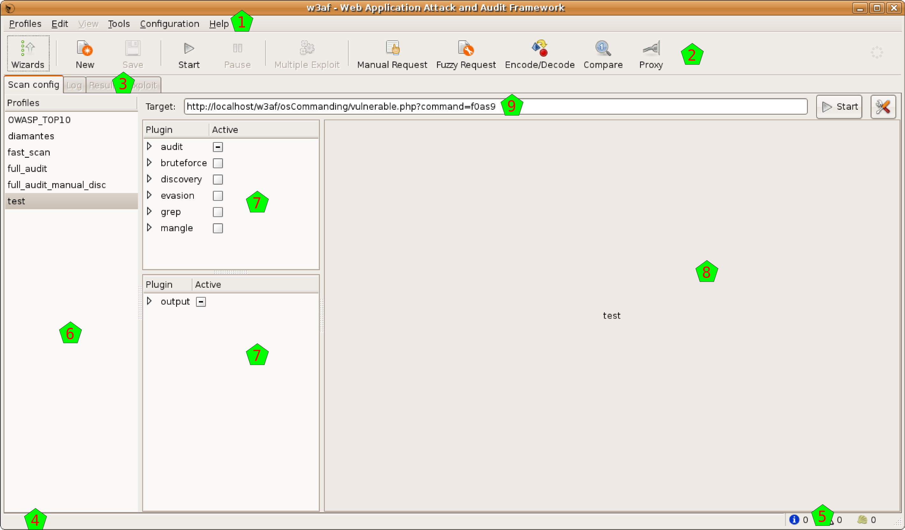
In the image you can see different sections. On top, as usual there's the menu [1] and the toolbar [2]. The body of the window is separated in different notebook tabs [3]. At the bottom of the window you have the the toolbar [4] and an indicator about the found elements [5].
In the notebook tab that you can see at the program beginning, there are three vertical panes: the profiles [6], the plugin selector [7], and the plugin configuration area [8] (where so far you see the w3af icon because you didn't select any plugin yet). Above them you also have the target URL [9].

The toolbar
The toolbar is separated in different functional groupings.
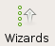
The first button opens the Point and Click Penetration Test, that is a Wizard that allows you to create profiles in an easy way, without having specific security related knowledge.

The second and third buttons, New and Save, operate on the Profiles. New will create a new Profile, and for this the system will ask you the profile name and a description, be creative! If you change a profile, you also can save the modifications it to disk, using the second button.
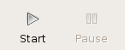
The third and fourth buttons, Play and Pause, control the state of the working Core. These buttons are mutable, as change over time, look the next section (Running the scan) for a deeper explanation of how these buttons behave.
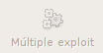
The sixth button is to trigger Multiple Exploits. It will be enabled only in the Exploits window, check that part of the documentation for a more detailed information about this.
The rest of the buttons are to open and use different tools:
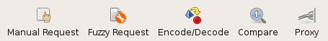
Check the Other Tools section of the documentation for an explanation of this different tools.

Finally, at the very right, there's a throbber that shows when the Core is working or not.

Scanning
In this section is explained the different steps to configure, start and supervise a security scanning over a web site.

Configuring the scan
To scan the web sites in different ways there are different plugins that can be configured in different ways.
In the second column of the main window you can select which plugins to configure. This plugins are separated in two big sections, as you can see in the following picture.
The first section has all the scan plugins, in the upper part of the column [1]. There you have the different plugins grouped regarding the scan type. They are separated in:
- audit
- bruteforce
- discovery
- evasion
- grep
- mangle
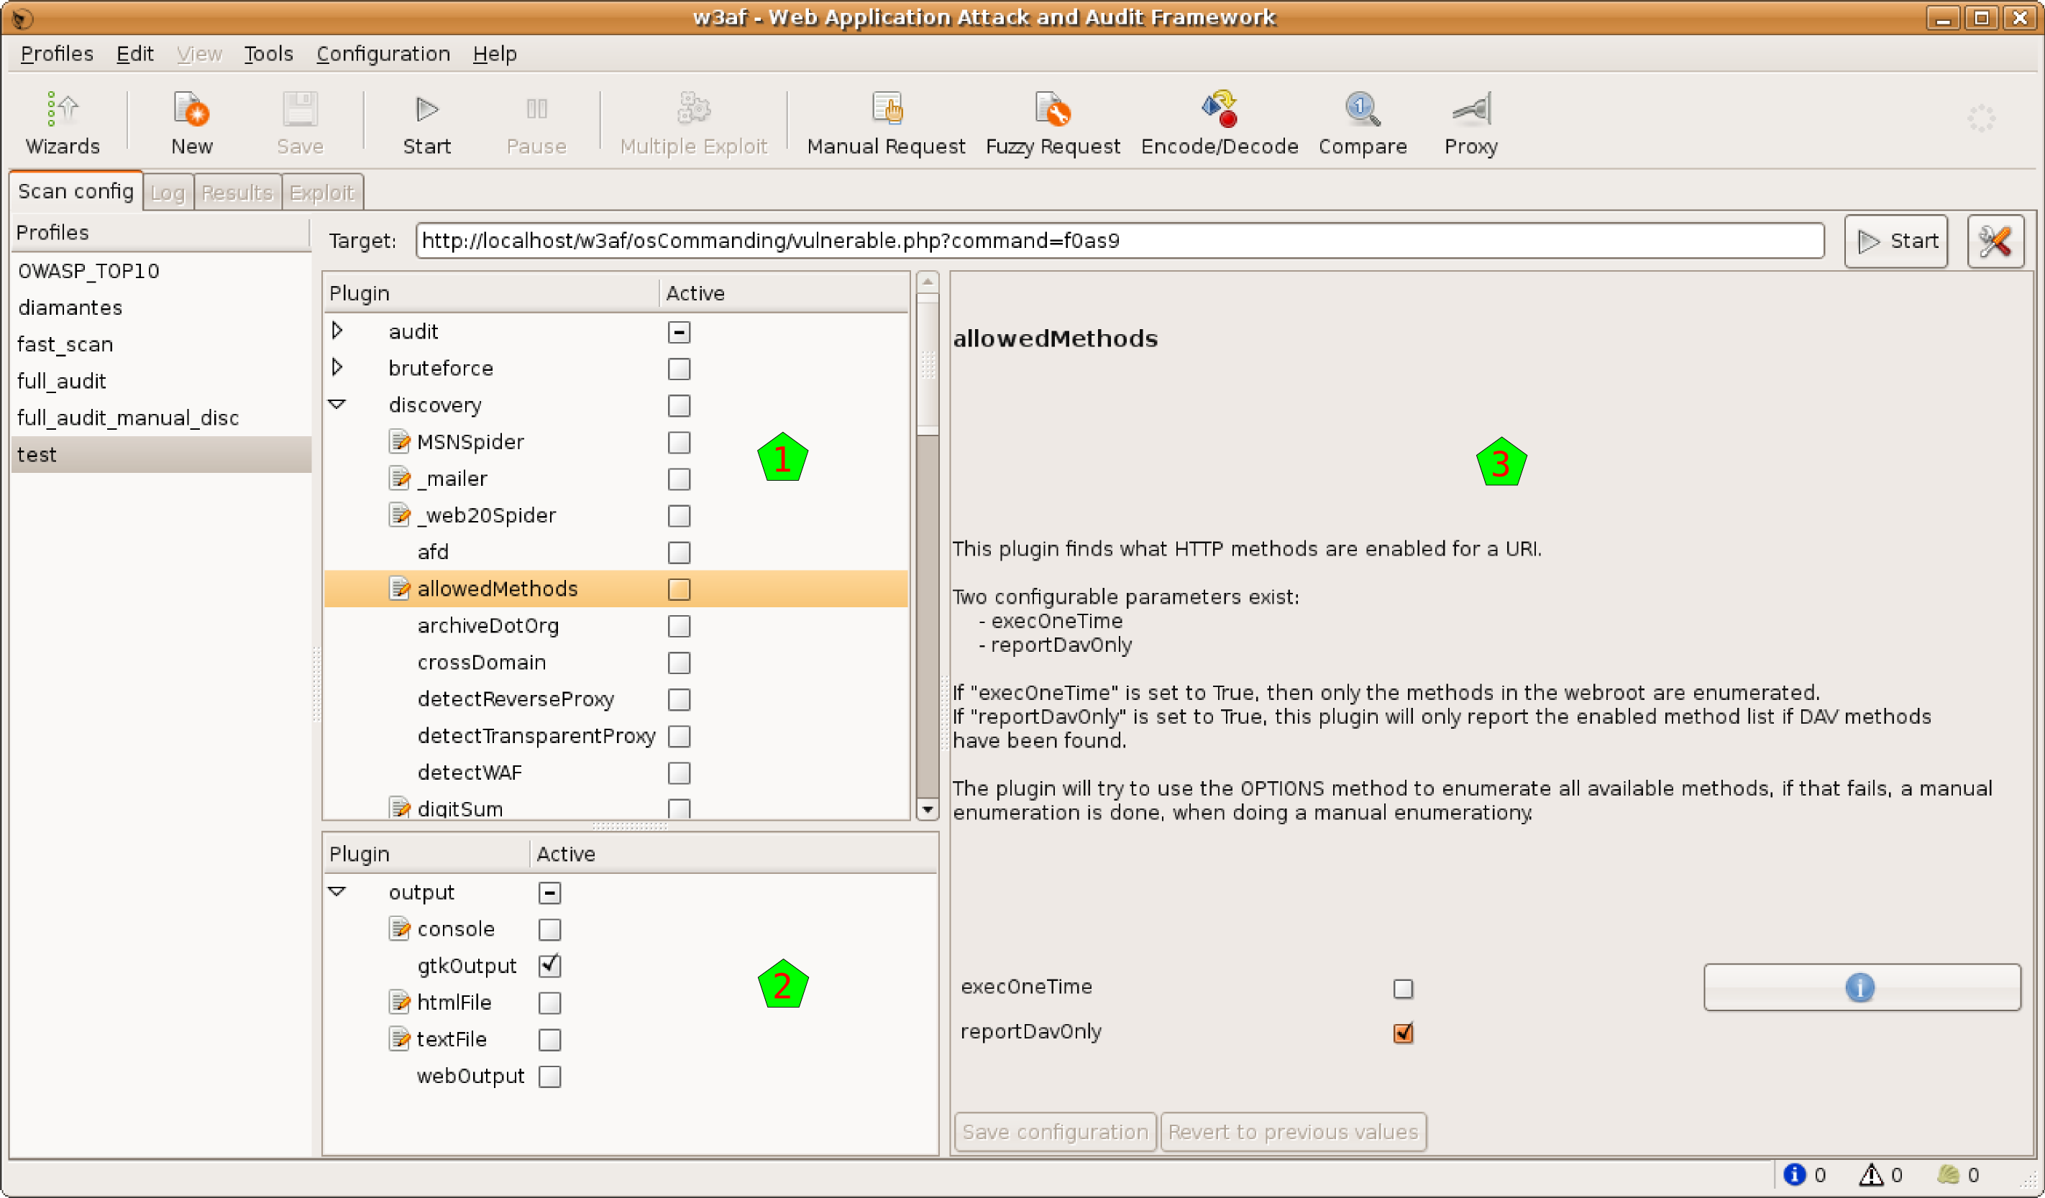
In the lower part of the column [2] there are the output plugins. As this is the GTK user interface, the gtkOutput plugin is always enabled, but note that you can enable here the console plugin to see all the information in the standard output, and also have plugins to send all that information to a file in different formats.
If you select on any plugin you will see in the right pane [3] some information of that plugin. If that plugin is configurable (something that you can know in advance, because the plugin has an editable icon in the plugin trees [1] & [2].
To configure the plugin, just select it, and modify the options that appears on in the right pane [3]. Note that you need to Save the configuration to use it. You can see easily if any plugin is modified and not saved because its name will be in bold font.
Even if you configure a plugin, to actually use it during a scan, you need to check it. You have, at the right of each plugin, a check box that you need to select to use that plugin during the scan. If you click on the group check box, all the plugins in that group will be selected and deselected. If some plugins in that group are selected, and others are not, you'll see the group's check box in an intermediary state (as you can see in [2] for output).
If you make right-click over a plugin (or select Edit Plugin in the Edit menu), a text editor will open and you'll be able to actually edit the plugin source code.
To finish configuration the scan, you need to insert a target URL in the upper text entry. When everything is ready to run, you will note that the Play buttons are automatically enabled.

Using the Profiles
In the profiles you can save different configurations. You can think a Profile as the collection of configured plugins and target URL.
In the column of the left [1] you can see which plugins do you have:
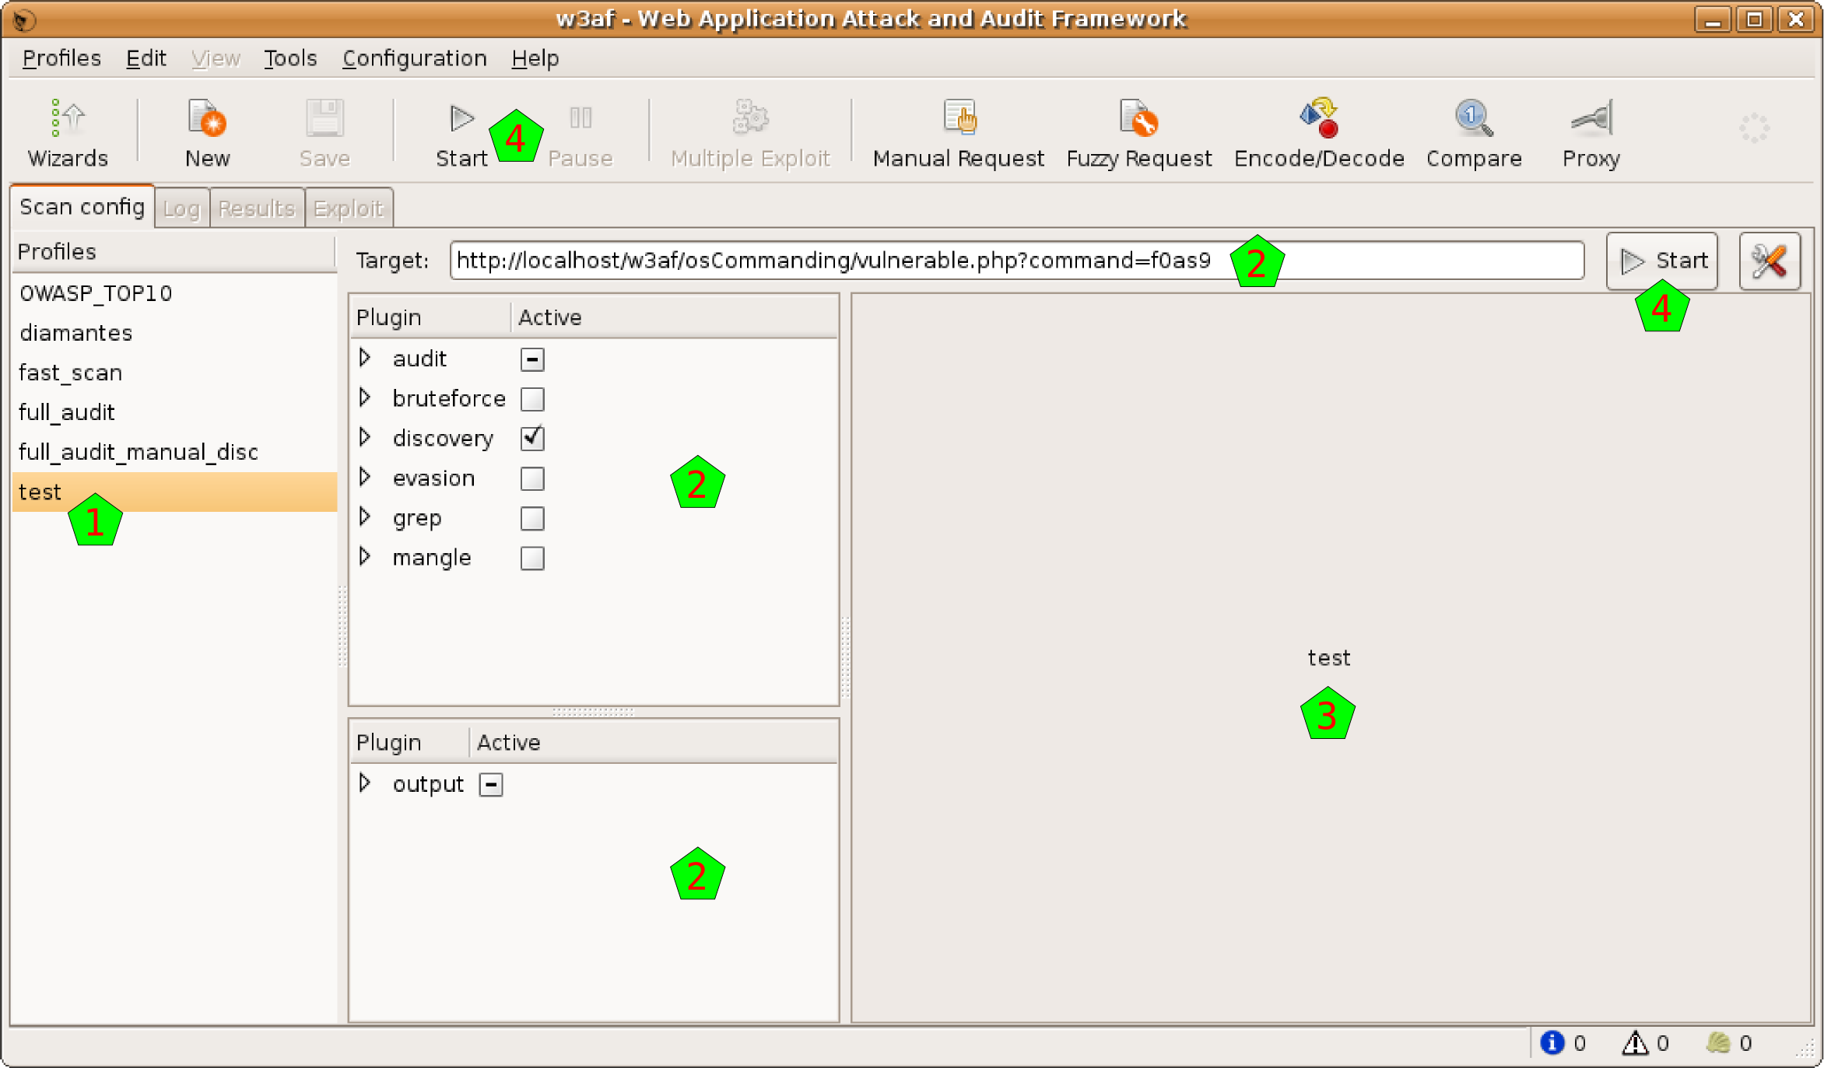
In this example, I selected a test plugin. In the moment I select it, the plugins and the target URL are all reconfigured [2]. Also, in the pane at the right, you can see a description of that plugin [3].
See, as now we have all the information needed to start the scan, that the Start buttons [4] are enabled. Note, however, that is possible that in the profile there was no saved URL, so the target URL will remain empty (you'll find it with a “Insert the target URL here” message).
In the Profiles menu,or doing right-click over any profile, you can see different actions that you can apply over the plugins:
- Save: Save the actual configuration to the profile. This will be enabled only if you changed some of the profile configuration.
- Save as: Save configuration a new profile, without affecting the one selected so far. If you click on this option, you will need to enter a new profile name and description.
- Revert: Discard the actual configuration and reload the one that is saved in the profile.
- Delete: Delete this profile

To create a new profile, you have the New button in the toolbar, and also the New option in the Profiles menu. To create a new profile, you will need to enter a name and descriptions. After creating the new profile, you'll be able to configure to your needs. Remember that you can always create a new profile using the Point and Click Penetration test tool, with the Wizard button at the toolbar's left.

Running the scan
To actually run the scan some conditions need to be met: at least one plugin needs to be activated, and a target URL must be set. You'll notice that everything is OK to go, because the Start button will be enabled.
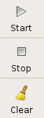
The whole scan process is controlled with two buttons that you can find in the toolbar. The first button is the Start one. When you click on it, the scan will start running, and you will see the throbber spinning. After the process starts, it can be stopped anytime, or you can let it go until the end, and it will finish automatically. To stop the process you can use the same button, note that it mutated and now it is called Stop: if you click on it you will see that it gets disabled, and there's some delay until the process is effectively stopped, you can check it because the throbber stopped spinning. When the scan is stopped, you can study the results all that you want, but if you want to start another scan you will need to clear the current results and start over. For this, you'll use again the same button as before, but note that it is called Clear now.
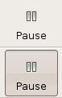
The second button to control the process is the Pause one. It will be enabled only when the process is running, and if you click on it, it will be pressed down (and the process paused) until you click on it again. Note that if you pause the process you can not cancel it until you restart it.
When the scanning process is started, the system will switch automatically to the Log tab. In this tab you can see how the scan evolves through the different indicators.
This tab has two main sections. In the upper part you have the logging text, where you can see all the information generated by the system. In the principal section of that part [1] you can see all the messages generated by the system, from the first one to the last generated. As this log is normally a large quantity of text, you can enable and disable the different type of messages, using the checkboxes in the log bar [4]. Note that these different types have different colors in the text itself. In the same bar you have a Search button, which enables the search functionality (explained in detail below).
Also, below that messages you can see exactly what the system is currently doing, through a single line message [2].
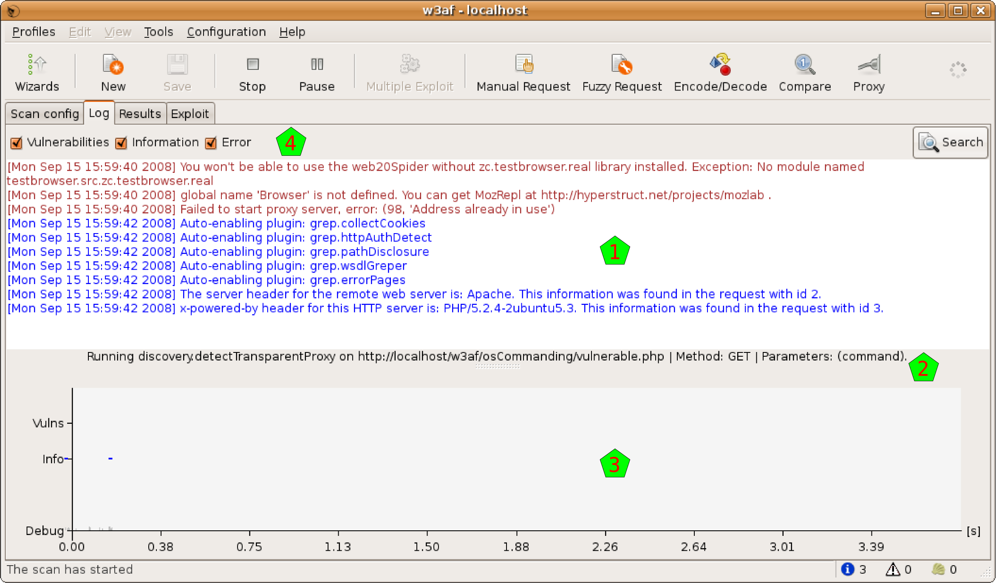
In the lower part of the window you can see a graph that represents what is going on with the scanning process in a visual way. In the x axis you can see the time (automatically rescaled), and in the y axis you can find three indicators: a grey bar which height indicates the quantity of debug messages at that time, a blue dot if there're information messages, and a vertical red bar with the quantity of vulnerabilities found there.
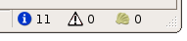
All this information is updated in real time. For a better visual following of the process, you also have, at the right of the toolbar, three indicators showing the quantity of information items found, of vulnerabilities found, and the shell which were successfully exploited (you'll find more information about this Shells in the Exploit section of this document).
Sometimes the log information is too much, even if you can separate it in the different message types, so there's a search functionality to help you. You can open the search bar using the previously mentioned button, or pressing CTRL-F when the log text window is in focus.
When the search bar opens, you'll see a text entry where you can write what you want to find, a Next and Previous buttons, and a Match case checkbox:
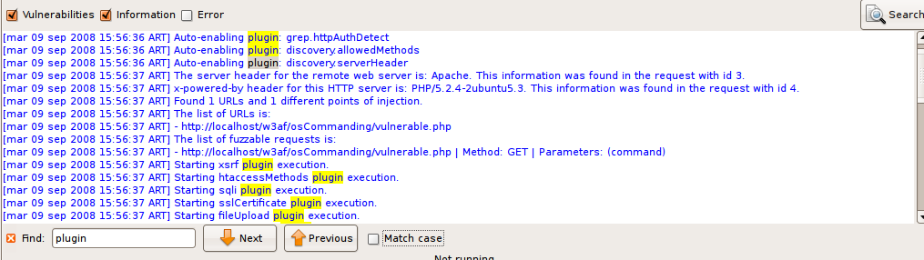
The system will find what you write in the text entry in real time, taking the letter case in consideration if the Match case checkbox is selected. If the inserted text doesn't match with anything in the whole text, the entry background will turn red.
Also in real time the matching text will be highlighted in yellow. If you hit the Next or Previous buttons, the system will walk the matching texts.

Analyzing the results
You can explore and analyze the scanning results after the scan process is completed (or before it's finished, because the system let's you work concurrently with that process). In this section I'll explain the different windows you have to work with the results.
There's a complete tab for results in w3af, and as there're a lot of information to analyze, this tab is also divided in tabs, as you can check the Knowledge Base, see the site structure, or navigate through the individual requests and responses.

Browsing the Knowledge Base
The Knowledge Base is a collection of discovered items, that can be classified in Vulnerabilities, Informations, and other stuff. The KB Browser tab lets you dive into this information.
In the left part of the window [1] you'll find the information of the Knowledge Base. By default it only shows you the vulnerabilities and informations, but you can enable also the miscellaneous stuff or hide any of them, using the checkboxes above the info [2].
The information is grouped in a tree way, but you have different nodes to expand. If you select one of the items, and that item corresponds to a HTTP request originated by the scanning, you will see in the right part of the window all the information about that request and its response (more info about this below).
The items in the tree has a color that indicates the severity of the issue: black for informations, orange for low-severity vulnerabilities, and red for medium or high severity ones. As they're in a tree structure, each node in the tree will have the color of the more severe of its children.
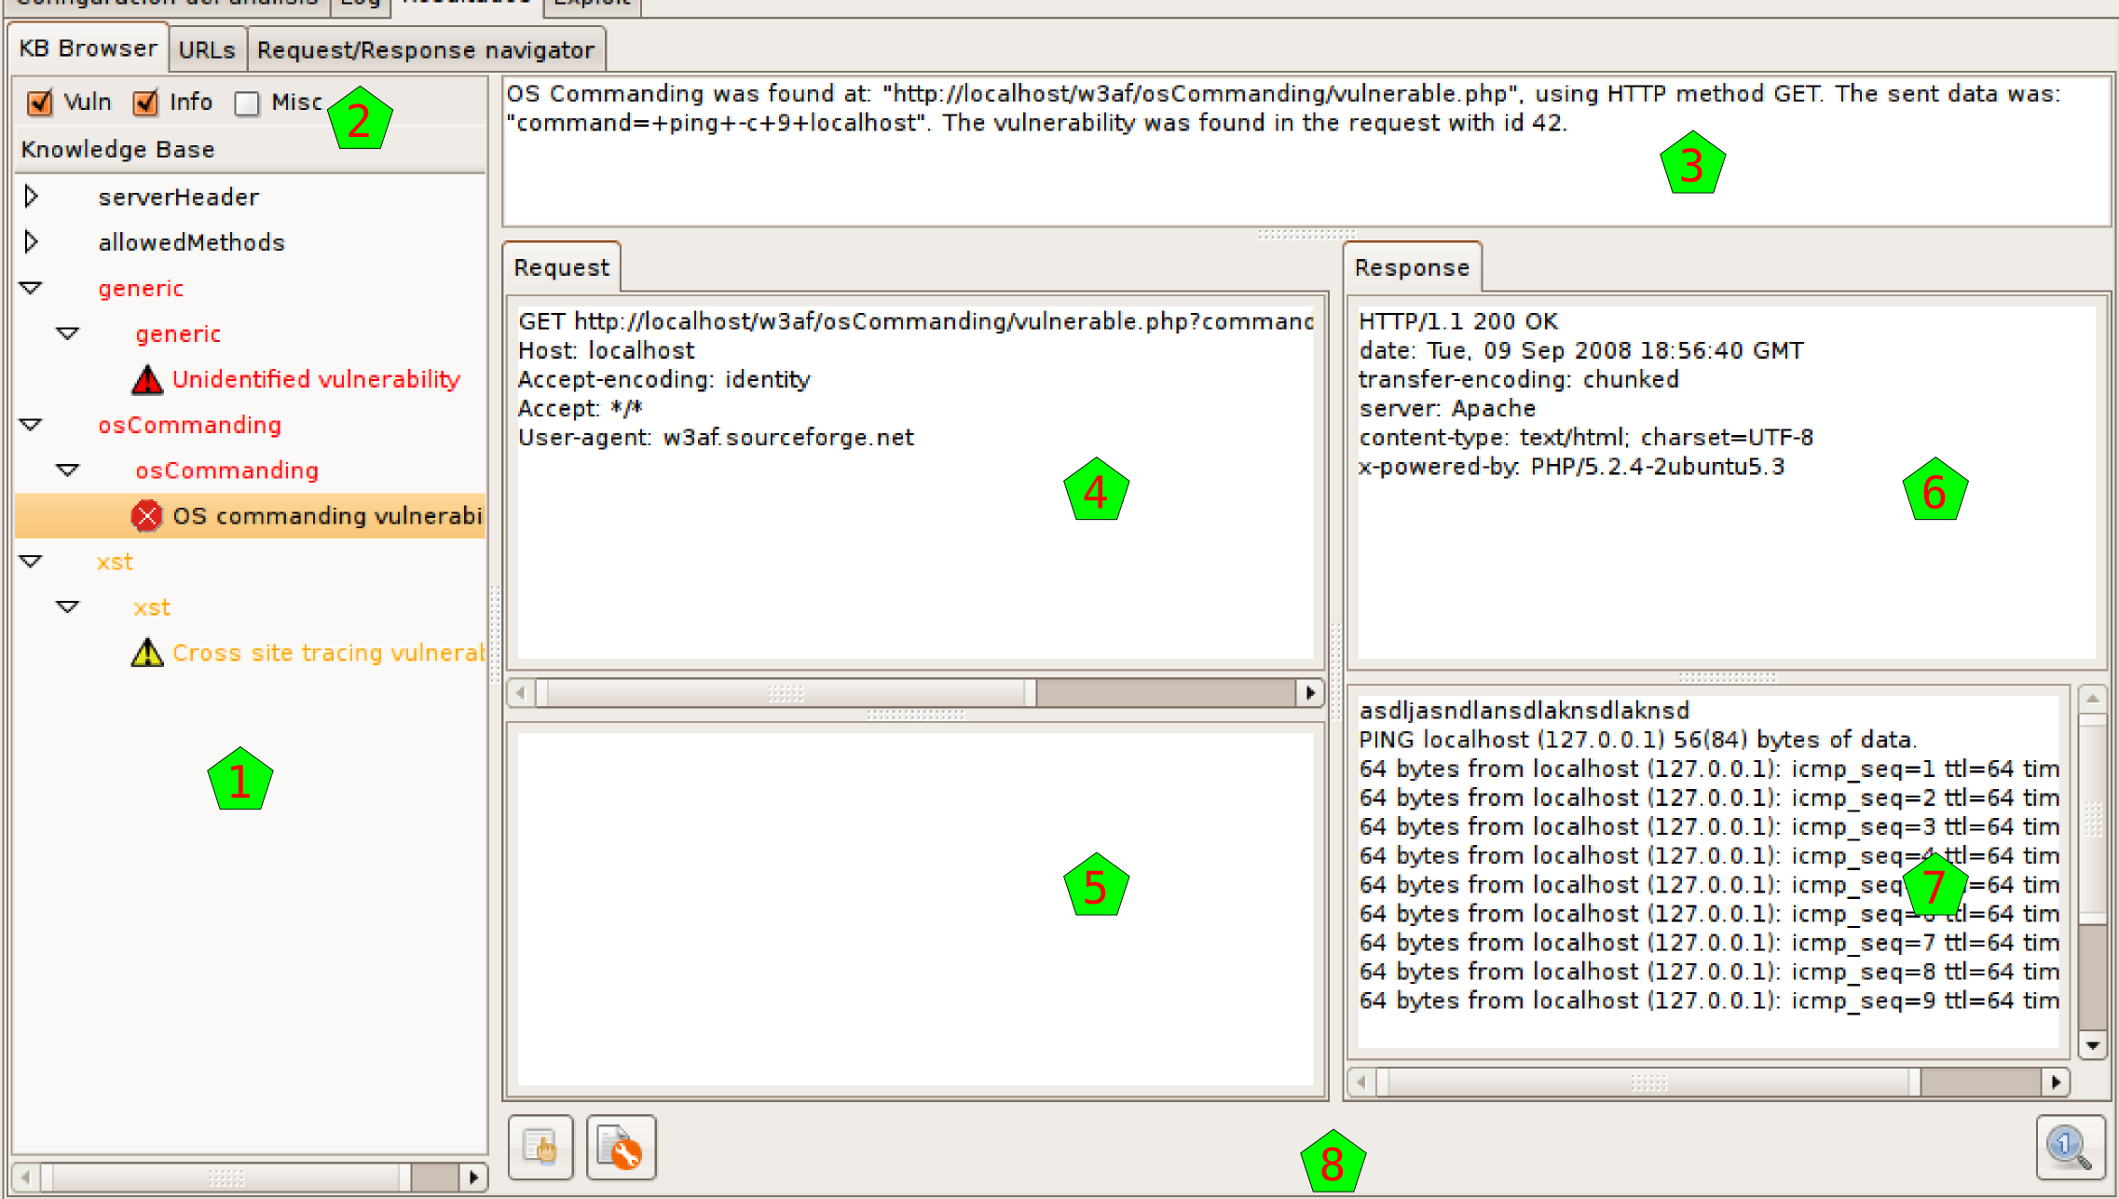
As said above, when you click on a tree node that actually is generated by a HTTP request, you can see in the left part of the window information about this request and its response. This part is separated in different panes.
Above everything [3] you have general information about when the request was found (actually, this is the same line that you can find in the logs regarding this request). Below that info you have the request headers [4], the request body [5], the response headers [6], and the response body [7].
At the bottom [8] you have some buttons that will enable you to make some actions with the request and response. With the buttons at the left you can send the HTTP Request to the Manual and Fuzzy Request tools. With the button at the right you can send everything to the Compare tool. These buttons refer to the same tools that have the same icon in the toolbar, but actually send the shown information to that tools, which is very handy.
This structure, the HTTP request and response with both panes each, and the buttons to use that information with other tools, is repeated all over the program interface, so it's good to get used to it.

Site structure
The URLs tab shows the structure of the site that the system worked on. It's separated In two parts, but both parts show actually the same information, although they show it in different ways.
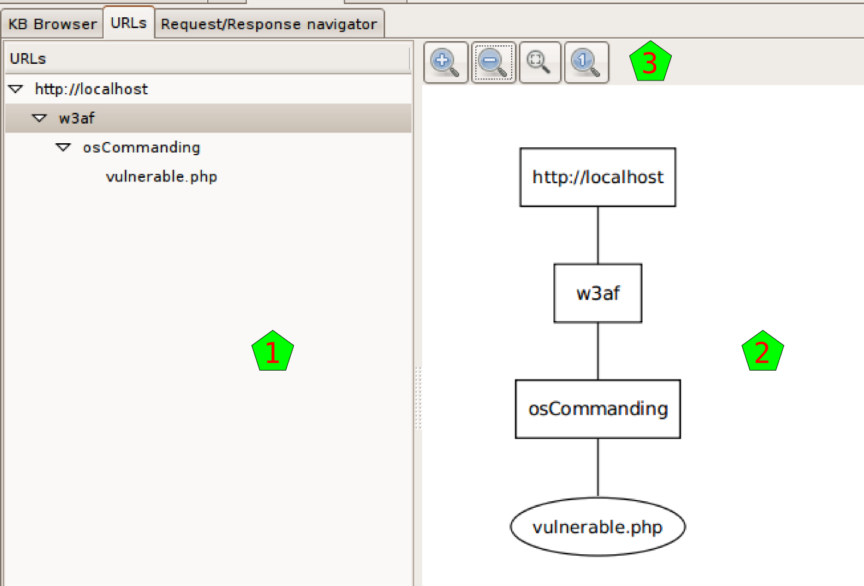
At the left [1] you can see the site structure in the old fashion way: with a tree-like list of nodes.
At the right [2] you have the same information but graphically. Above the drawing [3] you have different buttons that help you to see the graph better: zoom in, zoom out, fit all the graph in the window, and show the graph in the original size.

Requests and Responses
8. reqresp navigator

Exploitation
Contaremos como exploitear
9. exploit: partes

Executing an exploit
- exploit: exploiteando, :p
- 12. se nos habilita el multiple exploit, mostrarlo

Using a shell
- exploit: usando un shell

Other tools
Tenemos otras herramientas!

Manual Requests
13. manualrequest

Fuzzy Requests
14: fuzzy (todas!) + clusterresponses

Encode and Decode
15: encode/decode

Comparing HTTP traffic
16: comparator

Using the Proxy
17: proxy (FALTA SCREENSHOTS): mostrar request, request y response, history, y config

Configurations
Configuramos!
En todos: poner las opciones, y la ayuda de cada uno que sale del tooltip...

HTTP Configuration
- http

Miscellaneous Configuration
- - miscelaneous

Advanced target
- adv target

Proxy Configuration
- poner proxy aca

