1. Aunque el trabajo realizado en el desarrollo del simulador fue excelente, el documento no puede estar centrado en el simulador, ya que este no es el objetivo principal ni objetivos secundarios de su trabajo de grado. Adicionalmente, hace falta una validación del simulador, que permita mostrar que el simulador si corresponde a lo que se puede encontrar en un mundo real, y esto no lo vi en ninguna parte del documento a pesar que se lo pedí en repetidas ocasiones.

2. Después de la exposición realizada en el seminario, Enrique le realizó varios comentarios acerca del uso de la red neuronal y la lógica difusa, y no se ve como se dan respuestas a esos comentarios. Ya que muy probablemente Enrique sea el evaluador.

3. En la decisión de utilizar redes neuronales no hay una decisión soportada científicamente, como se evidencia en el documento se muestra como si usted HUBIERA decidido que fuese así y ya. Así mismo, la justificación de porqué se está utilizando esa topología de red neuronal está muy mal fundamentada y no se muestra que se haya hecho experimentos con otras topologías para seleccionar la mejor.

4. El modelo multi agente expuesto en el documento está incompleto, ya que hace falta mostrar cómo se van a manejar los conflictos, las asignaciones de roles, asignación de tareas, etc.

5. No hay un diseño de experimentos, lo cual permite soportar que lo realizado en verdad sea significativo.

**TAREAS**

1. Validación del simulador

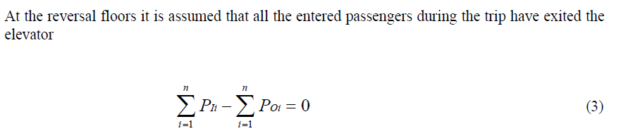(SIIKONEN-AICONTROL.pdf)

2. Sustentar red neuronal y lógica difusa

*Hall call assignment part* assigns the hall call to an suitable elevator considering the elevator status, passenger traffic, and control strategy.

3. Soportar científicamente el uso de redes neuronales para estimar TE y TV. Sustentar topología y mostrar experimentación con otras topologías.

The forecasting methods of economical and technical phenomena can roughly be classified into one of two categories: time series and causal regression (Makridakis et al. 1983). The causal regression forecasts deal with several variables and equations. The relationship between the causes and the consequences is described mathematically. These methods give the best results in long-term forecasting. In the time series methods the forecast is based on the earlier behavior. The time series methods are suitable for the forecasting of elevator traffic phenomena since the forecast periods are short. (SIIKONEN-AICONTROL.pdf)

When optimizing landing call times, k correlates to the traffic pattern. The weight factors for the up calls above the entrance floor, for the down calls, and for the calls from the entrance floors are defined. These three weight factors are changed in different traffic situations. For example, during down peak all down calls get a higher weight than the up calls above the entrance floor. (SIIKONEN-AICONTROL.pdf)

4. Hacer el modelo multi agente más riguroso, manejo de conflictos, asignación de roles, asignación de tareas.

*During heavy traffic peaks extra cars can be dispatched to the busiest floors according to the forecast traffic pattern; during light traffic, cars can be parked at the floors with most probable traffic. (SIIKONEN-AICONTROL.pdf)

*The other method to estimate the number of passenger transfers is an electronic safety beam, or a photocell signal device installed in the elevator door opening. An entering or exiting passenger breaks the safety beam or the photocell signal. An estimate to the total number of the transported passengers is obtained by dividing the number of photocell cuts by two since one passenger breaks the light ray twice during one journey. (SIIKONEN-AICONTROL.pdf)

*During peak traffic hours, several cars can be returned to the populated floors that need urgent service. For example, if an up-peak is forecast to begin, one or several vacant cars can be returned to the entrance floors. In the case of multiple entrance floors the group control returns cars at the entrance floors according to the forecast passenger arrival rates to the entrance floors.

*Special options, such as fixed or dynamic sectoring of the building (Ekholm et al. 1988), can be used to increase the handling capacity during up-peak. With these methods the building is divided into zones. The elevators accept car calls given from the entrance floors only to the floors within the zone. The round trip time, i.e. the average time it takes for an elevator to make an up and a down trip, is shortened because of the decreased number of stops during the trips.

*During light traffic the statistical passenger traffic forecasts are used in parking the cars at the floors with probably arriving passengers. The statistical forecasts are searched as long as the number of arriving passengers exceeds a certain percentage of the up-peak handling capacity (Leppälä 1991). A building is divided into sectors with equal passenger arrival rates, and sectors are given priorities.

5. Diseño de experimentos.

Resulktados

