Tabla 1-3

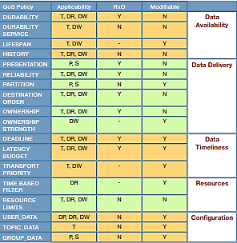

|  |  |  |  |  |
| --- | --- | --- | --- | --- |
| **QoS Policy** | **Applicability** | **RxO** | **Modifiable** |  |
| DURABILITY | T, DR, DW | Y | N | Data Availability |
| DURABILITY SERVICE | T, DW | N | N |
| LIFESPAN | T, DW | - | Y |
| HISTORY | T, DR, DW | N | N |
| PRESENTATION | P, S | Y | N | Data Delivery |
| RELIABILITY | T, DR, DW | Y | N |
| PARTITION | P, S | N | Y |
| DESTINATION ORDER | T, DR, DW | Y | N |
| OWNERSHIP | T, DR, DW | Y | N |
| OWNERSHIP STRENGTH | DW | - | Y |
| DEADLINE | T, DR, DW | Y | Y | Data Timeliness |
| LATENCY BUDGET | T, DR, DW | Y | Y |
| TRANSPORT PRIORITY | T, DW | - | Y |
| TIME BASE FILTER | DR | - | Y | Resources |
| RESOURCE LIMITS | T, DR, DW | N | N |
| USER_DATA | DP, DR, DW | N | Y | Configuration |
| TOPIC_DATA | T | N | Y |
| GROUP_DATA | P, S | N | Y |

Tabla 2-1

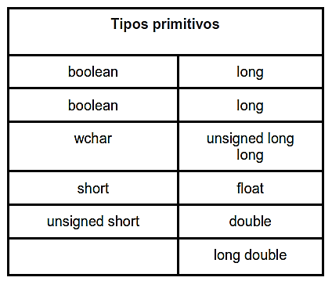

|  |  |
| --- | --- |
| **Tipos primitivos** | |
| boolean | long |
| boolean | long |
| wchar | unsigned long  long |
| short | float |
| unsigned short | double |
|  | long double |

Tabla 2-2

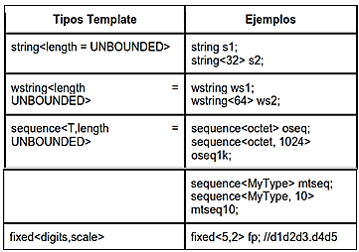

|  |  |
| --- | --- |
| **Tipos Template** | **Ejemplos** |
| string <length= UNBOUNDED> | string s1;  string<32> s2; |
| wstring<length= UNBOUNDED> | wstring ws1;  wstring<64> ws2; |
| sequence<T, length = UNBOUNDED> | sequence<octect> oseq;  sequence<octect, 1024> oseq1k; |
|  | Sequence<MyType> mtseq;  Sequence<MyType, 10> mtseq10; |
| fixed<digits, scale> | fixed<5, 2> fp; //d1d2d3.d4d5 |

Tabla 2-3

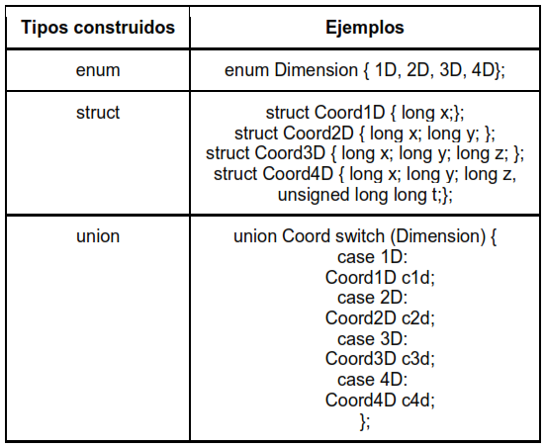

|  |  |
| --- | --- |
| **Tipos construidos** | **Ejemplos** |
| enum | enum Dimension {1D, 2D, 3D, 4D} |
| struct | struct Coord1D {long x;};  struct Coord2D {long x; long y;};  struct Coord3D {long x; long y; long z;};  struct Coord4D {long x; long y; long z; unsigned long long t;}; |
| union | union Coord switch (Dimension) {  case 1D:  Coord1D c1d;  case 2D:  Coord2D c2d;  case 3D:  Coord3D c3d;  case 4D:  Coord4D c4d;  }; |

Tabla 2-4

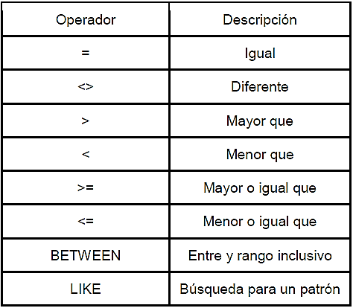

|  |  |
| --- | --- |
| **Operador** | **Descripción** |
| = | Igual |
| <> | Diferente |
| > | Mayor que |
| < | Menor que |
| >= | Mayor o igual que |
| <= | Menor o igual que |
| BETWEEN | Entre y rango inclusivo |
| LIKE | Búsqueda para un patrón |

Tabla 2-5

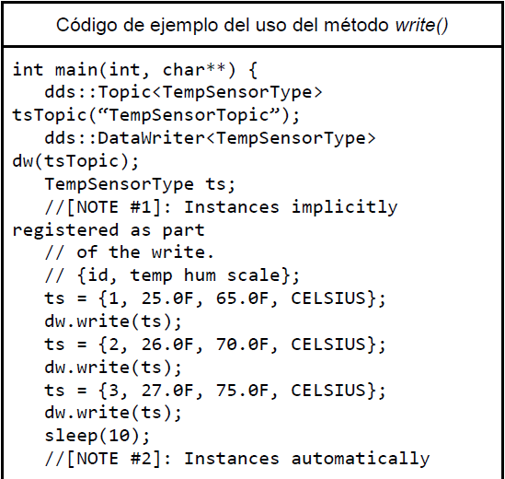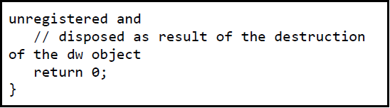

|  |
| --- |
| **Código de ejemplo del uso del método *write()*** |
|  |
|  |

Tabla 2-7

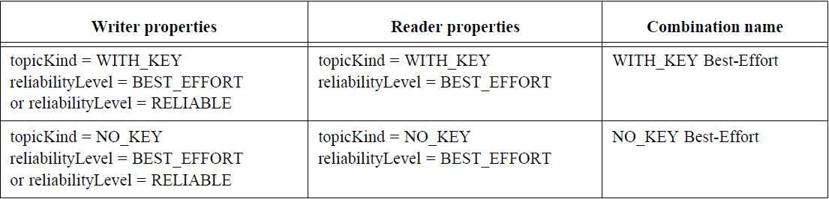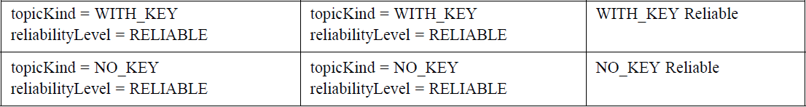

|  |  |  |
| --- | --- | --- |
| Writer properties | Reader properties | Combination name |
| topicKind= WITH_KEY  reliabilityLevel=BEST_EFFORT  or reliabilityLevel= RELIABLE | topicKind= WITH_KEY  reliabilityLevel=BEST_EFFORT | WITH_KEY Best-Effort |
| topicKind= NO_KEY  reliabilityLevel=BEST_EFFORT  or reliabilityLevel=RELIABLE | topicKind=NO_KEY  reliabilityLevel=BEST_EFFORT | NO_KEY Best-Effort |
| topicKind=WITH_KEY  reliabilityLevel=RELIABLE | topicKind=WITH_KEY  reliabilityLevel=RELIABLE | WITH_KEY Reliable |
| topicKind=NO_KEY  reliabilityLevel=RELIABLE | topicKind=NO_KEY  reliabilityLevel=RELIABLE | NO_KEY Reliable |