Analysis Report: Image2-1
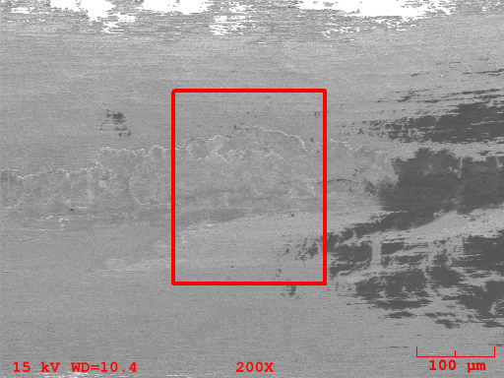
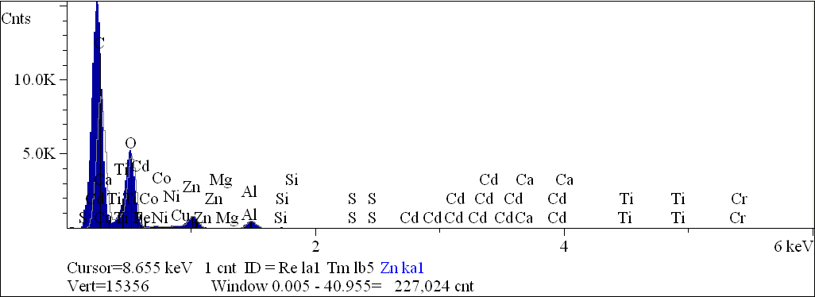
Component | Type | Mole  Conc. | Conc. | Units
C | Calc | 60.375 | 52.712 | wt.%
O | Calc | 38.338 | 44.588 | wt.%
Na | Calc | 0.189 | 0.316 | wt.%
Mg | Calc | 0.079 | 0.139 | wt.%
Al | Calc | 0.808 | 1.586 | wt.%
Si | Calc | 0.079 | 0.162 | wt.%
S | Calc | 0.041 | 0.096 | wt.%
Ca | Calc | 0.001 | 0.002 | wt.%
Ti | Calc | 0.005 | 0.018 | wt.%
Cr | Calc | 0.014 | 0.052 | wt.%
Fe | Calc | 0.007 | 0.028 | wt.%
Co | Calc | 0.004 | 0.015 | wt.%
Ni | Calc | 0.006 | 0.026 | wt.%
Cu | Calc | 0.016 | 0.076 | wt.%
Zn | Calc | 0.035 | 0.164 | wt.%
Cd | Calc | 0.003 | 0.021 | wt.%
 |  | 100.000 | 100.000 | wt.% | Total

kV 15.0
Takeoff Angle 35.0°
Elapsed Livetime 100.0

