Analysis Report: Image4-1
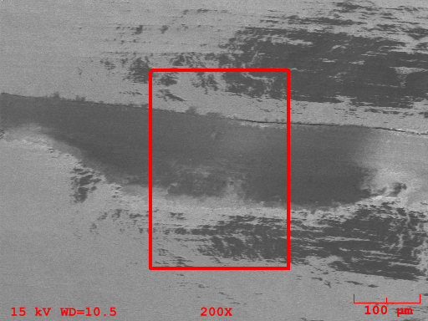
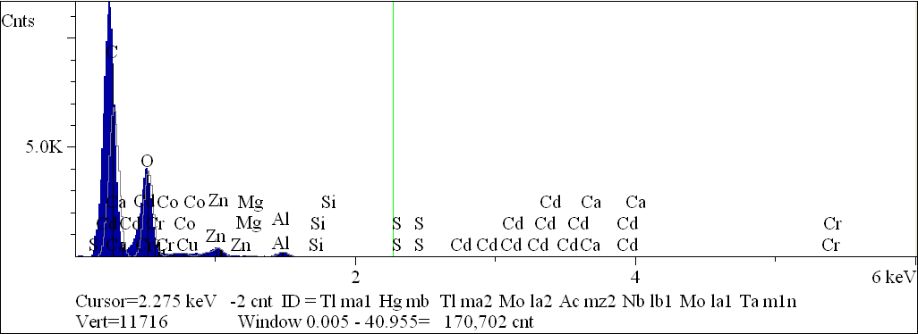
Component | Type | Mole  Conc. | Conc. | Units
C | Calc | 57.099 | 49.519 | wt.%
O | Calc | 41.784 | 48.271 | wt.%
Na | Calc | 0.344 | 0.571 | wt.%
Mg | Calc | 0.168 | 0.294 | wt.%
Al | Calc | 0.488 | 0.951 | wt.%
Si | Calc | 0.052 | 0.106 | wt.%
S | Calc | 0.006 | 0.013 | wt.%
Ca | Calc | 0.000 | 0.001 | wt.%
Cr | Calc | 0.000 | 0.002 | wt.%
Fe | Calc | 0.010 | 0.040 | wt.%
Co | Calc | 0.008 | 0.033 | wt.%
Cu | Calc | 0.026 | 0.118 | wt.%
Zn | Calc | 0.012 | 0.055 | wt.%
Cd | Calc | 0.003 | 0.028 | wt.%
 |  | 100.000 | 100.000 | wt.% | Total

kV 15.0
Takeoff Angle 35.0°
Elapsed Livetime 100.0

