Analysis Report: Image6-1
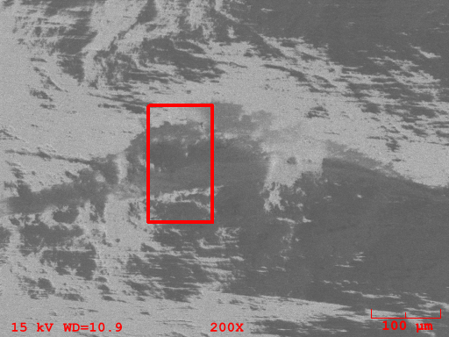
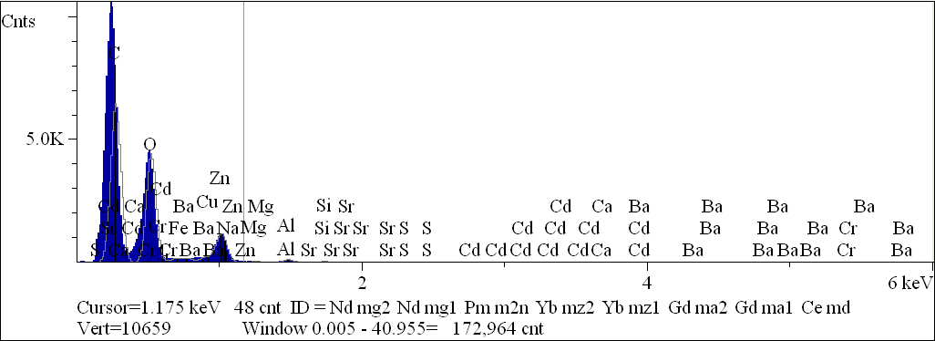
Component | Type | Mole  Conc. | Conc. | Units
C | Calc | 54.335 | 46.818 | wt.%
O | Calc | 44.934 | 51.575 | wt.%
Na | Calc | 0.189 | 0.311 | wt.%
Mg | Calc | 0.120 | 0.208 | wt.%
Al | Calc | 0.237 | 0.459 | wt.%
Si | Calc | 0.078 | 0.157 | wt.%
S | Calc | 0.031 | 0.072 | wt.%
Ca | Calc | 0.003 | 0.007 | wt.%
Cr | Calc | 0.003 | 0.012 | wt.%
Fe | Calc | 0.008 | 0.034 | wt.%
Co | Calc | 0.009 | 0.039 | wt.%
Cu | Calc | 0.010 | 0.045 | wt.%
Zn | Calc | 0.024 | 0.114 | wt.%
Sr | Calc | 0.010 | 0.061 | wt.%
Cd | Calc | 0.002 | 0.012 | wt.%
Ba | Calc | 0.008 | 0.074 | wt.%
 |  | 100.000 | 100.000 | wt.% | Total

kV 15.0
Takeoff Angle 35.0°
Elapsed Livetime 100.0

