Analysis Report: Image8-1
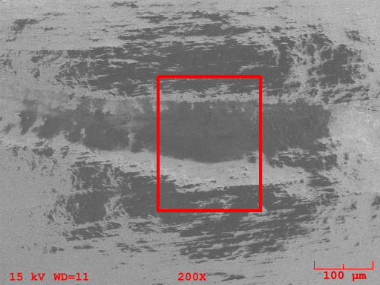
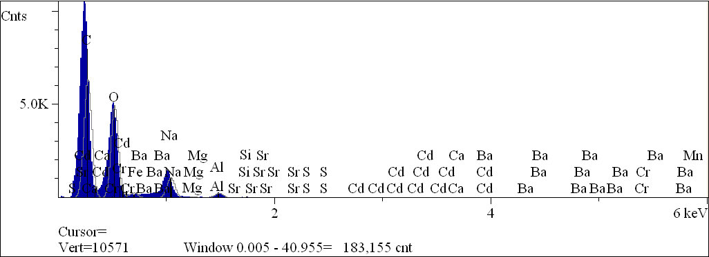
Component | Type | Mole  Conc. | Conc. | Units
C | Calc | 52.900 | 44.788 | wt.%
O | Calc | 43.399 | 48.946 | wt.%
Na | Calc | 3.025 | 4.903 | wt.%
Mg | Calc | 0.131 | 0.224 | wt.%
Al | Calc | 0.450 | 0.856 | wt.%
Si | Calc | 0.055 | 0.109 | wt.%
S | Calc | 0.015 | 0.034 | wt.%
Ca | Calc | 0.002 | 0.007 | wt.%
Cr | Calc | 0.006 | 0.023 | wt.%
Mn | Calc | 0.002 | 0.007 | wt.%
Fe | Calc | 0.001 | 0.004 | wt.%
Sr | Calc | 0.007 | 0.044 | wt.%
Cd | Calc | 0.001 | 0.011 | wt.%
Ba | Calc | 0.005 | 0.044 | wt.%
 |  | 100.000 | 100.000 | wt.% | Total

kV 15.0
Takeoff Angle 35.0°
Elapsed Livetime 100.0

