



**Los Aferrados**

**Members**

Andres Torres Garcia

Francisco Román Alfonso Sánchez García

Oscar Rodea Aragon

**Assessor**

Omar H. Longoria Gandara

**Freescale Cup**

**November 02, 2013**

# Description of mechanical design of car model

The main parts of this design are the encoders and board stages. Up next we will describe each one.

## Encoders design

In order to measure the speed, we decided to put a pair of encoders (one per wheel). The last version was this, the encoder is connected by a plastic mold to the wheel, then when the wheel rotate the encoder will spin at the same speed, using this method we have a little friction but we prefer that because it is more reliable than other methods.

7 cm

16 cm

4 cm

Image 1. Back view of the wheels with the encoder

4 cm

1.7 cm

Image 2. Lateral view of the wheel with the encoder

## Boards design

We decided to build our car with two floors, in case we need to put another board like the speed sensor board, in the lower base are the bolero and power board because they are easy to connect if we put together these boards, in the back of the upper base is the speed sensor board that is exactly under the wheel encoders.

13 cm

20.3 cm

12.7 cm

10 cm

**Speed sensor**

**Board**

12 cm

5 cm

Image 3. Upper base

13 cm

20.3 cm

12.7 cm

10 cm

**Bolero**

**Board**

**Power**

**Board**

9.5 cm

11 cm

5 cm

12 cm

4.7 cm

**Buffer linear camera**

Image 4. Lower base

# Description of control circuit design

The main part of this design is the microcontroller, the two encoders and the camera.

Microcontroller

Encoders

DC Motors

Speed

Image 5. Block diagram of the speed control

Ones we measure the speed of the dc motors using the encoder, it is send to the microcontroller where is processed and modified depending need to increase or decrease. With the position is almost the same, we use the camera map the road and see where the black line and how would it be, then the microcontroller change the position of the servo to follow the black line.

Microcontroller

Camera

Servo Motor

Angular position

Image 6. Block Diagram of the servo motor

# Description of electronic design

The main parts of this design are the power control, linear coupling for the camera and the speed sensor. Up next we will describe each one.

## Power control (DC motors and servo motor)

We control the DC motors and servo motor by PWM (pulse width modulation), we use the board provided by Freescale which has the following features:

* 2 – 5.0 A Throttle Control H-Bridge (MC33932)
* 2 – 5 volts regulators
* 4 – Operational amplifiers

This board has some advantages, for example, all the control pines correspond directly to a port of the bolero, it has a connector for the servo motor (5v and Input) and other for the linear camera (5v, CLK, SI and AO), the operational amplifiers are useful because in the camera and current measurement they amplified the signal between the source and the bolero, and we can also measure the voltage level battery by a divider resistor that is implemented inside the board.

But the only disadvantage is that this board doesn’t allow controlling the spin direction, the pins of the H-bridge are connected to ground.

## Linear coupling for the camera

At the beginning we had a lot of problems with the noise; our servo motor was doing strange moves, after investigate we decided to design a circuit between the linear camera output and the bolero, and then the signal is really more stable than before. We put two simple buffers in cascade configuration.

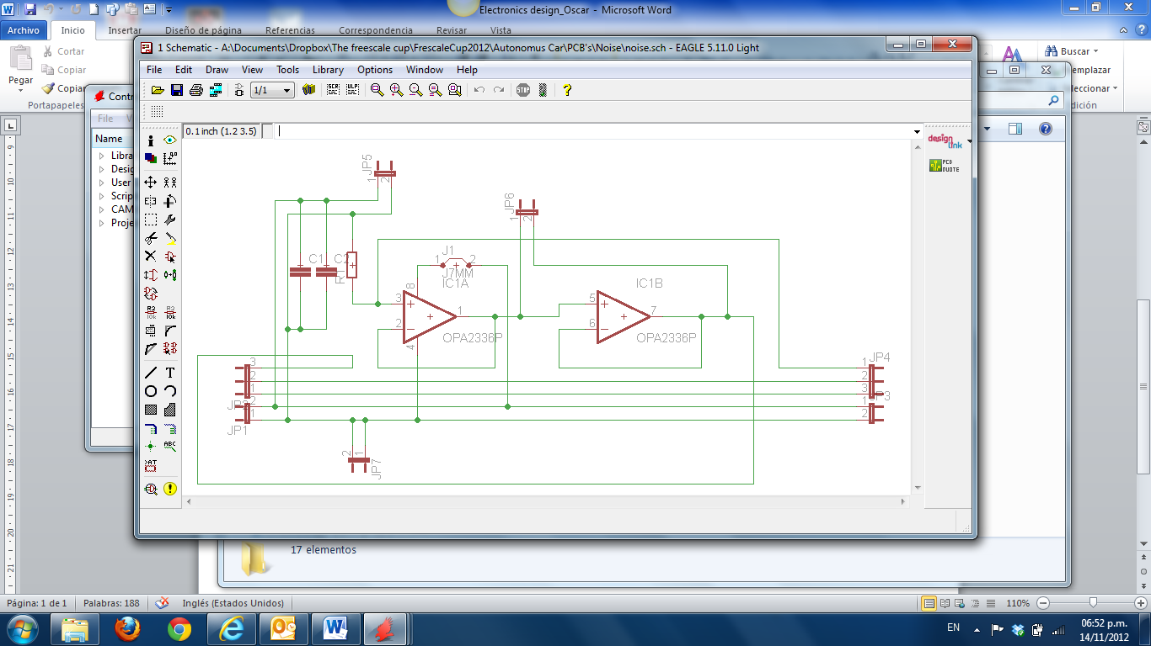

Image 7. Electric diagram of the linear coupling for the camera

## Speed sensor

We are using a pair of encoder in order to measure the speed of the car, the encoder deliver a square signal, we implement a buffer and a smith trigger I.C. to clean the signal. After that the clean square signal goes to the bolero in an eMios input pin.

This method has a disadvantage because the encoder is connected directly to the wheel, and it generates friction.

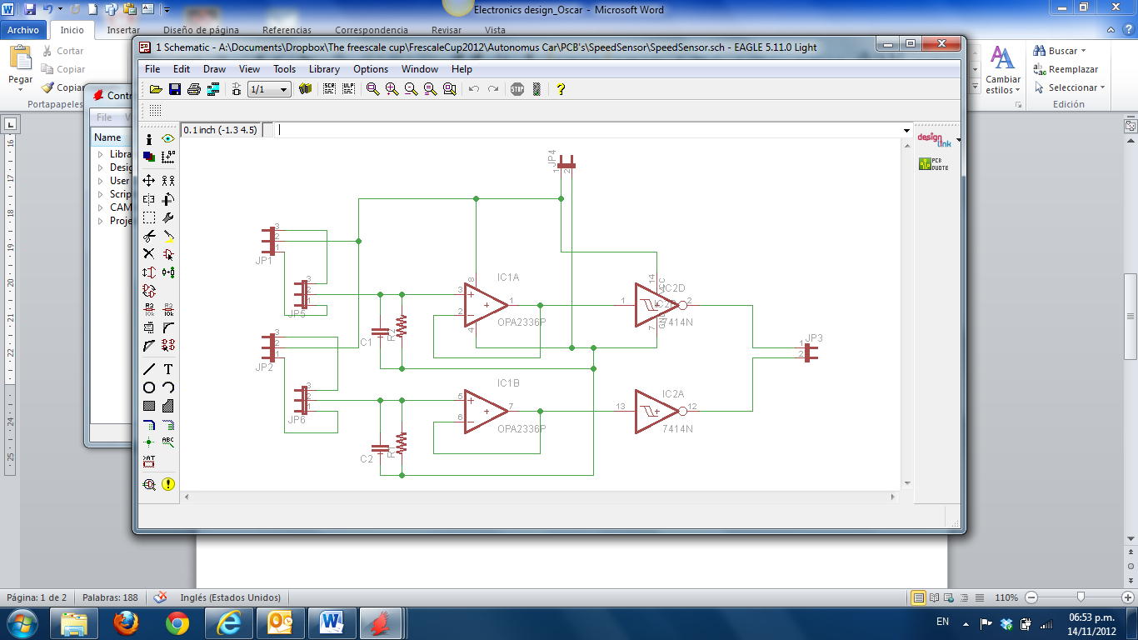

Image 8. Electric diagram speed sensor

**Software Architecture and module interaction block diagram**

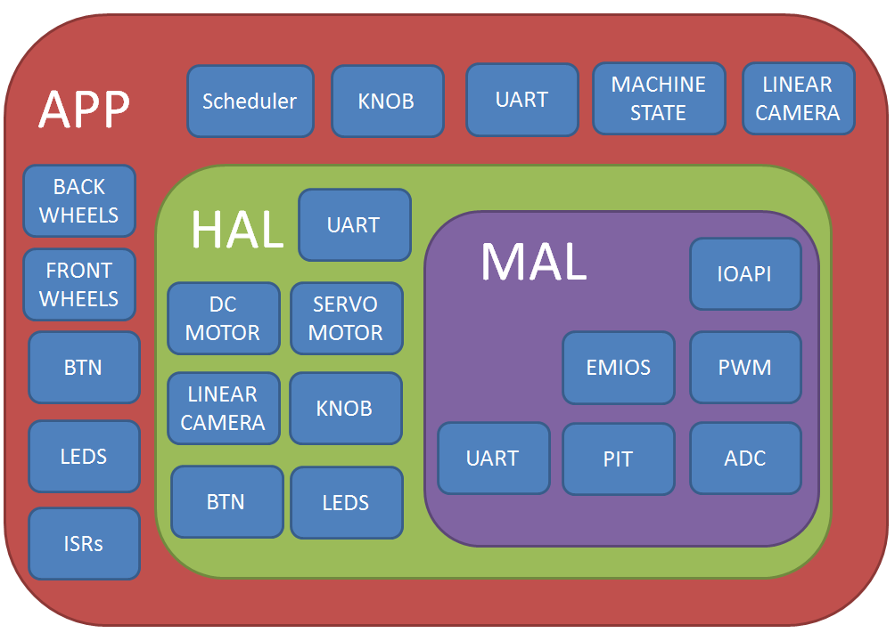

Image 9. Software architecture

**Link to Google code repository**

http://code.google.com/p/elementxyz/source/browse/

**Total weight and dimensions of the reengineered car**

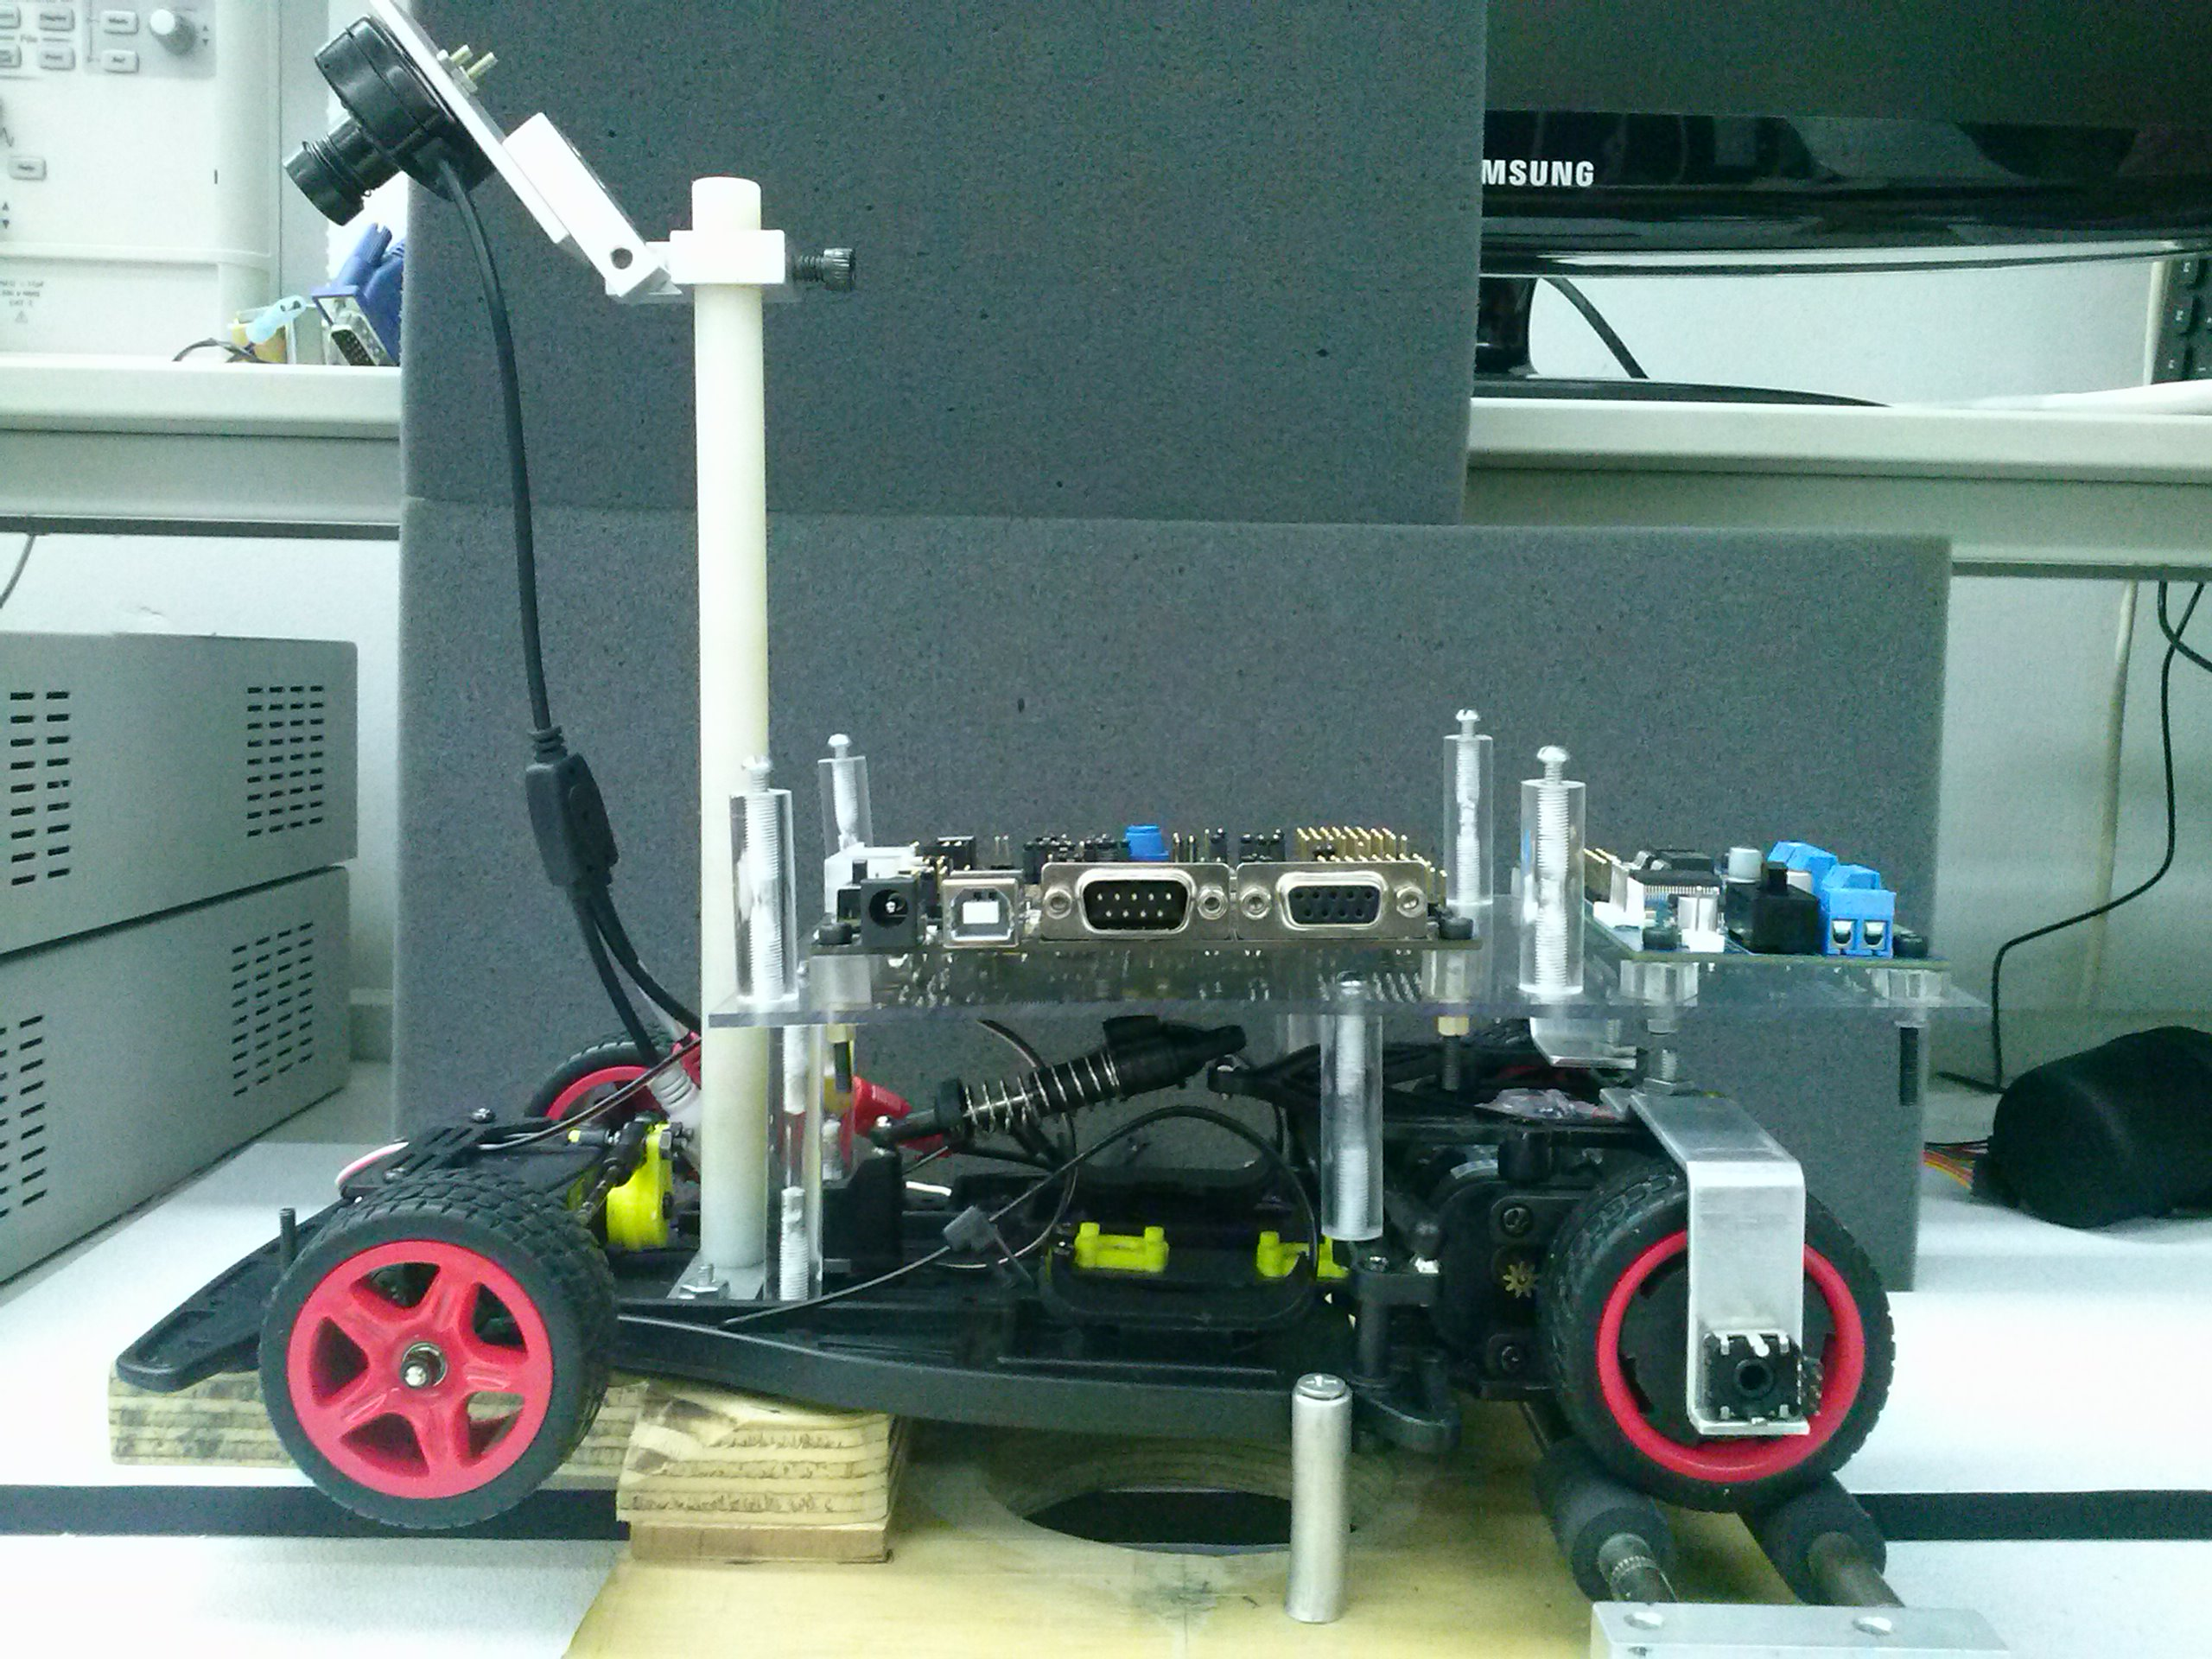

26 cm

28.5 cm

Weight 1.4Kg

# Power consumption

The consumption is different; it depends of the speed of the motors, if we take as a reference that the speed is the highest the power consumption is:

The consumption at sleep mode is:

# Count and type of sensors used

The sensor that we are using is a linear camera

# Number of servo motors

We don’t use any extra servo motor besides the existing ones.

**Bibliography**

<http://www.ams.com/eng/LinearSensorArray>

<https://community.freescale.com/groups/tfc-mexico>

<http://www.stefanv.com/rcstuff/qf200005.html>

<http://www.ntsc-tv.com/>