RUTAS

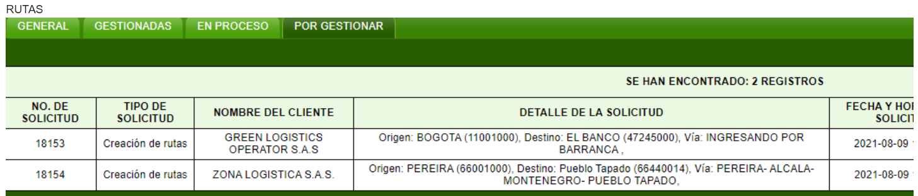

INNOVATECH

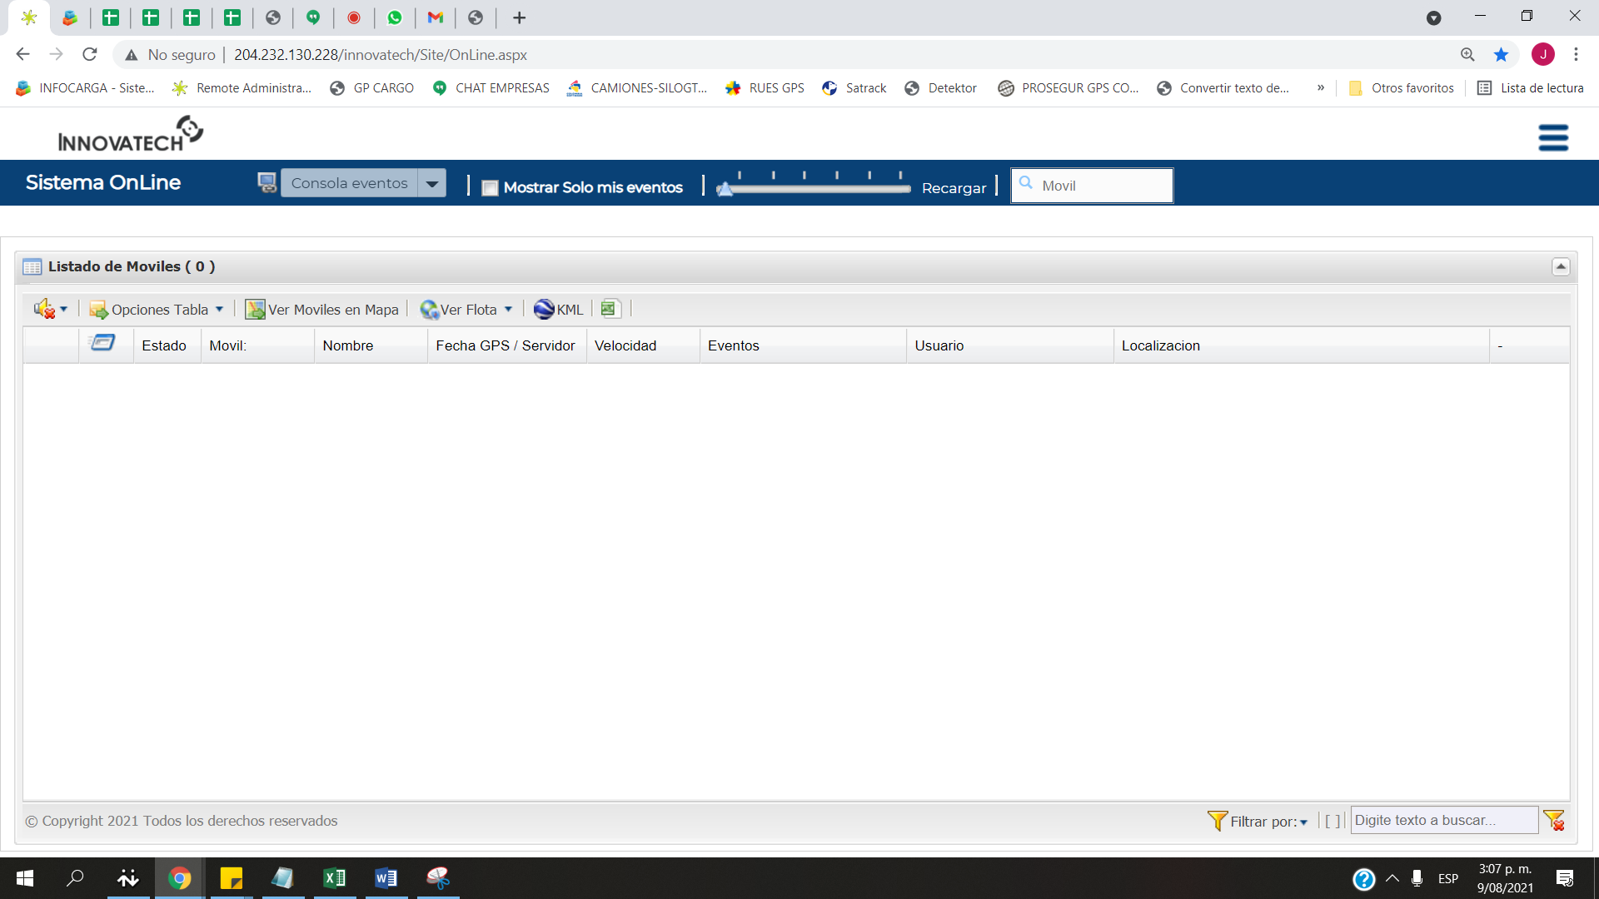

DETECTOR

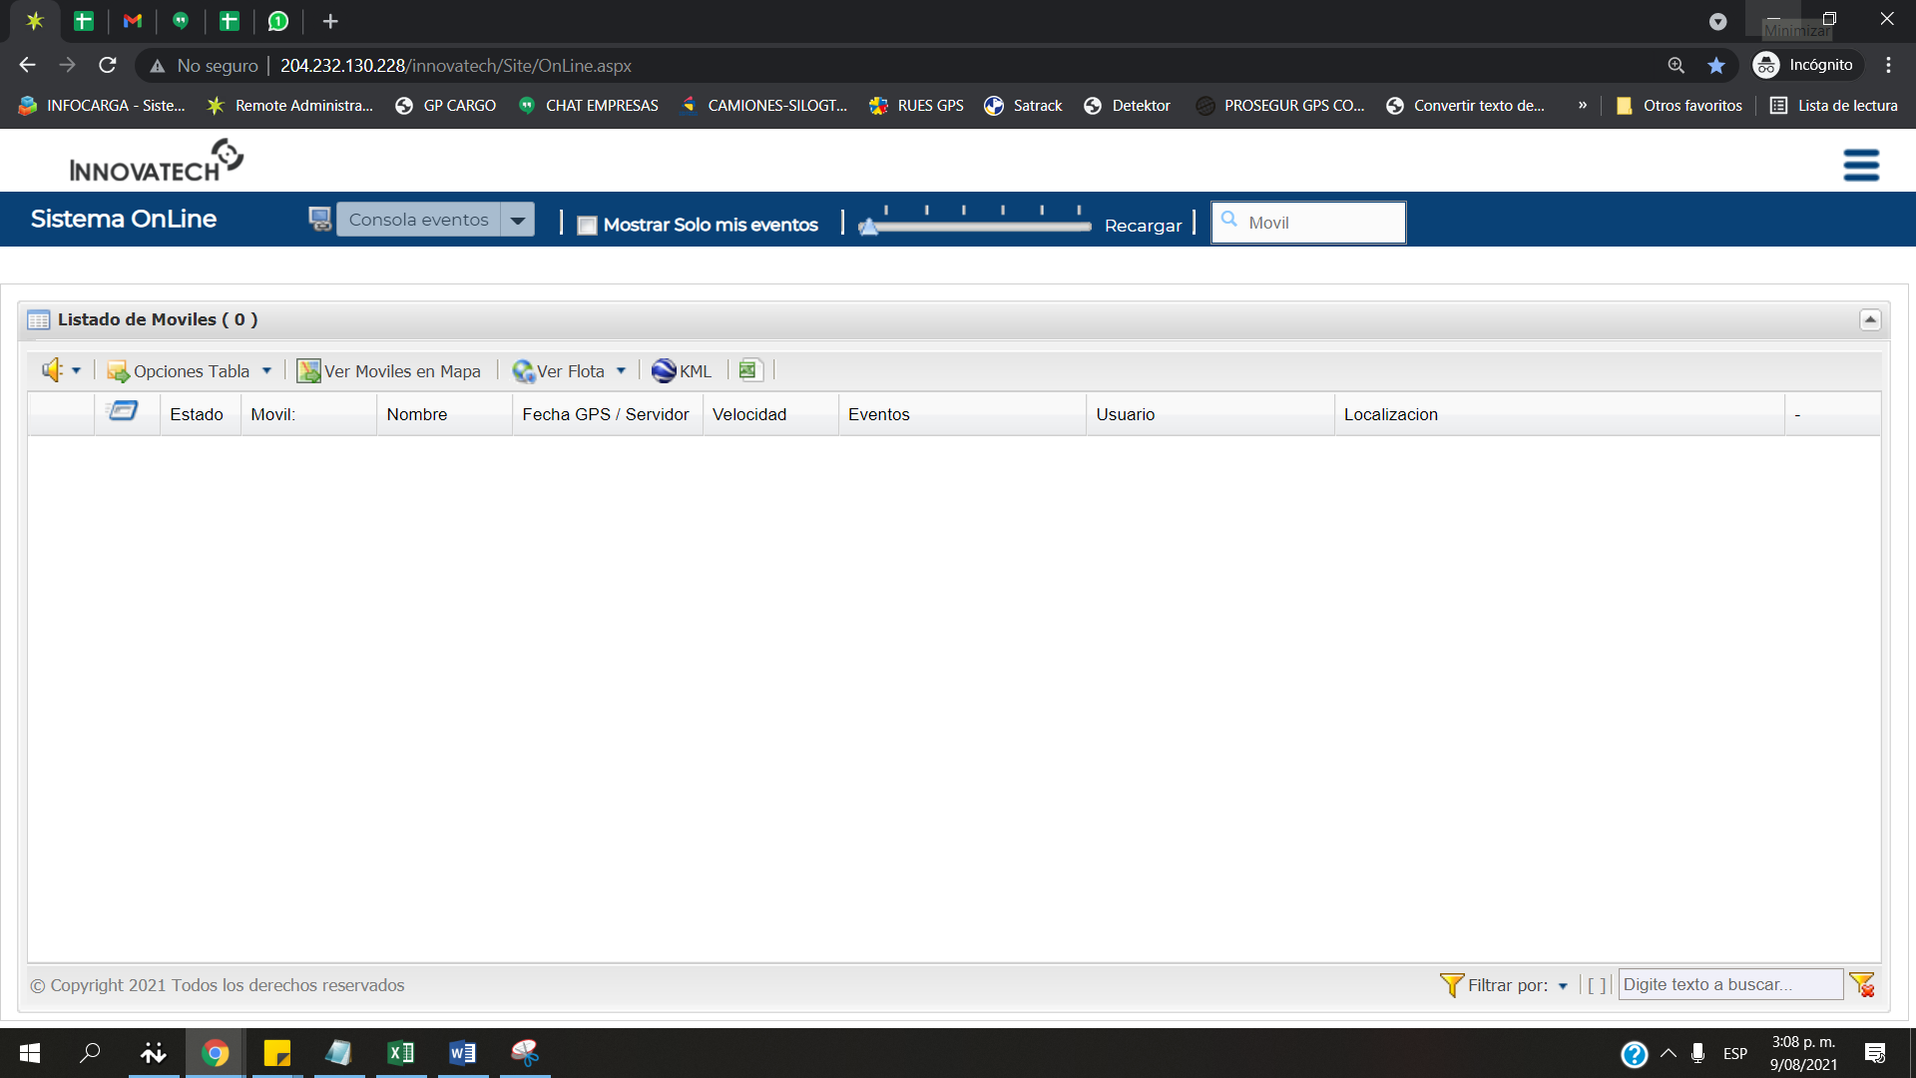

REGISTROS

|  |  |  |  |  |  |  |  |  |  |  |
| --- | --- | --- | --- | --- | --- | --- | --- | --- | --- | --- |
| **Usuario** | **Registros** | **Registros** | **Registros** | **Registros** | **Registros** | **Registros** | **Registros** | **Registros** | Total | Promedio |
| **6:00** | **7:00** | **8:00** | **9:00** | **10:00** | **11:00** | **12:00** | **13:00** |  |  |
| ANABELLA.C | 0 |  |  |  |  |  | 49 | 40 | 89 | 44 |
| ANDRESORTIZ | 7 |  |  |  |  |  |  |  | 7 | 7 |
| ANDRESPINZON | 27 | 36 | 45 | 39 | 42 | 26 | 34 | 21 | 270 | 34 |
| CATALINA.OSPINA | 19 |  |  |  |  |  |  |  | 19 | 19 |
| INGRID.H | 26 |  |  |  |  |  |  |  | 26 | 26 |
| ISABELGARCIA | 11 |  |  |  |  |  |  |  | 11 | 11 |
| LESLIE.S | 46 |  |  |  |  |  |  |  | 46 | 45 |
| LINA.N | 0 | 40 | 43 | 49 | 48 | 40 | 30 | 35 | 285 | 41 |
| NATALY.T | 25 | 27 | 30 | 30 | 28 | 30 | 25 | 24 | 219 | 27 |
| RUBEN.G | 38 |  |  |  |  |  |  |  | 38 | 38 |