RUTAS NUEVAS DESPUES DE LAS 14HRS

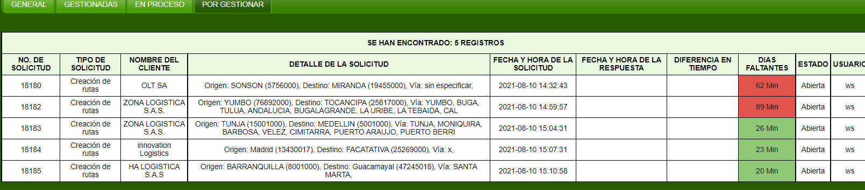

INNOVATECH

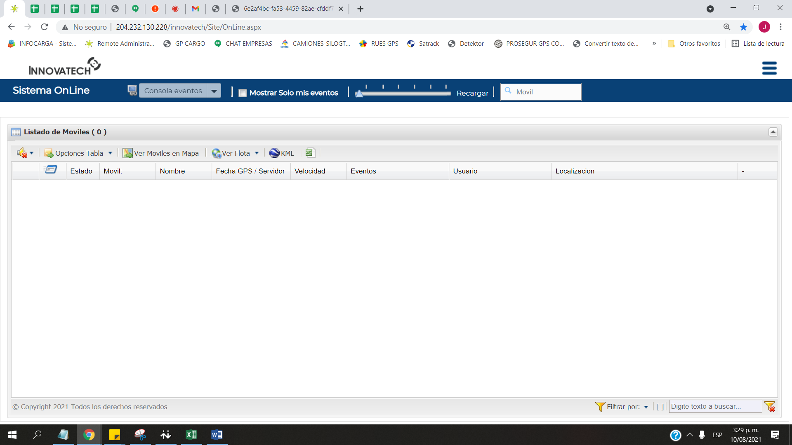

DETECTOR

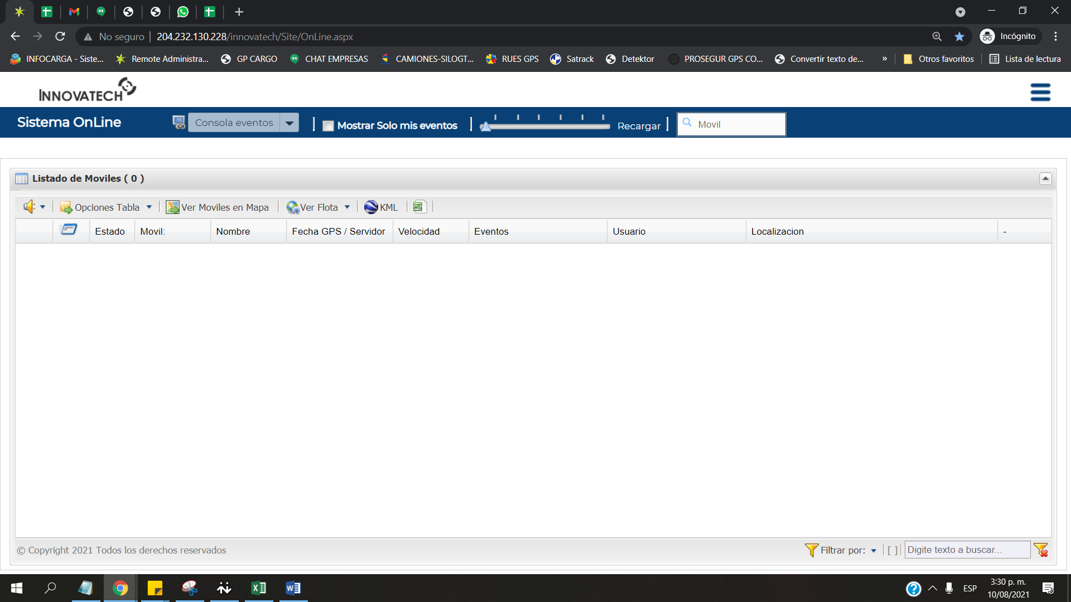

REGISTROS DEL TURNO DE LA MAÑANA

|  |  |  |  |  |  |  |  |  |  |  |
| --- | --- | --- | --- | --- | --- | --- | --- | --- | --- | --- |
| **Usuario** | **Registros** | **Registros** | **Registros** | **Registros** | **Registros** | **Registros** | **Registros** | **Registros** | Total | Promedio |
| **6:00** | **7:00** | **8:00** | **9:00** | **10:00** | **11:00** | **12:00** | **13:00** |  |  |
| ANABELLA.C | 51 | 58 | 36 | 62 | 53 | 59 | 43 | 34 | 396 | 49 |
| ANDRESPINZON | 28 | 36 | 37 | 39 | 39 | 36 | 25 | 38 | 278 | 35 |
| LINA.N | 36 | 34 | 49 | 30 | 41 | 40 | 38 | 30 | 298 | 37 |
| NATALY.T | 22 | 28 | 36 | 30 | 30 | 15 | Sin internet | Sin internet | 161 | 27 |