INNOVATECH NUEVA ALARMA

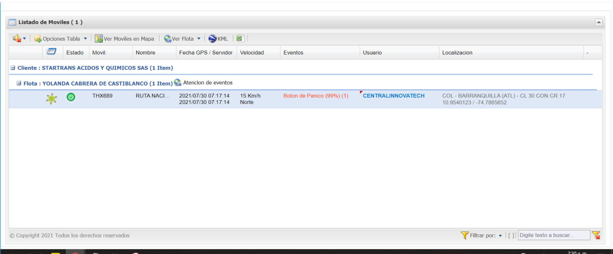

DETECTOR

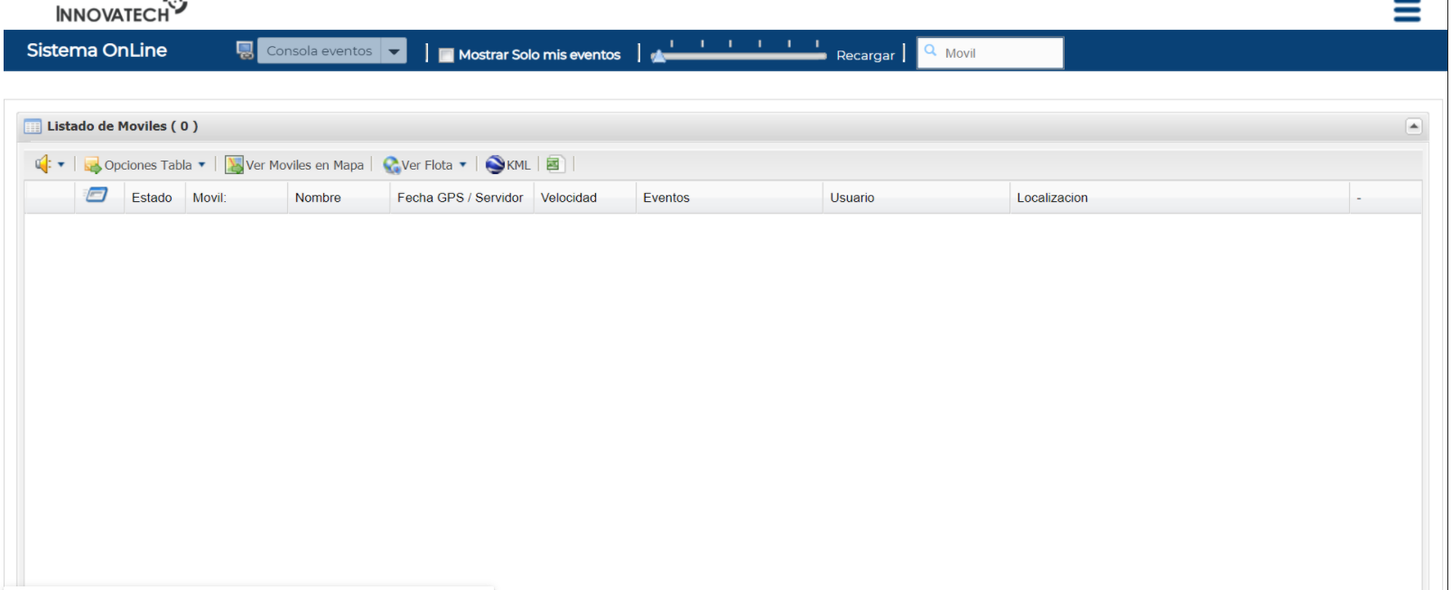

PROMEDIO DE REGISTROS

|  |  |  |  |  |  |  |  |  |  |  |  |
| --- | --- | --- | --- | --- | --- | --- | --- | --- | --- | --- | --- |
| **Usuario** | **Registros** | **Registros** | **Registros** | **Registros** | **Registros** | **Registros** | **Registros** | **Registros** | **Registros** | Total | Promedio |
| **22:00** | **23:00** | **0:00** | **1:00** | **2:00** | **3:00** | **4:00** | **5:00** | **6:00** |  |  |
| DAVIDCELY | 13 | 22 | 20 | 24 | 23 | 30 | 22 | 21 | 21 | 196 | 22 |
| DIEGOCASTILLO | 32 | 34 | 31 | 32 | 32 | 25 | 35 | 50 |  | 271 | 34 |
| LESLIE.S | 22 | 41 | 40 | 44 | 51 | 1 | 16 | 57 |  | 272 | 35 |
| RUBEN.G | 32 | 47 | 47 | 37 | 63 |  | 66 | 51 | 35 | 378 | 47 |