EQUITY RESEARCH | EARNINGS UPDATE | U.S. CYBERSECURITY
Fortinet, Inc. (NASDAQ: FTNT)
Q3 2026 EARNINGS UPDATE | October 29, 2026
Clean Beat, Messy Mix: Price-Led Product Surge Cannot Offset a 13% Service Line; Maintain HOLD, $130 PT
Rating: MAINTAIN HOLD 12-month price target: $130 (34x FY27E non-GAAP EPS of $3.81) Price: $174.08 (Oct 28 close); ~$129 indicated pre-market Oct 29
52-week range: $73.55 - $197.13 Diluted shares: 742.6M Mkt cap at ~$129: ~$96B Net cash (9/30/26): $4.8B P/E FY26E/FY27E at ~$129: 36.0x / 33.9x
Table 1 - Q3 2026 results vs. consensus and guidance
Q3 2026: BEAT | Reported | Consensus | Variance | Guidance | YoY
Revenue ($M) | 2,078.4 | ~2,060 | +~18 (+0.9%) | 2,010-2,100 | +20.5%
Product revenue ($M) | 765.0 | n/a | n/a | n/a | +36.8%
Service revenue ($M) | 1,313.4 | n/a | n/a | n/a | +12.7%
Billings ($M) | 2,336.3 | ~2,300 | +~36 (+1.6%) | 2,250-2,350 | +29.2%
Non-GAAP gross margin | 79.6% | n/a | n/a | 79.0-81.0% | -200 bps
Non-GAAP operating margin | 38.2% | 36.1% | +210 bps | 35.0-37.0% | +130 bps
Non-GAAP EPS ($) | 0.91 | 0.86 | +0.05 (+5.8%) | 0.83-0.87 | +23.0%
GAAP EPS ($) | 0.86 | n/a | n/a | n/a | +38.7%
Free cash flow ($M) | 864.8 | n/a | n/a | n/a | +52.4%
Source: Fortinet Q3 2026 8-K Ex. 99.1 (Oct 28, 2026); consensus per Investing.com, Seeking Alpha via TradingView and Tickeron (pre-release, Oct 28, 2026; billings consensus approximate); prior guidance from Q2'26 release. n/a = no published consensus found.
■ Every headline line beat, but the mix is what sold the stock. Revenue of $2.078B beat consensus of ~$2.06B by ~$18M (0.9%) and non-GAAP EPS of $0.91 beat $0.86 by $0.05, with a record Q3 non-GAAP operating margin of 38.2% (+130 bps YoY, ~210 bps above the 36.1% consensus). Billings rose 29% to $2.336B and free cash flow rose 52% to $865M. Yet shares, which had already fallen 5.9% to $174.08 in the regular session, indicated ~25% lower after hours (~$129). The reason is composition: product revenue grew 37% while service revenue grew only 12.7%, and revenue and billings landed inside the guidance range rather than clearing the top end as in Q2.
■ Service is the line that matters, and its outlook was trimmed. FY26 service revenue guidance moved to $5.150-5.170B from $5.180-5.220B in July, a $40M cut at the midpoint, even as total revenue guidance rose $70M at the midpoint. CFO Christiane Ohlgart called the shortfall "really a timing issue" tied to ramped service activations on large enterprise wins, and pointed to 26% service billings growth and 14.5% short-term deferred revenue growth. She was careful to promise "improved growth rates" in 2027, not "acceleration".
■ Product strength is flattered by price and inventory; gross margin fell 200 bps. Management said pricing contributed roughly 10 percentage points of YoY billings growth, and CEO Ken Xie said pricing has "probably stabilized, but not improved yet." The inventory cushion that supported first-half shipments has faded and lead times are lengthening. Product gross margin (GAAP) dropped to 64.4% from 69.8% in Q2 and 67.7% a year ago as component costs rose, pulling non-GAAP gross margin to 79.6% (from 81.6%). On-hand inventory jumped 39% QoQ to $591M.
■ Maintain HOLD; initiating a $130 12-month PT. We lift FY26E non-GAAP EPS to $3.58 (from $3.48) on the Q3 beat and Q4 guide, but cut FY27E to $3.81 (from $3.95) on a lower service base, slower product growth as pricing laps and gross margin pressure. Our $130 target equals 34x FY27E EPS, cross-checked at ~27x FY27E EV/FCF. At ~$129, FTNT still trades at 36x FY26E EPS. We want to see service revenue growth turn up before paying that multiple, so we stay on the sidelines despite the sell-off.
Table 2 - Updated financial estimates (old vs. new)
Our estimates | FY25A | FY26E Prior | FY26E New | Change | FY27E Prior | FY27E New | Change
Revenue ($M) | 6,800 | 8,140 | 8,191 | +0.6% | 9,250 | 9,065 | -2.0%
Service ($M) | 4,581 | 5,205 | 5,160 | -0.9% | 5,960 | 5,882 | -1.3%
Product ($M) | 2,218 | 2,935 | 3,031 | +3.3% | 3,290 | 3,183 | -3.3%
Billings ($M) | 7,554 | 9,480 | 9,664 | +1.9% | 10,500 | 10,437 | -0.6%
Non-GAAP gross margin (%) | n/a | 80.3% | 80.0% | -30 bps | 80.0% | 79.0% | -100 bps
Non-GAAP op. margin (%) | 35.5% | 36.4% | 37.3% | +90 bps | 36.5% | 36.0% | -50 bps
Non-GAAP EPS ($) | 2.76 | 3.48 | 3.58 | +2.9% | 3.95 | 3.81 | -3.5%
Free cash flow ($M) | 2,212 | 3,250 | 3,437 | +5.8% | 3,500 | 3,350 | -4.3%
P/E at ~$129 (x) | 46.7x | 37.1x | 36.0x |  | 32.7x | 33.9x
Source: FY25A from Q4'25 8-K Ex. 99.1; FY26E/FY27E are our estimates (E). "Prior" = our pre-results model, which for FY26 was anchored near the July 29, 2026 guidance midpoints. FY25A non-GAAP gross margin not shown because pre-2026 releases did not reconcile it. Free cash flow per company definition.
Detailed Results: Revenue and Billings
Total revenue grew 20.5% YoY to $2,078.4M, above the $2,055M guidance midpoint but $22M short of the $2,100M top end. That matters because Fortinet cleared the top of its revenue range by roughly $118M in Q2. Sequentially, revenue rose only 1.5% ($30.5M) after a 10.7% QoQ increase in Q2. Product revenue of $765.0M rose 36.8% YoY but slipped 1.0% QoQ from Q2's $773.0M, the first sequential product decline outside a seasonal first quarter in our eight-quarter data set. Service revenue rose 12.7% YoY to $1,313.4M (+3.0% QoQ), down from 13.7% growth in Q2 and back to the year-ago growth rate.
Figure 1 - Quarterly revenue by type and total YoY growth, Q4'24A-Q3'26A ($M)
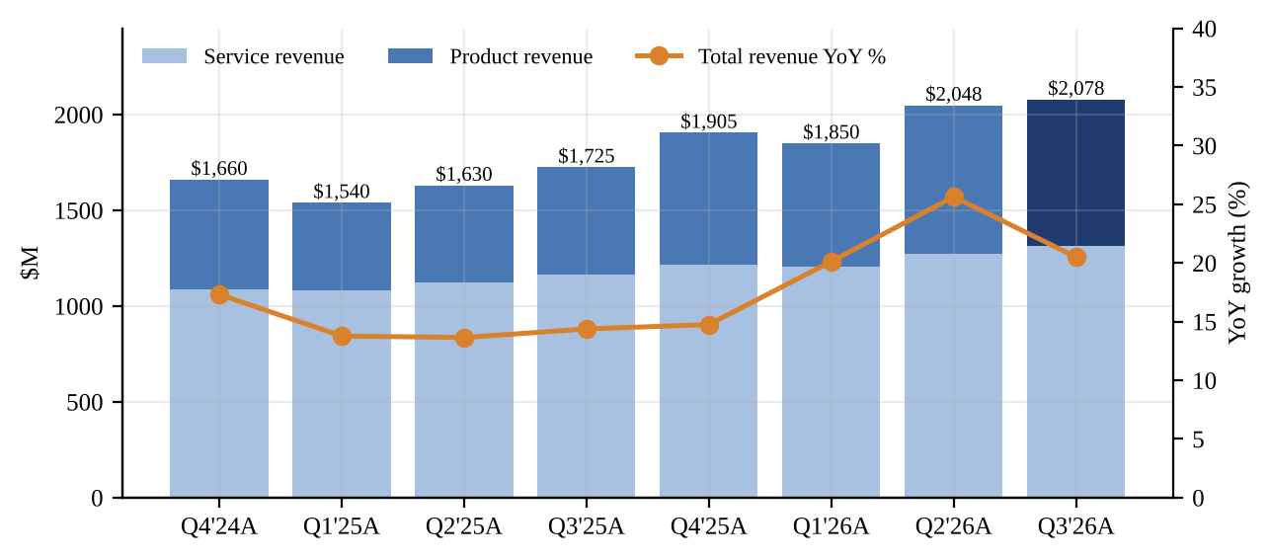
Source: Q4'24, Q1'25, Q2'25, Q3'25, Q4'25, Q1'26, Q2'26 and Q3'26 8-K Ex. 99.1 earnings releases (SEC EDGAR)
Billings rose 29.2% to $2,336.3M, inside the $2,250-2,350M range and ~$36M above the guidance midpoint, but down from 33.4% growth in Q2. Management highlighted that the total value of deals above $1M grew 51%, driven by U.S. large enterprise, that SASE Firewall billings grew 31%, OT billings grew nearly 40% and AI-driven security operations billings grew 15%. Our read is that demand is healthy at the top of the market. However, pricing explains a large part of the headline: Investor Relations clarified on the call that the list-price increases added around 10 percentage points to YoY billings growth. Ex-pricing, billings growth was closer to the high teens, which is solid but not the 29% headline.
Figure 2 - Quarterly billings and YoY growth ($M)
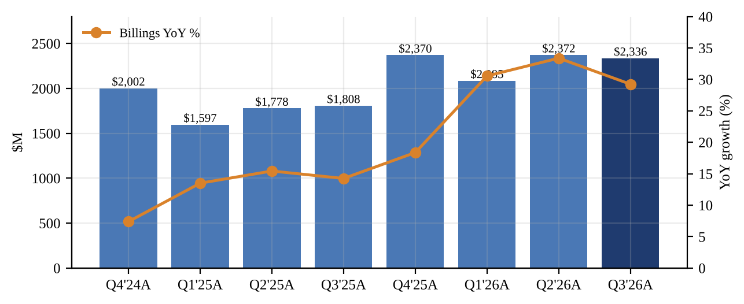
Source: Q4'24, Q1'25, Q2'25, Q3'25, Q4'25, Q1'26, Q2'26 and Q3'26 8-K Ex. 99.1 earnings releases (SEC EDGAR); billings are non-GAAP (revenue plus change in deferred revenue)
The chart below is the core of the bear argument. Product growth went from low double digits in early 2025 to 52% in Q2'26 on the firewall refresh, price increases and a large on-hand inventory position, while service growth went the other way, from 17% in Q4'24 to an 11.5% trough in Q1'26. The Q3 service print (12.7%) supports management's claim that Q1 was the trough, but the recovery is shallow. Service carries ~87% gross margins and is the recurring revenue the market pays a premium multiple for. A product-led mix lowers both earnings quality and gross margin.
Figure 3 - Product vs. service revenue YoY growth: the divergence
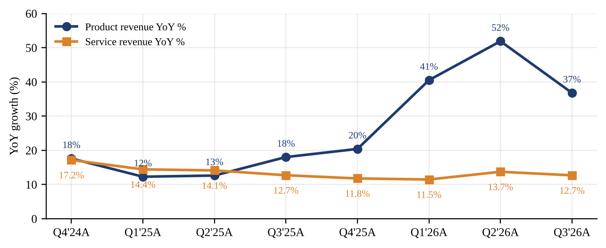
Source: Q4'24, Q1'25, Q2'25, Q3'25, Q4'25, Q1'26, Q2'26 and Q3'26 8-K Ex. 99.1 earnings releases (SEC EDGAR); growth rates computed by us from reported figures
Profitability: Operating Leverage Up, Gross Margin Down
Non-GAAP gross margin was 79.6%, down 200 bps YoY and 130 bps QoQ, and below the 80.0% guidance midpoint. The pressure is entirely in product: GAAP product gross margin fell to 64.4% from 69.8% in Q2'26 and 67.7% in Q3'25, while service gross margin improved to 87.4% (87.0% a year ago). Ohlgart said that "in the second half, you see that the costs are creeping up and then impacting the product gross margin." Xie reiterated that the policy is to hold gross margin steady through pricing, but the Q4 guide of 78-80% non-GAAP gross margin implies another step down at the midpoint, and the price increases have now largely been taken.
Operating leverage more than offset the gross margin decline. Non-GAAP operating margin reached 38.2% (+130 bps YoY), above the 35-37% guidance range, as sales and marketing grew 14.0% and R&D 5.4% against 20.5% revenue growth. GAAP operating margin was 33.9% vs. 31.7%. Non-GAAP EPS of $0.91 (+23%) also benefited from a 2.4% lower diluted share count (742.6M vs. 761.2M) after 2025 buybacks. GAAP EPS of $0.86 (+39%) included a $17.0M escrow settlement gain that is excluded from non-GAAP results and from free cash flow.
Figure 4 - Gross margin by type (GAAP) and non-GAAP operating margin (%)
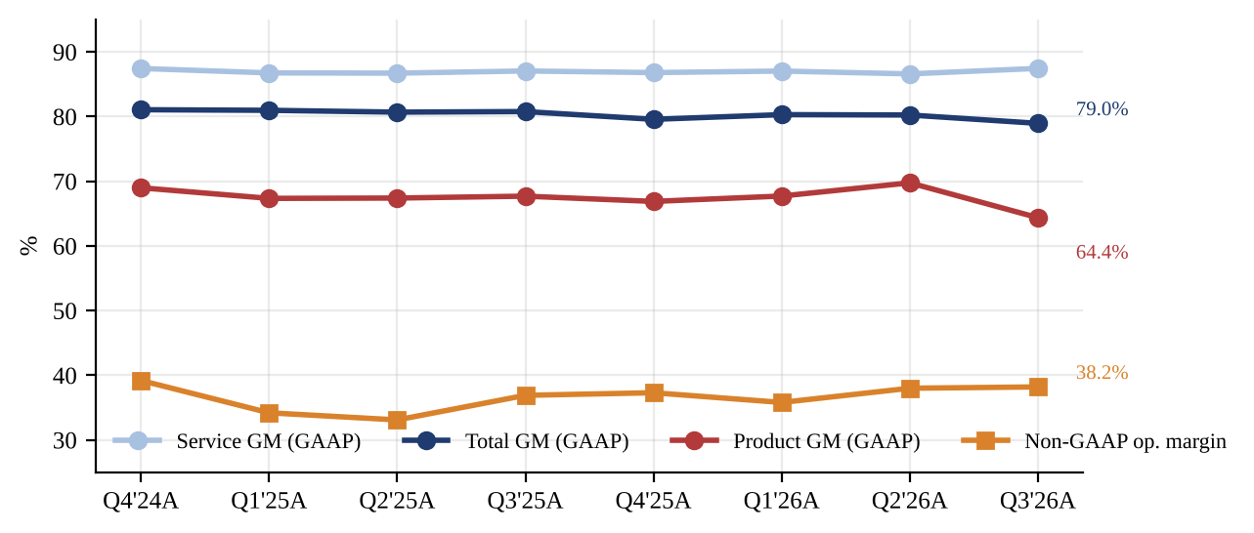
Source: Q4'24, Q1'25, Q2'25, Q3'25, Q4'25, Q1'26, Q2'26 and Q3'26 8-K Ex. 99.1 earnings releases (SEC EDGAR); segment gross margins computed by us
Figure 5 - Quarterly GAAP and non-GAAP diluted EPS ($)
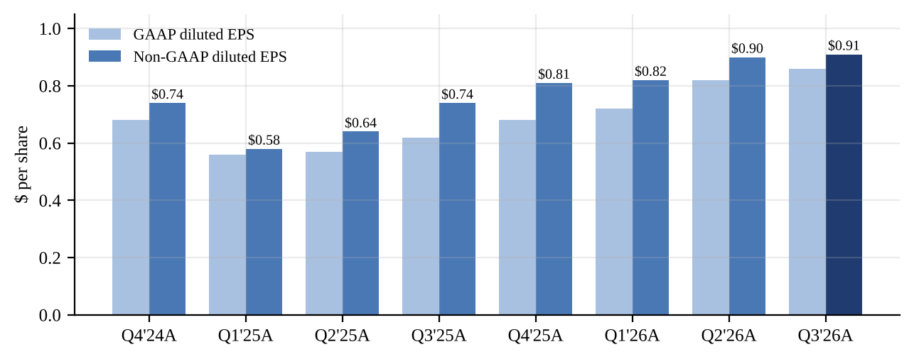
Source: Q4'24, Q1'25, Q2'25, Q3'25, Q4'25, Q1'26, Q2'26 and Q3'26 8-K Ex. 99.1 earnings releases (SEC EDGAR)
Key Metrics: Deferred Revenue, Inventory and Cash
Total deferred revenue reached $7,934.4M, up 19.3% YoY and $258.7M QoQ. The mix matters for 2027 service revenue: short-term deferred revenue (recognized within 12 months) grew 14.5% to $3,961.0M, the fastest rate in five quarters according to management, while long-term deferred revenue grew 24.6% to $3,973.4M. Ohlgart framed short-term deferred revenue as "a good indicator for future service revenue growth" and said contract duration was "pretty similar" to prior periods. We take the 14.5% short-term figure as the realistic ceiling for 2027 service growth, consistent with an "improved" rate vs. 2026's ~13%, but not a step change. The faster long-term growth means more of the billings strength is deferred beyond 2027.
Inventory rose to $591.2M from $426.3M at the end of Q2 (+$165M, +39% QoQ), while accounts payable rose to $430.3M from $230.8M at year-end. Xie said Fortinet normally holds about six months of inventory on hand, that the buffer supported first-half product shipments, and that this normalized from Q3. He also said component lead times are getting longer. We read the balance sheet build as Fortinet rebuilding stock at higher input costs. That supports supply continuity but will run through product cost of goods in coming quarters.
Figure 6 - Deferred revenue (short- and long-term) and inventory ($M, period-end)
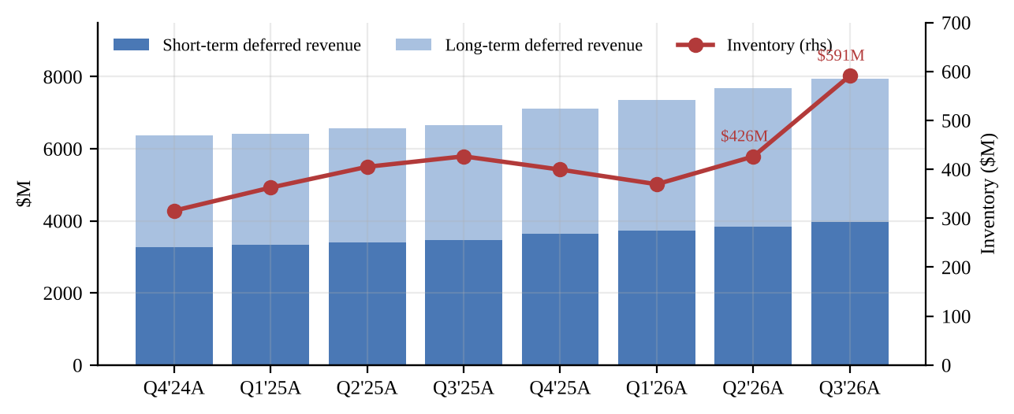
Source: Q4'24, Q1'25, Q2'25, Q3'25, Q4'25, Q1'26, Q2'26 and Q3'26 8-K Ex. 99.1 earnings releases (SEC EDGAR) (condensed consolidated balance sheets)
Cash generation remains the strongest part of the story. Operating cash flow was $946.0M and free cash flow $864.8M (41.6% margin, +52% YoY), taking year-to-date free cash flow to $2.84B (+74%). The Board added $1.2B to the repurchase authorization, leaving $2.0B available. Note that nine-month repurchases of $972.8M were all executed in the first half: Q3 financing outflow was only $18.2M. Cash and investments were $5.3B against $497M of debt, or ~$4.8B of net cash (~$6.5 per diluted share). At ~$129 the authorization equals roughly 2% of the market capitalization.
Figure 7 - Quarterly free cash flow and FCF margin
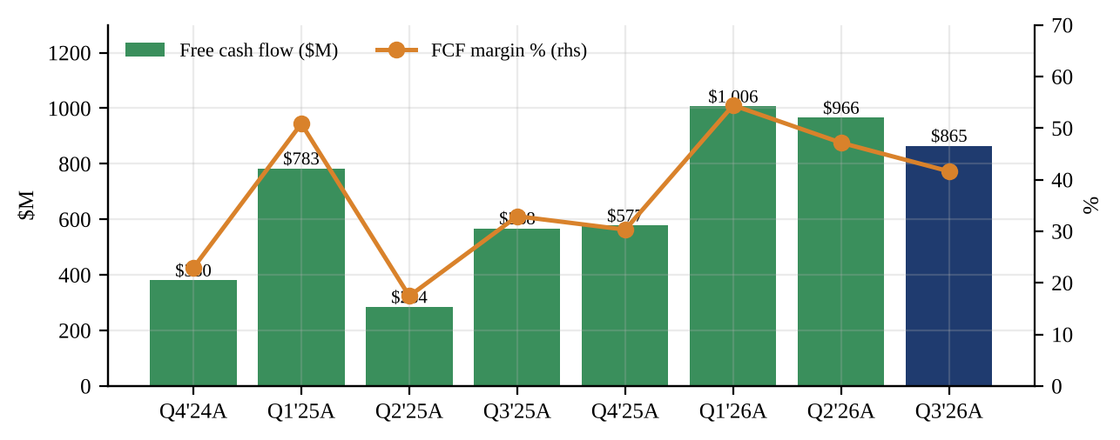
Source: Q4'24, Q1'25, Q2'25, Q3'25, Q4'25, Q1'26, Q2'26 and Q3'26 8-K Ex. 99.1 earnings releases (SEC EDGAR); FCF per company definition (Q3'26 excludes $17.0M escrow proceeds)
Guidance and Outlook
Fortinet raised full-year revenue, billings, operating margin and EPS guidance for the third time this year, but trimmed service revenue and narrowed gross margin. The Q4 guide implies a sharp deceleration: revenue growth of ~15.5% at the $2.200B midpoint (vs. 20.5% in Q3) and billings growth of ~20% at the $2.850B midpoint (vs. 29%). The full-year service guide implies Q4 service revenue of $1.357-1.377B, or 11.8-13.5% growth. Q4 EPS guidance of $0.93-0.95 is well above the $0.88 pre-release consensus cited by Seeking Alpha, and the $2.155-2.245B revenue range brackets the $2.17B consensus.
Table 3 - Management guidance: new vs. prior vs. Street
Guidance item | New (Oct 28) | Prior (Jul 29) | Change at mid | Street (pre-release)
Q4'26 revenue | $2.155-2.245B | n/a | n/a | $2.17B
Q4'26 billings | $2.775-2.925B | n/a | n/a | n/a
Q4'26 non-GAAP GM / OM | 78-80% / 35.5-37.5% | n/a | n/a | n/a
Q4'26 non-GAAP EPS | $0.93-0.95 | n/a | n/a | $0.88
FY26 revenue | $8.125-8.215B | $8.020-8.180B | +$70M (raised) | ~$8.12B (Oct 6)
FY26 service revenue | $5.150-5.170B | $5.180-5.220B | -$40M (lowered) | n/a
FY26 billings | $9.568-9.718B | $9.350-9.550B | +$193M (raised) | n/a
FY26 non-GAAP GM | 79.7-80.3% | 79.0-81.0% | Narrowed | n/a
FY26 non-GAAP OM | 36.5-37.5% | 35.0-37.0% | +100 bps (raised) | n/a
FY26 non-GAAP EPS | $3.54-3.58 | $3.41-3.47 | +$0.12 (raised) | n/a
Source: Fortinet Q3 2026 8-K Ex. 99.1 (Oct 28, 2026); prior guidance from Q2 2026 8-K Ex. 99.1 (Jul 29, 2026); Street Q4 figures per Seeking Alpha via TradingView; FY26 revenue consensus as of Oct 6, 2026 per Hudson Labs. n/a = not provided or not found.
On 2027, management did not give guidance ("still 3 months early," per Xie) but said total billings and revenue growth should outpace the addressable market and that "our 2027 service revenue is expected to grow at a higher rate compared to 2026." Asked directly, Ohlgart said: "I haven't used the word acceleration. I've used the word improved growth rates." We model 14% FY27E service growth, in line with the short-term deferred revenue trajectory, and only 5% product growth as the pricing benefit laps and the refresh wave matures.
Figure 8 - Evolution of FY26 guidance midpoints and ranges (service revenue in red)
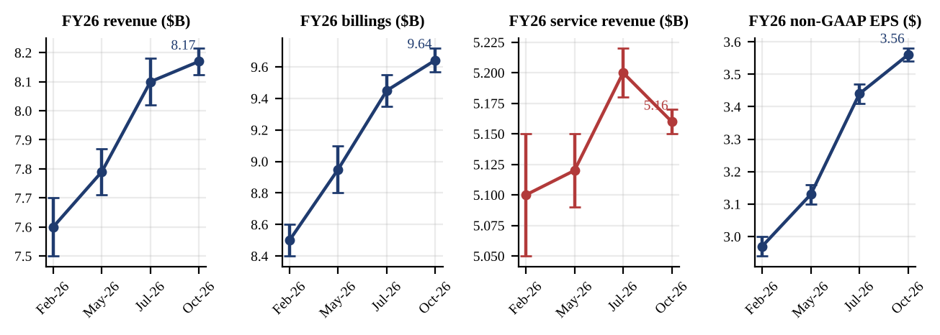
Source: Q4'25, Q1'26, Q2'26 and Q3'26 8-K Ex. 99.1 earnings releases (guidance sections)
Figure 9 - Where results landed within the guidance range: Q2'26 vs. Q3'26 (0% = low end, 100% = high end)
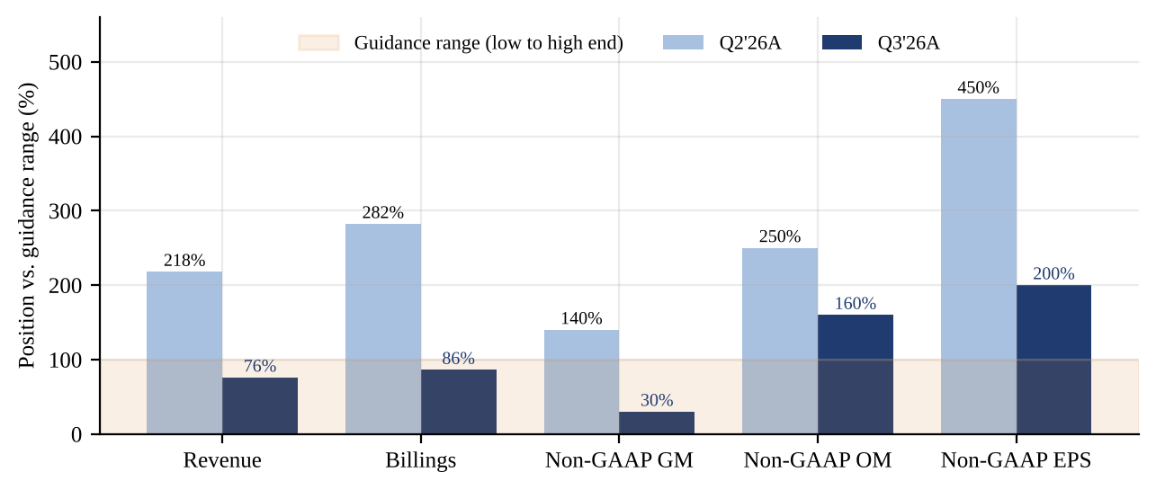
Source: Q1'26 and Q2'26 releases (guidance); Q2'26 and Q3'26 releases (actuals); our calculations
Figure 9 shows why the market reacted as it did. In Q2 every metric cleared the top of its range by a wide margin (revenue at 218% of the range, billings at 282%). In Q3, revenue (76%) and billings (86%) landed inside the range and gross margin finished in the lower third. Only operating margin and EPS, which benefit from cost discipline and a lower share count, beat the top end. For a stock that had more than doubled from its 52-week low, an in-range top line was not enough.
Earnings Call: What Management Said
■ Service timing. Ohlgart attributed the service shortfall to "headwinds from winning new large enterprise customers with ramp service activations" and enterprise agreements that consolidated existing services: "It's just a little bit of a delay from when it gets recognized." She reiterated that "the first quarter of 2026 marked the trough for our services revenue growth rate" (Motley Fool transcript).
■ Pricing. Xie first said pricing has "about 10% benefit on the top line"; VP Investor Relations Anthony Luscri later corrected this to "around a 10 percentage point impact to year-over-year billings growth, not top line." Xie added that pricing has "probably stabilized, but not improved yet" (Investing.com transcript).
■ Hardware life cycles. Xie acknowledged that some lower-end and retail customers are holding hardware longer, but argued that "if you're keeping the hardware like 5, 7, 10 years longer, a lot of function kind of difficult to run," and does not expect the stretching to last. Ohlgart said some U.S. customers are timing hardware purchases for tax depreciation reasons.
■ Channel and duration. Ohlgart said channel inventory is flat to down as a percentage of billings and that billings duration "didn't increase significantly," which argues against a channel-stuffing explanation for product strength.
■ Analyst focus. Questions centered on 2027 product growth against a tough comparison (Barclays), Q3 deceleration and supply (Stifel), service attach rates (Jefferies), large-enterprise ramp deals (Goldman Sachs), hardware life extension and gross margin vs. higher prices (Citi), and the service model for sovereign and neocloud customers and confidence in 2027 service growth (Raymond James).
Investment Thesis Update
■ Pillar 1 - Networking-security convergence keeps Fortinet a share gainer. Status: UNCHANGED. SASE Firewall billings grew 31%, which Xie said is nearly double the market growth rate. OT billings grew nearly 40% and $1M+ deal value grew 51%. Fortinet was again named a Leader in Gartner's 2026 Hybrid Mesh Firewall Magic Quadrant and added sovereign-cloud partnerships with Microsoft and Oracle. Competitive position is not the issue. The question is how much of the 2026 product surge was a one-time combination of refresh timing, pricing and inventory availability. Arete's October 21 double downgrade made exactly this argument, citing 5-20% list-price increases as a non-recurring tailwind and a fading 2020-21 refresh cohort.
■ Pillar 2 - Service revenue compounds at a mid-teens rate. Status: WEAKENED. This was the pillar the quarter was meant to repair, and it did not. Service revenue grew 12.7%, the FY26 service guide fell $40M at the midpoint, and Q4 implies 11.8-13.5% growth. The leading indicators are better (service billings +26%, short-term deferred +14.5%), and management's activation-timing explanation is plausible for large enterprise deals. But the language for 2027 was deliberately modest. Mix is also becoming a structural question: sovereign, neocloud and large networking-heavy deployments may carry lower service attach than the core FortiGate-plus-FortiGuard bundle. We need to see quarterly service growth back above 14% before restoring this pillar.
■ Pillar 3 - Industry-leading margins are durable. Status: WEAKENED (gross) / STRENGTHENED (operating). Operating discipline is excellent: a record 38.2% Q3 non-GAAP operating margin and FY26 guidance raised to 36.5-37.5%. Gross margin is moving the other way. Product gross margin fell 540 bps QoQ and the Q4 guide implies non-GAAP gross margin of 78-80%. With memory and component costs rising, lead times lengthening, $591M of inventory bought at higher prices and pricing "stabilized, but not improved," we model FY27E non-GAAP gross margin of 79.0% and operating margin of 36.0%, below the FY26E level.
■ Pillar 4 - Cash generation funds steady capital return. Status: STRENGTHENED. Year-to-date FCF of $2.84B (+74%), $4.8B of net cash and a $2.0B buyback authorization give real downside support, and a lower share count flatters EPS. Deferred revenue growth of 19% means a large share of 2026 billings converts to cash before it shows up as revenue. The buyback pause in Q3 means Fortinet has room to step in at lower prices.
Risks to Our View
Upside risks: service growth re-accelerates toward the 14.5% short-term deferred revenue rate as delayed activations go live in Q4 and Q1; pricing proves stickier than we assume; AI-infrastructure and sovereign security demand broadens; Fortinet uses its $2.0B authorization aggressively at depressed prices. Downside risks: product revenue declines YoY in 2027 as pricing and refresh tailwinds lap (Arete's sell case); memory and component inflation compresses product gross margin further; extended hardware life cycles spread from low-end and retail into the mid-market; service attach falls with networking-heavy mix. Post-close reports of a possible breach disclosure circulated on October 28 but were unverified at the time of writing (Investing.com).
Valuation and Price Target
Our $130 12-month price target equals 34x FY27E non-GAAP EPS of $3.81. We use a forward P/E because Fortinet is highly profitable and the debate is about the durability of earnings growth. We cross-check with EV/FCF: 27x FY27E free cash flow of $3.35B gives an equity value of ~$128 per share after adding ~$4.8B of net cash. The 34x multiple is a ~15% discount to the stock's two-year average trailing P/E of 39.9x (range 27x-60x). We think a discount is warranted because FY27E EPS growth of ~6% is well below the ~30% delivered in FY26E, and the mix is shifting toward lower-margin, less recurring product revenue. At ~$129 pre-market the stock trades at 36.0x FY26E and 33.9x FY27E EPS, and 37.5x trailing EPS, close to the two-year average. Our target implies ~1% upside from the indicated pre-market level, which is consistent with a HOLD.
For context, the Street went into the print split: MarketBeat showed a consensus Hold with an average target of $162.36 (range $117-225; 1 Strong Buy, 11 Buy, 21 Hold, 6 Sell) as of October 23. Notable pre-print actions included TD Cowen (Buy, $225), JPMorgan (Underweight, raised to $140 from $118) and Arete (double downgrade to Sell, $117). We expect Street targets to fall toward the low-to-mid $100s after the reset.
Figure 10 - Estimate revisions: prior vs. new (FY26E and FY27E)
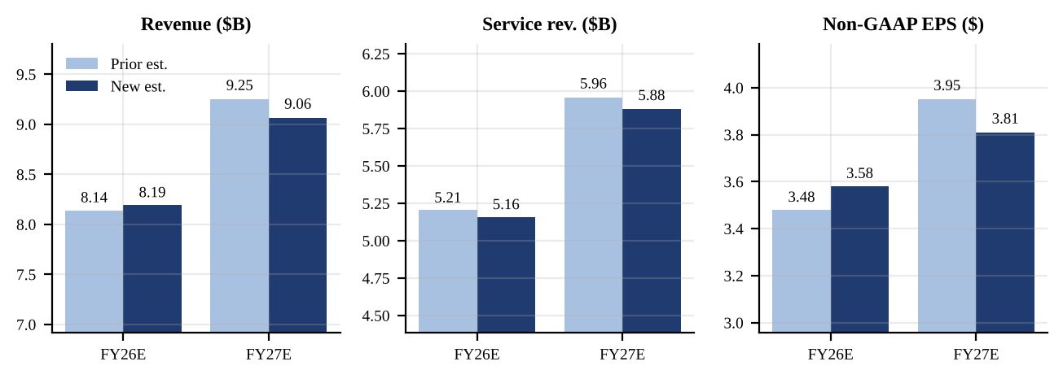
Source: Our estimates; FY26E new estimates incorporate Q3'26 results and Q4'26 guidance
Figure 11 - FTNT price / trailing four-quarter non-GAAP EPS, Nov 2024 - Oct 2026
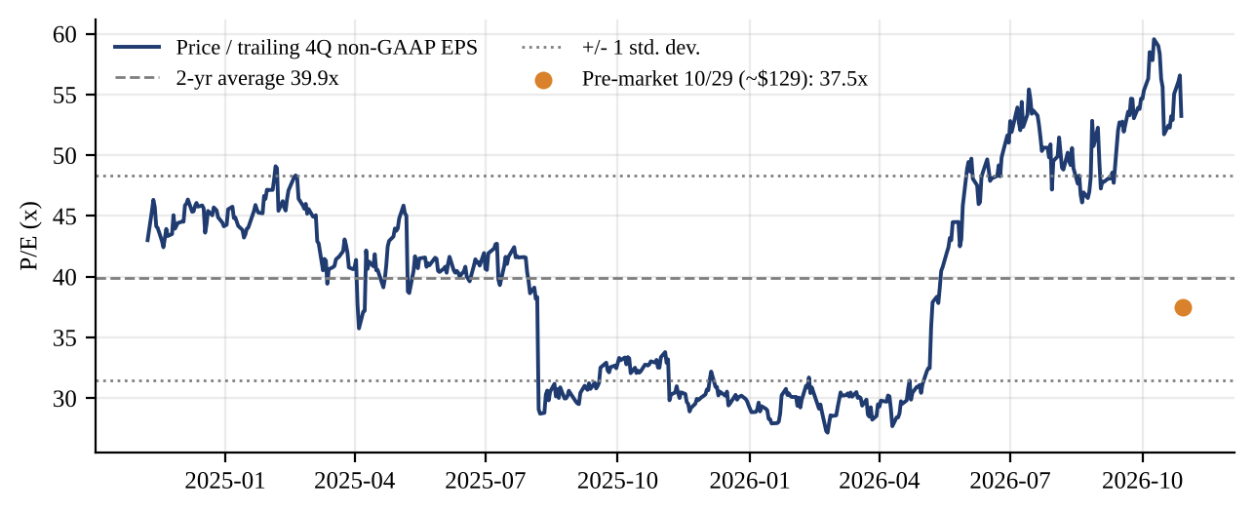
Source: Yahoo Finance daily closes; non-GAAP EPS from Q3'24-Q3'26 earnings releases; pre-market price indicative (Oct 29, 2026); our calculations
Scenario analysis. Bear ($98): product revenue declines YoY in 2027, service grows ~11%, operating margin falls to ~34.5%, giving FY27E EPS of ~$3.50 at 28x. Base ($130): our estimates at 34x. Bull ($164): service growth reaches ~16% as activations go live, product grows ~12% on AI and sovereign demand, operating margin holds at ~37%, giving ~$4.10 at 40x. The skew from ~$129 is roughly balanced (-24% / +27%), so we see no reason to buy the dip until service growth shows a sustained turn. An upgrade trigger would be quarterly service growth of at least 14% with stable product gross margin. A downgrade trigger would be a YoY product revenue decline before service has re-accelerated.
Figure 12 - 12-month scenario values vs. current price ($ per share)
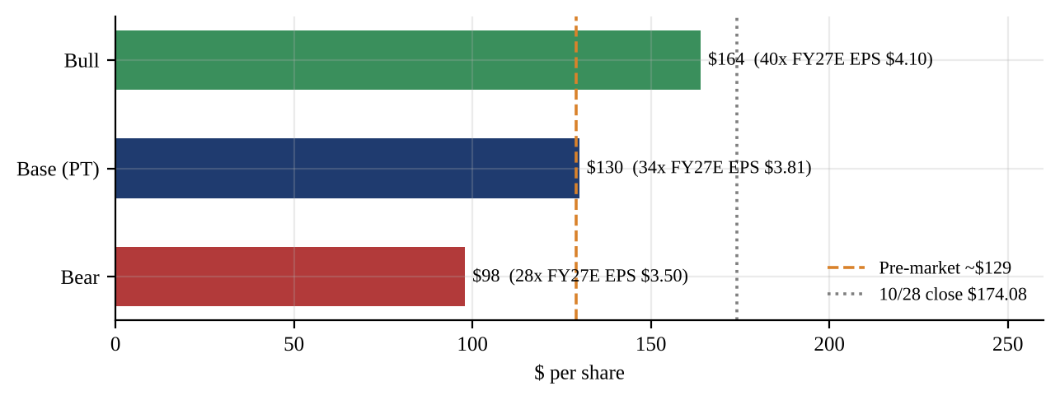
Source: Our estimates; prices from Yahoo Finance (Oct 28 close; Oct 29 indicative pre-market)
Sources and References
Earnings materials (Q3 2026)
• Fortinet Q3 2026 earnings release, 8-K Exhibit 99.1 (Oct 28, 2026), SEC EDGAR
• Fortinet Q3 2026 8-K filing index (Oct 28, 2026), SEC EDGAR
• "Fortinet Reports Strong Third Quarter 2026 Financial Results", Fortinet Investor Relations (Oct 28, 2026)
• Fortinet Q3 2026 earnings call transcript, The Motley Fool (Oct 29, 2026)
• Fortinet Q3 2026 earnings call transcript, Investing.com (Oct 28, 2026)
Prior periods and prior guidance (SEC EDGAR)
• Q2 2026 earnings release, 8-K Ex. 99.1 (Jul 29, 2026) - prior FY26 guidance
• Q2 2026 Form 10-Q (filed Jul 30, 2026)
• Q1 2026 earnings release, 8-K Ex. 99.1 (May 6, 2026)
• Q4 and FY2025 earnings release, 8-K Ex. 99.1 (Feb 5, 2026)
• Q3 2025 earnings release, 8-K Ex. 99.1 (Nov 5, 2025)
• Q2 2025 earnings release, 8-K Ex. 99.1 (Aug 6, 2025)
• Q1 2025 earnings release, 8-K Ex. 99.1 (May 7, 2025)
• Q4 and FY2024 earnings release, 8-K Ex. 99.1 (Feb 6, 2025)
• Fortinet 8-K filing list, SEC EDGAR
Consensus, market data and Street commentary
• "Fortinet falls despite strong Q3 results and higher guidance", Seeking Alpha via TradingView (Oct 28, 2026) - EPS, revenue, op. margin and Q4 consensus
• "Fortinet (FTNT) Delivers Q3 Beat and Raises Guidance but Shares Drop More Than 20%", Tickeron (Oct 2026) - billings consensus (approx.), Oct 28 close
• "Why is Fortinet stock plunging today?", Investing.com (Oct 28, 2026) - after-hours move
• "Fortinet (FTNT) - Q3 2026 Earnings Preview", Hudson Labs (Oct 6, 2026) - FY26 revenue consensus
• "Fortinet stock falls as Arete delivers rare double downgrade to sell", Investing.com (Oct 21, 2026)
• MarketBeat, JPMorgan price target note and consensus rating summary (Oct 23, 2026)
• Yahoo Finance FTNT historical prices (accessed Oct 29, 2026)
Notes on data. All Fortinet financial figures come from company 8-K exhibits; growth rates, segment gross margins, guidance positions and P/E history are our calculations. The Q3 2026 Form 10-Q had not been filed at the time of writing, so balance sheet detail is from the condensed statements in the release. Consensus figures come from media aggregators rather than a primary data terminal. The billings consensus (~$2.30B) is approximate and matches the guidance midpoint. The pre-market price (~$129) is indicative and was moving at the time of writing. All FY26E/FY27E figures, scenario values and the price target are our estimates. "Prior" estimates are from our internal pre-results model and were not previously published.
Disclosures. This report is for informational purposes only and is not an offer or solicitation to buy or sell any security. Ratings: BUY (expected total return >15% over 12 months), HOLD (-10% to +15%), SELL (<-10%). Estimates and opinions are as of the date of this report and may change without notice.

