EQUITY RESEARCH | EARNINGS UPDATE | US SOFTWARE
ServiceNow, Inc. (NYSE: NOW)
Q3 2026 EARNINGS UPDATE | October 29, 2026
Q3'26: Clean Beat on Every Guided Metric, but an 18.5% cRPO Guide Resets the Growth Debate - Maintaining HOLD, 12-Month PT $135
Rating: MAINTAIN HOLD | 12-month price target: $135 (EV/FY27E FCF of 21x; first published target under our updated framework) | Implied return: +10% vs. ~$122.60 indicated pre-market (-10% vs. $150.13 close)
Price (Oct 28 close): $150.13 (-3% on day) | Pre-market Oct 29: ~$122.60 (about -18%) | 52-week range: $81.24-$192.97 | Diluted shares: 1,043M | Market cap at $122.60: ~$128B | Net debt: ~$0.6B | All per-share data post 5-for-1 split (effective Dec 17, 2025)
Q3 2026 RESULTS: BEAT ON REVENUE, cRPO AND MARGIN; $0.02 MISS ON STREET EPS; Q4 cRPO GUIDE BELOW STREET
Table 1 - Q3'26 reported results vs. guidance and consensus
Metric | Q3'26A | Guide / Consensus | Variance | Q3'25A | YoY
Subscription revenue ($M) | 3,988 | 3,975-3,980 (guide) | +$8M vs. high end | 3,299 | +21% (20.5% cc)
Total revenue ($M) | 4,106 | ~4,090-4,100 (cons.) | +$6-16M (~0.3%) | 3,407 | +20.5%
cRPO ($B) / growth cc | 13.65 / 21% | 20% cc (guide) | +100bp | 11.35 | +20.5%
Non-GAAP operating margin | 32.5% | 31% (guide) | +150bp | 33.5% | -100bp
Non-GAAP diluted EPS | $1.00 | $1.02 (cons.) | -$0.02 (-2%) | $0.95 | +5%
GAAP diluted EPS | $0.27 | n/a | n/a | $0.48 | -44%
Free cash flow ($M) / margin | 822 / 20% | n/a | n/a | 592 / 17.5% | +39%
Q4'26 cRPO growth guide (cc) | 18.5% | ~20% (Street) | ~-150bp | n/a | n/a
Source: Q3'26 earnings release (8-K Ex. 99.1, Oct 28, 2026); Q3'26 guidance from Q2'26 release (Jul 22, 2026); consensus EPS/revenue as cited in pre-earnings Street coverage (Oct 28, 2026); Street Q4 cRPO per Morgan Stanley (Oct 29, 2026). Q3'25 EPS restated by company for 5-for-1 split.
Key Takeaways
■ Results beat on the metrics ServiceNow controls, but the Street wanted acceleration and got the opposite. Subscription revenue of $3,988M (+21%, +20.5% cc) cleared the top of the $3,975-3,980M guide by $8M, cRPO of $13.65B grew 21% cc vs. the 20% guide, and non-GAAP operating margin of 32.5% was 150bp above guidance. Non-GAAP EPS of $1.00 rose 5% YoY but missed the $1.02 consensus as higher interest costs on acquisition debt and a smaller cash balance cut the conversion of operating income to net income (78% vs. 87% a year ago, our calculation).
■ The Q4 cRPO guide of 18.5% cc is the story. It sits ~150bp below the ~20% the Street expected and 250bp below Q3's 21%. Management attributed the step-down to early renewals pulled into Q3 (about half of the Q3 cRPO beat), a higher on-prem mix in public sector (~25bp) and termination-for-convenience contract terms (~50bp excluded from cRPO). Morgan Stanley estimates organic cRPO growth slows to ~18% from ~19%, which, with Armis lapping in 2027, points to high-teens subscription growth next year.
■ AI monetization keeps improving; it is not yet showing up as acceleration. The FY26 AI ACV target rises to $1.7B from $1.5B, AI net-new ACV grew 65% YoY, 19 deals exceeded $5M net-new ACV (+135%) and customers above $5M ACV rose ~23% to 680. Some large AI deployments now carry professional services, shifting ~25bp of subscription growth to services in Q3 and ~50bp in Q4.
■ Maintaining HOLD; setting a $135 price target. We trim FY27E subscription revenue 1.1% to $18.55B and non-GAAP EPS 3.4% to $4.51. Our $135 PT applies 21x EV to FY27E FCF of $6.79B, cross-checked by 30x FY27E EPS. After an ~18% pre-market fall the stock is closer to fair value, but we want evidence that cRPO growth stabilizes around 18-19% before turning more constructive.

Detailed Results Analysis

Revenue and bookings: 20%+ growth intact, with inorganic help
Subscription revenue grew 21% YoY to $3,988M (20.5% cc), 50bp above the high end of the constant-currency guide. Total revenue of $4,106M (+20.5%) was roughly $6-16M above the ~$4.09-4.10B consensus range. Professional services and other revenue rose 10% to $118M. Reported growth eased from 24.5% in Q2'26, the first quarter to include Armis (closed April 20, 2026; the company said at Q1 the deal adds about 125bp to FY26 subscription growth). Veza closed March 2, 2026 and Moveworks closed December 15, 2025, so all three deals now sit in the base. ServiceNow does not report organic subscription growth. Our view is that the headline 21% overstates the organic run-rate by roughly a point, consistent with Morgan Stanley's ~19% organic cRPO estimate for Q3.
Figure 1 - Quarterly subscription revenue ($M) and YoY growth, Q1'25-Q3'26 and Q4'26 guidance midpoint
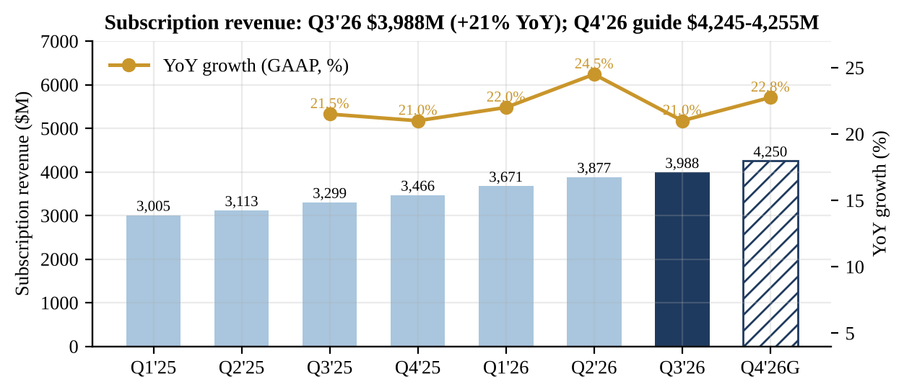
Source: Q3'26 earnings release (8-K Ex. 99.1, Oct 28, 2026); Q2'26 release; Q1'26 release; Q4'25 release; Q3'25 release. Q4'26G = midpoint of $4,245-4,255M guide; growth shown as reported (GAAP).
Current RPO reached $13.65B, up 20.5% (21% cc), a 100bp beat vs. the 20% cc guide, and total RPO grew 22% to $29.7B. Sequentially cRPO added $450M vs. $430M in Q3'25. The quality of the beat was weaker than the headline: CFO Gina Mastantuono said early renewals "contributed about half of the beat in Q3," and that this "has a negative impact in Q4 because we pulled those deals out of Q4 and into Q3." Excluding the pull-forward, cRPO grew roughly in line with the 20% cc guide. ServiceNow has now beaten its cRPO cc guide in every quarter shown in Figure 2, typically by 100-250bp, which is why the 18.5% Q4 guide reads as conservative. Still, it is the lowest cc guide in the series.
Figure 2 - cRPO ($B), constant-currency growth and the prior-quarter cc guide
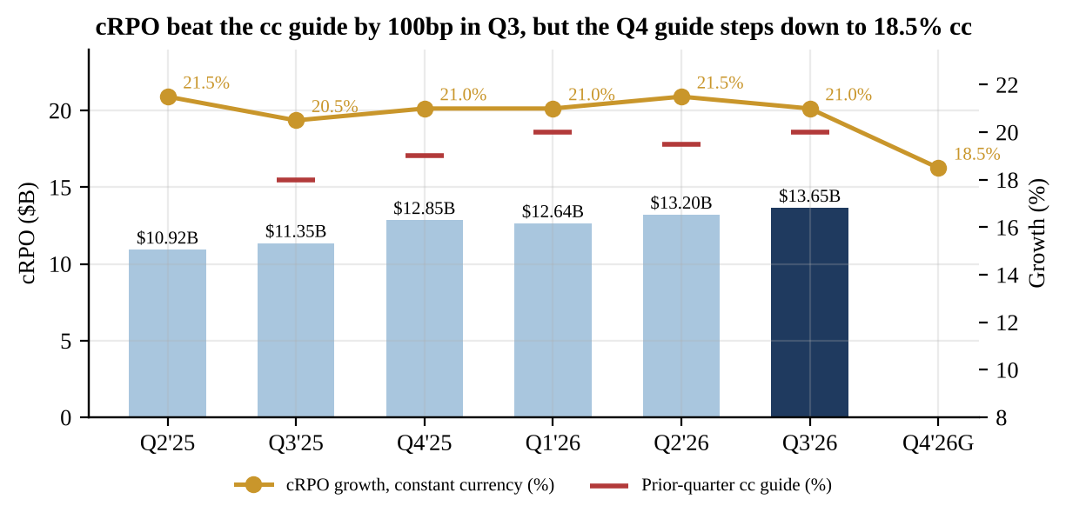
Source: Q3'26 earnings release (8-K Ex. 99.1, Oct 28, 2026); prior guides from Q2'26, Q1'26, Q4'25, Q3'25 and Q2'25 releases. Q4'26G shows guided growth only (no dollar value given).

Profitability: operating beat, below-the-line drag
Non-GAAP operating income rose 17% to $1,338M, a 32.5% margin vs. 33.5% a year ago and the 31% guide. Gross margin is under pressure: non-GAAP subscription gross margin fell to 80% from 83% and non-GAAP gross margin to 77.5% from 81%, reflecting lower-margin acquired revenue, AI compute costs and a professional services gross loss of $39M (break-even a year ago) as ServiceNow puts its own people into large AI deployments. Opex discipline absorbed most of it; management cited more than $1B of annualized internal AI efficiency. GAAP operating margin fell to 9.5% from 17% as the gap between GAAP and non-GAAP operating income widened to $953M from $568M, driven by stock comp and acquisition items including amortization of acquired intangibles.
Figure 3 - Non-GAAP and GAAP operating margin, Q1'25-Q3'26 and Q4'26 guidance
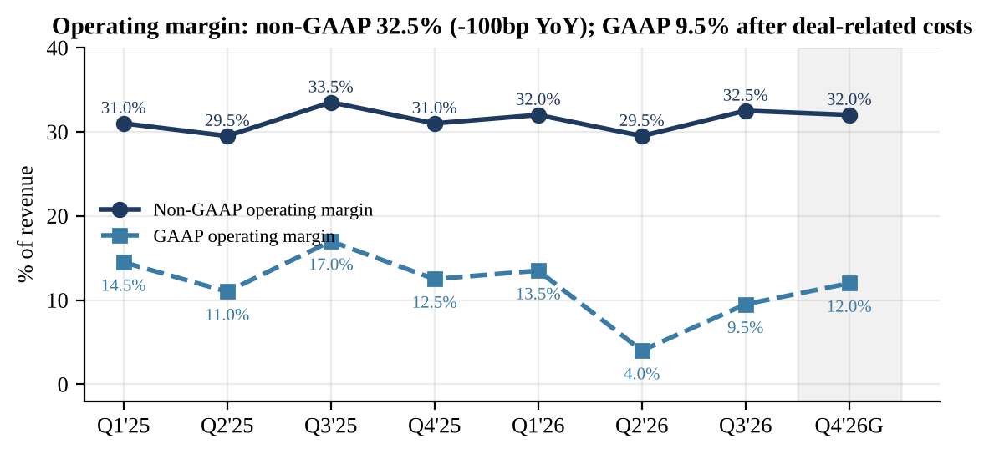
Source: Q3'26 earnings release (8-K Ex. 99.1, Oct 28, 2026) and prior quarterly releases (Q2'26, Q1'26, Q4'25). Q4'26G: 32% non-GAAP, 12% GAAP per Q3'26 release.
The EPS miss happened below the operating line. Non-GAAP net income of $1,039M was 78% of non-GAAP operating income vs. 87% in Q3'25 ($992M of $1,140M). Debt rose to $7.5B ($2.1B short-term, $5.4B long-term) from $1.5B at year-end 2025, while cash and marketable securities fell to $7.0B from $10.1B after $9.2B of cash paid for acquisitions year to date. In our view, higher interest expense and lower interest income explain most of the conversion gap. The release does not split out interest and tax, so this is our inference. At last year's 87% conversion, Q3 EPS would have been about $1.12. GAAP EPS fell 44% to $0.27.
Figure 4 - Quarterly non-GAAP and GAAP diluted EPS (post-split) vs. Q3'26 consensus
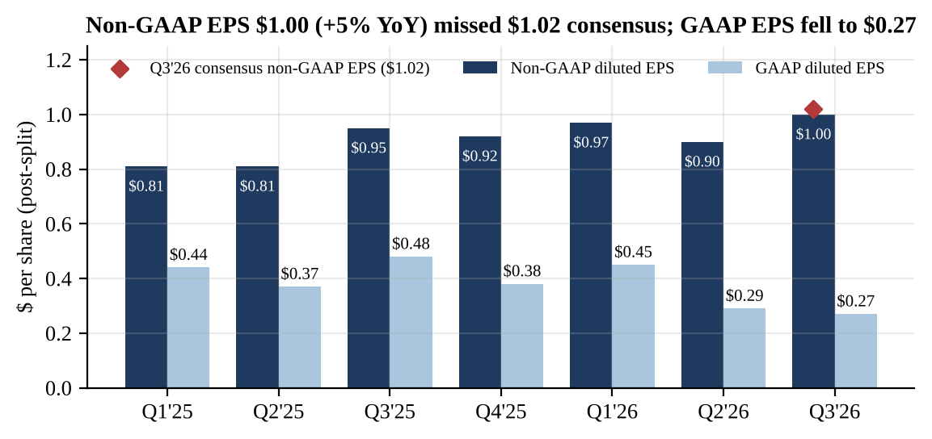
Source: Q3'26 earnings release (8-K Ex. 99.1, Oct 28, 2026) and prior releases; prior-period EPS as restated by ServiceNow for the 5-for-1 split; consensus $1.02 per pre-earnings Street coverage (Oct 28, 2026).

Cash flow and balance sheet
Free cash flow rose 39% to $822M (20% margin vs. 17.5%), and year-to-date FCF is $3,121M (26.5% margin). Q3 is seasonally ServiceNow's weakest cash quarter because collections are concentrated in Q4 and Q1. The raised 36% FY26 FCF margin target, on our ~$16.24B FY26E revenue, implies roughly $2.7B of Q4 FCF vs. $2.0B in Q4'25. Management attributed the raise to lower capex. There was no buyback in Q3, vs. $584M in Q3'25. All $2,225M of 2026 repurchases came in Q1, including a $2B accelerated share repurchase, and about $4.2B of authorization remained after Q1. Goodwill rose to $10.0B from $3.6B at year-end, a reminder of how much of 2026 growth was bought. Current deferred revenue was $7.6B.
Figure 5 - Quarterly free cash flow ($M) and FCF margin
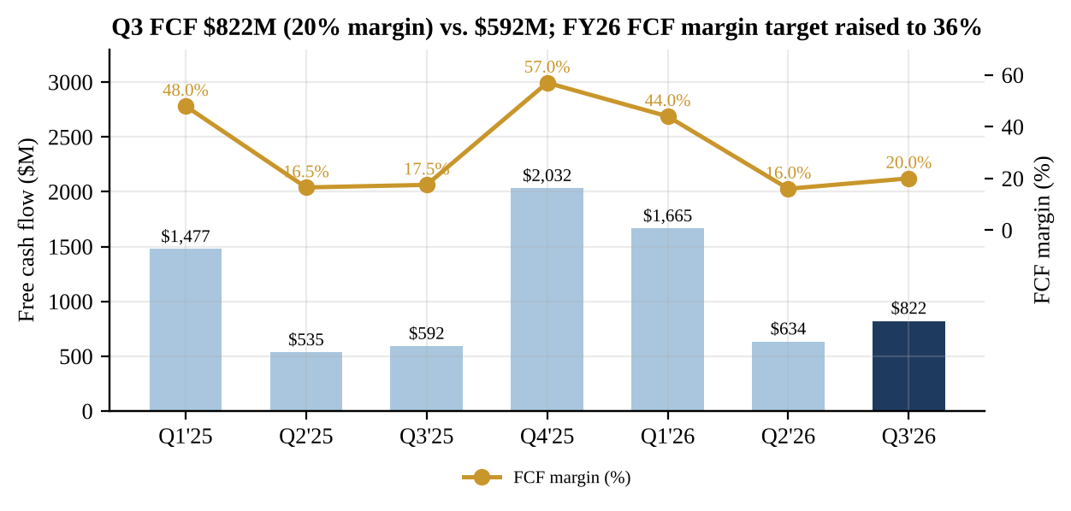
Source: Q3'26 earnings release (8-K Ex. 99.1, Oct 28, 2026); Q2'26, Q1'26 and Q4'25 releases (non-GAAP FCF as defined by the company; Q1'25-Q3'25 comparatives as restated in 2026 releases).

Beat/miss scorecard
Against its own guide ServiceNow beat on every line: subscription revenue by ~0.3% at the midpoint, constant-currency subscription growth by 50bp, cRPO cc growth by 100bp and non-GAAP operating margin by 150bp. Against the Street it beat on revenue by about 0.3% and missed on EPS by 2%. That would normally be a modestly positive print. The ~18% pre-market drop says investors are trading the forward cRPO trajectory, not the quarter.
Figure 6 - Q3'26 variance vs. company guidance and Street consensus
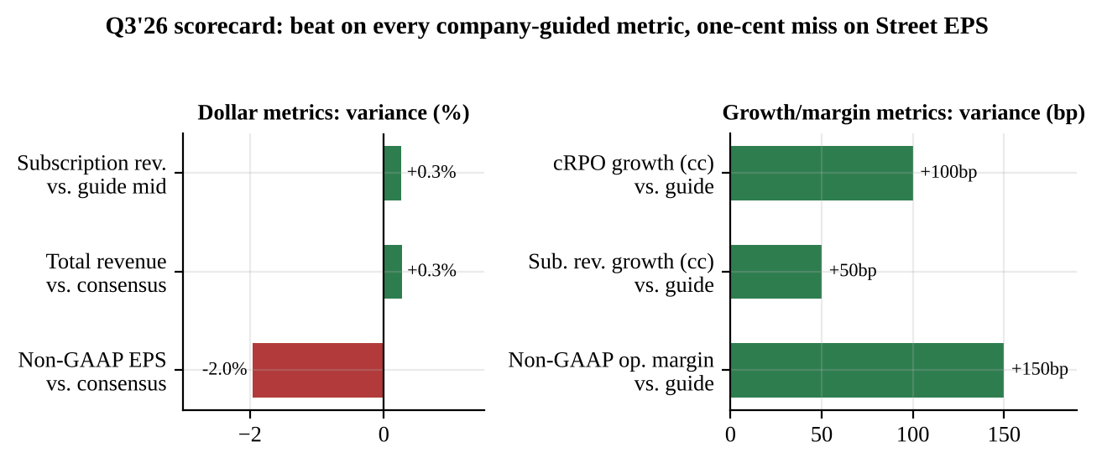
Source: Q3'26 earnings release (8-K Ex. 99.1, Oct 28, 2026); guidance from Q2'26 release; revenue consensus taken at ~$4.095B midpoint of ~$4.09-4.10B range, EPS consensus $1.02 (pre-earnings Street coverage, Oct 28, 2026).

Guidance and Outlook
Table 2 - Management guidance: new vs. prior and Street
Metric | New guide (Oct 28) | Prior guide (Jul 22) | Change | Street / comment
Q4'26 subscription revenue | $4,245-4,255M | n/a (new) | +22.5-23% YoY; 21.5% cc | Includes Armis
Q4'26 cRPO growth | 18.5% (GAAP & cc) | n/a (new) | vs. Q3'26 21% cc | ~20% (Morgan Stanley)
Q4'26 non-GAAP op. margin | 32% | n/a (new) | +100bp YoY | GAAP 12%
FY26 subscription revenue | $15,780-15,790M | $15,760-15,780M | +$15M at midpoint | 22.5% (21% cc)
FY26 non-GAAP sub. gross margin | 81% | 81% | Unchanged | 82% at Jan guide
FY26 non-GAAP op. margin | 31.5% | 31.5% | Unchanged | 32% at Jan guide
FY26 FCF margin | 36% | 35% | +100bp | Lower capex
FY26 AI ACV target | $1.7B | $1.5B | +$0.2B | AI NNACV +65% YoY
FY26 diluted shares | 1.04B | 1.04B | Unchanged | Q4: 1.05B
Source: Q3'26 earnings release (8-K Ex. 99.1, Oct 28, 2026); Q2'26 release (Jul 22, 2026); Q4'25 release (Jan 28, 2026); AI ACV prior target and Q4 Street cRPO per Q3'26 call transcript and Morgan Stanley (Oct 29, 2026).
The FY26 subscription raise of $15M at the midpoint is essentially the $10.5M Q3 beat (vs. the guide midpoint) flowed through. Our calculation is that the implied Q4 midpoint of $4,249M (FY midpoint less $11,536M nine-month actual) is only ~$5M above what the July guide implied. Since January the FY26 subscription guide has risen $235M at the midpoint (Figure 7). Most of that came in April, when Armis was added; we estimate Armis's ~125bp at roughly $160M. The organic raise over the year is therefore a modest ~$75M. The non-GAAP operating margin target held at 31.5%, 50bp below January's 32%, as ServiceNow absorbs deal dilution. The FCF margin target is back at the 36% it started the year at.
Figure 7 - Evolution of FY26 guidance: subscription revenue, operating margin and FCF margin
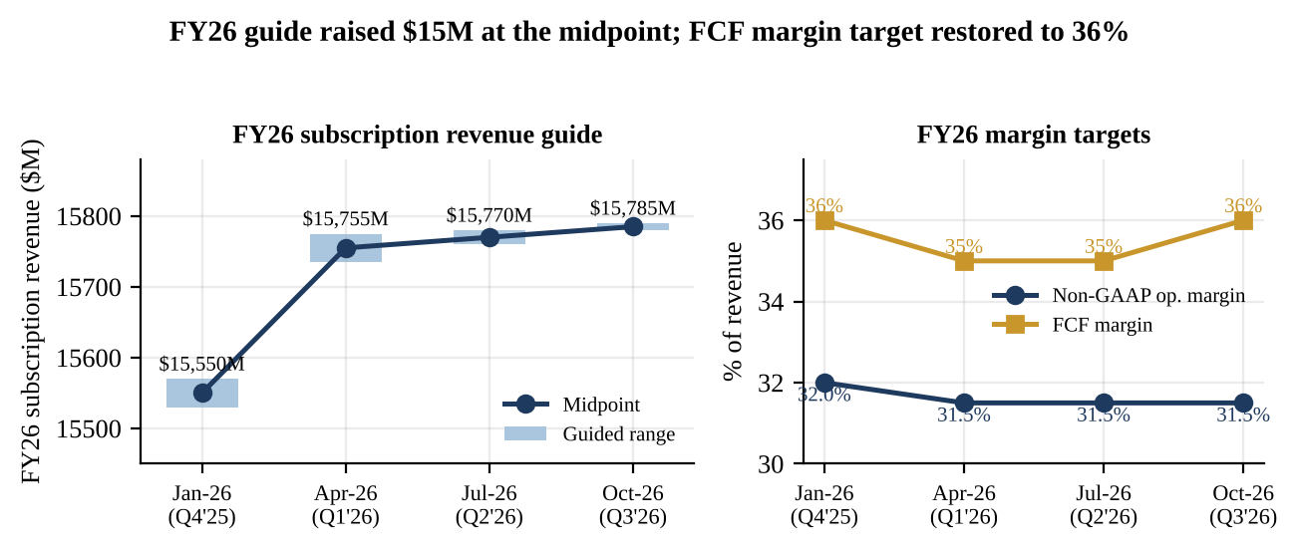
Source: Q4'25 release (Jan 28, 2026); Q1'26 release (Apr 22, 2026); Q2'26 release (Jul 22, 2026); Q3'26 earnings release (8-K Ex. 99.1, Oct 28, 2026).

Unpacking the 18.5% Q4 cRPO guide
Management named three mechanical drags. (1) Early renewals: about half of Q3's 100bp beat came from renewals pulled out of Q4. (2) On-prem mix: "Strong public sector demand is driving higher on-prem mix in Q4," a ~25bp headwind, because on-prem licenses are recognized upfront and fall outside cRPO. (3) Termination-for-convenience (T4C) clauses, common in public-sector contracts, exclude ~50bp of backlog growth from cRPO, although management expects that revenue to be recognized. The on-prem and T4C items explain ~75bp of the 250bp step-down. We estimate the pull-forward at ~50bp, which leaves a ~125bp residual we cannot attribute to any disclosed item (Figure 8). That residual, together with Morgan Stanley's estimate that organic cRPO growth slows to ~18% from ~19%, is why we do not treat the guide as purely mechanical. Mastantuono's comment that cRPO "is a good indicator of next year's revenue, [but] it's certainly not perfect" tells us management expects the 2027 debate to centre on this number.
Figure 8 - Illustrative bridge from Q3'26 cRPO growth (21% cc) to Q4'26 guide (18.5%)
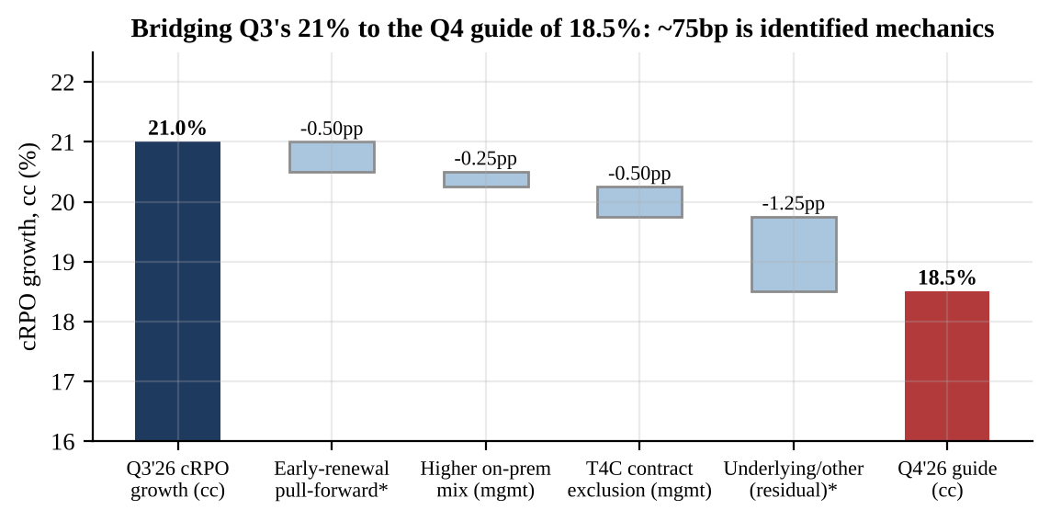
Source: Q3'26 earnings call transcript (Oct 28, 2026) for on-prem (~25bp) and T4C (~50bp) items; *pull-forward size and residual are our estimates (management quantified only that early renewals were ~half of the Q3 beat); Q3'26 earnings release (8-K Ex. 99.1, Oct 28, 2026).

Key Metrics: Large Customers and AI
Customers with more than $5M ACV grew ~23% YoY to 680, adding 22 in the quarter vs. 28 in Q2'26. Nineteen transactions exceeded $5M net-new ACV (+135% YoY) and the renewal rate was 98%. On AI, ServiceNow raised its FY26 AI ACV target to $1.7B from $1.5B (the year began at $1B). AI net-new ACV grew 65% YoY, production agentic-AI consumption is up more than 13x year to date, Control Tower net-new ACV grew more than 6x and EmployeeWorks passed $100M ACV in under three quarters. The 2030 goal of 30% of ACV from AI was reiterated. The bull case rests on these data points, but at ~$1.7B AI is still roughly 10% of the subscription base. It is not yet large enough to offset slowing growth in core IT workflows, or a slower pace of seat additions if customers shrink headcount.
Figure 9 - Customers with >$5M ACV and FY26 AI ACV target progression
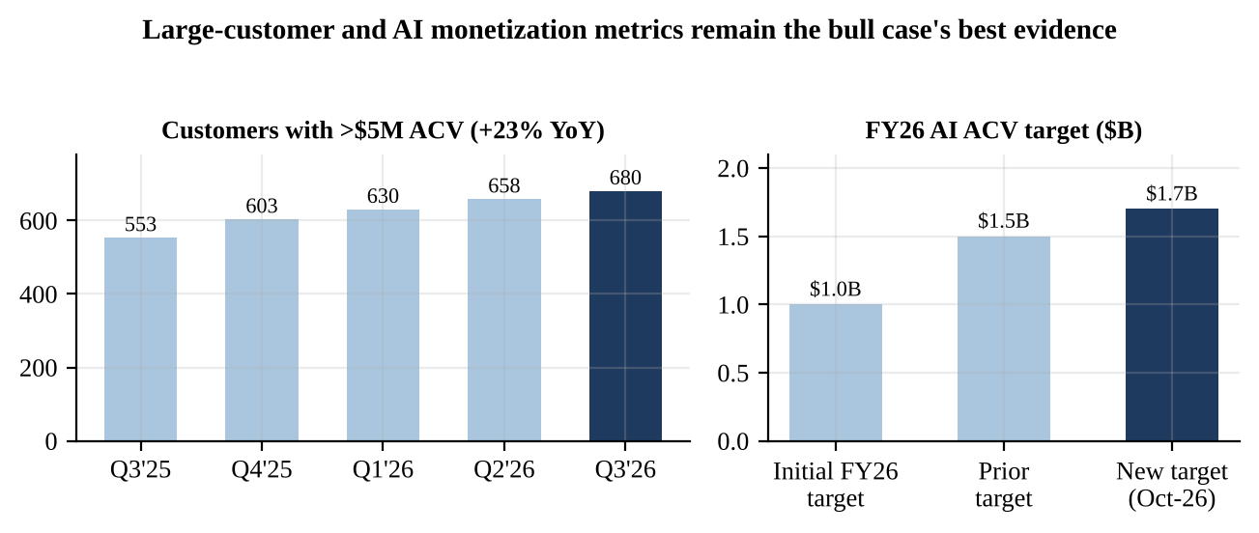
Source: Q3'26 earnings release (8-K Ex. 99.1, Oct 28, 2026); Q2'26, Q1'26, Q4'25 and Q3'25 releases; prior $1.5B AI ACV target per Q3'26 call transcript; initial $1B target per Q3'26 release.

Management commentary
CEO Bill McDermott said this "was more than another beat-and-raise quarter for ServiceNow" and on the call argued that "the business has never been in better shape than it is right now" and that the AI "hockey stick formation has yet to be fully realized." On pricing he defended the hybrid model: "the customer likes the predictability of the seat-based pricing model," with consumption layered on top. Mastantuono said services attached to AI deployments are temporary: "upon renewal of those contracts, the value of those services return to subscription revenue." No numeric 2027 outlook was given. Management said AI momentum will translate into strong revenue growth in 2027 and beyond, and did not discuss capital return on the call. Analyst questions centred on outcome-based pricing (Deutsche Bank), the Q4 guide (Wolfe), cRPO acceleration (Morgan Stanley), whether AI cannibalizes software budgets (William Blair) and how deployment services are accounted for (Jefferies).
Quotes are taken from a third-party transcript that the publisher notes may contain errors, and should be checked against the official webcast replay.

Investment Thesis Update
■ Pillar 1 - Durable 20%+ subscription growth at scale. Status: WEAKENED. Reported growth remains above 20% and the Q4 guide implies 22.5-23%, but that includes Armis, Veza and Moveworks. Organic cRPO is slowing toward ~18%, and the services shift (50-100bp headwind into 2027 per Morgan Stanley) plus T4C terms (~50bp cRPO headwind in 2027) cap reported growth next year. We now model 17.5% FY27E subscription growth, down from 19%. Our thesis assumed ServiceNow could hold ~20% organically through 2027, and the Q4 guide makes that harder to underwrite.
■ Pillar 2 - AI as an incremental monetization layer. Status: STRENGTHENED. The AI ACV target has risen 70% from the $1B starting point and net-new AI ACV grew 65%. Large-deal metrics are accelerating. The hybrid seat-plus-consumption model gives customers predictability and lets ServiceNow capture usage. The open question is net, not gross: if agentic AI lowers the number of human fulfiller seats, AI ACV may partly replace seat revenue rather than add to it. William Blair asked this directly on the call and management gave no quantitative answer.
■ Pillar 3 - Best-in-class cash generation. Status: UNCHANGED / MODESTLY STRENGTHENED. The FY26 FCF margin target goes back to 36%, Q3 FCF grew 39% and the non-GAAP operating margin beat by 150bp. Offsets: FCF does not deduct stock comp, the GAAP margin fell to 9.5%, and the balance sheet moved from ~$8.6B net cash at year-end 2025 to ~$0.6B net debt after $9.2B of acquisitions. Interest costs now dilute EPS, which drove this quarter's miss.
■ Pillar 4 - M&A extends the platform into security and identity. Status: UNDER REVIEW. Armis (asset and exposure security), Veza (identity security) and Moveworks (employee AI assistant) feed the Autonomous Security and EmployeeWorks offerings, and management says the deals are "way ahead" of plan. Together they lifted goodwill by $6.4B and blur the organic growth picture. We want organic disclosure, or at least cRPO stability once Armis laps in Q2'27, before crediting the strategy.

Risks Update
Downside risks: (1) further cRPO deceleration below 18% in 1H27, especially if the residual in Figure 8 proves structural; (2) AI-driven seat compression in IT, HR and customer-service workflows; (3) public-sector budget or contracting disruption, given the higher on-prem and T4C mix; (4) integration risk on three acquisitions and a higher interest burden; (5) multiple compression across application software. Upside risks: (1) Q4 cRPO lands at 20% or better, in line with ServiceNow's record of beating its guide by 100bp or more; (2) faster AI ACV conversion to subscription revenue once deployment services roll to renewal; (3) resumption of buybacks under the remaining ~$4.2B authorization; (4) a 2027 framework at the Q4 print that holds 20% cc growth.

Estimate Revisions
Table 3 - Updated estimates: prior vs. new (our estimates; FY25 actuals for reference)
$M except per share | FY25A | FY26E old | FY26E new | Chg | FY27E old | FY27E new | Chg
Subscription revenue | 12,883 | 15,770 | 15,790 | +0.1% | 18,766 | 18,553 | -1.1%
Subscription growth | 21.0% | 22.4% | 22.6% | +20bp | 19.0% | 17.5% | -150bp
Total revenue | 13,278 | 16,220 | 16,242 | +0.1% | 19,246 | 19,113 | -0.7%
Q4'26E cRPO growth (cc) | - | 20.0% | 18.5% | -150bp | - | - | -
Non-GAAP operating income | ~4,116 | 5,109 | 5,116 | +0.1% | 6,255 | 6,116 | -2.2%
Non-GAAP operating margin | 31.0% | 31.5% | 31.5% | 0bp | 32.5% | 32.0% | -50bp
Non-GAAP diluted EPS | $3.51 | $3.92 | $3.90 | -0.5% | $4.67 | $4.51 | -3.4%
Free cash flow | 4,636 | 5,677 | 5,847 | +3.0% | 7,025 | 6,785 | -3.4%
FCF margin | 35.0% | 35.0% | 36.0% | +100bp | 36.5% | 35.5% | -100bp
P/E at $122.60 (x) | - | 31.3x | 31.4x |  | 26.3x | 27.2x
EV/FCF at $122.60 (x) | - | 22.6x | 22.0x |  | 18.3x | 18.9x
Source: Q4'25 release (FY25A; FY25 non-GAAP operating income approximated as 31% x revenue); Q3'26 earnings release (8-K Ex. 99.1, Oct 28, 2026); our estimates. Old estimates = our pre-print model anchored to the July 22 guide.
What changed and why. FY26E is essentially unchanged: we move to the new guide midpoint plus ~$5M of upside and adopt the 36% FCF margin. For FY27E we cut subscription growth to 17.5% from 19% to reflect (a) the Q4 cRPO exit rate of 18.5%, (b) Armis lapping from Q2'27, (c) Morgan Stanley's 50-100bp services-mix headwind, which we partly mirror by raising FY27E services revenue to $560M from $480M, and (d) ~50bp from T4C terms. We lower FY27E non-GAAP operating margin 50bp to 32.0% to reflect deployment-services costs and integration. Higher interest expense lowers FY27E EPS by a further ~$0.05 vs. our prior. FY27E FCF falls 3.4% to $6.79B (35.5% margin) as cash interest and lower services margins offset a lighter capex profile. FY25A FCF and EPS are from the Q4'25 release.
Figure 10 - Estimate revisions: prior vs. new (FY26E and FY27E)
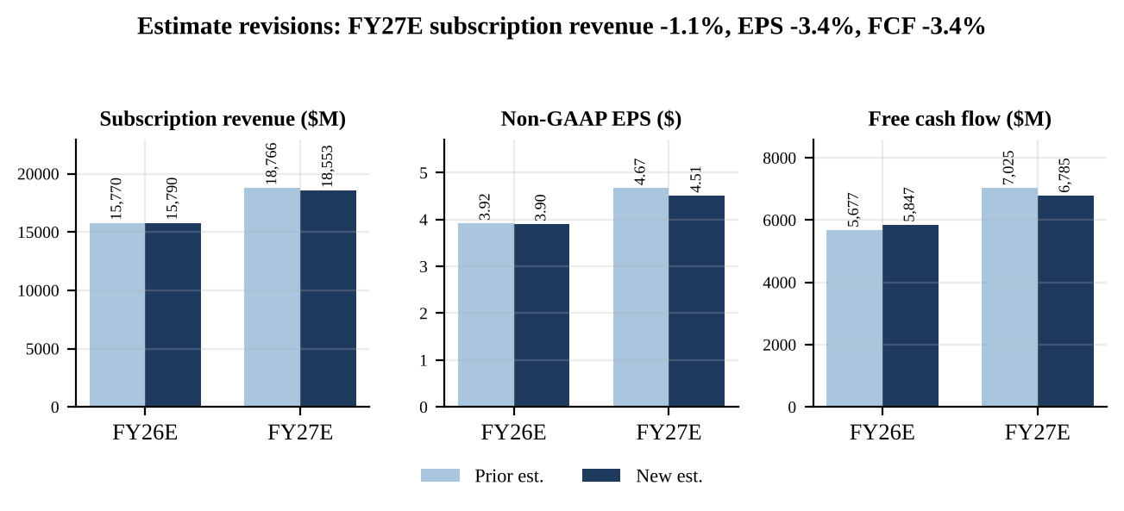
Source: Our estimates; FY26 guidance from Q3'26 earnings release (8-K Ex. 99.1, Oct 28, 2026).

Valuation and Price Target
Methodology. Our 12-month price target of $135 applies 21x EV to FY27E free cash flow of $6.785B. That gives an enterprise value of $142.5B; we subtract ~$0.56B of net debt (debt of $7.52B less $6.96B of cash and marketable securities at September 30, 2026, excluding $2.05B of strategic investments) and divide by the 1.05B Q4 diluted share guide. The result is $135. As a cross-check, 30x FY27E non-GAAP EPS of $4.51 also gives $135. We use 21x, below the ~23x the shares traded on at Tuesday's close, for three reasons: FCF excludes stock compensation, which is material, as the $953M quarterly GAAP-to-non-GAAP operating gap shows; organic growth is decelerating into the high teens; and the balance sheet now carries net debt. At the ~$122.60 indicated open the stock trades on 18.9x EV/FY27E FCF and 27.2x FY27E EPS, vs. 23.2x and 33.3x at the $150.13 close (31.5x forward P/E on consensus).
Figure 11 - Share price, 52-week range and price targets
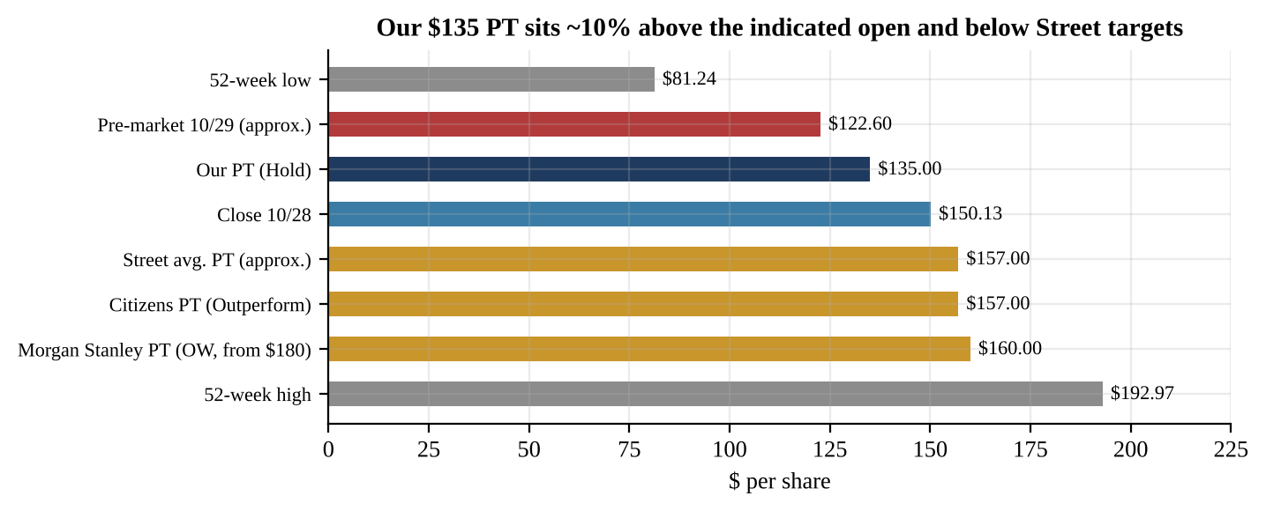
Source: Share prices: NYSE close Oct 28, 2026 and indicated pre-market Oct 29, 2026 (approximate); 52-week range per market data; Morgan Stanley ($180 to $160, Overweight) and Citizens ($157, Outperform) notes dated Oct 29, 2026 as reported; Street average approximate; our PT.
Scenarios. Bull ($171): FY27E subscription growth of 20% as cRPO re-accelerates on AI and renewals of services-heavy deals, a 37% FCF margin ($7.2B) and 25x. Base ($135): 17.5% growth, 35.5% margin, 21x. Bear ($96): growth slows to 15% on seat compression and public-sector friction, a 34% margin ($6.4B) and 16x, a multiple we think is consistent with mid-teens growth. From the ~$122.60 indicated price, the skew is +40% / +10% / -21%. That is balanced enough for a Hold but not compelling enough for a Buy until the cRPO trajectory is clearer.
Figure 12 - Implied value per share by EV/FY27E FCF multiple under bear/base/bull FCF
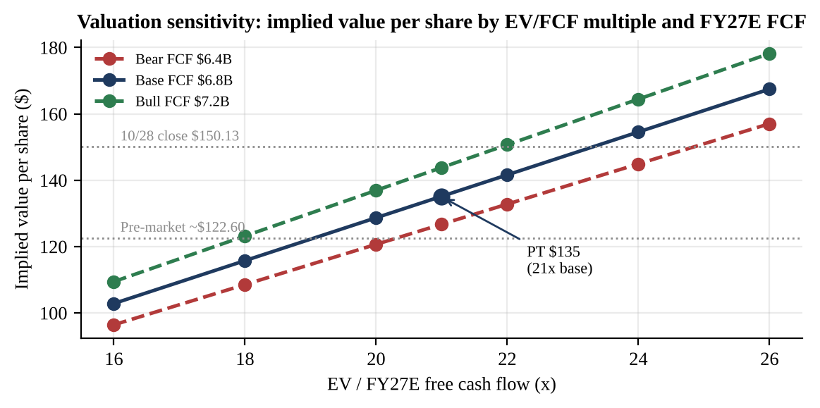
Source: Our estimates; net debt and share count from Q3'26 earnings release (8-K Ex. 99.1, Oct 28, 2026) (balance sheet at Sep 30, 2026; Q4'26 diluted share guide 1.05B).
Why HOLD and not BUY after an 18% drop. Growth above 20%, a 36% FCF margin and an AI ACV target raised twice this year describe a high-quality franchise, and the post-print price of ~27x FY27E EPS is undemanding for that profile. But the variable that sets this stock's multiple, forward cRPO growth, has just stepped down 250bp, and the Q4 guide leaves ~125bp of the decline unexplained. Organic growth is slowing beneath an acquisition-flattered headline, and debate over AI replacing seats will not be settled within a quarter. We would turn more constructive on evidence that Q4 cRPO lands at 19.5% or better, a 2027 framework that holds organic growth around 18% or higher, or buybacks resuming. We would turn more cautious if 1H27 cRPO falls below 17%.

Sources & References
All URLs below are clickable hyperlinks. Data were accessed October 29, 2026.
Earnings materials (Q3 2026)
• ServiceNow Q3 2026 earnings release, Form 8-K Ex. 99.1 (filed Oct 28, 2026) - reported results, Q4 and FY26 guidance, balance sheet, cash flow, stock split note
• Form 8-K/A, accession 0001373715-26-000095 (filed Oct 28, 2026) - amendment filed solely to add Inline XBRL tagging omitted from the original 8-K; no figures changed
• ServiceNow Q3 2026 earnings call transcript (The Motley Fool, Oct 29, 2026) - management quotes, cRPO bridge items, AI metrics, analyst Q&A (third-party transcript)
• ServiceNow Investor Relations - webcast replay and investor materials
• SEC EDGAR filing index, ServiceNow (CIK 0001373715) - Q3'26 Form 10-Q not yet filed as of publication; balance-sheet data from the earnings release
Prior-period materials and prior guidance
• Q2 2026 earnings release (8-K Ex. 99.1, Jul 22, 2026) - Q2'26 results; Q3'26 guidance; prior FY26 guidance ($15,760-15,780M; 35% FCF margin)
• Q1 2026 earnings release (8-K Ex. 99.1, Apr 22, 2026) - Q1'26 results; Veza and Armis closing dates; ASR and buyback authorization
• Q4 2025 earnings release (8-K Ex. 99.1, Jan 28, 2026) - Q4'25 and FY25 results; initial FY26 guidance; 5-for-1 split effective Dec 17, 2025; Moveworks closing
• Q3 2025 earnings release (8-K Ex. 99.1, Oct 29, 2025) - Q3'25 results, cRPO and customer metrics; split announcement; Q4'25 guidance
• Q2 2025 earnings release (8-K Ex. 99.1, Jul 23, 2025) - Q2'25 cRPO; Q3'25 guidance
• SEC EDGAR 8-K filing list, ServiceNow - index of all Item 2.02 earnings filings
Consensus, sell-side and market data (no public link)
• Consensus non-GAAP EPS of $1.02 and revenue of ~$4.09-4.10B: pre-earnings Street aggregates as cited in sell-side and press coverage, as of Oct 28, 2026. Not independently reconciled to a primary consensus database.
• Morgan Stanley (Overweight; PT $180 to $160), Oct 29, 2026: organic cRPO deceleration (~19% to ~18%), services-mix headwind (50-100bp to subscription growth in Q4'26 and 2027), T4C headwind (~50bp to 2027 cRPO), Street Q4 cRPO expectation (~20%).
• Citizens (Outperform; PT $157), Oct 29, 2026. Street average PT of ~$157 is approximate.
• Share prices: NYSE close Oct 28, 2026 ($150.13); indicated pre-market Oct 29, 2026 (~$122.60, approximate and subject to change at the open); 52-week range $81.24-$192.97.
Disclosures: This report is for informational purposes only and is not investment advice. Estimates (E), price targets and scenario values are the author's own and are subject to change. Reported figures are taken from company filings; where figures could not be verified against a primary source this is stated. Rating definitions: BUY, expected 12-month total return above 15%; HOLD, -10% to +15%; SELL, below -10%.

