**Diminishing returns of investment in "preparedness":**

Given that an event occurs, the larger the investment, the lower the fraction of the maximal impact experienced by the population.

Units – economy [eco], year [yr], event [eve]

C – Investment in preparedness (cost) [eco/yr]

p – Probability of climatic event [eve/yr]

I – Climatic event impact [eco/eve]

E – Effectiveness of the cost, years to recover investment? This can be linked with memory [yr/eco]

f(C) – payoff, function to be maximised [eco/eve]. Represents how much demography is impacted from either the impact or the cost of preparing.

$$f(C)=-C/p-I∙e^{-EC}$$

Find the optimal cost

$$df/dC=-1/p+I∙d∙e^{-EC}$$

E related to memory 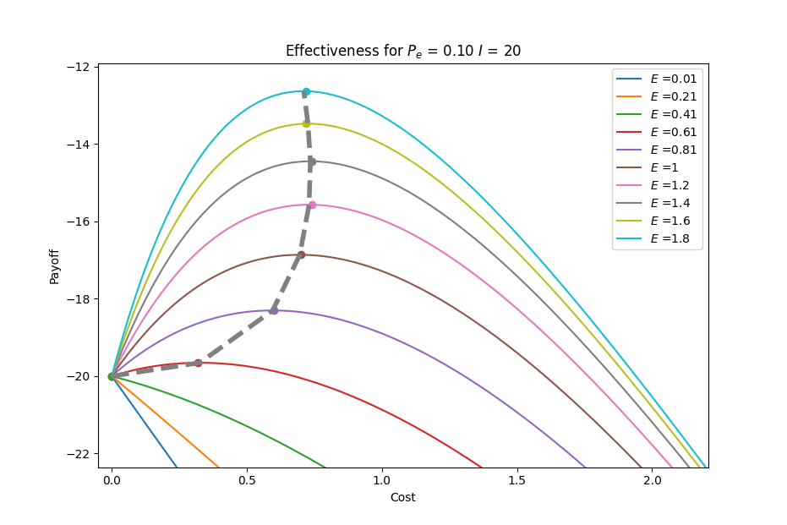

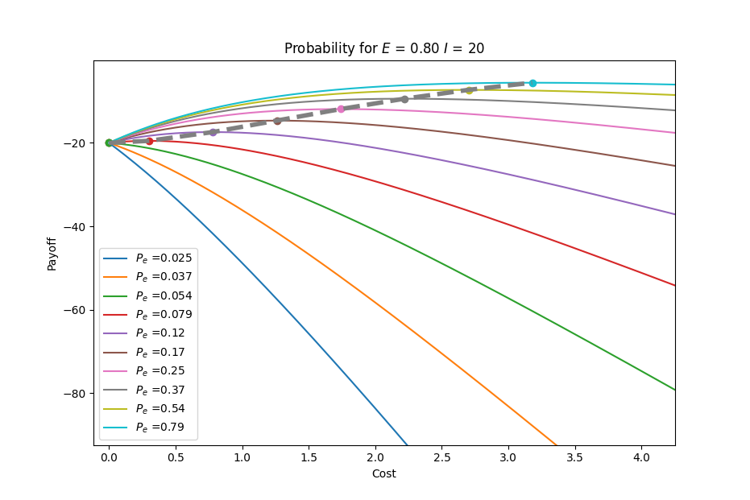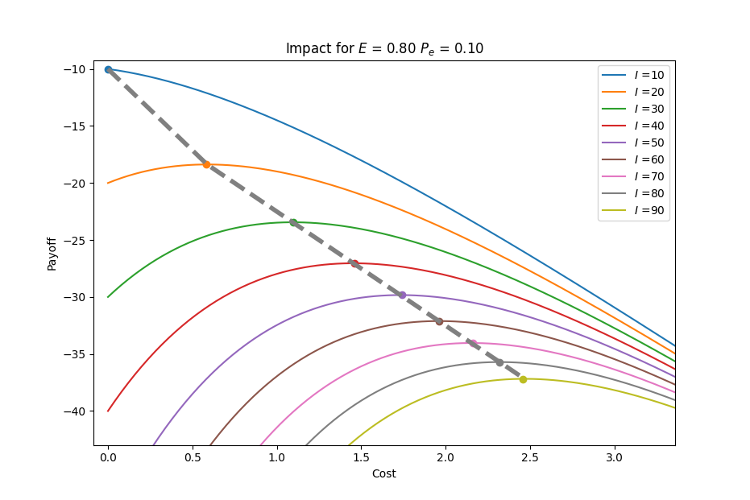

Natural tipping points!

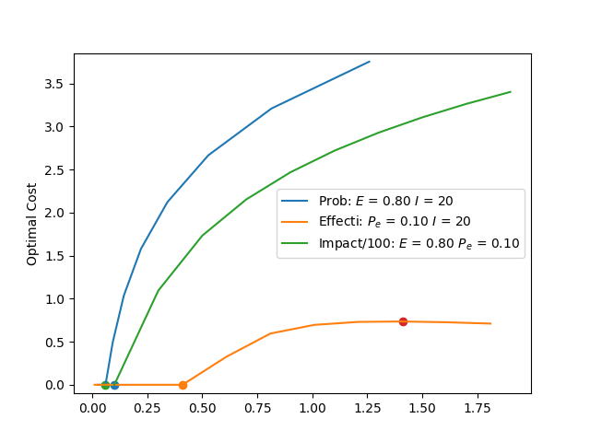

* prestige
* norm propagation
* investment in future returns
* investment in social network cohesion
* "waste economy
* family investment
* cases to illustrate the dynamics of the model chose a couple of archaeological and contemporary examples

Prepare an interesting argument.

Time perspective in preparedness

the human propensity for nich construction has the unintended consequence of being susceptible us to a larger impact. Double edge sword, ambivalent

example of the growth of electric network interconnectedness, the more it grows and is interconnected, the fewer blackouts there are, but the next one would be much bigger by necessity. Look for a Pan-European blackout

the increased carrying capacity allows for preparedness the lack of increased capacity would lad to unprepared strategies. Tragedy of the Commons