1.1 Schrodinger Equation

From differential equations we can infer the solution everywhere for a given potential since we have the variation of values across the space domain and time, for example we can infer the values one step of space further and/or one step of time ahead.

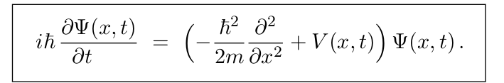
Ψ(x,t) is bounded, then |x|→ infinite , Ψ(x,t) tends to zero

Non normalized wavefunctions there is no physical interpretation, due to the fact the probability may have values greater than 1, but can be useful for some applications.

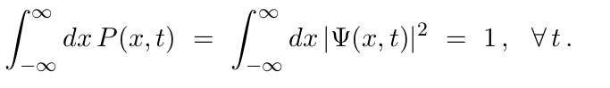
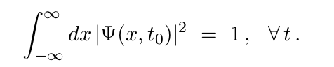

1.2 Stationary States
If the Schrodinger potential V(x,t) does not possess time dependence.
The stationary solution takes this form,
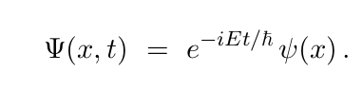

Thus we obtain the time independent form of Schrodinger Equation:
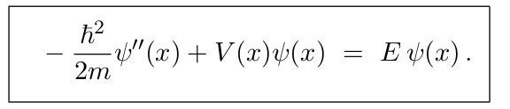

we can impose we impose the following regularity conditions on the
wavefunction Ψ(x) is continous and bounded, and its first derivative is bounded.

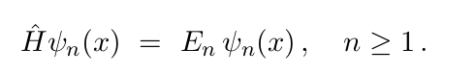
It should be emphasized that the superposition of stationary states of different energies is not a stationary state. Thus Ψ(x, t) in (1.2.20) is not a stationary state: you can’t write Ψ(x, t) as the product of a single time-dependent exponential times a spatial function. However, if respected the completeness, orthogonality and orthonormality, the solution has physical interpretation.

Otherwise for Ψ1= Ψ2. It holds once they are multiples, thus Ψcombination=(c1+c2)* Ψ1, it is stationary state.

The energy eigenstates are also complete in the sense that any reasonable (see (1.2.12))
wavefunction ψ(x) can be expanded as a superposition of energy eigenstates
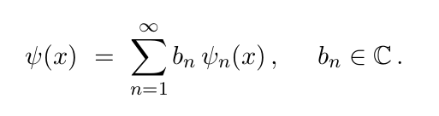

1.3 Bound States

Bound states cannot be degenerate, To be a bound state, the wavefunction should be noramlizable, which implies for |x|→ infinite , Ψ(x,t) tends to zero

Theorem 1. There is no degeneracy for bound states in one-dimensional potentials.

ψ 1 (x) = c ′ ψ 2 (x)
Theorem 2. The energy eigenstates ψ(x) can be chosen to be real.
Corollary 1. Any bound state ψ(x) of a one-dimensional potential is, up to an overall
constant phase, real.

Theorem 3. If V (−x) = V (x), the energy eigenstates can be chosen to be even or odd
under x → −x.

Both ψ and ψ ′ are continuous unless the potential has delta functions
or hard walls in which cases ψ ′ may have finite discontinuities.

1.3 Energy Spectrum

