In both cities prostitution and drug-related crimes happens next to each other
but not at the same places

In attempt to verify conventional wisdom that drugs and prostitution always comes together I've decided to put them on the map of both San Francisco and Seattle and compare against all other types of incidents. On the maps below you may see that both prostitution and drug related crimes have higher concentration at the cities center. Even though clusters of both types are very close to each-other, it is clearly not the very same places.

San Francisco | Seattle
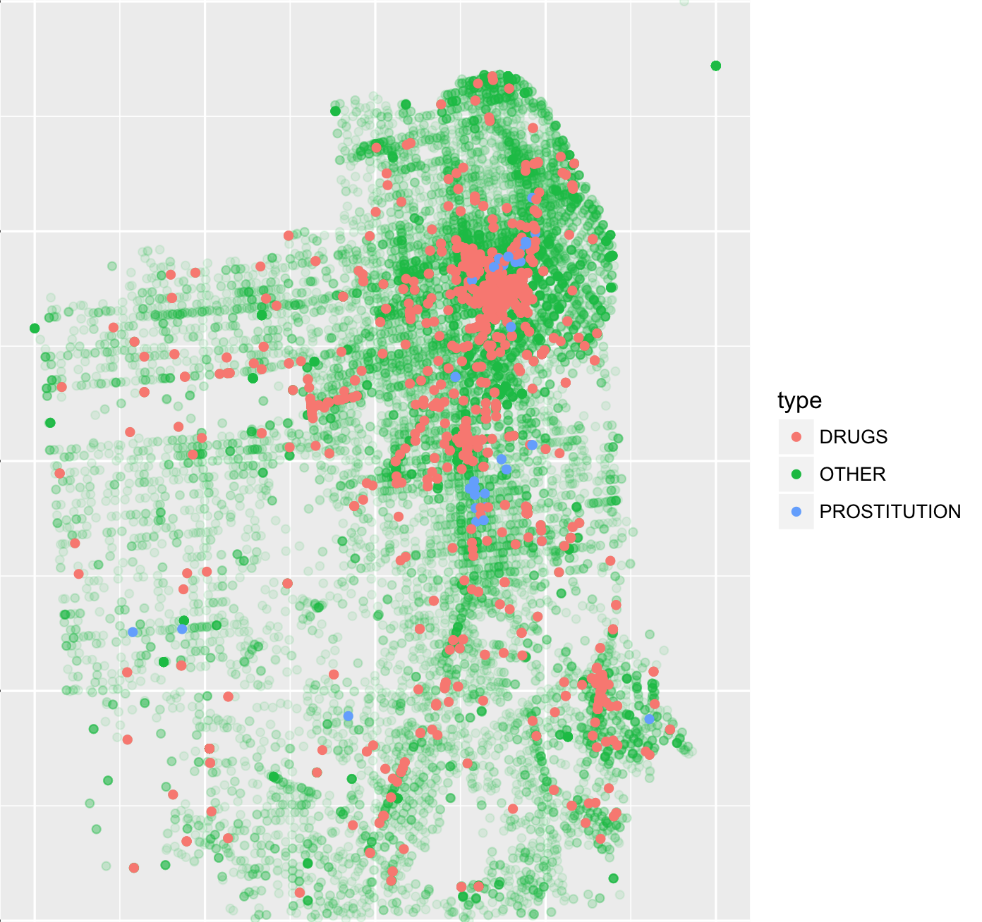 | 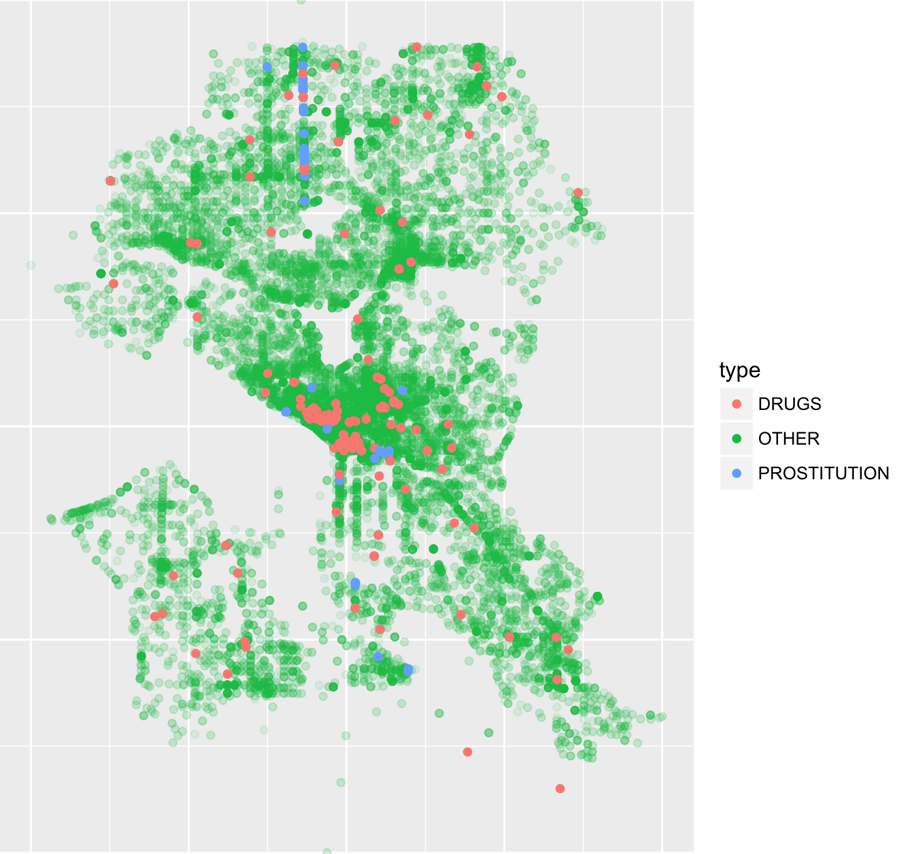

Approach

During the research major difficulty I've met was the fact that datasets available for San Francisco and Seattle has different structure of crimes classification. San Francisco's dataset gives 34 types of incidents, while Seattle offers 147. Seattle has 4 prostitution-related crime types and 28 drug related, while San Francisco has one type for each of them.
Taking R as a primary tool for analysis and 'ggplot' library as a visualization tool I've unified both datasets replacing crime types with 'PROSTITUTION' for all prostitution-related crimes, 'DRUGS' for every crime related to drugs or narcotics and 'OTHER' for all other types of crimes, as they were not in the focus of the study.
Second thing I did was normalization of coordinates of incidents, using simple formula new_x = (x-min(x))/(max(x)-min(x), I've transformed all coordinates to the range of [0;1]. Y coordinate was transformed the very same way.
After that major drawback of plots I gain was that significantly large number of 'OTHER' incidents made concealed points I was interested in.
I've got much better picture after increasing transparency (reducing alpha channel to 0.1) of 'OTHER' points and sorting results by alpha channel (so points I was interested more appeared 'on-top' of background consisting of 'OTHER's.

