# Lab1:

#### Installing Ansible & Preparing SSH

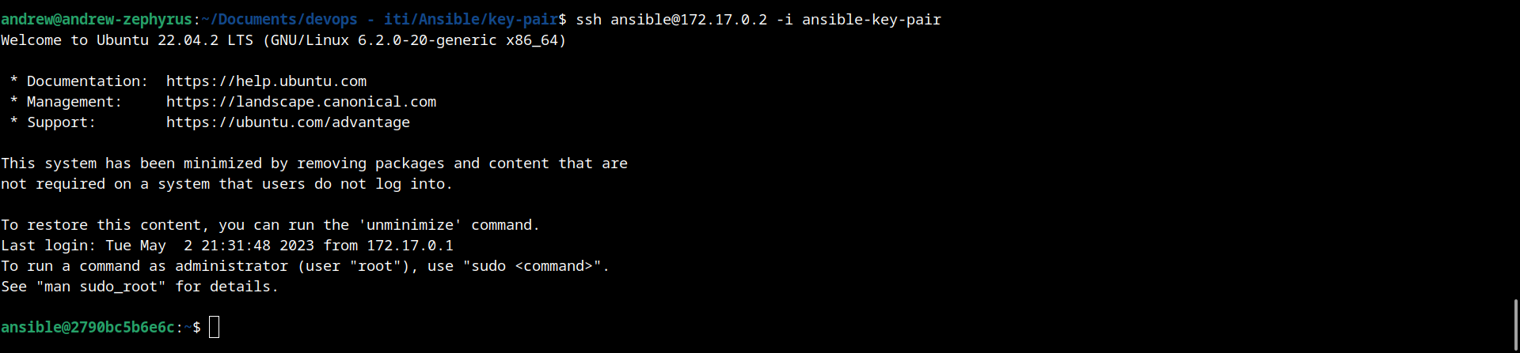

### **INVENTORY FILE**

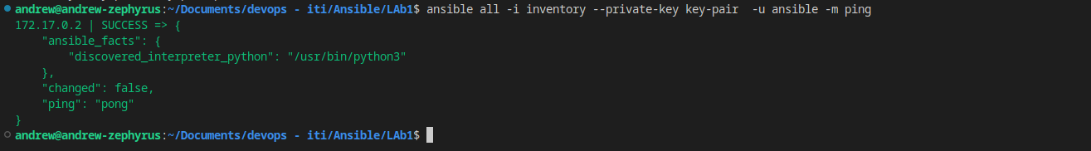

### **CONFIGURATION FILE**

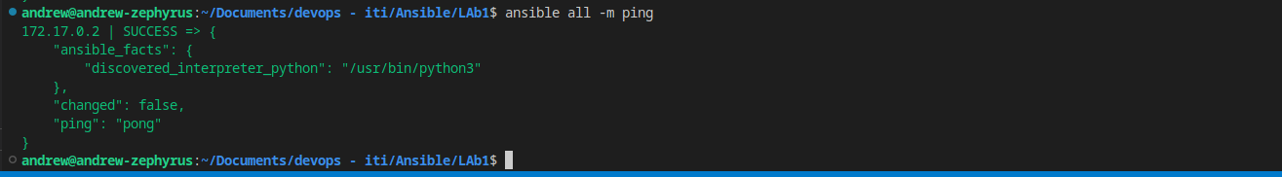

### **AD-HOC COMMAND ESCALATION USING ROOT USER**

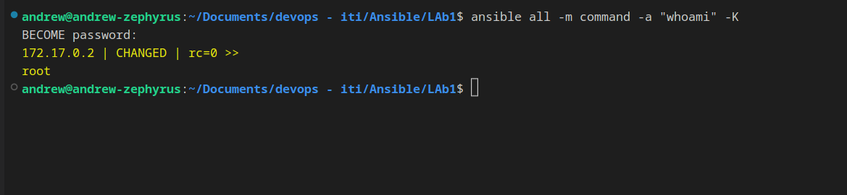

##### PLAYBOOK

