**Documentation for the Knapsack Problem Project Using Genetic Algorithms**

**Introduction and Overview**

**Project Idea and Overview**

This project addresses the Knapsack Problem, a classic combinatorial optimization problem. The goal is to determine the optimal selection of items, each with a specified weight and value, to maximize the total value without exceeding a given weight limit. Two variations are implemented:

* 0-1 Knapsack Problem: Items can either be included or excluded from the knapsack.
* Unbounded Knapsack Problem: An unlimited number of each item can be included.

**Similar Applications**

Several applications, including inventory management, resource allocation, and logistics optimization, employ algorithms similar to this project. Tools such as Microsoft Excel's Solver and MATLAB Optimization Toolbox provide functionalities for solving linear and non-linear problems, including knapsack variations.

**Literature Review**

1. Martello, S., & Toth, P. (1990). Knapsack Problems: Algorithms and Computer Implementations. Springer.
2. Goldberg, D. E. (1989). Genetic Algorithms in Search, Optimization, and Machine Learning. Addison-Wesley.
3. Persinger, D. (2005). Where are the hard knapsack problems? Computers & Operations Research.
4. Zitzler, E., Deb, K., & Thiele, L. (2000). Comparison of Mult objective evolutionary algorithms: Empirical results. Evolutionary computation.
5. Michalewicz, Z. (1996). Genetic Algorithms + Data Structures = Evolution Programs. Springer.

**Proposed Solution & Dataset**

**Main Functionalities/Features**

1. User Interaction: Interface for entering item weights, values, and weight capacity.
2. Visualization: Display of evolution and convergence of the Genetic Algorithm (GA).
3. Solution Export: Capability to export results in tabular or graphical formats.

**Dataset**

For testing and demonstration, publicly available datasets such as those from the OR-Library or user-defined test cases are utilized.

**Applied Algorithms**

**Genetic Algorithm**

The GA implementation consists of the following steps:

1. Initialization: Generate a population of random solutions.
2. Fitness Evaluation: Calculate the total value of each solution, ensuring the weight constraint is met.
3. Selection: Employ selection strategies (e.g., tournament or roulette wheel) to choose parents for the next generation.
4. Crossover: Perform single-point or multi-point crossover to create offspring.
5. Mutation: Introduce random changes to maintain genetic diversity.
6. Termination: Stop when a convergence criterion is met (e.g., number of generations or minimal change in fitness).

**Flowchart Diagram**

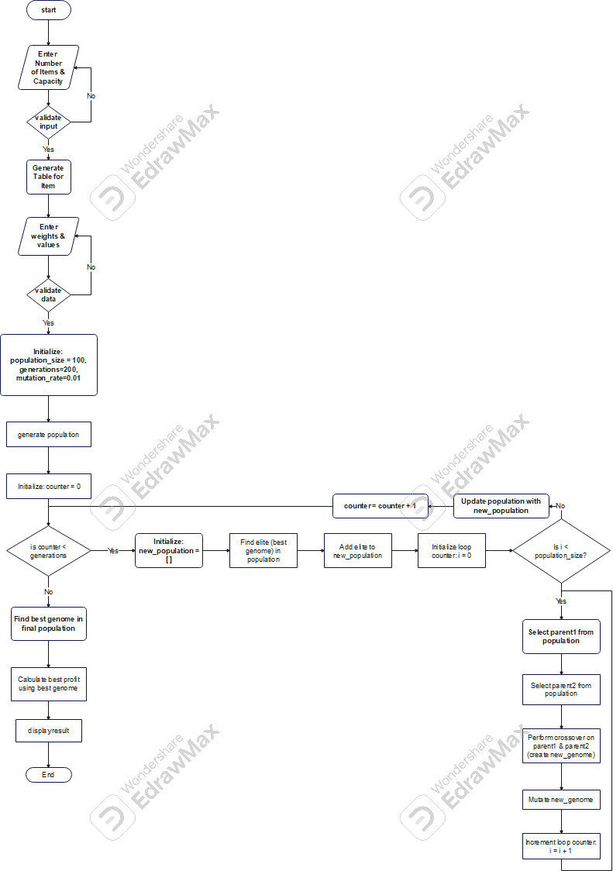

**Block Diagram**

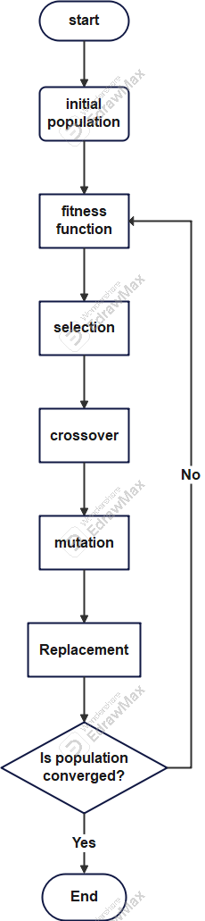

**Experiments & Result**s

**Experiments**

- 0-1 Knapsack Problem: Tested with varying population sizes, mutation rates, and crossover rates.

- Unbounded Knapsack Problem: Evaluated using scenarios with large weight capacities and item duplication.

**Results**

- Visualizations: Convergence plots and fitness evolution graphs.

- Output: Item selection and total value achieved.

**Testing**

- Unit testing of fitness evaluation and selection functions.

- Comparison of GA results with brute-force solutions for small problem instances.

Analysis, Discussion, and Future Work

**Analysis of Results**

The GA approach balances exploration and exploitation, effectively handling complex search spaces. However, the solution quality depends on parameter tuning.

**Advantages/Disadvantages**

- Advantages: Scalability, adaptability to problem constraints.

- Disadvantages: Computationally expensive for very large instances, sensitivity to hyper-parameter values.

**Future Work**

1. Integrate hybrid approaches combining GA with local search algorithms.
2. Explore parallel processing for faster convergence.
3. Implement dynamic parameter tuning strategies for better performance.