Dell Boomi Molecule on the  
AWS Cloud

Quick Start Reference Deployment

*July 2020*

*Ryan Vanderwerf, Partner Solutions Architect*

*Sean Williams, Global Partner Solutions Architect*

*Andrew Glenn, Global Partner Solutions Architect, AWS Quick Start team*

Visit our [GitHub repository](https://fwd.aws/Vmnx4) for source files and to post feedback,   
report bugs, or submit feature ideas for this Quick Start.

**Contents**

Overview 2

Dell Boomi on AWS 2

Cost and licenses 3

Architecture 3

Planning the deployment 5

Specialized knowledge 5

AWS account 5

Technical requirements 5

Deployment options 7

Deployment steps 7

Step 1. Sign in to your AWS account 7

Step 2. Launch the Quick Start 8

Option 1: Parameters for deploying Dell Boomi Molecule into a new VPC 9

Option 2: Parameters for deploying Dell Boomi Molecule into an existing VPC 11

Step 3. Test the Deployment 14

Security 14

Performance monitoring 15

Troubleshooting 15

Send us feedback 16

Additional resources 16

Document revisions 16

This Quick Start was created by Amazon Web Services (AWS).

[Quick Starts](http://aws.amazon.com/quickstart/) are automated reference deployments that use AWS CloudFormation templates to deploy key technologies on AWS, following AWS best practices.

# Overview

This Quick Start reference deployment guide provides step-by-step instructions for deploying a Dell Boomi Molecule cluster on the AWS Cloud.

This Quick Start is for users who are looking for an integration platform as a service (iPaaS) that can be hosted on AWS. This Quick Start enables you to deploy a Dell Boomi Molecule cluster on AWS and administer it through the [Dell Boomi AtomSphere platform](https://platform.boomi.com/).

## Dell Boomi on AWS

Dell Boomi service is a minimal-code, cloud-based iPaaS that enables customers to design, deploy, manage, and govern all of their data across their hybrid and software as a service (SaaS) applications by connecting and integrating external application data with AWS services such as Amazon Simple Storage Service (Amazon S3), Amazon Simple Notification Service (Amazon SNS), Amazon Relational Database Service (Amazon RDS), and Amazon Redshift using Dell Boomi’s point-and-click graphical interface.

The Dell Boomi Molecule is a single-tenant, clustered runtime that runs separately from the platform, enabling multiple processes to run concurrently. The enterprise-grade version of a Boomi Atom runtime, the Boomi Molecule can be deployed across multiple servers to enhance load balancing and ensure high availability for mission-critical integration processes.

## Cost and licenses

You are responsible for the cost of the AWS services used while running this Quick Start reference deployment. There is no additional cost for using the Quick Start.

The AWS CloudFormation template for this Quick Start includes configuration parameters that you can customize. Some of these settings, such as instance type, will affect the cost of deployment. For cost estimates, see the pricing pages for each AWS service you will be using. Prices are subject to change.

**Tip** After you deploy the Quick Start, we recommend that you enable the [AWS Cost and Usage Report](https://docs.aws.amazon.com/awsaccountbilling/latest/aboutv2/billing-reports-gettingstarted-turnonreports.html) to track costs associated with the Quick Start. This report delivers billing metrics to an S3 bucket in your account. It provides cost estimates based on usage throughout each month, and finalizes the data at the end of the month. For more information about the report, see the [AWS documentation](https://docs.aws.amazon.com/awsaccountbilling/latest/aboutv2/billing-reports-costusage.html).

This Quick Start requires an account with Dell Boomi. The Dell Boomi account used to stage this Quick Start will determine the licensing model that applies. To get started, sign up for the [Free Trial](https://boomi.com/form/trial/). You will then receive a call from a Boomi Sales Engineer, who will enable access to Boomi Molecule.

# Architecture

Deploying this Quick Start for a new virtual private cloud (VPC) with **default parameters** builds the following Dell Boomi environment in the AWS Cloud.

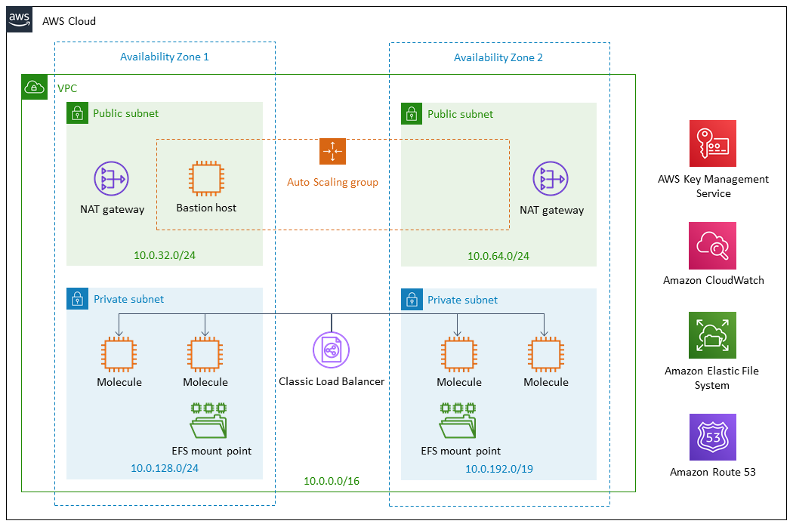

**Figure 1: Quick Start architecture for Dell Boomi on AWS**

The Quick Start sets up the following:

* A highly available architecture that spans two Availability Zones.*
* A VPC configured with public and private subnets according to AWS best practices, to provide you with your own virtual network on AWS.*
* A Application Load Balancer.
* In the public subnets:
* Managed NAT gateways to allow outbound internet access for resources in the private subnets.*
* A Linux bastion host in an Auto Scaling group to allow inbound Secure Shell (SSH) access to Amazon Elastic Compute Cloud (Amazon EC2) instances in public and private subnets, with Amazon CloudWatch for monitoring.
* In the private subnets:
* Four Amazon EC2 instances with the Dell Boomi Molecule software installed, two in each Availability Zone.
* Amazon Elastic File System (Amazon EFS) deployed in the Region. Two Amazon EFS mount points are created also, one in each Availability Zone.

**\*** The template that deploys the Quick Start into an existing VPC skips the components marked by asterisks and prompts you for your existing VPC configuration.

# Planning the deployment

## Specialized knowledge

This Quick Start assumes familiarity with basic concepts of networking, bastion hosts, volume sizing, and compute performance. It also assumes familiarity with the Dell Boomi variables that are required when deploying a Molecule cluster. These variables include Molecule Name, Local Path, Local Temp Path, Account Id, Account Name, and Account Password. If you don’t have have an Account Name or Password, you can enter an installation token provided by your system administrator into the ‘Boomi MFA install token’ field. If you are an administrator, see the ‘Create an Installation Token’ section in this guide. You will also need an API Token with this installation method. See the steps later in the document on how to create both of these. This Quick Start follows the patterns for Unattended Dell Boomi Molecule deployments found in the [Dell Boomi User Guide](http://help.boomi.com/atomsphere/GUID-27BDD6B1-E6BD-48C9-8C6D-EC1B2CA60316.html).

This deployment guide also requires a moderate level of familiarity with AWS services. If you’re new to AWS, visit the [Getting Started Resource Center](https://aws.amazon.com/getting-started/) and the [AWS Training and Certification website](https://aws.amazon.com/training/) for materials and programs that can help you develop the skills to design, deploy, and operate your infrastructure and applications on the AWS Cloud.

## AWS account

If you don’t already have an AWS account, create one at [https://aws.amazon.com](https://aws.amazon.com/) by following the on-screen instructions. Part of the sign-up process involves receiving a phone call and entering a PIN using the phone keypad.

Your AWS account is automatically signed up for all AWS services. You are charged only for the services you use.

## Technical requirements

Before you launch the Quick Start, your account must be configured as specified in the following table. Otherwise, deployment might fail.

|  |  |  |  |  |  |  |  |  |  |  |  |  |  |  |  |  |  |  |  |  |  |  |  |
| --- | --- | --- | --- | --- | --- | --- | --- | --- | --- | --- | --- | --- | --- | --- | --- | --- | --- | --- | --- | --- | --- | --- | --- |
| [**Resources**](http://docs.aws.amazon.com/general/latest/gr/aws_service_limits.html) | **If necessary, request [service limit increases](https://console.aws.amazon.com/support/home" \l "/case/create?issueType=service-limit-increase&limitType=service-code-) for the following resources. You might need to do this if you already have an existing deployment that uses these resources, and you think you might exceed the default limits with this deployment. For default limits, see the** [**AWS documentation**](https://docs.aws.amazon.com/)**.**  [**AWS Trusted Advisor**](_blank) **offers a service limits check that displays your usage and limits for some aspects of some services.**   | Resource | This deployment uses (default configuration) | | --- | --- | | VPCs | 1 | | Elastic IP addresses | 2 | | Auto Scaling groups | 1 | | Classic Load Balancers | 1 | | t3.medium instances | 1 | | m5.xlarge instances | 4 | | EFS file systems | 1 | | EFS mount targets | 2 | | AWS Key Management Service (KMS) encryption key | 1 | | Secure Sockets Layer (SSL) certificate | 1 | |
| [**Regions**](https://aws.amazon.com/about-aws/global-infrastructure/) | This deployment includes Amazon EFS, which is not available in all AWS Regions. For a current list of supported Regions, see [AWS Regions and Endpoints](https://docs.aws.amazon.com/general/latest/gr/rande.html" \l "elasticfilesystem-region) in the AWS documentation. |
| [**Key pair**](https://docs.aws.amazon.com/AWSEC2/latest/UserGuide/ec2-key-pairs.html) | Make sure that at least one Amazon EC2 key pair exists in your AWS account in the Region where you are planning to deploy the Quick Start. Make note of the key pair name. You’ll be prompted for this information during deployment. To create a key pair, follow the [instructions in the AWS documentation](https://docs.aws.amazon.com/AWSEC2/latest/UserGuide/ec2-key-pairs.html).  If you’re deploying the Quick Start for testing or proof-of-concept purposes, we recommend that you create a new key pair instead of specifying a key pair that’s already being used by a production instance. |
| [**IAM permissions**](https://docs.aws.amazon.com/IAM/latest/UserGuide/access_policies_job-functions.html) | To deploy the Quick Start, you must log in to the AWS Management Console with IAM permissions for the resources and actions the templates will deploy. The *AdministratorAccess* managed policy within IAM provides sufficient permissions, although your organization may choose to use a custom policy with more restrictions. |
| [**S3 buckets**](http://docs.aws.amazon.com/AWSCloudFormation/latest/UserGuide/aws-properties-s3-bucket.html) | Unique Amazon S3 bucket names are automatically generated based on the account number and Region. If you delete a stack, the logging buckets are not deleted (to support security review). If you plan to re-deploy this Quick Start in the same Region, you must first manually delete the S3 buckets that were created during the previous deployment; otherwise, the re-deployment will fail. |
| Amazon EFS | Amazon EFS is an AWS managed file storage system for Linux systems. With Amazon EFS, there is no requirement to provision, patch, or manage a file storage system. Linux systems mount EFS through mount targets using standard NFSv4 mounting options. |
| SSL Certificate | You can supply your own SSL certificate, or provision one with AWS Certificate Manager (ACM) prior to launching this Quick Start. |
| **Boomi MFA install token** | An MFA installation token generated by your Dell Boomi Administrator |
| **Boomi MFA API token** | An MFA API token generated by your Dell Boomi Administrator |

## Deployment options

This Quick Start provides two deployment options:

* **Deploy Dell Boomi Molecule into a new VPC (end-to-end deployment)**. This option builds a new AWS environment consisting of the VPC, subnets, NAT gateways, security groups, bastion hosts, and other infrastructure components, and then deploys Dell Boomi Molecule into this new VPC.
* **Deploy Dell Boomi Molecule into an existing VPC**. This option provisions Dell Boomi in your existing AWS infrastructure.

The Quick Start provides separate templates for these options. It also lets you configure CIDR blocks, instance types, and Dell Boomi settings, as discussed later in this guide.

## Authentication options

This Quick Start provides two authentication options:

* **Deploy Dell Boomi Molecule with username/password.** This option allows the user to put in a username/password who is authorized to create new Atoms.
* **Deploy Dell Boomi Molecule with installation token and API key**. This option provisions doesn’t share any passwords and is recommended. Instead of providing username/password, you will provide the following: username, API Key, and installation token.

# Deployment steps

## Step 1. Sign in to your AWS account

1. Sign in to your AWS account at [https://aws.amazon.com](https://aws.amazon.com/) with an IAM user role that has the necessary permissions. For details, see Planning the deployment earlier in this guide.
2. Make sure that your AWS account is configured correctly, as discussed in the Technical requirements section.
3. Use the Region selector in the navigation bar to choose the AWS Region where you want to deploy Dell Boomi Molecule on AWS.
4. Select the key pair that you created earlier. In the navigation pane of the [Amazon EC2 console](https://console.aws.amazon.com/ec2/), choose **Key Pairs**, and then choose your key pair from the list.
5. Select the SSL certificate, as discussed in the Technical requirements section. In the navigation pane of the [Amazon ACM console](http://console.aws.amazon.com/acm/), select the domain the certificate is associated with, and then copy the Amazon Resource Name (ARN) of the certificate.

## Step 2. Launch the Quick Start

**Notes** The instructions in this section reflect the older version of the AWS CloudFormation console. If you’re using the redesigned console, some of the user interface elements might be different.  
  
You are responsible for the cost of the AWS services used while running this Quick Start reference deployment. There is no additional cost for using this Quick Start. For full details, see the pricing pages for each AWS service you will be using in this Quick Start. Prices are subject to change.

1. Choose one of the following options to launch the AWS CloudFormation template into your AWS account. For help choosing an option, see deployment options earlier in this guide.

|  |  |
| --- | --- |
|  |  |
| [Deploy Dell Boomi into a  new VPC on AWS](https://fwd.aws/XExbV) | [Deploy Dell Boomi into an  existing VPC on AWS](https://fwd.aws/aDgWD) |

**Important** If you’re deploying Dell Boomi Molecule into an existing VPC, make sure that your VPC has two private subnets in different Availability Zones for the workload instances, and that the subnets aren’t shared. This Quick Start doesn’t support [shared subnets](https://docs.aws.amazon.com/vpc/latest/userguide/vpc-sharing.html). These subnets require [NAT gateways](https://docs.aws.amazon.com/vpc/latest/userguide/vpc-nat-gateway.html) in their route tables, to allow the instances to download packages and software without exposing them to the internet. You will also need the domain name option configured in the DHCP options as explained in the [Amazon VPC documentation](http://docs.aws.amazon.com/AmazonVPC/latest/UserGuide/VPC_DHCP_Options.html). You will be prompted for your VPC settings when you launch the Quick Start.

Each deployment takes about 20 minutes to complete.

1. Check the Region that’s displayed in the upper-right corner of the navigation bar, and change it if necessary. This is where the network infrastructure for Dell Boomi Molecule will be built. The template is launched in the US East (Ohio) Region by default.
2. On the **Select Template** page, keep the default setting for the template URL, and then choose **Next**.
3. On the **Specify Details** page, change the stack name if needed. Review the parameters for the template. Provide values for the parameters that require input. For all other parameters, review the default settings and customize them as necessary.

In the following tables, parameters are listed by category and described separately for the two deployment options:

* Parameters for deploying Dell Boomi Molecule into a new VPC
* Parameters for deploying Dell Boomi Molecule into an existing VPC

When you finish reviewing and customizing the parameters, choose **Next**.

### Option 1: Parameters for deploying Dell Boomi Molecule into a new VPC

[View template](https://fwd.aws/Paeba)

*Network configuration:*

|  |  |  |
| --- | --- | --- |
| **Parameter label (name)** | **Default** | **Description** |
| **Availability Zones** (AvailabilityZones) | *Requires input* | The list of Availability Zones to use for the subnets in the VPC. This deployment uses two Availability Zones, and the logical order of your selections is preserved. |
| **VPC CIDR** (VPCCIDR) | 10.0.0.0/16 | The CIDR block for the VPC. |
| **Public subnet 1 CIDR** (PublicSubnet1CIDR) | 10.0.32.0/24 | The CIDR block used for the public subnet located in Availability Zone 1. |
| **Public subnet 2 CIDR** (PublicSubnet2CIDR) | 10.0.64.0/24 | The CIDR block used for the public subnet located in Availability Zone 2. |
| **Private subnet 1 CIDR** (PrivateSubnet1CIDR) | 10.0.128.0/24 | The CIDR block used for the private subnet located in Availability Zone 1. |
| **Private subnet 2 CIDR** (PrivateSubnet2CIDR) | 10.0.192.0/24 | The CIDR block used for the private subnet located in Availability Zone 2. |
| **Allowed external access CIDR (OCP UI)** (RemoteAccessCIDR) | *Requires input* | The CIDR IP range that is permitted to access the instances. We recommend that you set this value to a trusted IP range. |

*Amazon EC2 configuration:*

|  |  |  |
| --- | --- | --- |
| **Parameter label (name)** | **Default** | **Description** |
| **SSH key name** (KeyPairName) | *Requires input* | A public/private key pair, which allows you to connect securely to your instance after it launches. |
| **Volume size for Boomi instances** (MoleculeEBSVolume) | 100 | The size of the Amazon Elastic Block Store (Amazon EBS) volume attached to the Molecule instances. Size range is 1 GiB - 16 TiB. |

*Boomi Molecule node sizing:*

|  |  |  |
| --- | --- | --- |
| **Parameter label (name)** | **Default** | **Description** |
| **Boomi Atom instance type** (NodeInstanceType) | m5.xlarge | The Boomi host instance type. |

*Boomi Molecule configuration Common Settings:*

|  |  |  |
| --- | --- | --- |
| **Parameter label (name)** | **Default** | **Description** |
| **Molecule cluster name** (MoleculeClusterName) | molecule1 | The name for the Boomi Molecule cluster. |
| **Molecule local path** (MoleculeLocalPath) | /opt/molecule/local/ | The local path for the Molecule installation. |
| **Molecule local temp directory** (MoleculeLocalTemp) | /mnt/tmp | The local temporary path for the Molecule installation. |
| **Boomi account ID** (BoomiAccountID) | *Requires input* | The Boomi account ID that you want to associate with the new Molecule cluster. |
| **Molecule shared directory** (MoleculeSharedDir) | /mnt/molecule | A shared directory for the EFS volume that the Molecules will mount. |

*Boomi Molecule configuration Settings (Using Username/Password method):*

|  |  |  |
| --- | --- | --- |
| **Boomi user name** (BoomiUsername) | *Requires input* | The email account associated with the Boomi account. |
| **Boomi password** (BoomiPassword) | *Requires input* | The password associated with the Boomi account. |

*Boomi Molecule configuration Settings (Using API Key/Installation Token Method):*

|  |  |  |
| --- | --- | --- |
| **Boomi user name** (BoomiUsername) | *Requires input* | The email account associated with the Boomi account. |
| **Boomi API Token** (BoomiMFAAPIToken) | *Requires input* | API Token associated to the Boomi account. |
| **Boomi Installation Token** (BoomiMFAInstallToken) | *Requires input* | The installation token created for the account. Can be set to last up to 24 hours. |

*Amazon EFS configuration:*

|  |  |  |
| --- | --- | --- |
| **Parameter label (name)** | **Default** | **Description** |
| **EFS encryption** (EFSEncryption) | True | EFS volumes can be encrypted. |
| **EFS performance mode** (EFSPerformanceMode) | generalPurpose | The performance mode for the EFS volume. Choose **generalPurpose** or **maxIO**. |
| **EFS throughput mode** (EFSThroughputMode) | provisioned | The throughput mode for tje EFS volume. Choose **provisioned** or **bursting**. |
| **EFS provisioned throughput** (EFSProvisionedThroughput) | 10 | The provisioned throughput value for the EFS volume. |

*DNS and SSL configuration:*

Provide values for either MoleculeFDQN and HostedZoneID or, if using SSL, provide a value for SSLCertificateArn.

|  |  |  |
| --- | --- | --- |
| **Parameter label (name)** | **Default** | **Description** |
| **Molecule FQDN** (MoleculeFQDN) | *Requires input* | The fully qualified domain name (FQDN) for the Boomi Molecule cluster. Use with HostedZoneID if you are not using SSL. |
| **Route 53 hosted zone ID** (HostedZoneID) | *Requires input* | Route 53 Hosted Zone ID of the domain name. Used in conjunction with a MoleculeFQDN. |
| **SSL certificate ARN** (SSLCertificateArn) | *Requires input* | The ARN of the SSL certificate to use for the load balancer. Use SSLCertificateArn if you are not using MoleculeFQDN and HostedZoneID. |

*AWS Quick Start configuration:*

**Note** We recommend that you keep the default settings for the following two parameters, unless you are customizing the Quick Start templates for your own deployment projects. Changing the settings of these parameters will automatically update code references to point to a new Quick Start location. For additional details, see the [AWS Quick Start Contributor’s Guide](https://aws-quickstart.github.io/option1.html).

|  |  |  |
| --- | --- | --- |
| **Parameter label (name)** | **Default** | **Description** |
| **Quick Start S3 key prefix** (QSS3KeyPrefix) | quickstart-boomi-molecule/ | S3 key prefix for the Quick Start assets. Quick Start key prefix can include numbers, lowercase letters, uppercase letters, hyphens (-), and forward slash (/). |
| **Quick Start S3 bucket name** (QSS3BucketName) | aws-quickstart | S3 bucket name for the Quick Start assets. This string can include numbers, lowercase letters, uppercase letters, and hyphens (-). It cannot start or end with a hyphen (-). |

### Option 2: Parameters for deploying Dell Boomi Molecule into an existing VPC

[View template](https://fwd.aws/Pxvn9)

*Network configuration:*

|  |  |  |
| --- | --- | --- |
| **Parameter label (name)** | **Default** | **Description** |
| **VPC ID** (VPCID) | *Requires input* | The ID of your existing VPC. |
| **Public subnet 1 ID** (PublicSubnet1ID) | *Requires input* | The ID of the public subnet in Availability Zone 1 in your existing VPC. |
| **Public subnet 2 ID** (PublicSubnet2ID) | *Requires input* | The ID of the public subnet in Availability Zone 2 in your existing VPC. |
| **Private subnet 1 ID** (PrivateSubnet1ID) | *Requires input* | The ID of the private subnet in Availability Zone 1 in your existing VPC. |
| **Private subnet 2 ID** (PrivateSubnet2ID) | *Requires input* | The ID of the private subnet in Availability Zone 2 in your existing VPC. |
| **Bastion security group ID** (BastionSecurityGroupID) | *Requires input* | The ID of the bastion security group in your existing VPC (e.g., sg-1a2b3c4d). |

*Amazon EC2 configuration:*

|  |  |  |
| --- | --- | --- |
| **Parameter label (name)** | **Default** | **Description** |
| **SSH key name** (KeyPairName) | *Requires input* | Key name for access to EC2 instances |
| **Volume size for Boomi instances** (MoleculeEBSVolume) | 100 | The size of the Amazon EBS volume attached to the Molecule instances. Size range is 1 GiB - 16 TiB. |

*Boomi Molecule node sizing:*

|  |  |  |
| --- | --- | --- |
| **Parameter label (name)** | **Default** | **Description** |
| **Molecule node instance type** (NodeInstanceType) | m5.xlarge | The Boomi host instance type. |

*Boomi Molecule configuration (Common settings):*

|  |  |  |
| --- | --- | --- |
| **Parameter label (name)** | **Default** | **Description** |
| **Molecule cluster name** (MoleculeClusterName) | molecule1 | The name for the Boomi Molecule cluster. |
| **Molecule local pat**h (MoleculeLocalPath) | /opt/molecule/local/ | The local path for the Molecule installation. |
| **Molecule local temp directory** (MoleculeLocalTemp) | /mnt/tmp | The local temporary path for the Molecule installation. |
| **Boomi account ID** (BoomiAccountID) | *Requires input* | The Dell Boomi account ID that you want to associate with the new Molecule cluster. |
| **Molecule shared directory** (MoleculeSharedDir) | /mnt/molecule | A shared directory for Molecules. |

*Boomi Molecule configuration Settings (Using Username/Password method):*

|  |  |  |
| --- | --- | --- |
| **Boomi user name** (BoomiUsername) | *Requires input* | The email account associated with the Boomi account. |
| **Boomi password** (BoomiPassword) | *Requires input* | The password associated with the Boomi account. |

*Boomi Molecule configuration Settings (Using API Key/Installation Token Method):*

|  |  |  |
| --- | --- | --- |
| **Boomi user name** (BoomiUsername) | *Requires input* | The email account associated with the Boomi account. |
| **Boomi API Token** (BoomiMFAAPIToken) | *Requires input* | API Token associated to the Boomi account. |
| **Boomi Installation Token** (BoomiMFAInstallToken) | *Requires input* | The installation token created for the account. Can be set to last up to 24 hours. |

*Amazon EFS configuration:*

|  |  |  |
| --- | --- | --- |
| **Parameter label (name)** | **Default** | **Description** |
| **EFS encryption** (EFSEncryption) | True | EFS volumes can be encrypted. |
| **EFS performance mode** (EFSPerformanceMode) | generalPurpose | The performance mode for your EFS volume. Choose **generalPurpose** or **maxIO**. |
| **EFS throughput mode** (EFSThroughputMode) | provisioned | The throughput mode for your EFS volume. Choose **provisioned** or **bursting**. |
| **EFS provisioned throughput** (EFSProvisionedThroughput) | 10 | The provisioned throughput value for your EFS volume. |

*SSL configuration:*

|  |  |  |
| --- | --- | --- |
| **Parameter label (name)** | **Default** | **Description** |
| **SSL certificate ARN** (SSLCertificateArn) | — | The SSL Certificate ID used with the load balancer. |

1. On the **Options** page, you can [specify tags](https://docs.aws.amazon.com/AWSCloudFormation/latest/UserGuide/aws-properties-resource-tags.html) (key-value pairs) for resources in your stack and [set advanced options](https://docs.aws.amazon.com/AWSCloudFormation/latest/UserGuide/cfn-console-add-tags.html). When you’re done, choose **Next**.
2. On the **Review** page, review and confirm the template settings. Under **Capabilities**, select the two check boxes to acknowledge that the template will create IAM resources and that it might require the capability to auto-expand macros.
3. Choose **Create** to deploy the stack.
4. Monitor the status of the stack. When the status is **CREATE_COMPLETE**, the Dell Boomi Molecule is ready.
5. Use the URLs displayed in the **Outputs** tab for the stack to view the resources that were created.

## Step 3. Test the Deployment

To view the Molecule in the Dell Boomi AtomSphere platform, log in to your Dell Boomi [account](https://platform.boomi.com/), navigate to the **Manage** drop-down menu, and choose **Atom Management**. The newly created Amazon EC2 instance Molecule cluster will be displayed.

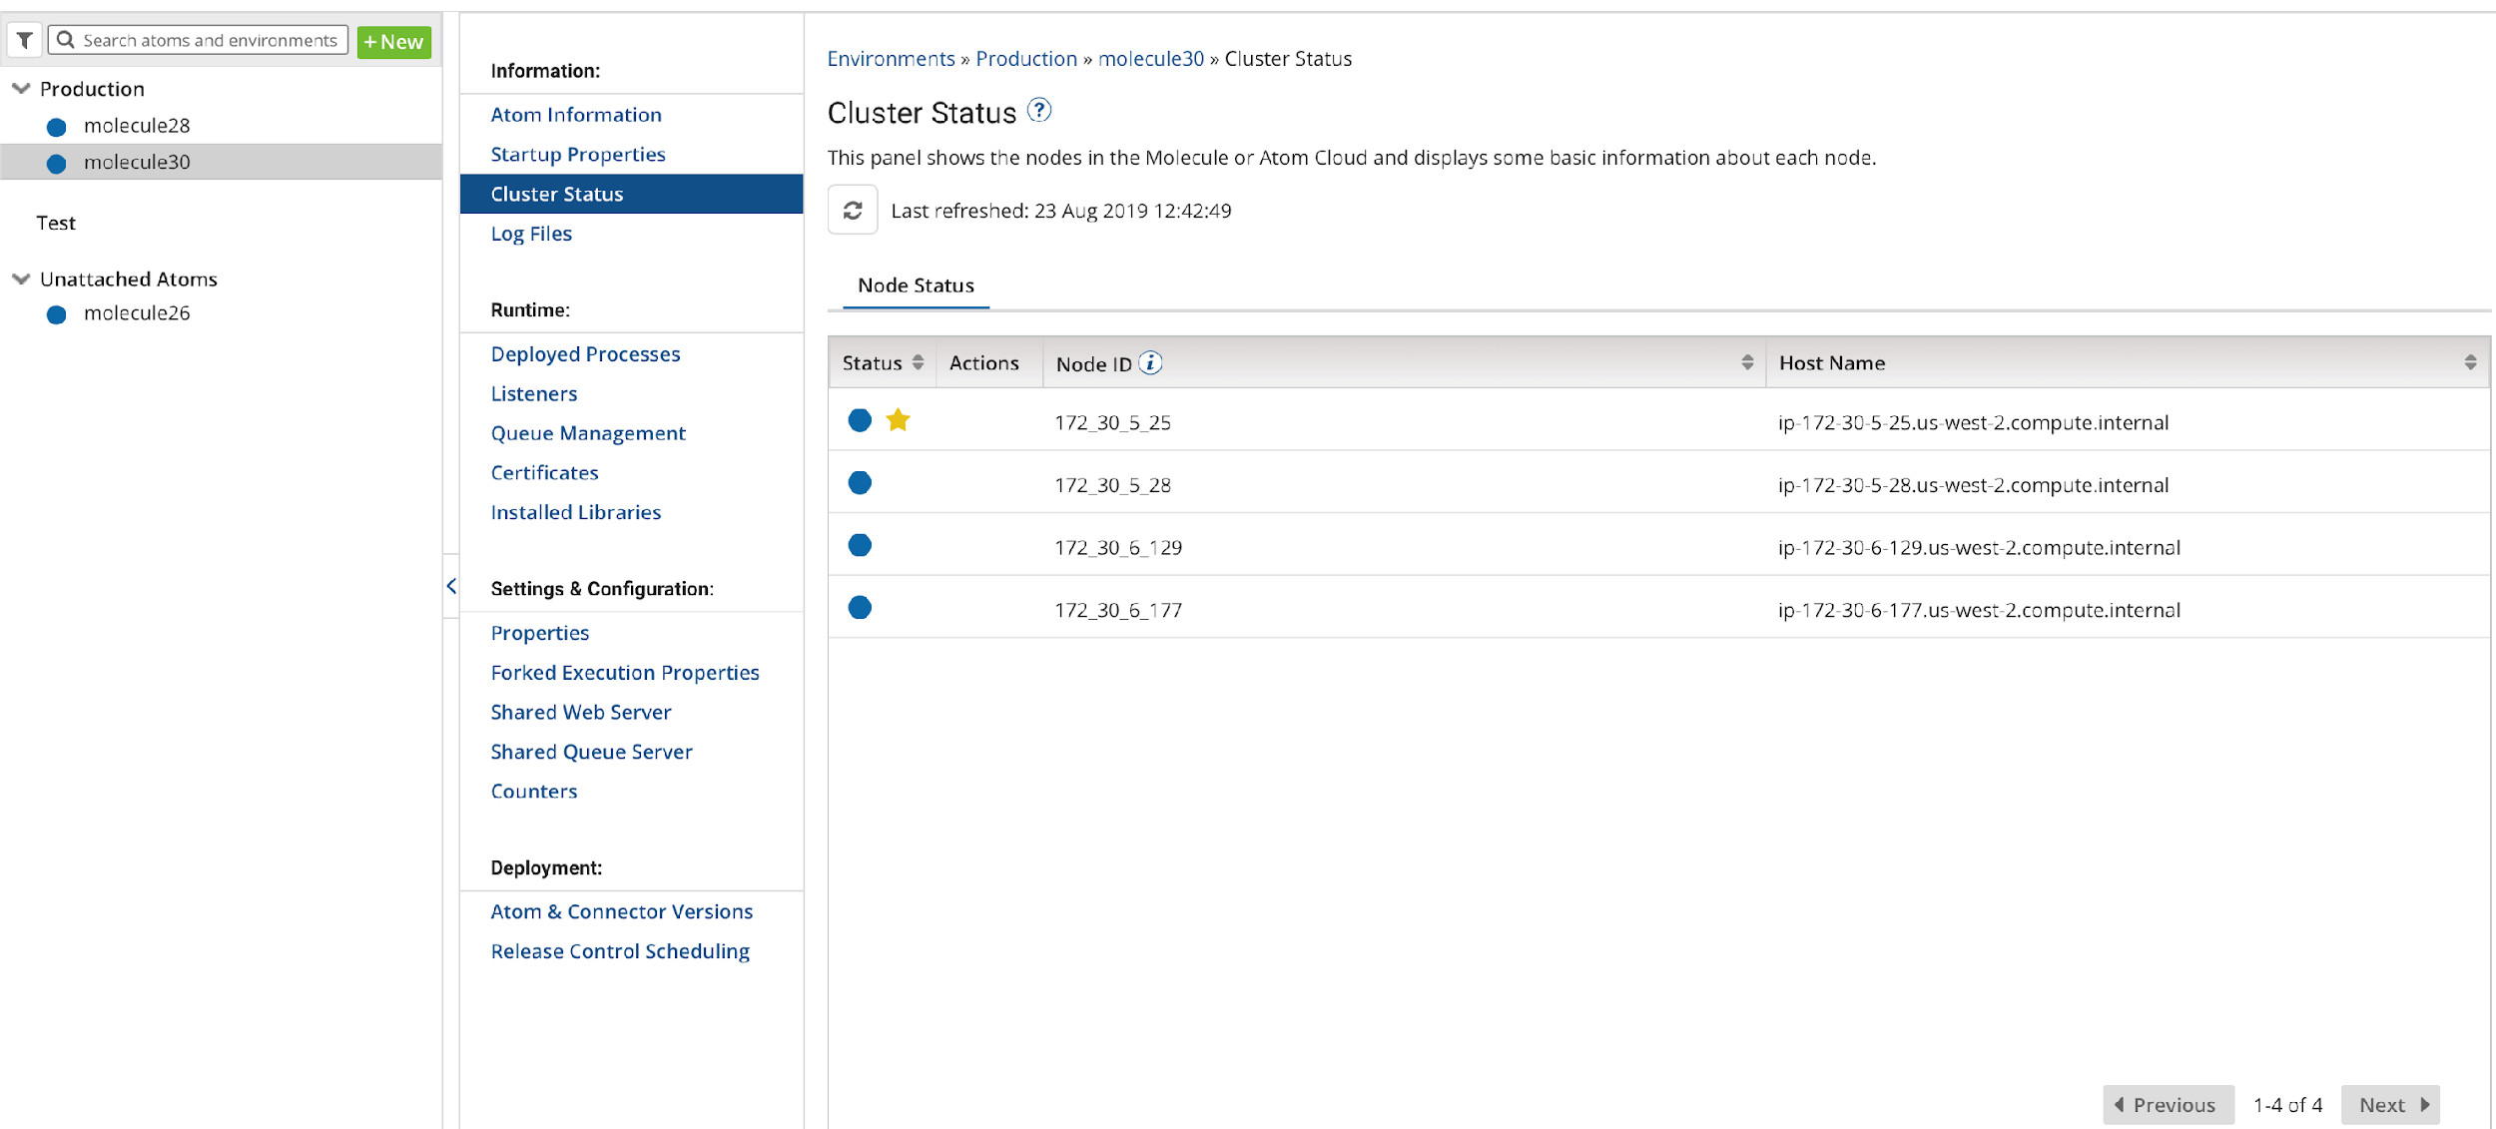

**Figure 2: Dell Boomi Dashboard with an unattached AWS-managed Molecule cluster**

You can then attach the Molecules to any environment you have staged and deploy workloads to that Molecule cluster. By Default the molecule you deployed will be under ‘Unattached Atoms’. When you click on ‘Atom Information’ you will see an option to attach it to an environment.

# Security

This Quick Start deploys a bastion host and a Dell Boomi Molecule cluster into an AWS VPC. The bastion host is the only means of accessing the Dell Boomi Molecule cluster at a command-line level. The Dell Boomi Molecule cluster is deployed into private subnets and cannot be reached through the internet. The Boomi Molecule cluster communicates through a NAT Gateway for updates and patches, and it communicates through the public-facing Classic Load Balancer to communicate with the Dell Boomi AtomSphere platform.

# Performance monitoring

Monitoring the CPU, network, and Amazon Elastic Block Store (Amazon EBS) performance of your AWS Dell Boomi Molecule cluster is done through CloudWatch metrics.

CPU and network performance are measured in utilization, network in and out, network packets in and out, and system status checks.

Amazon EBS volume performance is measured in read and write throughput, average read and write size, read and write bandwidth, read and write latency, and volume idle time.

Amazon EFS reports metrics to CloudWatch and can be monitored there. Metrics include client connections, data read and data write bytes, and IO percent limits.

# Creating an Installation Token

You can create an installation token without having to share your login credentials for an Atom/Molecule installation. If you are an administrator, follow the steps below to create an installation token:

Go to Integration → Build → Create → Atom Runtime → Molecule

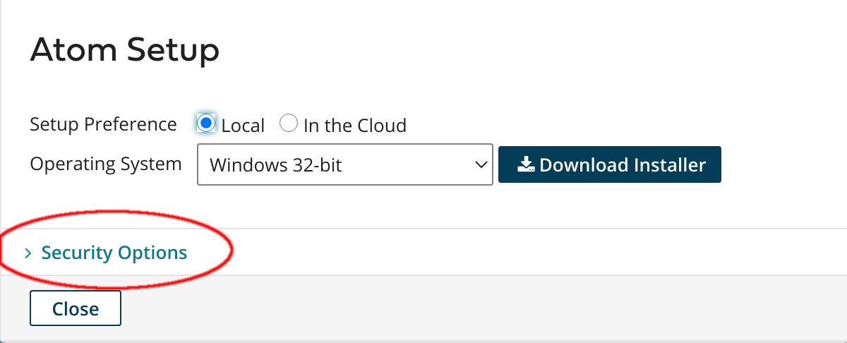Next expand ‘Security Options’.

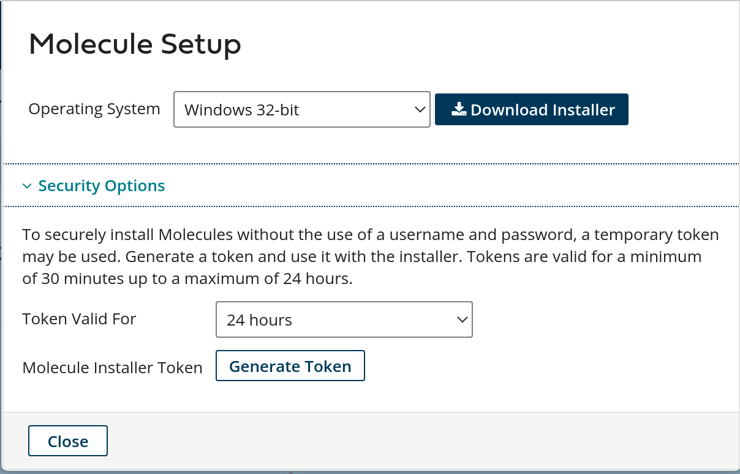

Now you can generate the installation token. You can specify up to 24 hours duration for the token before it expires.

# Creating an API Token

You can create an long-lived API token without having to share your login credentials for an Atom/Molecule installation. If you are an administrator, follow the steps below to create an user API token:

Click on Integration → My User Settings → AtomSphere API Tokens and select ‘Add New Token’.

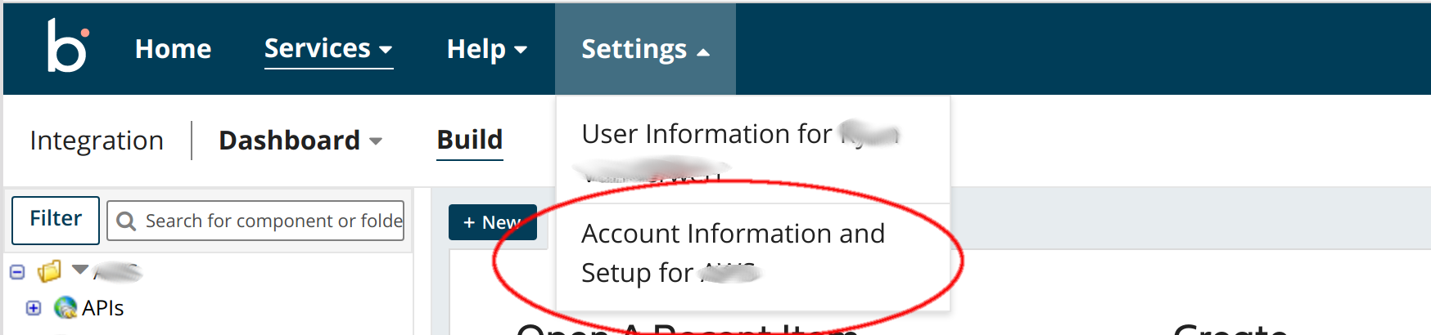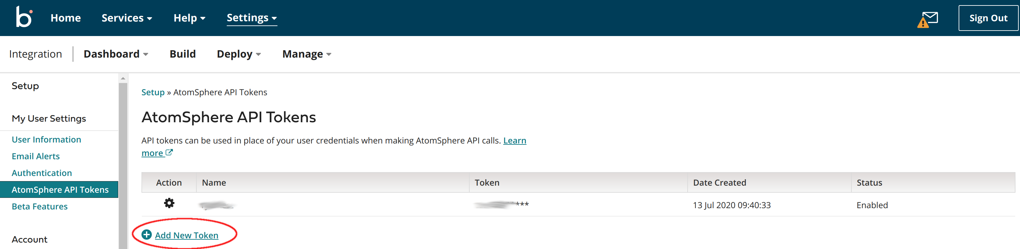

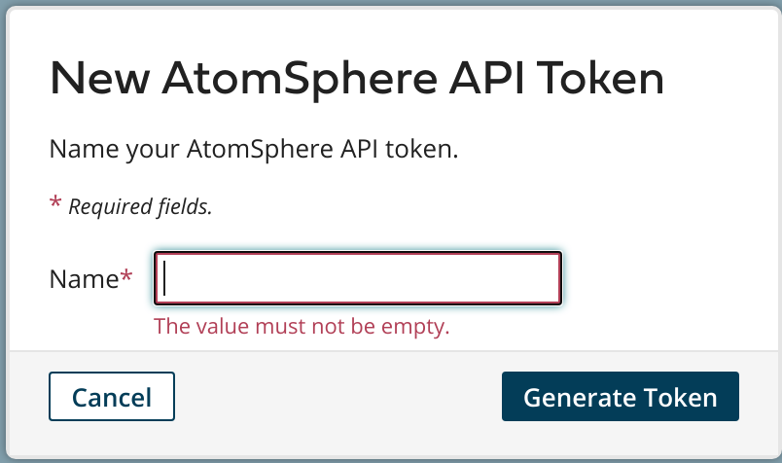

Provide a unique name for the token then click ‘Generate Token’.

# Copy your token key value to a safe place. If you lose it, you will have to generate a new token and revoke the old one.

# Troubleshooting

**Q.** I encountered a CREATE_FAILED error when I launched the Quick Start.

**A.** If AWS CloudFormation fails to create the stack, we recommend that you relaunch the template with **Rollback on failure** set to **No**. (This setting is under **Advanced** in the AWS CloudFormation console, **Options** page.) With this setting, the stack’s state will be retained and the instance will be left running, so you can troubleshoot the issue (check /var/log/cloud-init-output.log). Also check *var*log/cfn-init.log for errors.

**Important** When you set **Rollback on failure** to **No**, you will continue to incur AWS charges for this stack. Please make sure to delete the stack when you finish troubleshooting.

For additional information, see [Troubleshooting AWS CloudFormation](https://docs.aws.amazon.com/AWSCloudFormation/latest/UserGuide/troubleshooting.html) on the AWS website.

**Q.** I encountered a size limitation error when I deployed the AWS CloudFormation templates.

**A.** We recommend that you launch the Quick Start templates from the links in this guide or from another S3 bucket. If you deploy the templates from a local copy on your computer or from a non-S3 location, you might encounter template size limitations when you create the stack. For more information about AWS CloudFormation limits, see the [AWS documentation](http://docs.aws.amazon.com/AWSCloudFormation/latest/UserGuide/cloudformation-limits.html).

# Send us feedback

To post feedback, submit feature ideas, or report bugs, use the **Issues** section of the [GitHub repository](https://fwd.aws/Vmnx4) for this Quick Start. If you’d like to submit code, please review the [Quick Start Contributor’s Guide](https://aws-quickstart.github.io/).

# Additional resources

**AWS resources**

* [Getting Started Resource Center](https://aws.amazon.com/getting-started/)
* [AWS General Reference](https://docs.aws.amazon.com/general/latest/gr/)
* [AWS Glossary](https://docs.aws.amazon.com/general/latest/gr/glos-chap.html)

**AWS services**

* [AWS CloudFormation](https://docs.aws.amazon.com/cloudformation/)
* [Amazon EBS](https://docs.aws.amazon.com/AWSEC2/latest/UserGuide/AmazonEBS.html)
* [Amazon EC2](https://docs.aws.amazon.com/ec2/)
* [IAM](https://docs.aws.amazon.com/iam/)
* [Amazon VPC](https://docs.aws.amazon.com/vpc/)
* [Amazon EFS](https://docs.aws.amazon.com/efs/latest/ug/whatisefs.html)
* [Amazon CloudWatch](https://docs.aws.amazon.com/AmazonCloudWatch/latest/monitoring/WhatIsCloudWatch.html)
* [Elastic Load Balancing](https://docs.aws.amazon.com/elasticloadbalancing/latest/userguide/what-is-load-balancing.html)
* [AWS KMS](https://docs.aws.amazon.com/kms/latest/developerguide/overview.html)

**Dell Boomi documentation**

* [Dell Boomi User’s Guide](http://help.boomi.com/atomsphere/GUID-A98714FA-9EAB-4B69-BCC8-7D8984F0B0EC.html)

**Other Quick Start reference deployments**

* [AWS Quick Start home page](https://aws.amazon.com/quickstart/)

# Document revisions

| **Date** | **Change** | **In sections** |
| --- | --- | --- |
| **October 2019** | Initial publication | — |

© 2019, Amazon Web Services, Inc. or its affiliates. All rights reserved.

Purchase of AWS services from AWS does not entitle any user to rights to use Dell Boomi Integration services. Each such service is sold and offered separately. Dell Boomi reserves the right to modify the functionality of any of its services in Dell Boomi’s sole discretion in the future.

**Notices**

This document is provided for informational purposes only. It represents AWS’s current product offerings and practices as of the date of issue of this document, which are subject to change without notice. Customers are responsible for making their own independent assessment of the information in this document and any use of AWS’s products or services, each of which is provided “as is” without warranty of any kind, whether express or implied. This document does not create any warranties, representations, contractual commitments, conditions or assurances from AWS, its affiliates, suppliers or licensors. The responsibilities and liabilities of AWS to its customers are controlled by AWS agreements, and this document is not part of, nor does it modify, any agreement between AWS and its customers.

The software included with this paper is licensed under the Apache License, Version 2.0 (the "License"). You may not use this file except in compliance with the License. A copy of the License is located at http://aws.amazon.com/apache2.0/ or in the "license" file accompanying this file. This code is distributed on an "AS IS" BASIS, WITHOUT WARRANTIES OR CONDITIONS OF ANY KIND, either express or implied. See the License for the specific language governing permissions and limitations under the License.