MSBF MERCHANT CREDIT INTELLIGENCE

Power BI Validation Report
  - MSBF Merchant Credit Intelligence - Module 2 v2.1.0-rc2
Decisioning, Portfolio & Servicing Intelligence
Document ID | MSBF-MCI-PBI-VAL-R2
Product release | Module 2 v2.1.0-rc2
Document date | September 4, 2026
Status | PASS - CONTROLLED PUBLICATION ACTION PENDING
Evidence boundary | Deterministic synthetic evidence; not production underwriting or servicing
Publication-support artifact. GitHub publication and public supersession are not executed by this document.

Contents
The complete requirements and validation traceability are provided in the companion workbook and CSV registers.
1. Executive validation conclusion
2. Validation objectives
3. Scope
4. Validation authority and evidence hierarchy
5. System under test
6. Validation methodology
7. Physical package validation
8. Governance and release-identity validation
9. Source-population validation
10. Semantic-model and binding validation
11. P01 validation
12. P02 validation
13. P03 narrative and application-journey validation
14. P04 servicing and certification validation
15. Accessibility validation
16. Interaction validation
17. Temporal and interpretation-boundary validation

Post-audit focused correction - IA-D-R16-PBI-001
Independent Audit decision IA-D-R16-PBI-001 returned HOLD for one localized P04 visual-filter defect only. The correction removed FactAccountDaily[monitoring_status_rank] >= 1 and FactMonitoringEndpoint[P04 Monitoring Status] <> "Paid off" from P04 visual 36e098c177fe1ff70689 (Payment & certification detail). The successor R26 P04 Requires Attention Flag = 1 predicate remains physically present.
The corrected client PBIX is 27,635,305 bytes with SHA-256 ca46e8551860836a0cf4ff9239c42fcf8df02f1705596b9f8ca1bd047b5294e4. The embedded DataModel SHA-256 remains 24396d02c0fbcb782cc9918e842886711146b8ff9455c8822d2aeaf009b96061, exactly unchanged from the audited R2 candidate.
Complete physical visual-JSON scan including filterConfig: 96 visuals, 293 field-reference occurrences, 26 filterConfig rows, 3 active predicates, 0 predecessor-fact references, and 0 predecessor-fact filter rows.
Correction boundedness: only four PBIX members changed. The target P04 visual and Endpoint monitoring posture visual are unchanged outside filterConfig. The second visual change is benign Desktop serialization of current/shared field references with no active predicates; pages.json changed only the saved active page; SecurityBindings changed as save metadata.
Owner evidence signoff: the owner observed no visual or numerical change after the stale-filter removal and expressly approved reuse of the existing P04 Baseline, Recession Energy, filtered-account, tooltip, accessibility, and QA captures without re-capture.

Focused re-audit scope
Verify the corrected PBIX identity and target filterConfig, independently scan all physical visual JSON including filterConfig for predecessor-fact references, reconcile the updated hashes/registers/persistence receipt, and confirm the owner no-recapture signoff. Do not reopen R26, G3-v2, P03 1,500-path QA, broad semantic testing, or duplicate screenshot capture absent a newly demonstrated regression.
18. Evidence and publication-package validation
19. Findings and observations
20. Release recommendation
Appendix A - Validation summary
Appendix B - Full control register
Appendix C - Companion evidence and registers

1. Executive validation conclusion
The current MSBF Merchant Credit Intelligence Power BI release candidate is validated as a coherent, source-authorized, deterministic synthetic analytical product across its current P01-P04 scope.
The validation established that:
- the client-facing PBIX is physically readable and hash-identified;
- the report contains the intended four visible pages and one hidden diagnostic;
- every current page binding resolves to an R1 successor fact or a current shared dimension/metadata object;
- no predecessor fact remains bound to P01-P04 or P02-DIAG;
- accepted R26 source populations and G3-v2 certification are preserved;
- P03 narrative behavior passes across all 1,500 application-scenario paths;
- P03 monitoring and funded-lifecycle behavior reconciles across 130 funded paths and 15,600 monitoring rows;
- P04 preserves exact 130-key equality through intervention, setup, execution, certification, and endpoint performance;
- scenario isolation, interactions, tooltips, alt text, and tab order operate as designed;
- the report's temporal, synthetic, and nonproduction interpretation boundaries are visible and consistent.
The final portfolio-wide persistence/nonregression gate has been closed as PASS based on owner-confirmed post-reopen final evidence. One release control remains open by design: GitHub publication and public supersession have not been executed and require a separate controlled release action.
Accordingly, the report is accepted as the final rc2 publication candidate for audit and controlled publication handoff, but this validation report does not declare the artifact publicly released or production-ready.

2. Validation objectives
The validation was designed to determine whether the current PBIX:
1. matches the accepted product and release identity;
2. consumes the accepted R26 successor source architecture;
3. excludes predecessor fact bindings;
4. preserves exact source populations, keys, and scenario boundaries;
5. implements the approved P01-P04 business story;
6. presents accurate and interpretable KPIs, charts, tables, narratives, and tooltips;
7. maintains correct filter and selection behavior;
8. retains accessibility and navigation controls;
9. contains no unresolved page-level semantic defect;
10. is suitable for GitHub publication support with persistence/nonregression closed and the separately authorized publication action pending.

3. Scope

Included
- Physical PBIX package
- Embedded report definition
- Four visible pages and one hidden diagnostic
- Current report bindings and interactions
- Current R1 source populations
- P01 and P02 page conformance
- P03 narrative, monitoring, lifecycle, and servicing integration
- P04 endpoint monitoring, servicing, payment, and certification integration
- Tooltips, alt text, and tab order
- Owner evidence organization
- Requirements and validation traceability
- Release-boundary review

Excluded
- P05 and P06 page acceptance
- Power BI Service deployment
- Tenant, workspace, gateway, or scheduled refresh validation
- Production performance/load testing
- Real customer data, underwriting, payment, or servicing execution
- GitHub release execution

4. Validation authority and evidence hierarchy
Validation used the following precedence:
1. accepted R26 M2.5-M2.12 / G3-v2 technical authority;
2. current client-facing PBIX and physically installed DAX;
3. extracted report definitions, pages, visuals, bindings, and interactions;
4. owner-captured final page, QA, tooltip, accessibility, and interaction evidence;
5. canonical implementation register and source-population records;
6. derived validation analysis and publication documentation.
No external facts were used to change or supplement the source-defined results.

5. System under test
Attribute | Validated value
File | MSBF_Merchant_Credit_Intelligence_M2_v2.1.0-rc2.pbix
Bytes | 27,635,305
SHA-256 | ca46e8551860836a0cf4ff9239c42fcf8df02f1705596b9f8ca1bd047b5294e4
DataModel bytes | 27,485,797
DataModel SHA-256 | 24396d02c0fbcb782cc9918e842886711146b8ff9455c8822d2aeaf009b96061
PBIX entries | 128
Visible pages | 4
Hidden pages | 1
Visual containers | 96
Query bindings | 221
Observed-source cutoff | 2026-07-23
Synthetic lifecycle endpoint | 2026-11-22

6. Validation methodology
The validation combined:
- direct ZIP/CRC and path inspection of the PBIX;
- extraction and hashing of embedded report definitions;
- page, visual, binding, field-reference, interaction, and DAX-query inventories;
- comparison to the previously controlled R4 canonical register;
- review of owner-confirmed measure and calculated-column changes;
- automated DAX QA for P03 and P04;
- full-page visual evidence under both scenarios;
- representative account-level regressions;
- tooltip, alt-text, tab-order, and interaction evidence;
- explicit review of synthetic, temporal, and release boundaries.
Controls were classified as:
- PASS - requirement satisfied by direct test, QA, or approved evidence;
- DEFERRED - required but intentionally scheduled for the final portfolio gate;
- PENDING - requires a separately authorized release action.

7. Physical package validation
Control ID | Control | Observed | Expected | Status | Evidence
VAL-PHY-001 | PBIX ZIP CRC | PASS | PASS | PASS | Direct PBIX testzip
VAL-PHY-002 | Unsafe/duplicate/case-colliding paths | 0 / 0 / 0 | 0 / 0 / 0 | PASS | Direct PBIX path inspection
VAL-PHY-003 | Client-facing visible pages | 4 | 4 | PASS | Embedded pages.json
VAL-PHY-004 | Hidden diagnostic pages | 1 | 1 | PASS | Embedded P02-DIAG page.json
VAL-PHY-005 | Client-facing PBIX identity, size, and SHA-256 | MSBF_Merchant_Credit_Intelligence_M2_v2.1.0-rc2.pbix; 27,635,305 bytes; ca46e855...94e4 | Exact current client-facing release candidate | PASS | Direct project ZIP and PBIX hash inspection

Assessment
The client-facing PBIX passed CRC validation. No unsafe paths, duplicate paths, or case-fold collisions were identified. The embedded report definition contains the expected page structure, and the file identity matches the owner-approved market-facing name.

8. Governance and release-identity validation
Control ID | Control | Observed | Expected | Status | Evidence
VAL-GOV-001 | R26 G3-v2 controls | 70 PASS / 0 FAIL | 70 PASS / 0 FAIL | PASS | R26 checkpoint and authority evidence
VAL-GOV-002 | R26 certification ID | G3V2_R26_C053DC064AB32A4D21864F94 | Exact accepted ID | PASS | R26 authority evidence

Control ID | Control | Observed | Expected | Status | Evidence
VAL-REL-003 | Visible product/model identity | MSBF Merchant Credit Intelligence / MSBF MCI - M2 v2.1.0-rc2 | Owner-approved market-facing identity | PASS | PBIX filename and P01-P04 final footers

The build retains the accepted 70/70 G3-v2 control result and exact certification ID. The visible product identity has been changed from internal R26/C2 engineering nomenclature to the market-facing MSBF MCI identity without changing technical lineage.

9. Source-population validation
Control ID | Control | Observed | Expected | Status | Evidence
VAL-SRC-001 | Application-scenario paths | 1,500 | 1,500 | PASS | R1DimApplicationScenario
VAL-SRC-002 | Daily monitoring rows / paths / days | 15,600 / 130 / 120 | 15,600 / 130 / 120 | PASS | P03 operational QA result 1
VAL-SRC-003 | M2.6 intervention distribution | 126 / 3 / 1 | 126 / 3 / 1 | PASS | P03 operational QA result 4

Key populations were reconciled as follows:
Object or stage | Validated population | Result
Application-scenario dimension | 1,500 paths | PASS
Funded lifecycle | 130 unique paths | PASS
Daily monitoring | 15,600 rows / 130 paths / 120 days each | PASS
M2.6 intervention | 130 rows; 126 closed / 3 outreach / 1 temporary review | PASS
M2.7 operational setup | 130 rows; 126 no setup / 3 governance review / 1 temporary setup ready | PASS
M2.8 servicing execution | 130 rows; 126 no execution / 3 review hold / 1 active temporary processing | PASS
M2.9 certification | 130 rows; 126 closed / 3 review hold / 1 reassessment after retry | PASS
M2.10 performance | 130 rows; 126 closed stable / 3 controlled review / 1 active reconciled | PASS
G3-v2 certification | 70 PASS / 0 FAIL | PASS

10. Semantic-model and binding validation
Control ID | Control | Observed | Expected | Status | Evidence
VAL-SEM-001 | Successor-or-shared binding coverage and predecessor-fact exclusion | 96 visuals; 293 physical field-reference occurrences; 26 filterConfig rows; 3 active predicates; 0 predecessor-fact references and 0 predecessor-fact filter rows | 0 predecessor-fact references across all physical visual JSON, including filterConfig | PASS | CURRENT_PHYSICAL_VISUAL_REFERENCES_R7, CURRENT_PHYSICAL_FILTER_REFERENCES_R7, and PHYSICAL_VISUAL_REFERENCE_SCAN_SUMMARY_R7

Control ID | Control | Observed | Expected | Status | Evidence
VAL-SEM-002 | Model inventory qualification | R4 exact base 55 tables / 1,804 columns / 316 measures / 55 relationships; R5 estimated 1,807 columns / 349 measures | Exact base plus explicitly qualified readable/owner additions | PASS | R4 canonical register plus R5 query overlays and owner changes

The current binding inventory establishes:
Page | Bindings | R1 successor | Shared dimension/metadata | Predecessor facts | Result
P01 - Cohort Command Center | 49 | 39 | 10 | 0 | PASS_PAGE_FROZEN
P02 - Cohort Lifecycle | 49 | 39 | 10 | 0 | PASS_PAGE_FROZEN
P02-DIAG - Attention States | 33 | 26 | 7 | 0 | HIDDEN_DIAGNOSTIC_RETAINED
P03 - Application Journey | 55 | 42 | 13 | 0 | PASS_PAGE_FROZEN
P04 - Servicing & Exceptions | 35 | 29 | 6 | 0 | PASS_PAGE_FROZEN

Assessment
The critical version-mixing defect family is closed for the current report scope. Following the R16 focused correction, P01-P04 and P02-DIAG contain zero predecessor-fact references across all physical visual JSON, including filterConfig. Shared non-R1 dimensions remain permissible where they are the current canonical category or metadata dictionary for R1 facts.
The model inventory remains qualified: the R4 exact base contained 55 tables, 1,804 columns, 316 measures, and 55 relationships. R5 readable overlays and owner changes support an estimated current total of 1,807 columns and 349 measures. Exact final DMV counts were not separately recaptured; the qualified inventory remains a nonblocking documentation observation because the owner has closed the final persistence/nonregression gate on the persisted PBIX.

11. P01 validation
Control ID | Control | Observed | Expected | Status | Evidence
VAL-P01-001 | P01 public page composition and final release identity | Command center present with KPI, sourcing, decision, industry, endpoint, alert, and evidence sections | Approved P01 page design | PASS | Focused P01 Baseline/Recession captures and binding inventory

Control ID | Control | Observed | Expected | Status | Evidence
VAL-P01-002 | Final-observation funded paths and endpoint state | Baseline 103 funded / $1.39M / $7.82K exposure; Recession Energy 27 funded / $344.20K / $0 exposure | Current accepted cohort results | PASS | Focused P01 Baseline and Recession Energy captures

Validated behavior
P01 provides the intended executive command center with:
- four segmentation/as-of controls;
- six core KPIs;
- funding by acquisition source;
- seven-outcome decision distribution;
- industry risk and economics;
- endpoint reconciliation and operational attention;
- visible evidence gates.
At the final observation date:
Measure | Baseline | Recession Energy
Funded accounts | 103 | 27
Funded amount | $1.39M | $344.20K
Current exposure | $7.82K | $0.00
Remittance fulfillment | 99.5% | 100.0%
Supportable path rate | 40.0% | 10.7%
Comparative expected-loss rate | 9.4% | 11.4%

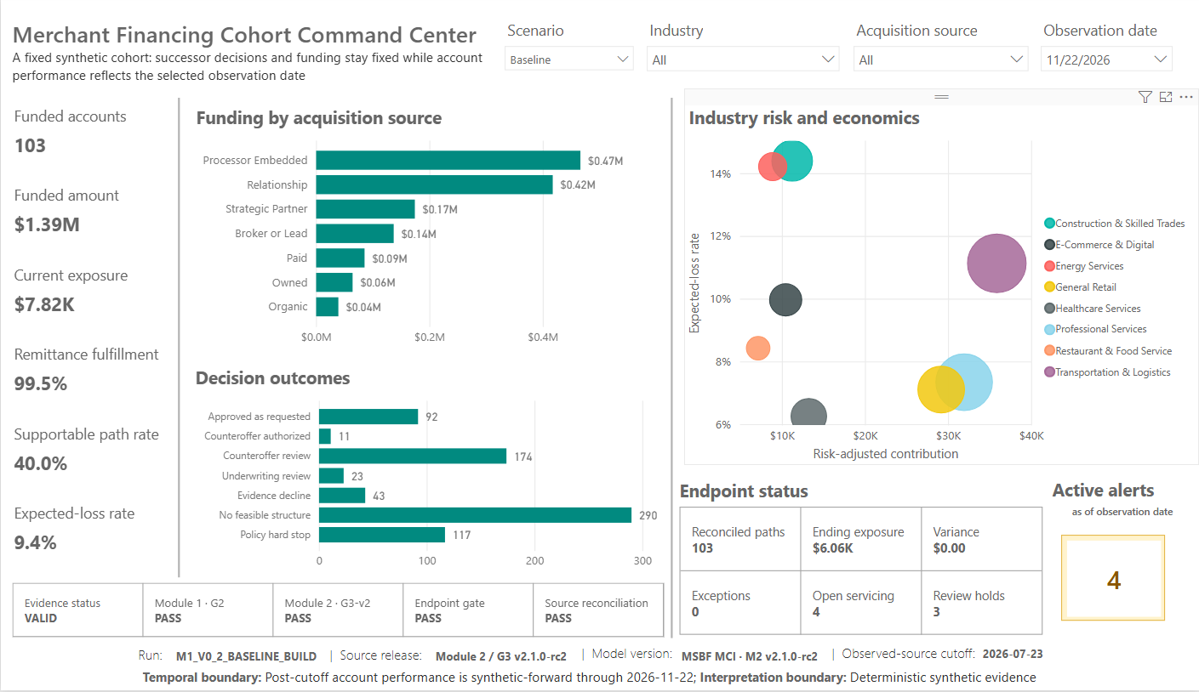
Figure: P01 Baseline
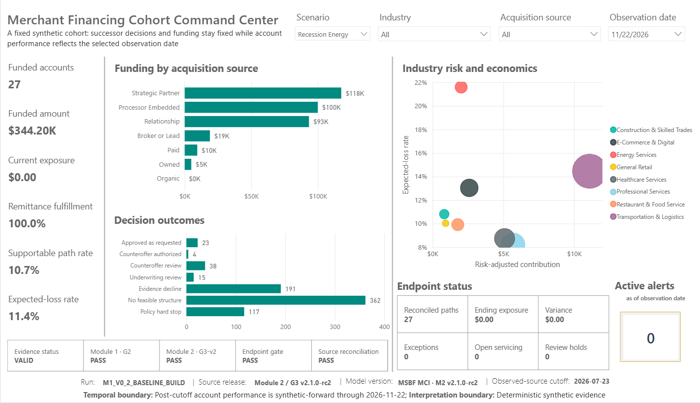
Figure: P01 Recession Energy

12. P02 validation
Control ID | Control | Observed | Expected | Status | Evidence
VAL-P02-001 | Lifecycle page composition | Receivable runoff, remittance fulfillment, monitoring breadth/severity, and payoff timing present | Approved P02 page design | PASS | Focused P02 Baseline/Recession captures and binding inventory

Control ID | Control | Observed | Expected | Status | Evidence
VAL-P02-002 | Observation-period and segmentation behavior | Scenario, industry, acquisition-source, and observation-period interactions evidenced | Approved interaction behavior | PASS | Owner P02 interaction and observation-period captures

Control ID | Control | Observed | Expected | Status | Evidence
VAL-P02-003 | Operational-alert diagnostic tooltips | Raw alert conditions, operational alert families, and per-alerted-account context evidenced | Approved tooltip design | PASS | Owner P02 tooltip capture

Validated behavior
P02 displays:
- receivable runoff;
- remittance fulfillment;
- monitoring breadth and severity;
- payoff timing versus plan;
- scenario, industry, acquisition-source, and observation-period interactions.
The current R26 monitoring design correctly distinguishes operational-alert breadth from adverse monitoring status. Tooltips provide source-owned raw-condition and alert-family detail. The hidden P02-DIAG page remains available for internal analysis and hidden from view mode.
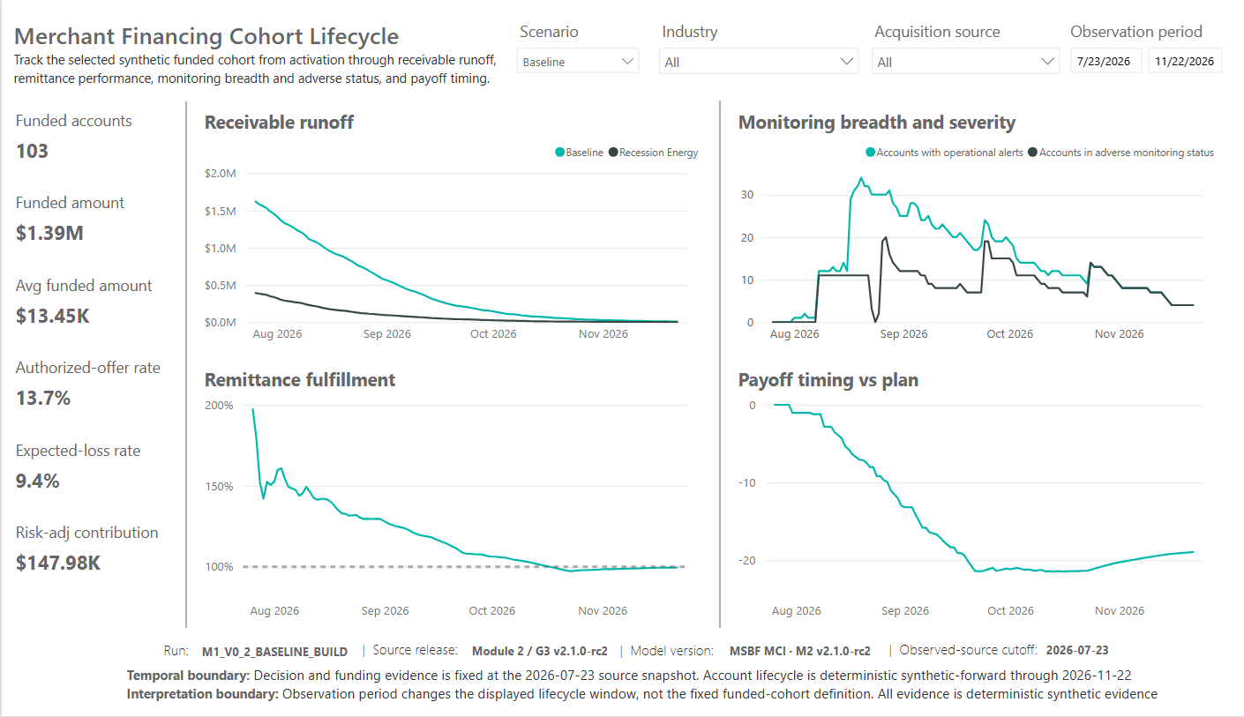
Figure: P02 Baseline
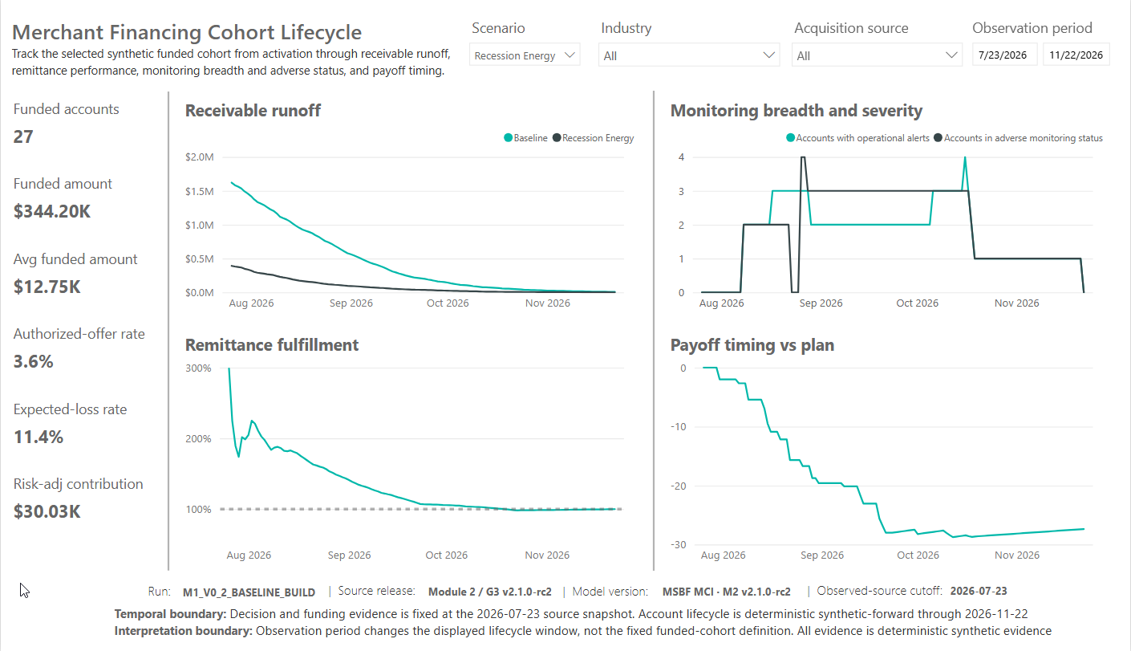
Figure: P02 Recession Energy

13. P03 narrative and application-journey validation
Control ID | Control | Observed | Expected | Status | Evidence
VAL-P03-001 | 738 scenario pair | 2 rows, both PASS | 2 rows, both PASS | PASS | P03 narrative QA result 1
VAL-P03-002 | Narrative failures | 0 | 0 | PASS | P03 narrative QA result 2
VAL-P03-003 | Full narrative inventory | 1,500 rows; PASS only | 1,500 unique paths; PASS only | PASS | P03 narrative QA result 3

Control ID | Control | Observed | Expected | Status | Evidence
VAL-P03-004 | Successor reconciliation failures | 0 | 0 | PASS | P03 performance/monitoring QA result 2

Control ID | Control | Observed | Expected | Status | Evidence
VAL-P03-005 | 738 scenario pair | Baseline 120 monitoring rows; Recession Energy 0 rows | Exact isolation | PASS | P03 performance/monitoring QA result 3

Control ID | Control | Observed | Expected | Status | Evidence
VAL-P03-006 | Final P03 application-to-account page composition | Request, decision, proposed structure, three narratives, performance, monitoring, and servicing present | Approved P03 final design | PASS | Focused P03 branch captures and final page evidence

Control ID | Control | Observed | Expected | Status | Evidence
VAL-P03-007 | Final P03 alt text, tab order, account-performance and monitoring tooltips | Implemented and evidenced | Approved accessibility/tooltip design | PASS | P03 alt-text, tab-order, and tooltip captures

Narrative QA
The final corrected narrative sequence produced:
- Result 1: exactly two rows for merchant 738 Baseline and Recession Energy; both PASS;
- Result 2: zero failures;
- Result 3: 1,500 rows, 1,500 unique ApplicationScenarioKeys, PASS only.
The final visible architecture retains three separate narratives:
1. Merchant operating evidence
2. Risk & economics assessment
3. Decision
Technical source rationales remain available in the model but are not forced into visible or redundant tooltips.

Monitoring and lifecycle QA
The operational QA established:
- 15,600 monitoring rows;
- 130 application-scenario paths;
- exactly 120 monitoring days per path;
- zero successor reconciliation failures;
- merchant 738 Baseline with 120 monitoring rows and funded lifecycle;
- merchant 738 Recession Energy with zero monitoring rows and no lifecycle;
- M2.6 intervention distribution of 126 / 3 / 1.

Representative visual evidence
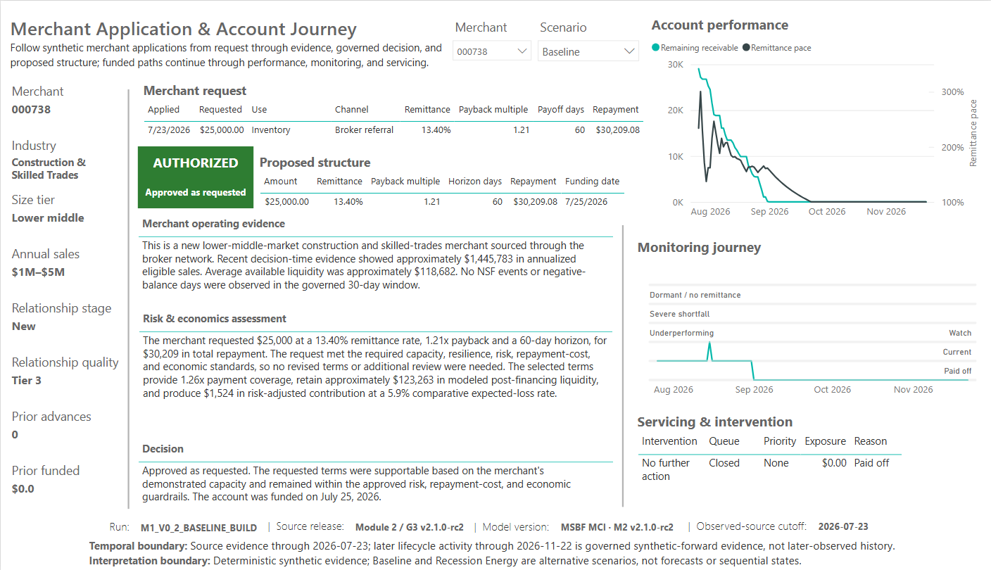
Figure: P03 738 Baseline
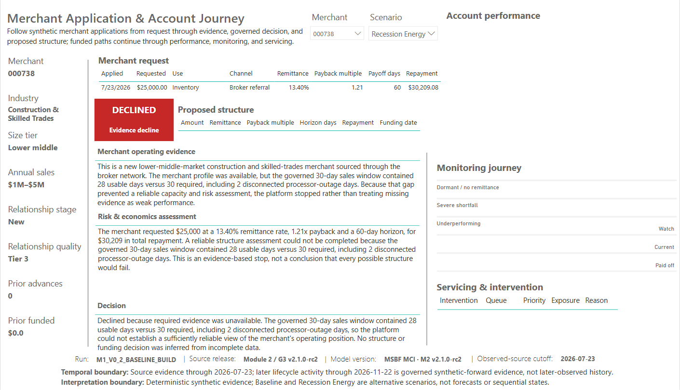
Figure: P03 738 Recession Energy
The full focused P03 evidence set covers all seven governed outcomes and material review, evidence, no-feasible, stress-floor, and hard-stop branches.

14. P04 servicing and certification validation
Control ID | Control | Observed | Expected | Status | Evidence
VAL-P04-001 | M2.6-M2.10 rows and unique keys | 130 / 130 each stage | 130 / 130 each stage | PASS | P04 QA result 1

Control ID | Control | Observed | Expected | Status | Evidence
VAL-P04-002 | M2.7 distribution | 126 / 3 / 1 | 126 / 3 / 1 | PASS | P04 QA result 2

Control ID | Control | Observed | Expected | Status | Evidence
VAL-P04-003 | M2.8 distribution | 126 / 3 / 1 | 126 / 3 / 1 | PASS | P04 QA result 3

Control ID | Control | Observed | Expected | Status | Evidence
VAL-P04-004 | M2.9 distribution | 126 / 1 / 3 | 126 closed / 1 retry / 3 review | PASS | P04 QA result 4

Control ID | Control | Observed | Expected | Status | Evidence
VAL-P04-005 | M2.10 distribution | 126 closed / 1 active / 3 review | Exact | PASS | P04 QA result 5

Control ID | Control | Observed | Expected | Status | Evidence
VAL-P04-006 | Baseline KPIs | 4; $7,823.28; 1; 3; $6,061.03; 0 | Exact | PASS | P04 QA result 6
VAL-P04-007 | Recession Energy KPIs | All operational exception measures 0 | All 0 | PASS | P04 QA result 6

Control ID | Control | Observed | Expected | Status | Evidence
VAL-P04-008 | 098/112/312/749/264 chain | Expected states observed | Exact representative cases | PASS | P04 QA result 7

Control ID | Control | Observed | Expected | Status | Evidence
VAL-P04-009 | Final P04 alt text, tab order, endpoint and servicing tooltips | Implemented; servicing burden removed from public tooltip | Approved P04 final design | PASS | P04 alt-text, tab-order, and final tooltip captures

Baseline endpoint
Measure | Validated value
Requiring attention | 4
Attention exposure | $7,823.28
Active servicing | 1
Review holds | 3
Certified exposure | $6,061.03
Unresolved exceptions | 0
Endpoint status | 99 Paid off / 4 Severe shortfall
Servicing disposition | 1 Reassessment / 3 Review hold

Recession Energy endpoint
- 27 Paid off;
- zero attention paths;
- zero attention exposure;
- zero active servicing;
- zero review holds;
- zero certified ending exposure;
- zero unresolved exceptions.

Representative-path regression
Merchant | Validated chain
098 Baseline | Severe shortfall -> targeted outreach -> governance review -> execution review hold -> controlled review
112 Baseline | Severe shortfall -> targeted outreach -> governance review -> execution review hold -> controlled review
312 Baseline | Severe shortfall -> targeted outreach -> governance review -> execution review hold -> controlled review
749 Baseline | Severe shortfall -> temporary remittance review -> setup ready -> active servicing -> active reconciled
264 Baseline | Paid off -> no further action -> no setup -> no execution -> closed stable

Merchant 749 additionally validates seven payment events, $1,762.25 processed, one return, one retry, reconciliation after retry, and $2,937.12 certified exposure.
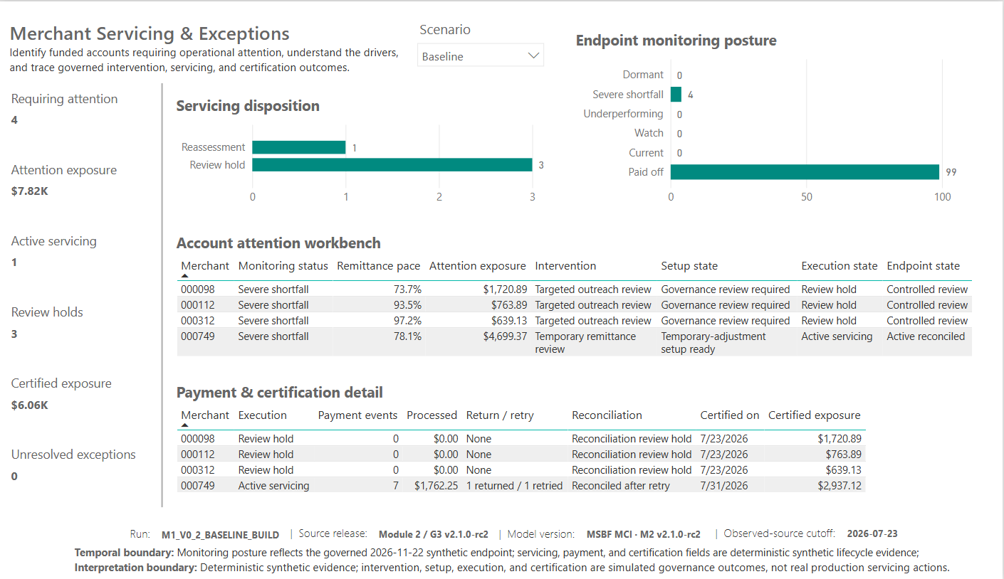
Figure: P04 Baseline
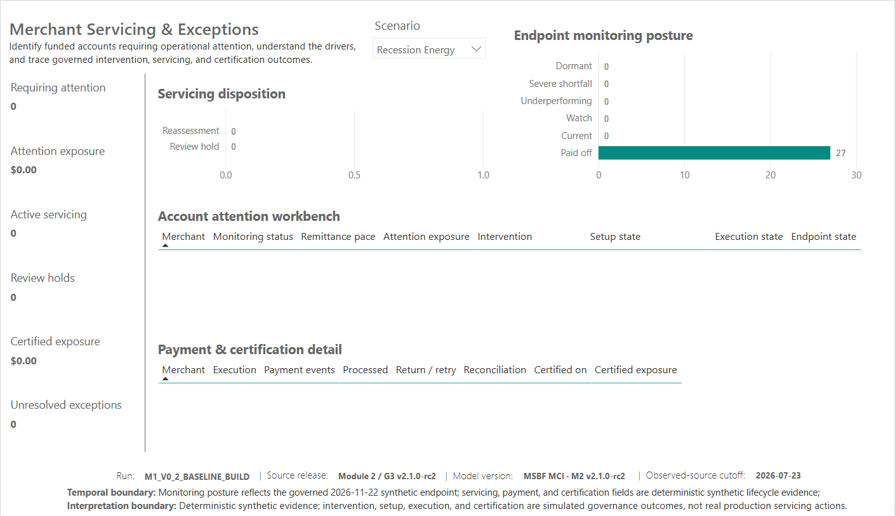
Figure: P04 Recession Energy

15. Accessibility validation
Control ID | Control | Observed | Expected | Status | Evidence
VAL-ACC-001 | P01-P04 title/KPI/chart/table alt text | Implemented and evidenced | Implemented | PASS | Owner alt-text captures
VAL-ACC-002 | Logical tab order P01-P04 | Implemented and evidenced | Implemented | PASS | Owner tab-order captures

The owner evidence demonstrates substantive alt text and logical tab order across P01-P04. Dynamic KPI alt text is used where it materially improves comprehension. Slicers and visible footer text intentionally use native labels rather than redundant custom alt text.
The final P04 servicing tooltip was reviewed after removal of the unexplained servicing-burden metric. It now provides concise axis context, full queue wording, account count, and certified exposure.

16. Interaction validation
Control ID | Control | Observed | Expected | Status | Evidence
VAL-INT-001 | Scenario isolation and visual interactions | Observed as designed | As designed | PASS | Owner interaction and scenario captures
VAL-INT-002 | P04 workbench-to-detail selection behavior | Merchant 098 and 749 selections isolate the lower detail table while page posture remains stable | Approved workbench-detail interaction | PASS | P04 filtered owner captures

Validated interactions include:
- scenario isolation;
- P01/P02 industry and acquisition-source segmentation;
- observation-date/period behavior;
- P03 merchant/scenario case resolution;
- P04 workbench selection filtering only the lower detail;
- valid empty-state behavior under Recession Energy.

17. Temporal and interpretation-boundary validation
Control ID | Control | Observed | Expected | Status | Evidence
VAL-TMP-001 | Observed-source cutoff | 2026-07-23 | 2026-07-23 | PASS | Visible footer and source controls
VAL-TMP-002 | Synthetic-forward lifecycle endpoint | 2026-11-22 | 2026-11-22 | PASS | P01-P04 footers and lifecycle evidence

The report visibly communicates:
- observed decision-time source evidence through 2026-07-23;
- deterministic synthetic-forward lifecycle evidence through 2026-11-22;
- alternative governed scenarios rather than forecasts or sequential states;
- no real production servicing, payment, or adverse-action execution.

18. Evidence and publication-package validation
Control ID | Control | Observed | Expected | Status | Evidence
VAL-EVD-001 | Owner evidence inventory and duplicate-hash scan | 142 files / 15,519,282 bytes / 0 duplicate-hash groups | Complete, nonduplicated owner evidence inventory | PASS | OWNER_EVIDENCE_MANIFEST and direct hash analysis
VAL-EVD-002 | Focused presentation-capture inventory | 94 presentation-focused captures across P01-P04 | Publication-candidate visual evidence separated from internal QA evidence | PASS | Owner evidence folder organization and manifest

The owner-evidence package contains 142 files totaling 15,519,282 bytes and no duplicate-hash groups. The focused presentation area contains 94 curated Power BI captures, while raw QA/accessibility/interaction evidence remains separately identifiable as internal support.

Publication-support payload
Control ID | Control | Observed | Expected | Status | Evidence
VAL-PUB-001 | Publication-support payload completeness | PBIX, canonical MD/XLSX/JSON, BRD MD/DOCX/PDF, validation MD/DOCX/PDF, registers, curated captures, manifests, and checksums present | Complete approved publication-support payload | PASS | Publication-support package inspection and payload manifest
VAL-PUB-002 | Package path safety, archive integrity, clean extraction, and manifest reconciliation | CRC PASS; clean extraction PASS; zero unsafe, duplicate, case-fold-colliding, symlink, or encrypted paths; manifest/SHA256 reconciliation PASS | All checks PASS; all disallowed-path counts zero | PASS | MANIFEST.csv; SHA256SUMS.txt; ZIP_VALIDATION_REPORT.md/json

The validated package is the final publication candidate for this rc2 scope. The owner-confirmed persistence/nonregression gate is PASS. Package integrity validation does not itself execute GitHub publication.

19. Findings and observations

Finding F-01 - R16 focused correction closed by physical re-scan
Status: CLOSED / PASS Evidence: Owner confirmation dated 2026-09-04 that the latest final P01-P04 captures were taken after save, complete Desktop close, and reopen; current PBIX/package designated final. Disposition: No further report edits are authorized absent a verified defect or a new controlled release cycle.

Finding F-02 - GitHub publication not executed
Status: PENDING Impact: The current package supports publication but does not activate public supersession or claim that the release is live. Disposition: Execute through the separately authorized release action.

Observation O-01 - Exact final model inventory
The current measure and column totals are reconstructed from the last exact R4 inventory plus readable overlays and owner-confirmed additions. This is adequate for publication-support documentation when clearly qualified. Exact DMV inventory was not separately recaptured. The qualified R4-plus-overlay inventory remains documented as a nonblocking observation; the physical PBIX and binding inventories remain controlling for publication.

Observation O-02 - P05/P06 excluded
P05 and P06 remain internal candidate pages and are intentionally absent from the client-facing rc2 PBIX. No current public claim should imply that M2.11 strategy analysis is already presented through a completed P05/P06 experience.

20. Release recommendation
Recommendation: ACCEPT AS CORRECTED FINAL PUBLICATION CANDIDATE SUBJECT TO EXPEDITED FOCUSED INDEPENDENT RE-AUDIT; if accepted, proceed directly to controlled GitHub publication.
The P01-P04 report build is accepted as complete and page-frozen. The final persistence/nonregression gate is closed as PASS, and the PBIX/package identities are final for audit/publication handoff.
The remaining controlled release sequence is:
1. independent audit acceptance of this final publication-candidate package;
2. the separately authorized GitHub publication/public-supersession action;
3. post-publication download verification of every hosted asset against the package hash/size register and Windows-native clean extraction.

Appendix A - Validation summary
Status | Count | Meaning
PASS | 51 | Validated by direct test, automated QA, physical inspection, or approved owner evidence
DEFERRED | 0 | No remaining deferred validation controls
PENDING | 1 | Separate controlled publication action
TOTAL | 52 | Corrected publication-support control population

Appendix B - Full control register
Control ID | Control | Observed | Expected | Status | Evidence
VAL-ACC-001 | P01-P04 title/KPI/chart/table alt text | Implemented and evidenced | Implemented | PASS | Owner alt-text captures
VAL-ACC-002 | Logical tab order P01-P04 | Implemented and evidenced | Implemented | PASS | Owner tab-order captures
VAL-EVD-001 | Owner evidence inventory and duplicate-hash scan | 142 files / 15,519,282 bytes / 0 duplicate-hash groups | Complete, nonduplicated owner evidence inventory | PASS | OWNER_EVIDENCE_MANIFEST and direct hash analysis
VAL-EVD-002 | Focused presentation-capture inventory | 94 presentation-focused captures across P01-P04 | Publication-candidate visual evidence separated from internal QA evidence | PASS | Owner evidence folder organization and manifest
VAL-GOV-001 | R26 G3-v2 controls | 70 PASS / 0 FAIL | 70 PASS / 0 FAIL | PASS | R26 checkpoint and authority evidence
VAL-GOV-002 | R26 certification ID | G3V2_R26_C053DC064AB32A4D21864F94 | Exact accepted ID | PASS | R26 authority evidence
VAL-INT-001 | Scenario isolation and visual interactions | Observed as designed | As designed | PASS | Owner interaction and scenario captures
VAL-INT-002 | P04 workbench-to-detail selection behavior | Merchant 098 and 749 selections isolate the lower detail table while page posture remains stable | Approved workbench-detail interaction | PASS | P04 filtered owner captures
VAL-P01-001 | P01 public page composition and final release identity | Command center present with KPI, sourcing, decision, industry, endpoint, alert, and evidence sections | Approved P01 page design | PASS | Focused P01 Baseline/Recession captures and binding inventory
VAL-P01-002 | Final-observation funded paths and endpoint state | Baseline 103 funded / $1.39M / $7.82K exposure; Recession Energy 27 funded / $344.20K / $0 exposure | Current accepted cohort results | PASS | Focused P01 Baseline and Recession Energy captures
VAL-P02-001 | Lifecycle page composition | Receivable runoff, remittance fulfillment, monitoring breadth/severity, and payoff timing present | Approved P02 page design | PASS | Focused P02 Baseline/Recession captures and binding inventory
VAL-P02-002 | Observation-period and segmentation behavior | Scenario, industry, acquisition-source, and observation-period interactions evidenced | Approved interaction behavior | PASS | Owner P02 interaction and observation-period captures
VAL-P02-003 | Operational-alert diagnostic tooltips | Raw alert conditions, operational alert families, and per-alerted-account context evidenced | Approved tooltip design | PASS | Owner P02 tooltip capture
VAL-P03-001 | 738 scenario pair | 2 rows, both PASS | 2 rows, both PASS | PASS | P03 narrative QA result 1
VAL-P03-002 | Narrative failures | 0 | 0 | PASS | P03 narrative QA result 2
VAL-P03-003 | Full narrative inventory | 1,500 rows; PASS only | 1,500 unique paths; PASS only | PASS | P03 narrative QA result 3
VAL-P03-004 | Successor reconciliation failures | 0 | 0 | PASS | P03 performance/monitoring QA result 2
VAL-P03-005 | 738 scenario pair | Baseline 120 monitoring rows; Recession Energy 0 rows | Exact isolation | PASS | P03 performance/monitoring QA result 3
VAL-P03-006 | Final P03 application-to-account page composition | Request, decision, proposed structure, three narratives, performance, monitoring, and servicing present | Approved P03 final design | PASS | Focused P03 branch captures and final page evidence
VAL-P03-007 | Final P03 alt text, tab order, account-performance and monitoring tooltips | Implemented and evidenced | Approved accessibility/tooltip design | PASS | P03 alt-text, tab-order, and tooltip captures
VAL-P04-001 | M2.6-M2.10 rows and unique keys | 130 / 130 each stage | 130 / 130 each stage | PASS | P04 QA result 1
VAL-P04-002 | M2.7 distribution | 126 / 3 / 1 | 126 / 3 / 1 | PASS | P04 QA result 2
VAL-P04-003 | M2.8 distribution | 126 / 3 / 1 | 126 / 3 / 1 | PASS | P04 QA result 3
VAL-P04-004 | M2.9 distribution | 126 / 1 / 3 | 126 closed / 1 retry / 3 review | PASS | P04 QA result 4
VAL-P04-005 | M2.10 distribution | 126 closed / 1 active / 3 review | Exact | PASS | P04 QA result 5
VAL-P04-006 | Baseline KPIs | 4; $7,823.28; 1; 3; $6,061.03; 0 | Exact | PASS | P04 QA result 6
VAL-P04-007 | Recession Energy KPIs | All operational exception measures 0 | All 0 | PASS | P04 QA result 6
VAL-P04-008 | 098/112/312/749/264 chain | Expected states observed | Exact representative cases | PASS | P04 QA result 7
VAL-P04-009 | Final P04 alt text, tab order, endpoint and servicing tooltips | Implemented; servicing burden removed from public tooltip | Approved P04 final design | PASS | P04 alt-text, tab-order, and final tooltip captures
VAL-PHY-001 | PBIX ZIP CRC | PASS | PASS | PASS | Direct PBIX testzip
VAL-PHY-002 | Unsafe/duplicate/case-colliding paths | 0 / 0 / 0 | 0 / 0 / 0 | PASS | Direct PBIX path inspection
VAL-PHY-003 | Client-facing visible pages | 4 | 4 | PASS | Embedded pages.json
VAL-PHY-004 | Hidden diagnostic pages | 1 | 1 | PASS | Embedded P02-DIAG page.json
VAL-PHY-005 | Client-facing PBIX identity, size, and SHA-256 | MSBF_Merchant_Credit_Intelligence_M2_v2.1.0-rc2.pbix; 27,635,305 bytes; ca46e855...94e4 | Exact corrected client-facing release candidate | PASS | Direct project(2).zip and corrected PBIX hash inspection
VAL-PUB-001 | Publication-support payload completeness | PBIX, canonical MD/XLSX/JSON, BRD MD/DOCX/PDF, validation MD/DOCX/PDF, registers, curated captures, manifests, and checksums present | Complete approved publication-support payload | PASS | Publication-support package inspection and payload manifest
VAL-PUB-002 | Package path safety, archive integrity, clean extraction, and manifest reconciliation | CRC PASS; clean extraction PASS; zero unsafe, duplicate, case-fold-colliding, symlink, or encrypted paths; manifest/SHA256 reconciliation PASS | All checks PASS; all disallowed-path counts zero | PASS | MANIFEST.csv; SHA256SUMS.txt; ZIP_VALIDATION_REPORT.md/json
VAL-REL-001 | Persistence/nonregression closure including bounded post-audit P04 correction | Pre-audit full save/close/reopen PASS; corrected PBIX saved with unchanged DataModel and unchanged non-filter visual payload; owner observed no visual/result change and approved reuse of existing captures without re-capture | Current corrected PBIX persisted and no output regression from localized filter removal | PASS | Persistence closure receipt R2; focused correction member diff; owner no-recapture signoff; physical scan
VAL-REL-002 | GitHub publication / public supersession | NOT EXECUTED | Separate authorized release action | PENDING | This package supports but does not execute publication
VAL-REL-003 | Visible product/model identity | MSBF Merchant Credit Intelligence / MSBF MCI - M2 v2.1.0-rc2 | Owner-approved market-facing identity | PASS | PBIX filename and P01-P04 final footers
VAL-RPT-001 | Page / visible / hidden / visual / binding inventory | 5 pages / 4 visible / 1 hidden / 96 visuals / 221 bindings | Exact current PBIX inventory | PASS | Embedded PBIX report definition extraction
VAL-SEM-001 | Successor-or-shared physical visual-reference coverage and predecessor-fact exclusion, including filterConfig | 96 visuals; 293 physical field-reference occurrences; 26 filterConfig rows; 3 active predicates; 0 predecessor-fact references / 0 predecessor-fact filter rows | 0 predecessor fact references across all physical visual JSON | PASS | CURRENT_PHYSICAL_VISUAL_REFERENCES_R7; CURRENT_PHYSICAL_FILTER_REFERENCES_R7; PHYSICAL_VISUAL_REFERENCE_SCAN_SUMMARY_R7
VAL-SEM-002 | Model inventory qualification | R4 exact base 55 tables / 1,804 columns / 316 measures / 55 relationships; R5 estimated 1,807 columns / 349 measures | Exact base plus explicitly qualified readable/owner additions | PASS | R4 canonical register plus R5 query overlays and owner changes
VAL-SRC-001 | Application-scenario paths | 1,500 | 1,500 | PASS | R1DimApplicationScenario
VAL-SRC-002 | Daily monitoring rows / paths / days | 15,600 / 130 / 120 | 15,600 / 130 / 120 | PASS | P03 operational QA result 1
VAL-SRC-003 | M2.6 intervention distribution | 126 / 3 / 1 | 126 / 3 / 1 | PASS | P03 operational QA result 4
VAL-TMP-001 | Observed-source cutoff | 2026-07-23 | 2026-07-23 | PASS | Visible footer and source controls
VAL-TMP-002 | Synthetic-forward lifecycle endpoint | 2026-11-22 | 2026-11-22 | PASS | P01-P04 footers and lifecycle evidence
VAL-COR-001 | R16 audit finding bounded to one P04 visual | IA-D-R16-PBI-001 HOLD identified exactly two stale predecessor filters; broad remediation not required | Localized correction only | PASS | Owner-provided R16 audit decision and focused correction authorization summary
VAL-COR-002 | Authorized stale filters removed from Payment & certification detail | Two predecessor predicates absent; R26 P04 Requires Attention Flag = 1 retained | Two predecessor filters removed; successor attention filter retained | PASS | Direct corrected visual filterConfig inspection
VAL-COR-003 | Complete physical visual JSON scan including filterConfig references | 96 visuals / 293 refs / 26 filterConfig rows / 3 active predicates / 0 predecessor fact refs / 0 predecessor fact filter rows | Predecessor fact references across all physical visual JSON = 0 | PASS | CURRENT_PHYSICAL_VISUAL_REFERENCES_R7; CURRENT_PHYSICAL_FILTER_REFERENCES_R7; PHYSICAL_VISUAL_REFERENCE_SCAN_SUMMARY_R7
VAL-COR-004 | Correction boundedness and semantic nonregression | DataModel unchanged; target and endpoint-monitoring visuals unchanged outside filterConfig; only 4 PBIX members changed | No semantic-model or visual query/layout change beyond authorized filter metadata correction | PASS | FOCUSED_CORRECTION_PBIX_MEMBER_DIFF_R7; direct normalized JSON comparison
VAL-COR-005 | Owner visual-output equivalence and no-recapture signoff | Owner observed no visual/result change and expressly approved reuse of existing P04 captures without re-capture | No re-capture required when bounded correction does not change displayed results | PASS | Owner attestation dated 2026-09-04; existing final P04 captures retained

Appendix C - Companion evidence and registers
- CANONICAL_SOURCE_OF_TRUTH.md
- POWER_BI_BUSINESS_REQUIREMENTS.md
- registers/MSBF_MCI_POWER_BI_CANONICAL_SOURCE_OF_TRUTH_R7_20260904.xlsx
- registers/MSBF_MCI_POWER_BI_BUSINESS_REQUIREMENTS_REGISTER_R3_20260904.csv
- registers/MSBF_MCI_POWER_BI_REQUIREMENTS_TRACEABILITY_MATRIX_R3_20260904.csv
- registers/MSBF_MCI_POWER_BI_VALIDATION_CONTROL_REGISTER_R7_20260904.csv
- registers/CURRENT_REPORT_PAGES.csv
- registers/CURRENT_REPORT_VISUALS.csv
- registers/CURRENT_REPORT_BINDINGS.csv
- registers/OWNER_EVIDENCE_MANIFEST.csv

