Project Proposal: Hurricane Preparedness and Assistance
Group Members: Leticia Barbosa, Tyler Helderman, Andrew Kaimana

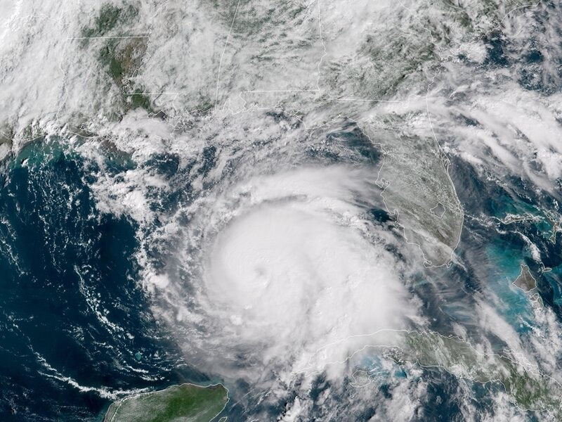

Summary

One of the most impactful natural hazards that affects Florida is hurricanes. These hurricanes can cause significant damage and even death in some cases, so it is extremely important to be, not only aware that one may occur, but also prepared if one does. We aim to inform our audience about hurricanes and our organization specifically through means of setting up fliers around the UCF community as well as through social media platforms and web applications.

Our goal is focused on assisting and preparing the homeless, the elderly, and those who may not have access to shelter, food, and/or transportation for hurricanes. This will be done through collecting various resources through donations or other means, as well as reaching out to organizations who can help inform people about certain safety precautions to take and how to better prepare yourselves for a hurricane. Our organization will first and foremost be looking to recruit volunteers who are willing and able to help those in need when it comes to preparing for hurricanes. We will not only provide supplies and provisions to those in need, but we will also provide services to set up shutters and/or provide anti-flooding measures.
Project Description
Relevance:

Community Responsibility:

According to the UCF creed, it is our responsibility as members of the University of Central Florida to serve our community and ensure those within it are properly cared for and acknowledged (Student Development and Enrollment Services). This is clear through the tenant of Community.

Impact of Florida Hurricanes:

Hurricanes occur in Florida quite often and affect not only the student population at the University of Central Florida but also members of surrounding communities. The hurricanes in question are not only frequent in nature but also quite intense and notable. According to the National Oceanic and Atmospheric Administration, several very notable and devastating hurricanes affected Florida (National Oceanic and Atmospheric Administration).
The image below (National Oceanic and Atmospheric Administration)
depicts the magnitude and location of rainfall and tracks the path of Hurricane Frances, a storm that reached classification of a category 4 in 2004 (noaa). The hurricane, along with others, caused significant damage and resulted in great financial costs, damages, and deaths. We must take note of the intensity of the hurricanes and their respective consequences.
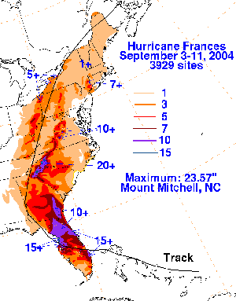
While recent storms and hurricanes may not receive mention on the noaa page, it is still important to recognize more recent storms like Hurricane Irma, (US Department of Commerce) which in 2017 caused great damage with its high speed winds and heavy rainfall.
Furthermore, we must consider the vulnerable position of Florida as a peninsula to hurricanes and strong storms. In 2021, the NOAA predicts several intense storms and hurricanes to affect Florida (National Oceanic and Atmospheric Administration). Regardless of the path, rainfall and strong winds may still affect central Florida and preparations ought to be in place.

Specific Audience:

The United States Census Bureau marks Orlando as having a poverty rate of 17.2%, which accounts for approximately 49,440 people according to their population (United States Census Bureau). These individuals may be disproportionately affected by hurricanes as they may lack access to shelter, food, and/or transportation. Thus the initiative would focus on providing for this community as they express the most need.
According to the Junior League of Greater Orlando, “in Florida, 40% of the homeless sleep outdoors due to overcrowded shelters.” The focus of the project will be targeted towards these individuals because they find themselves displaced in terms of location and resources.
The audience may also include elderly individuals who may need set up assistance for certain preparatory measures.

Proposed Solution:

The intent of the project is to assist charities, impoverished communities, elderly individuals, and others who express the need for assistance as it relates to hurricane preparation.
Fliers and proper technological marketing will be employed to recruit new members to assist in the organization’s tasks. Tasks include but are not limited to resource collection and distribution, shutter and anti-flooding preparations, and informational tools.
Resource collection will occur periodically for items such as flashlights, nonperishable foods, and other key items to ensure preparedness. It is the responsibility of the organization to properly announce any distribution and collection dates and times to the community partners and potential donors. Marketing will be done via physical fliers, phone calls to local organizations, and digital marketing and announcements.
The organization ought to do community outreach to speak with charities, shelters, and homes to set up proper dates and times and establish clear relationships for proper assistance.
The organization may also reach out to first responders and individuals trained in hurricane response to provide safe and accurate demonstrations of safety measures and information regarding hurricane expectations. From this, the organization may also design basic, informational pamphlets to distribute not only to the homes, charities, and shelters but to all members of the community to ensure knowledge on preparedness.

Work Plan and Team Qualifications
Timing:
Most of the preparation for the organization will be for recruitment efforts. We plan on spending 1 week designing the first recruitment handout, then spending another 2 weeks printing and distributing these handouts. We plan on spending 3 weeks designing and setting up the group website. The other time contributions in the organization depend on what branch of the organization a member is in. This time investment changes drastically depending on whether Florida is currently in hurricane season and ramps up heavily if a hurricane is forecasted to land in Central Florida. This time commitment and time variance based on hurricane threat changes based on which of the three organization branches you are a member of. This is addressed in each respective branch section listed below.

Members and Qualifications:
The first branch will be the management branch. Andrew has management experience, making him the best candidate to organize the whole organization. He will take over the roles of recruiting new members, managing these members, and financial and logistical management. These roles also put him in charge of our handouts, website, and marketing, along with being the “face” of our organization. Recruiting will mainly be done through the website, handouts, and university outreach. The finances will be entirely used on hurricane supplies and recruitment efforts. In terms of logistics, this will mainly involve distributing new members among the three main branches of the organization based on demand. This group will have the most consistent time commitment, likely around one or two hours a week, as most of its time will be dedicated to recruiting, which will ramp up in case of hurricane threat.
Leticia will take over one of the two large parts of the organization: emergency supply collection and distribution. As someone with experience working in customer service, she is the best choice for leading this program. In preparation for hurricanes, she will set up collection areas for non-perishable food, storable water, and other supplies such as first aid kits. This service will be advertised in our marketing and will be focused on helping low-income families and those in need of these supplies in case of a hurricane. When a hurricane is forecasted to arrive, Leticia will begin working with charities, homeless shelters, churches, and other groups to be able to distribute these supplies as fast as possible, along with ramping up rates of collection. This organization's average member is also expected to work one or two hours a week in non-threat times, while this time commitment will drastically increase in case of a hurricane threat.
As Tyler has been through numerous hurricanes and has experience with the rigorous labor involved in hurricane preparedness, he will oversee the second large part of the organization: shutter and anti-flooding operations. This will mainly involve setting up shutters for the elderly and the busy. While shutters will be a large majority of the work, it will also involve anti-flooding measures such as loading and moving sandbags. This branch of the organization will be largely focused on assisting Andrew’s management and Leticia’s collection efforts when hurricanes are not in season or not a current threat. When a hurricane is forecast to be hitting, recruitment will be heavily increased, and the division will quickly get to work organizing its members for shutter building and anti-flooding efforts. This group will have very little time commitment in times of no hurricane threat, with the group’s members being able to volunteer themselves as members for the other branches at this time. This group will be the busiest during actual hurricane threats and will dedicate as much time as possible to doing their duties in threat of a hurricane.
Budget

Group Member Pay | Volunteer/Course Credit
Web Hosting | $275.88/year
Social Media Marketing | Free
Flyers (per 2,500) | $165
Water (6 pack of 1 gallon water jugs) | $3.59/case / $897.50 for 250 cases
Non-perishable Food Items | Donations
AA Batteries (case of 576) | $201.60/case / $1,209.60 for 6 cases
First Aid Kits | $1.01/each / $1,515 for 1,500
Flashlights (case of 500) | $3.04/case / $9.12 for 3 cases
Total Cost (based on providing for 1,500 people) | $4,072.10

*any of the above items may be obtained through donations, not just food items, though those will specifically be obtained through donations alone.

Conclusion

Overall, our group's intention is to help our fellow peers and our community through one of the most regularly unfortunate events in Florida: hurricanes. Hurricanes disproportionately affect the poor, homeless, and elderly. They all need support in times of crisis, whether that support comes financially, by donating supplies, or through volunteership. Setting up an on-campus organization dedicated to hurricane preparedness will give support to those in need and expose more people to the struggles that many face. We can support hurricane preparedness in our community by setting up food and supply drives during hurricane season, along with having a volunteer workforce ready to help people set up shutters or anti-flooding measures. By setting up direct connections with churches, charities, and homeless shelters, we can make sure that all of these supplies and volunteer workers will help prepare the most vulnerable people in Florida for the most dangerous phenomenon in Florida.
Bibliography

Junior League of Greater Orlando. “Junior League of Greater Orlando.” Florida Poverty Overview – Junior League of Greater Orlando, www.jlgo.org/florida-poverty-overview/.
National Oceanic and Atmospheric Administration. Hurricane Frances Graph. www.nhc.noaa.gov/prepare/images/noaa-hpc_frances2004_rainfall.gif.
National Oceanic and Atmospheric Administration. Hurricanes in History, www.nhc.noaa.gov/outreach/history/.
National Oceanic and Atmospheric Administration. “NOAA Predicts Another Active Atlantic Hurricane Season.” NOAA Predicts Another Active Atlantic Hurricane Season | National Oceanic and Atmospheric Administration, 20 May 2021, www.noaa.gov/news-release/noaa-predicts-another-active-atlantic-hurricane-season.
NOAA Satellites. “Hurricane Humberto.” NOAA, 15 September 2019, https://www.noaa.gov/education/resource-collections/weather-atmosphere/hurricanes
Student Development and Enrollment Services. “The UCF Creed.” The UCF Creed • Student Development and Enrollment Services • UCF, www.sdes.ucf.edu/creed/.
United States Census Bureau. “QuickFacts.” United States Census Bureau, 2019, www.census.gov/quickfacts/fact/table/orlandocityflorida/MAN450212.
US Department of Commerce, NOAA. Hurricane Irma Local Report/Summary, NOAA's National Weather Service, 23 July 2018, www.weather.gov/mfl/hurricaneirma.

