Sea Level Changes
Sea levels around the world have been slowly rising over the past few decades, with one of the main forces behind it being global warming. Looking at Daytona Beach Shores, specifically, we can clearly see this increase in sea level from the pictures on the right, with the top picture being taken around the 1960s and the bottom picture being taken in 2019.
The more the sea levels rise, the more damaging effects it can have on local communities, ranging from the loss of wildlife habitat to the displacement of millions of people due to the destruction of their homes and property.
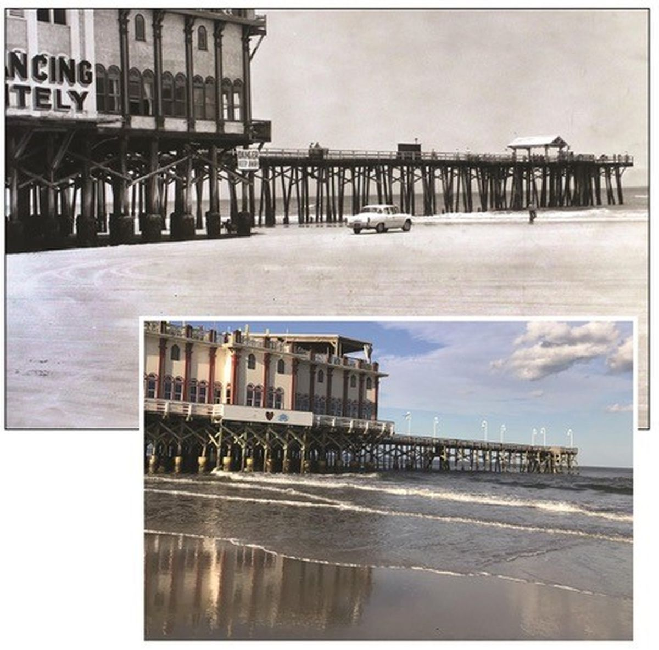

Photo taken from: SunSentinel
Top image courtesy of: The Daytona Beach News-Journal’s archives
Bottom image courtesy of: The News-Journal’s editor Pat Rice

Why Should You Care?

As sea levels continue to rise, the habitat of many coastal species along Daytona Beach Shores, like turtles, fish, birds, and even plants, continues to decline. Not only does the rise of sea levels affect coastal species, but it also affects species and environments further inland by causing “destructive erosion, wetland flooding, aquifer and agricultural soil contamination with salt” (Nunez).
With the rise of sea levels comes the potential for more dangerous hurricanes as well (Nunez). Living in a low-lying area, like Daytona Beach Shores, makes these hurricanes exponentially more dangerous because of the increased risk for flooding and storm surges, along with other life-threatening storm events that can occur (Krieger).
By 2100, sea levels in and around Daytona Beach Shores are expected to rise between 0.03 and 5.99 feet (Figure 1-1); this is an estimate based on the sea level change projection of five different models. This change can result in a multitude of problems for Daytona Beach Shores along with the surrounding areas.
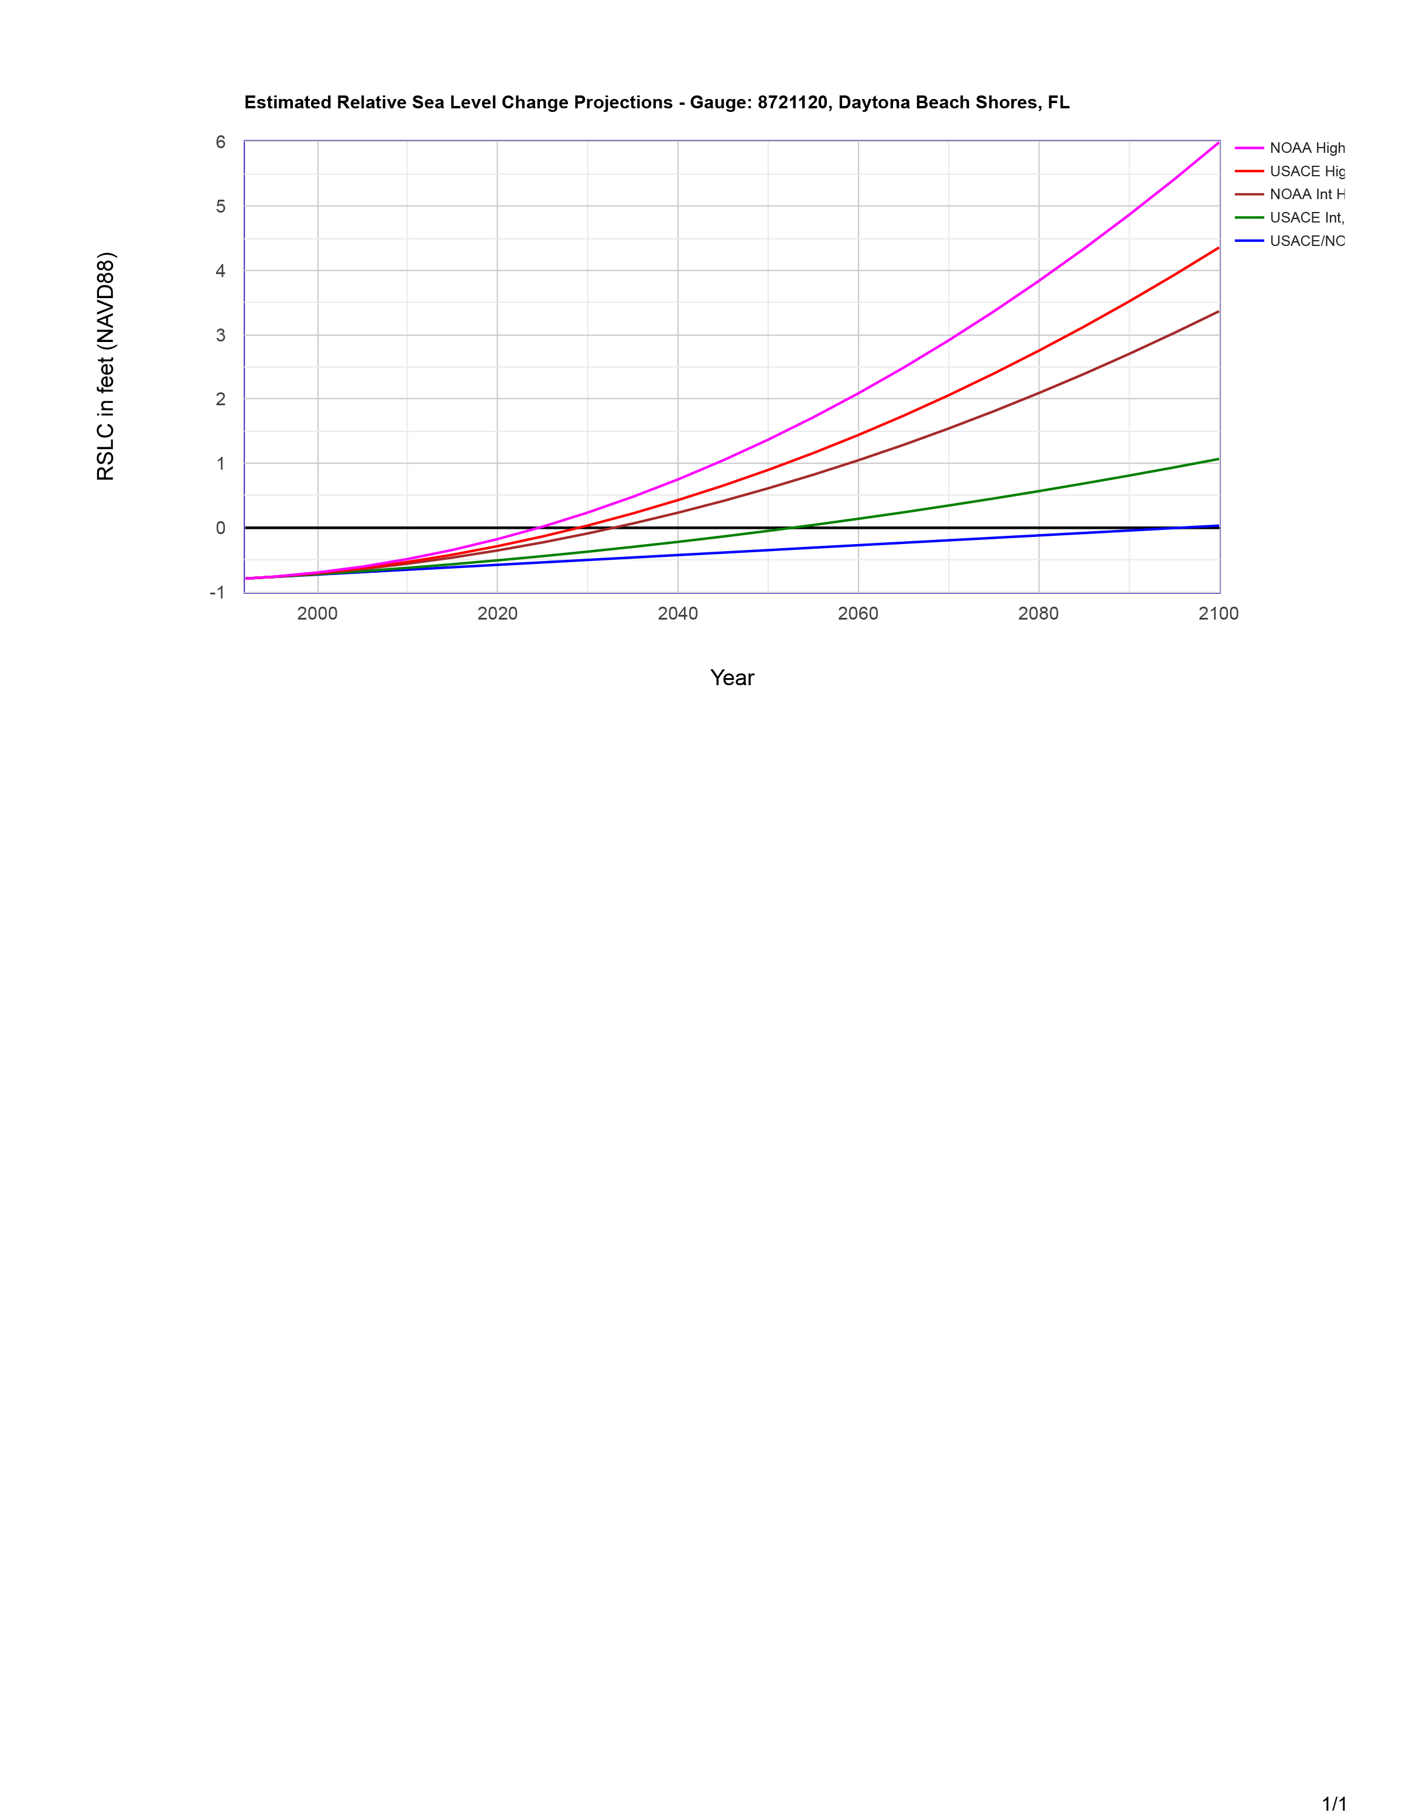
According to a 2017 analysis, the total population that sits below 4 feet along Daytona Beach Shores and the surrounding areas is over 7,000 (Surging Seas Risk Finder). By 2050, the total home value that is at risk of flooding will reach over $163 million, and that number will likely continue to grow by the year 2100.

Figure 1-1

What can you do to help?
Though the rising of sea levels is inevitable, it is important to do your part to help minimize damages in the future.
- Reduce your carbon footprint. Learn how at www.carbonfootrpint.com
- Get involved with local groups that are working towards helping protect wetlands.
- Plant more!
- Reduce your energy use in your home by turning off and unplugging unnecessary appliances.
- Try carpooling.
- Understand your flood-zone risks.
- Push for a Climate Action Plan in your community.
(The items in this list were taken from Clean Ocean Action’s 10 Tips on Sea Level Rise)
Works Cited
“Clean Ocean Action’s 10 Tips on Sea Level Rise.” CleanOceanAction, CleanOceanAction, https://cleanoceanaction.org/fileadmin/editor_group2/COAST/10_Tips_on_Sea_Level_Rise_final.pdf.
Daytona Beach News-Journal Editorial Board. “Daytona's Once-Wide Beaches Are Shrinking. Blame Rising Seas.” South Florida Sun-Sentinel, Sun-Sentinel, 13 Dec. 2019, www.sun-sentinel.com/opinion/commentary/fl-op-edit-daytona-beach-volusia-county-shrinking-rising-seas-20191213-ixmk3rypcnhsxlgxbupw73zora-story.html.
Krieger, Jenna. “Hurricane Risk Index.” Arcgis.com, ESRI, 2018, www.arcgis.com/apps/Cascade/index.html?appid=8f6013fdba6445e9a8732ff6cab9cd1a.
Nunez, Christina. “Sea Level Rise, Explained.” National Geographic, National Geographic Society, 19 Feb. 2019, www.nationalgeographic.com/environment/article/sea-level-rise-1.

