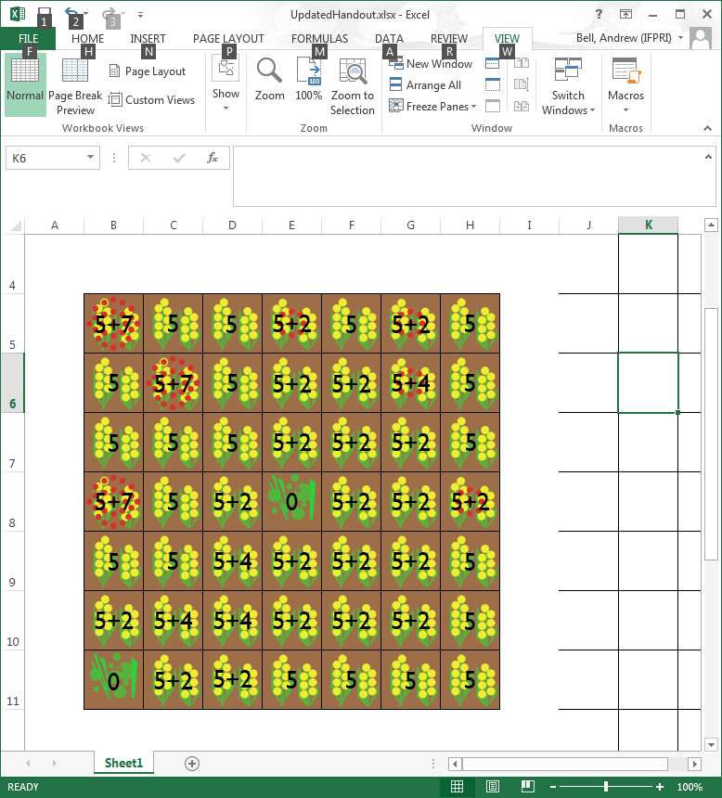

|  |  |  |  |
| --- | --- | --- | --- |
|  | **Cost** | **Yield** | **Neighborhood Effects** |
| Baseline (No action) | 0 | 5 |  |
| Non-crop Habitat | 0 | 0 | +2 to all squares in a neighborhood of 2 |
| Light Spray | 1 | +2 |  |
| Heavy Spray | 2 | +7 | Cancels all Non-crop Habitat bonuses in a neighborhood of 1 |