[first set up the seating, preferably forming a circle, collect player names, write them on the score recording sheeting, set up tablets, put in player names, ANYTHING ELSE?]

Hello, and thank you for making time to be here this afternoon.

Today we are going to conduct an experiment that is a continuation of the work we started when we spoke to you the other day. Just as before, your participation is voluntary but your participation of the full section is greatly appreciated. The game can’t run without all four participants. We are offering a total of $10 for your participation in the survey and in today’s experiment, which should take about 90 minutes. In addition, there will be a bonus of $1-3 dollars at the end of today’s experiment, depending on your performance in the experiment, which we will explain in a moment. With this in mind, do you consent to continue?

Today we are going to play a game about land use decision making. You’ll play in groups of 4, and each player will have an equal share of the land in the game, a total of 9 squares.

In each turn, in each of those squares, you can do one of 4 things:

|  |  |  |  |  |  |  |  |  |  |  |  |  |
| --- | --- | --- | --- | --- | --- | --- | --- | --- | --- | --- | --- | --- |
|  | |  | | --- | |  | |  | |  | | --- | |  | |  | |  | | --- | |  | |  | |  | | --- | |  | |  |

1. Plant a crop, without doing anything else.
2. Plant ‘non-crop’ land – like hedgerows, shrubs, etc.
3. Plant a crop, with light, targeted application of pesticides
4. Plant a crop, with heavier, broad spectrum application of pesticides

Each of these options has costs, and each will bring different benefits. Let me introduce each of them in turn.

The first choice of planting a crop, without doing anything else, doesn’t cost anything, and brings a yield of 5 from that square. However, yield from each square can be as high as 15, and the other 3 choices each can help increase yields in different ways.

Planting a non-crop square costs nothing, but brings a yield of 0 in that square. However, it brings a bonus of +2 to every square in a radius of 2 squares around it, in all directions. Thus, if there were a square next to a non-crop square that had a yield of 5 originally, the non-crop square would give a bonus of +2, making the yield 7 in that square. This bonus continues for 2 squares in any direction from the non-crop square across the landscape, even into the land of your neighbors.

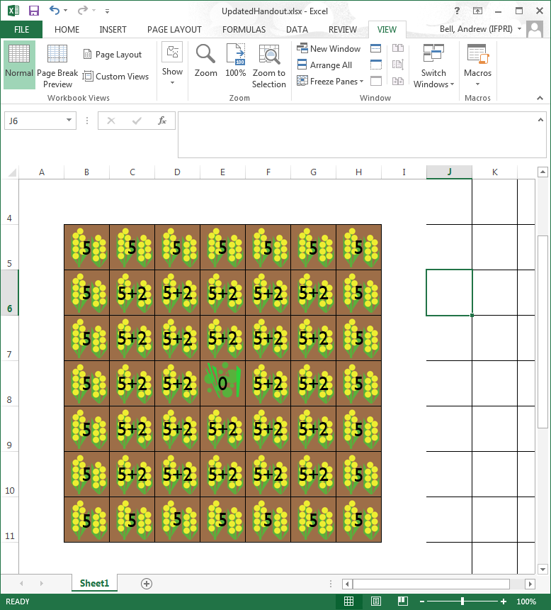

Now, the bonuses from non-crop habitat are additive. By that I mean that if a particular square falls within the 2-square radius from 1 non-crop square, it gets a bonus of +2, but if it falls within the 2-square radius of 2 different non-crop squares, it gets a bonus of +4, and so on.

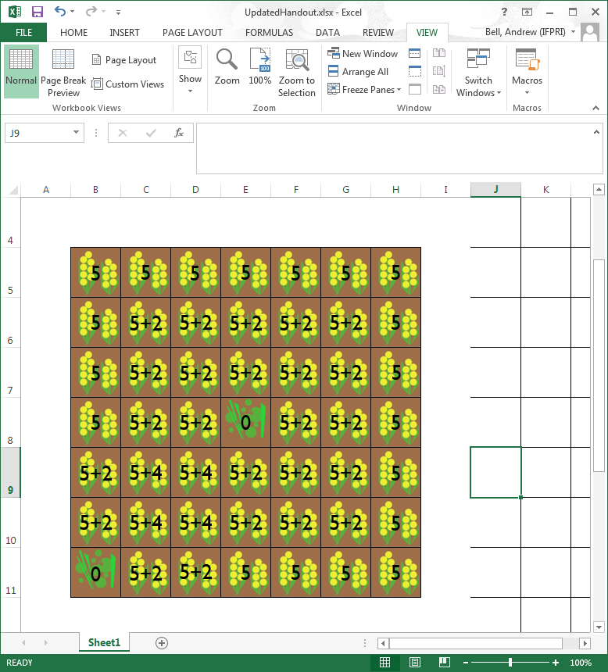

The third choice that can be made in a square is to plant, with a targeted pesticide spray. This costs 1, but brings a benefit of +2 to the square that is sprayed, on top of any other bonus the square receives, up to the maximum of 15. So, if a cell was already receiving a bonus of +2 from a nearby non-crop square, it would now receive a bonus of +4, for a total of 9. However, it is important to remember that it costs 1 to do the spraying, so the net benefit for the square is 8.

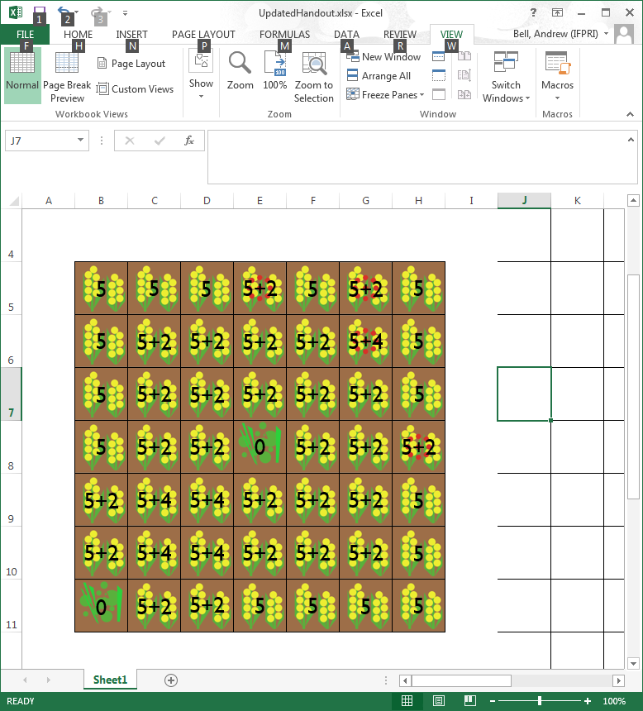

The last choice that can be made for the square is a heavier, broad spectrum pesticide spraying. This costs 2, but brings a benefit of +7 to the square in which it is applied. There is a catch, however – the broad spectrum spraying cancels out any bonus from non-crop squares in the square that is sprayed, and in a radius of 1 square around it in all directions – even into neighboring farms.

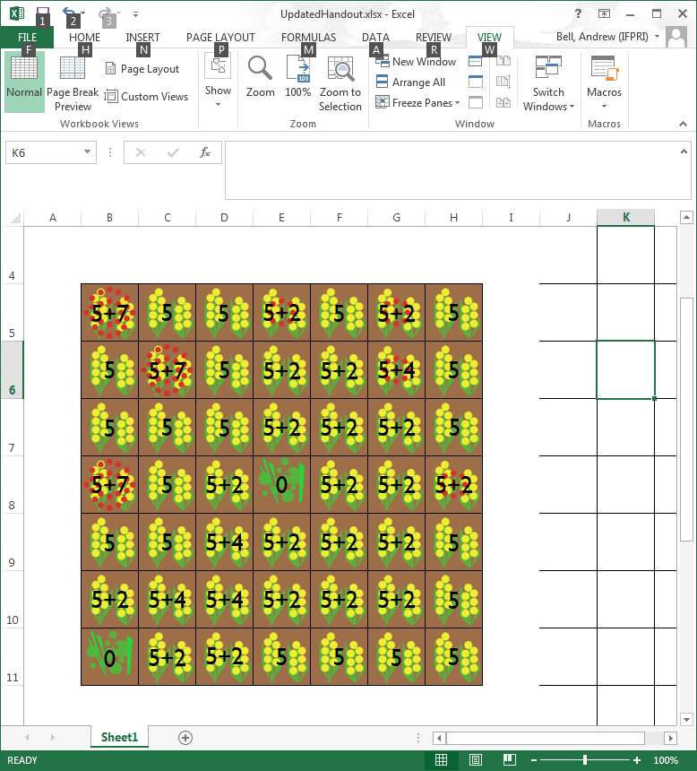

So just to review – planting a crop and not doing anything else (the default, brown square when you play) gives a benefit of 5. Different choices can make that yield higher, up to a maximum of 15. Non-crop squares give a bonus of +2 to the squares within a radius of 2 squares around them, and can add up. Targeted spraying gives a benefit of +2, but costs 1 to use. Broad spectrum spraying gives a benefit of +7, at a cost of 2, and blocks benefits from non-crop squares in a radius of 1.

In some of games following, you may be offered a subsidy. For each square of non-crop habitat in your land, you’ll receive a subsidy between +1 and +10. In other word, instead of earning a yield of 0 in the non-crop land square, you will be earning a benefit at the subsidy value. The bonus that non-crop habitat square brings to its surrounding land remains the same.

You don’t need to memorize this – you can use this sheet as a reference while you play the game *[hand out sheet only now]*.

Let’s look now at the game screen and see how this all fits together.

This is a screen shot from the first turn for Player 4, in the upper left quadrant. The names of the other three players are shown over their quadrants, which are lighter in color, and can’t be modified by Player 4.

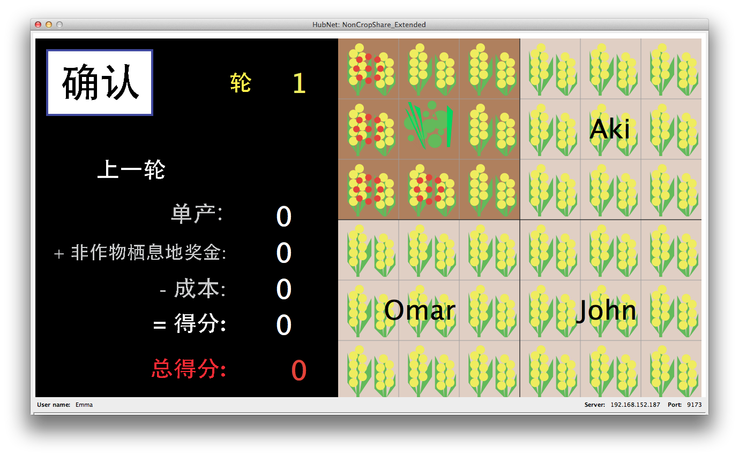

Player 4’s total score appears at the bottom of the screen in red, and right above it, the points that you earned during the last turn. This screen is from the first turn, so both of those numbers are still 0.

You can cycle through the choices for each square by clicking on the square itself, and we’ll practice that in a minute. When you’ve finished your turn, you can click ‘Confirm’ and wait for the other players to finish. Once you have confirmed, you can’t go back. Once everyone has confirmed, the round is over.

At the end of each turn, you’ll be able to see what happened across the landscape, and what the yields were for each square. You’ll also be able to see what each player earned during their turn. You’ll be able to see this in the practice session, which we’ll do in a moment.

Now, during the game you should feel free to talk to the other players about anything you like – the game, your moves, your life – anything you like. However, please do not show your screen to the other players. Keep that private.

One other note – you can change any of the 9 squares to any of the four land use choices you like, in each turn. At the beginning of each turn, land that was planted as non-crop habitat in the last turn, will default as non-crop habitat in the new turn. All other land will default as unsprayed crops; if you wish to spray, it needs to be redone each turn.

*[Note, we don’t show a sample here as we don’t wish to suggest any strategies]*

**PRACTICE [GP]**

We’ll just play a few short rounds now so that you get comfortable with the mechanics of the game. I’ll walk you through the first turn so you can see how it goes, and you can ask me questions during your turn or between rounds. I encourage you to use the practice session as an opportunity to explore different options and see what happens. Feel free to discuss with others, but please do keep your screen to yourself. The scores from the practice section will not be used to calculate your cash bonus.

*[walk through a 3-round practice game]*

Got it? *[answer any follow-up questions]*

Ok, let’s move on to the experiment

We are going to play 4 different games, each one of which will differ a little bit, and might change a bit from what we’ve done in the practice.

As you make your decisions, we’d like you to try to earn points, and that’s where the bonus comes in. At the end of the session, we’ll record the score for each player on the paper and pick one of the 4 games that you played and look at the scores. Each of you will receive a bonus of 2000 Riel for every 100 points you earn in the game. We aren’t going to tell you in advance which game we will choose to be the one we count.

Ok, let’s begin.

*[Each game group will play 4 treatments – 1, 2, 3 and 4 – but the order will be randomized. Thus, each treatment needs to be introduced in a way that does not depend on other treatments having been played first]*

**Treatment 1 [G1]**

*[No subsidy; moves of other players shown after everyone has confirmed]*

In this game, the settings are just like they were in the practice. Non-crop habitat has a yield of zero. You are free to discuss the game with the other players, but keep your screen to yourself. You’ll be able to see what’s going on at the end of each round. This game will last at least 8 rounds.

**Treatment 2 [G2]**

*[No subsidy; moves of other players shown as soon as they confirm]*

In this game, the settings are similar to what they were in the practice. Non-crop habitat has a yield of zero. You are free to discuss the game with the other players, but keep your screen to yourself. You’ll be able to see the choices that other players have made as soon as they confirm them. This game will last at least 8 rounds.

**Treatment 3 [G3]**

*[Subsidy of randomized value 1-10; moves of other players shown after everyone has confirmed]*

In this game, you are being offered a subsidy. For each square of non-crop habitat in your land, instead of earning a yield of zero, you’ll receive a subsidy of (RANDOM VARIABLE 1 -10). You are free to discuss the game with the other players, but keep your screen to yourself. You’ll be able to see what’s going on at the end of each round. This game will last at least 8 rounds.

**Treatment 4 [G4]**

*[Subsidy of randomized value 1-10, moves of other players shown as soon as they confirm]*

In this game, you are being offered a subsidy. For each square of non-crop habitat in your land, instead of earning a yield of zero, you’ll receive a subsidy of (RANDOM VARIABLE 1 -10). You are free to discuss the game with the other players, but keep your screen to yourself. You’ll be able to see the choices that other players have made as soon as they confirm them. This game will last at least 8 rounds.

[before we do the bonus, I’d like to ask you one question: SOCIAL NETWORK MATRIX]

[calculate bonus and hand out cash]