**MIDAS Bangladesh Application**

*SESYNC Pursuit - A forecast of the timing, locations, sequence and likeliest destinations of populations displaced by sea level rise and coastal extremes*

***Fall 2018***

*Coordinating Author Andrew Bell*

This application simulates the period from 2005 to 2015 as 44 quarterly annual timesteps with an additional (randomized) number of timesteps added to the beginning of the simulation as spin-up time. This document supplements the main MIDAS ODD documentation, describing data and submodels specific to this application and not general to MIDAS. Specifically, it summarizes our approach to estimating the following model inputs:

1. **Initial demographic distribution**
2. **Mortality and fertility**
3. **Additional modeled effects of demography**
4. **Social network structure**
5. **Utility layers**
6. **Moving costs**
7. **Remittance costs**

***1 Initial demographic distribution***

We model demography (age, gender, and location) at simulation start based on age- and gender-disaggregated district-level population data from the 2011 Bangladesh Population Census, made available via IPUMS International (Minnesota Population Center 2015). Specifically, for each agent initialized in a simulation, we assigned their location probabilistically based on census populations by district, then assigned gender probabilistically based on gender-disaggregated census populations within the assigned district, then finally assigned age probabilistically based on age-disaggregated census population within assigned gender and district. Age classification included the groups of 0 years, 1-4 years, 5-9 years and all 5-year groups up to 84, and a final group of 85-100 years.

***2 Mortality and Fertility***

Mortality data was taken from the Global Health Observatory data repository of the WHO (WHO 2015), with age- and gender-disaggregated mortality rates for age classes matching those of the Population Census data used for demographic distribution. Mortality rates are the same in all districts.

Fertility data was taken from the World Fertility Data 2012 dataset produced by the United Nations Department of Economic and Social Affairs (UNDESA 2013). Fertility rates are reported for females in age classes from 15-19 and all 5-year groups up to 49.

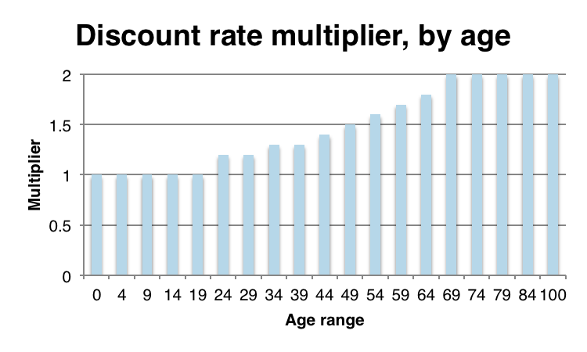

**Figure 1: Discount rate multiplier**

***3 Additional modeled effects of demography***

There is considerable flexibility in MIDAS to implement demography-specific effects on decision, structure, etc. In the current simulation, only one age-specific effect is implemented – a gradual increase in discount rate over time, such that older agents will discount the future more highly (and thus value possible returns from a change in portfolio less highly against the upfront costs). Agents’ individual discount rates are randomly distributed with distribution parameters included as calibration parameters; however, the factor by which their individual discount rates change over time is not. It is presently a fixed data input (Figure 1), but there is room to explore this and other demographic effects on decisions and behavior in model extensions.

***4 Social Network Structure***

Social network connections in MIDAS are non-directed links between two agents *i* and *j,* described by a strength between 0 and 1 that influences the degree and likelihood of information and resource sharing in a simulation (see main ODD for more detail). Social network connections decay over time and are strengthened through interaction, via parameters set during calibration.

The network of connections among agents is constructed following a simple model. The number of network connections *n* that an agent *i* ‘initiates’ is drawn from the normal distribution N(μn, σn), where both μn and σn are calibration parameters. This is repeated for all *i*, generating a list of network connections for which one end of the link is defined. The ordering of this list is randomized, and then for each link, an agent *j* is selected probabilistically to be the other end of the link (note – links are not directed in MIDAS). The model used for identifying the likelihood of selection of an agent used in this application develops a weighted score of three factors: shared network connections, physical distance, and shared layers. The shared network connection score is the sum of the strengths of all links agent *i* has with other agents also connected to agent *j*, normalized by the highest raw connection score across all agents *j*. The distance score is calculated from the distance between agent *i* and agent *j*, raised to a polynomial (chosen by calibration) and normalized by all distances to agents *j*, such that shorter distances have nonlinearly higher scores. The shared layer score is estimated by the number of layers in the same place that agent *i* and agent *j* both occupy, again normalized by the highest number of shared layers between agent *i* and any agent *j.* The weights allocated to each of these three scores are also found by calibration.

***5 Utility Layers***

We derived all utility layers for this simulation from three waves (2005, 2010, 2015) of the Bangladesh Household Income and Expenditure Survey (HIES). Utility in timesteps representing the years 2005 to 2015 are developed as described below; spin-up time periods are a repeating cycle of the year 2005.

A complete specification for a utility layer includes i) the utility stream over time, ii) the time commitment of the layer as a fraction of total available time, iii) a classification of the number of openings in the layer as ‘fixed’ (meaning only a certain number of agents may access the layer – e.g., a limited number of teaching jobs in a district) or ‘open’ (meaning no restriction on access, though the value of the layer may decline with excess occupation – e.g., too many taxi drivers competing for fares drives down individual earnings) and iv) a cost for initially accessing the layer, which may allow an agent to access the same layer in other places (e.g., passing a certification valid anywhere in a state or country) or only in one place (e.g., buying an immovable asset like a house). We describe below our identification of the set of included income sources as utility layers, and the estimation of these three properties of the included utility layers.

*5.1 Included layers*

We identified all income layers recorded in the survey as:

1. Remittance income
2. Transfer income
3. Rest of other income (including rental income)
4. Annual wage income
5. Annual in-kind income
6. Annual salary income
7. Sugarcane income
8. Jute income
9. Wheat income
10. Boro rice income
11. Aman rice income
12. Aus rice income
13. Oilseed income
14. Pulse income
15. Maize income
16. Income from other crops
17. Total livestock sales
18. Total fish sales
19. Total tree sales

We summed all income sources at the household level, and classified households into four income quartiles (Q4 highest, Q1 lowest).

Next, we selected income layers for inclusion in our model – we chose to exclude income sources 1, 2, and 5 (remittance, transfer, and in-kind) as those sources would be treated through social network interactions in MIDAS, making these layers more appropriate as possible calibration data; additionally, we excluded income sources 17 through 19 (livestock, fish, and tree sales) as at least one of these streams (livestock) appeared to have a larger order of magnitude than other sources, suggesting that they may not be directly interpretable as income (and rather, as revenue).

*5.2 Utility Stream*

We use the following formula for utility or ‘value’ for layer *i* in a particular place *j* at time *t*:

|  |  |  |
| --- | --- | --- |
|  |  |  |

where *Vbase,ijt* is a base rate for the utility value estimated from reported income, as described below; *nexpected,ij* is the expected number of agents occupying the layer, obtained by scaling the number of observed occupants of a layer in the HIES by *nagents / nHIES*, the ratio of the number of agents in the simulation to number of people in the HIES sample; *nactual,ij* is the number of agents actually occupying the layer; and *m* and *k* are parameters that shape how utility declines as the number of actual occupants exceeds the number of expected occupants. All agents occupying layer *i* in a particular place *j* at time *t* derive the same value from the stream, but have agent-specific coefficients specifying their utility on a unit of value from a particular source.

To develop the values *Vbase,ijt* for the included layers, we used our initial classification of households into income quartiles to identify average earnings per layer by members of a particular quartile in a particular district (e.g., what do Q1 households earn on average in sugarcane income in Bogra?). Our dataset included values for each of the years 2005, 2010, and 2015 for each of 13 included income sources, each broken into four quartile layers, for each of 64 districts. We used Matlab’s *interp* function to estimate the interior annual averages 2006-2009, 2011-2014.

At this point we have an array of 52 layers x 64 districts x 11 years. However, this application of MIDAS uses a quarterly annual time periods (i.e., four time periods per annual cycle, and 44 time periods in 11 years), so that annual income must be attributed to one or more of these steps. We assumed income sources 3, 4, 6, and 16 to be spread equally across all 4 quarterly periods (P), and consulted an agricultural calendar for Bangladesh (BBS 2017) for approximate harvest periods for crop income, such that the fraction of annual income earned in each quarter, for each layer, is as follows:

**Table 1: Annual income spread across quarterly periods, by income source**

|  |  |  |  |  |  |  |  |  |  |  |  |  |  |
| --- | --- | --- | --- | --- | --- | --- | --- | --- | --- | --- | --- | --- | --- |
|  | Rest of other income | Wage income | Salary income | Sugarcane income | Jute income | Wheat income | Boro rice income | Aman rice income | Aus rice income | Oilseed income | Pulse income | Maize income | Income from other crops |
| P1 | 0.25 | 0.25 | 0.25 | 1 | 0 | 1 | 0 | 0 | 0 | 0.25 | 1 | 0 | 0.25 |
| P2 | 0.25 | 0.25 | 0.25 | 0 | 0 | 0 | 1 | 0 | 0 | 0.25 | 0 | 1 | 0.25 |
| P3 | 0.25 | 0.25 | 0.25 | 0 | 1 | 0 | 0 | 0 | 1 | 0.25 | 0 | 0 | 0.25 |
| P4 | 0.25 | 0.25 | 0.25 | 0 | 0 | 0 | 0 | 1 | 0 | 0.25 | 0 | 0 | 0.25 |

We spread each annual average across four periods according to the table above, giving us the complete array *Vbase* of size 52x64x44.

Each simulation includes a spinup time of random length (8 to 20 periods in this application); these are treated as repeated cycles of the year 2005.

*5.3 Time constraints*

We estimated time constraints specific to layers from each income quartile, for each place, in a two step procedure.

First, we identified quarters in which income sources would demand an agent’s time as follows: we assumed income sources 3, 4, 6, and 16 to take time across all four quarterly periods, and consulted an agricultural calendar for Bangladesh (BBS 2017) for approximate sowing and harvest periods, such that quarters in which a layer demands time from an agent, for each layer, is as follows:

**Table 2: Quarterly periods requiring effort, by income source**

|  |  |  |  |  |  |  |  |  |  |  |  |  |  |
| --- | --- | --- | --- | --- | --- | --- | --- | --- | --- | --- | --- | --- | --- |
|  | Rest of other income | Wage income | Salary income | Sugarcane income | Jute income | Wheat income | Boro rice income | Aman rice income | Aus rice income | Oilseed income | Pulse income | Maize income | Income from other crops |
| P1 | 1 | 1 | 1 | 1 | 1 | 0 | 1 | 0 | 0 | 1 | 1 | 1 | 1 |
| P2 | 1 | 1 | 1 | 1 | 1 | 0 | 1 | 0 | 1 | 1 | 0 | 1 | 1 |
| P3 | 1 | 1 | 1 | 1 | 0 | 0 | 0 | 1 | 1 | 1 | 0 | 0 | 1 |
| P4 | 1 | 1 | 1 | 1 | 0 | 1 | 0 | 1 | 0 | 1 | 1 | 1 | 1 |

Second, we calibrated time constraints such that income diversity for agents in each income quartile in the simulation could match that observed in the HIES. Generally speaking, respondents in higher income quartiles in the HIES tended to have more diversified incomes (Figure XXX), with the poorest quartile having 0 or 1 sources on average, and the richest quartiles having 3 or 4.

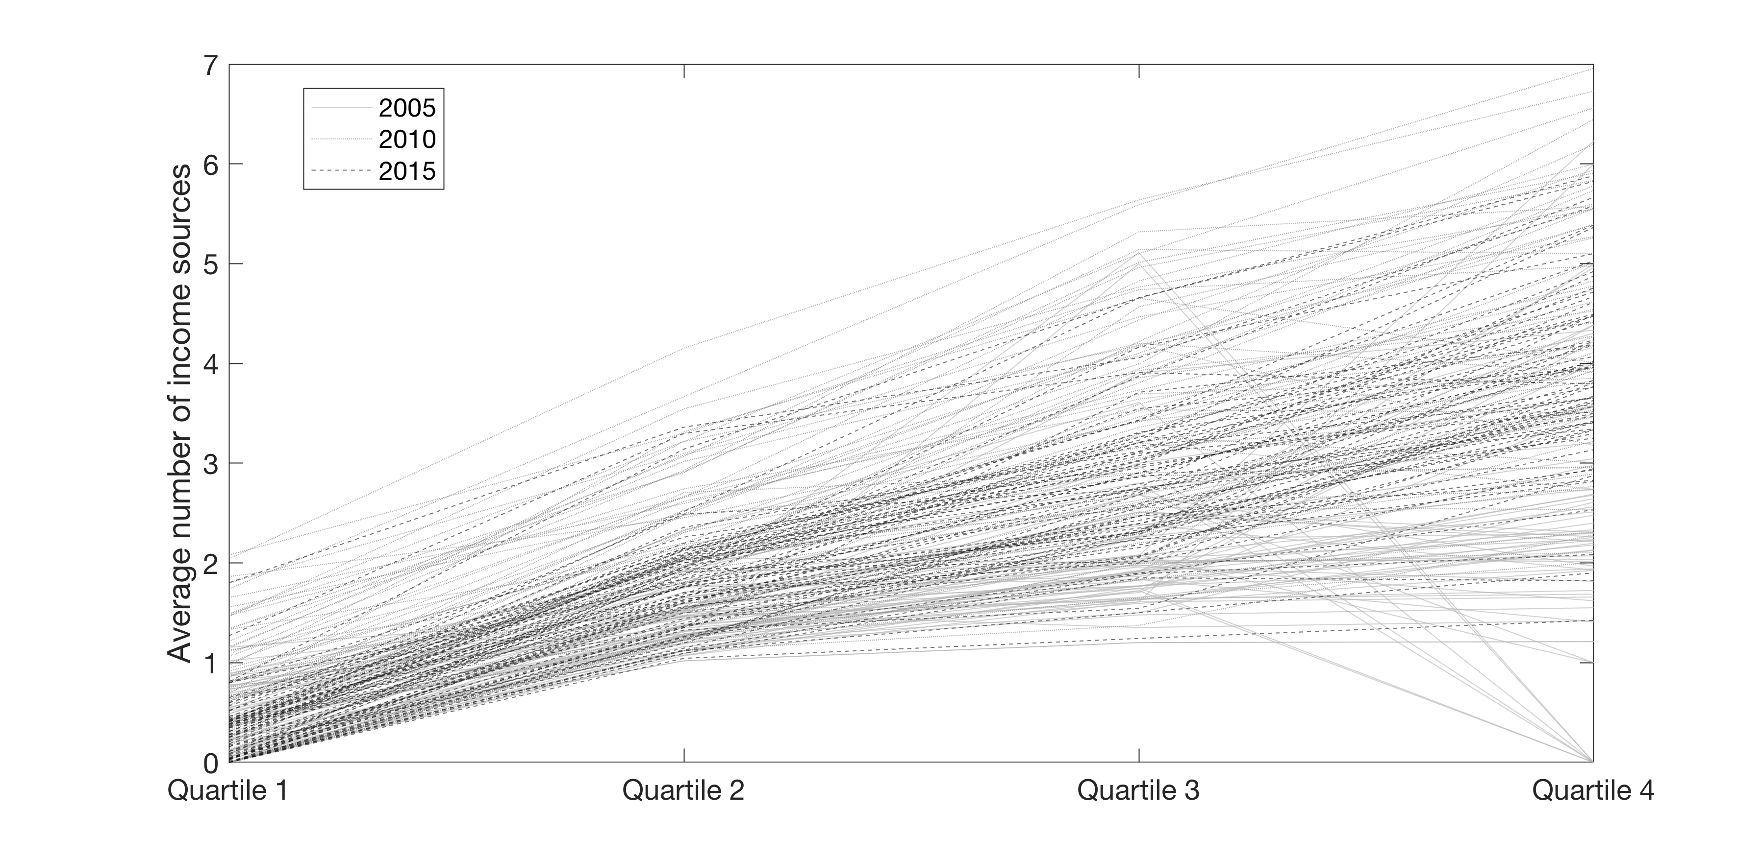

**Figure 2: Average number of income sources, by income quartile, in the HIES. Each line represents one district in one wave (2005, 2010, or 2015) of the HIES.**

We used the data displayed in Figure 2 to estimate appropriate time constraints for each district, averaging across survey waves to generate one set of average income source counts for each quartile *i*. We specified that for each income source, the *i-1th* income quartile layer was a **prerequisite** (see main ODD for explanation of prerequisites) for the *ith* layer (e.g., to be a Q3 boro rice earner, an agent must also be occupying Q1 and Q2 for boro rice), and estimated time constraints such that the cumulative time constraint of layers 1 through *i* would allow an agent to occupy the expected number of layers at income quartile *i,* with a small amount of random noise added to the calculation. Consider the following example:

**Table 3: Example time constraint calculation along quartiles from same income source**

|  |  |  |  |
| --- | --- | --- | --- |
| **Quartile** | **Additional time constraint** | **Cumulative time constraint** | **Maximum possible layers within time constraint ( < 1)** |
| **Q1** | 0.95 | 0.95 | 1 |
| **Q2** | -0.475 | 0.475 | 2 |
| **Q3** | -0.15833 | 0.31667 | 3 |
| **Q4** | -0.0792 | 0.23747 | 4 |

In this example, the first-quartile layer for the income source has a time constraint of 0.95 (95% of an agent’s time), such that it is the only layer the agent can occupy. The second-quartile layer of the same source has a marginal time constraint of -0.475, such that the combined time constraint is 0.475, allowing up to 2 layers of similar time constraint to be occupied. In the agricultural case, this might represent an agent purchasing more property but also mechanizing and capturing economies of scale (in both time and income, perhaps).

*5.4 Fixed and open layers*

We specified all agricultural layers as ‘open,’ meaning that there were not a defined number of slots, but that the earned income from each layer may decline (depending on the values *m* and *k* in Eqn. 1) as the number of agents occupying the layer exceeded those expected (i.e., proportional to the HIES). We specified the layers ‘rest of other income’ (which we believe to largely be property income), wage income, and salary income as ‘fixed,’ with a hard number of slots that could not be exceeded:

**Table 4: Fixed or open layers, by income source**

|  |  |  |  |  |  |  |  |  |  |  |  |  |  |
| --- | --- | --- | --- | --- | --- | --- | --- | --- | --- | --- | --- | --- | --- |
|  | Rest of other income | Wage income | Salary income | Sugarcane income | Jute income | Wheat income | Boro rice income | Aman rice income | Aus rice income | Oilseed income | Pulse income | Maize income | Income from other crops |
| Fixed? | Yes | Yes | Yes | No | No | No | No | No | No | No | No | No | No |

For layers that are fixed, agents have a belief about the likelihood of actually gaining a slot, which allows them to estimate the expected utility from that layer. This belief is updated through their social networks (i.e., I heard from my cousin that company X in place Y was hiring; see main ODD for mechanism); agents may choose to migrate based on an expected utility, but in the end not gain access to the layer.

*5.5 Access Costs*

Access costs are coded in MIDAS as a list of discrete cost items that may be associated with one or more layers; in turn, layers may be associated with one or more access costs. This allows representation, for instance, of the cost of multiple certifications in order to be able to practice law in a particular place (and the additional costs at the margin to transfer those credentials to a new place). It also allows representation of immobile assets such as properties, by specifying unique and separate access costs to access a ‘property’ layer in different places, for example.

In the current application, we include only income streams, but make the following assumption – that the costs of accessing sources 4 and 6 (wage and salary income) allow agents to access those sources in all parts of Bangladesh; i.e., they are transferrable qualifications. All other sources represent earnings from assets (properties in the case of source 3; farm land in all other cases), which we treat as immovable. **The present application does not include the possibility of selling assets to facilitate a move, though this is a possible area for extension if model findings indicate that it is a relevant constraint.**

Rather than try to identify from an additional data source the likely costs of purchasing land, buildings, or accessing wage and salary levels – which could be unavailable or inconsistent – we applied a simple model to generate plausible access costs for each layer, based on an underlying assumption of a reasonable expected rate of return on investment. The fraction of an investment that must be recovered each year of a project in order to break even, known as the uniform series capital cost recovery factor, is defined as:

|  |  |  |
| --- | --- | --- |
|  |  |  |

Where *A* is the annual return in each of *n* project years, *P* is the upfront cost, and *i* is the discount rate. We leverage this model to estimate the reasonable investment costs to earn a return on investment *r* as:

|  |  |  |
| --- | --- | --- |
|  |  |  |

The value of *P* is used as the cost of accessing a layer with average annual return *A*. Values for *r*, *i*, and *n* are estimated as calibration parameters, with the same values applied to all layers in the simulation.

***6 Moving costs***

We did not have data to estimate moving costs in this simulation, and set them to 0.

***7 Remittance costs***

We did not have data to estimate remittance costs in this simulation, and set them to 0.

***Literature Cited***

BBS. 2017. “Yearbook of Agricultural Statistics-2016.” Dhaka, Bangladesh. http://bbs.portal.gov.bd/sites/default/files/files/bbs.portal.gov.bd/page/1b1eb817_9325_4354_a756_3d18412203e2/Yearbook-2016-Final-19-06-2017.pdf.

Minnesota Population Center. 2015. “Integrated Public Use Microdata Series, International: Version 6.4 [Dataset].” Minneapolis, MN: University of Minnesota. doi:10.18128/D020.V6.4.

UNDESA. 2013. “World Fertility Data 2012.”

WHO. 2015. “Global Health Observatory Data Repository.”