Andrew Pester

2/14/2021

Homework 2

For this assignment I created the first validation form which asks for the name gender and state. The gender and state must be selected to be approved and the first and last name are alphanumeric. If they are not approved, they print the messages below. 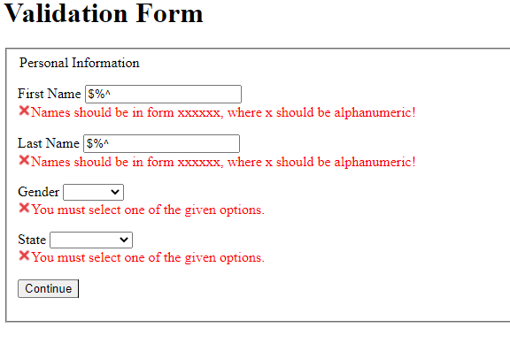

The screen will not change until all are in the correct form then the program waits for one second to show that everything is validated then goes to the next page. Below is what happens if validation is successful. The code to check all of this is based off of the examples we were given.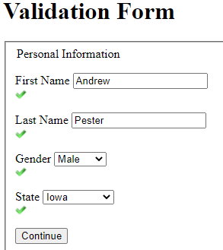

Next on validation 2 the check email is identical to that of the example we were given and then the phone number and address were using similar ideas just modifying the code a bit. Below is the incorrect outputs.

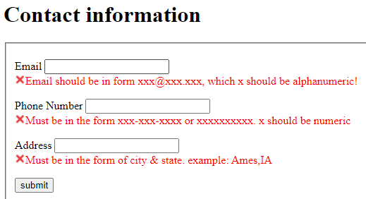

Then if the correct values are entered the result will look like below.

