Reality Commons Project
Social Evolution Datasets

Preliminary Assessment of the Data
Participants in the experiment were tracked in a multitude of ways. Their proximity to each other was tracked via Bluetooth devices, their calls and texts were tracked via their cellphones, and different personal preferences such as musical taste, political opinions, health (cold and flu symptoms), fitness activities, friendship with each other, and eating habits were tracked via survey. We viewed the CSV data using spreadsheets and reviewed the papers and visualizations on the Reality Commons website before deciding that the most fruitful data were probably the proximity and communication (call/SMS) data, and that we would supplement it with the participants' musical taste and political opinions. The latter two items were less likely to change over time and could be seen as "attributes" of each person, while we examine the participants' changing relationships with each other by way of the changing frequency of communications between them over time.

Andrew: "Graphing the final tallies as pairwise edge weights, and then poking around a bit with different personality/preference variables might give us a sense for which features were driving communication between subjects."

First Prototype, using proximity data:

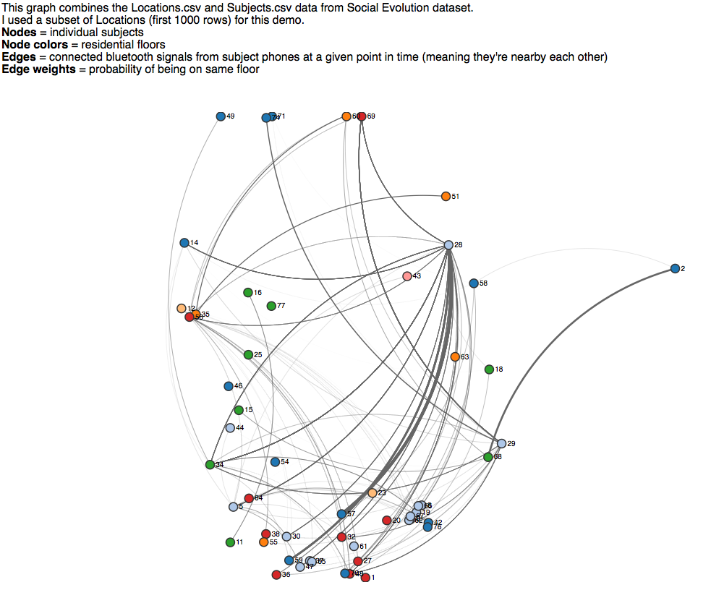

Initial Data Cleanup
We knew we wanted to explore the communication network between participants. There was communication data in disparate CSV files; there was also the challenge of aggregating the time-stamped events into snapshots of defined time periods so the visualizations could show transitions over time. We created a data file that combined Call and SMS data, grouping the senders and recipients into source/target pairs and tallying the count of communications for two-week chunks of time.
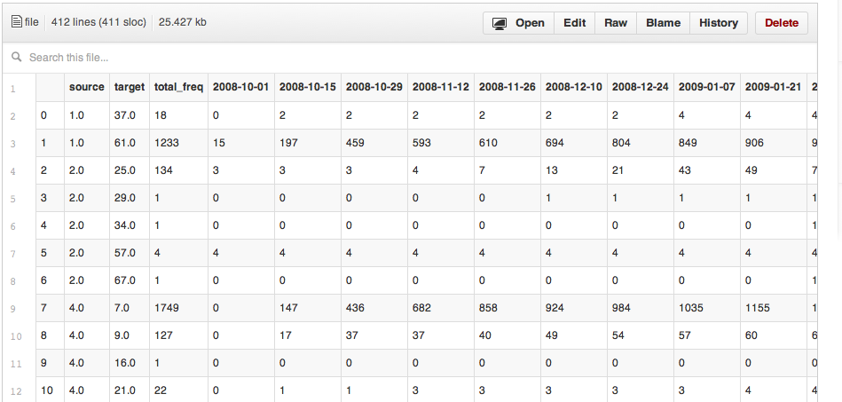

Wrangling the Proximity data presented some unforeseen challenges. While using Queue.js to attempt to load in several data files, Brian found that the full file of Proximity data, over 2 million rows, caused the process to crash for unknown reasons. Attempts to solve this included: using the Zap Gremlins feature in TextWrangler; loading the file into Google Refine and exporting a CSV; splitting the file into three parts and attacking it piece by piece. None of these worked, so Proximity.csv was set aside for the time being. After successfully wrangling the combined call/SMS data (above), a similar pattern was used to tame the Proximity data (using Python).

Different issues arose with MusicGenreImmersion data. In this dataset, users indicate the amount of time they spend listening to each listed genre, such as showtunes or heavy metal/hardcore. We wished to track the musical preferences as attributes of a person, but each person might select more than one genre of music. A given person's musical taste does not seem to change much over time.

Brian: "This data is a good example of data that may not be so useful as individual observations, but may be useful as an aggregate. I load the data, and materialize the aggregate."

Example of aggregate musical taste data:
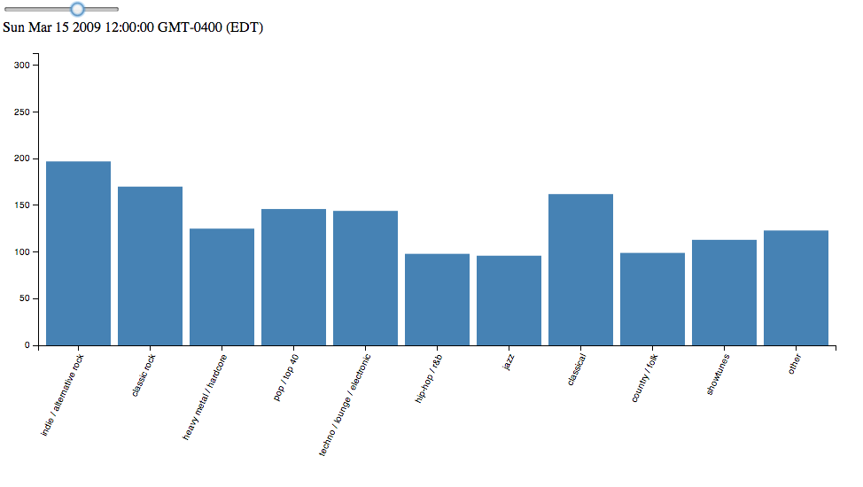
We noticed that a person's musical taste profile usually doesn't change much over time, so a time series may not be a useful visualization. Instead, the user's aggregate preference may be used as an "attribute" of that person, and we may compare the overall taste profile of two persons who have a relationship--for example, two persons who call each other frequently.

