**BGGN-213: FOUNDATIONS OF BIOINFORMATICS**

The find-a-gene project assignment <http://thegrantlab.org/bggn213>

Dr. Barry Grant

**Overview:**

The find-a-gene project is a required assignment for BGGN-213. You should prepare a written report in **PDF** format that has responses to each question labeled **[Q1] - [Q10]** below. You may wish to consult the scoring rubric at the end of this document and the example report provided online (note that the example report is from a previous quarter and the questions may differ).

The objective with this assignment is for you to demonstrate your grasp of database searching, sequence analysis, structure analysis and the R environment that we have covered in class.

**Due Date:**

Your responses to questions Q1-Q4 are due at 12pm on the **Monday of Week 5** (see the Assignments and Grading section of our website for details). Note that these first set of answers can be obtained very quickly (at best within 15 or 20 minutes), so if you don’t succeed at first, just keep trying.

The complete assignment, including responses to all questions, is due at 12pm on the **Monday of Week 10**.

**Submission instructions:**

Your report formatted as a **PDF document** should be uploaded to ***GradeScope****.* Please make sure to include your UCSD email and PID number on the first page.

**Be sure to include your UCSD email and PID number on the first page of your report.**

Submit your preliminary report with answers to Q1-Q4 as soon as you can so we can determine if you have found a novel gene. Submit this preliminary report as one document with screen shots of the results inserted appropriately.

See the demonstration report linked to on the course website for an example of format but note that questions there may differ as it is from a previous quarter. I will email you my decision; proceed with subsequent questions only after we are sure you have found a novel gene (and thus be successful in the later stages of the project).

For the final report add your results for Q5-Q10 to the preliminary report and submit the final document containing your results for all questions - **Please do not send only Q5-Q10 answers as the final report**.

**Questions:**

[**Q1**] Tell me the name of a protein you are interested in. Include the species and the accession number. This can be a human protein or a protein from any other species as long as it's function is known.

If you do not have a favorite protein, select human RBP4 or KIF11. Do not use beta globin as this is in the worked example report that I provide you with online.

**Name: ECT-2**

**Function: activates Rho GTPases and controls cytokinesis and many other cellular processes**

**Accession number: NP_001245244 Species: Human**

[**Q2**] Perform a BLAST search against a DNA database, such as a database consisting of genomic DNA or ESTs. The BLAST server can be at NCBI or elsewhere. Include details of the BLAST method used, database searched and any limits applied (e.g. Organism).

**Method: tBLASTN general search Database : Expressed sequence tags (EST) Organism: None**

Also include the output of that BLAST search in your document. If appropriate, change the font to Courier size 10 so that the results are displayed neatly. You can also screen capture a BLAST output (e.g. alt print screen on a PC or on a MAC press ⌘-shift-4. The pointer becomes a bulls eye. Select the area you wish to capture and release. The image is saved as a file called Screen Shot [].png in your Desktop directory). It is **not** necessary to print out all of the blast results if there are many pages.

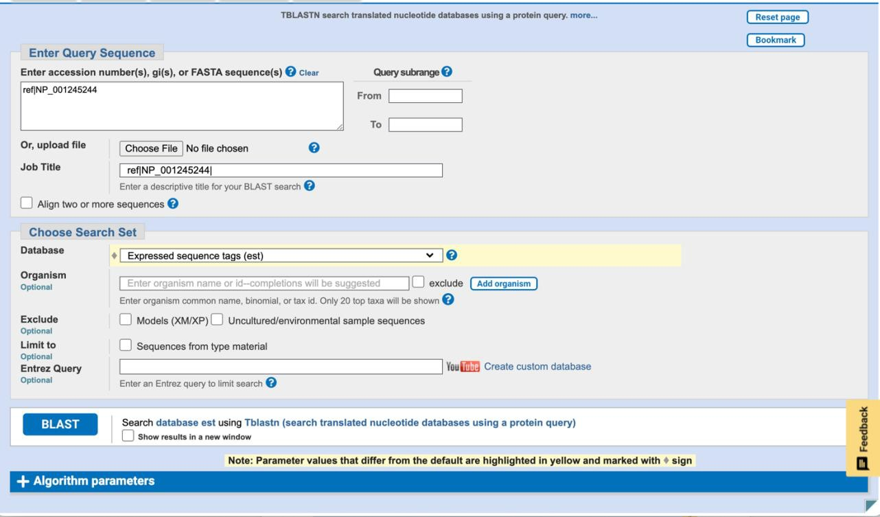

On the BLAST results, clearly indicate a match that represents a protein sequence, encoded from some DNA sequence, that is homologous to your query protein. I need to be able to inspect the pairwise alignment you have selected, including the E value and score. It should be labeled a "genomic clone" or "mRNA sequence", etc. - but include no functional annotation.

**Chosen match: Accession number: BU511372.1 1204 base pair mRNA sequence from Mus Musculus**

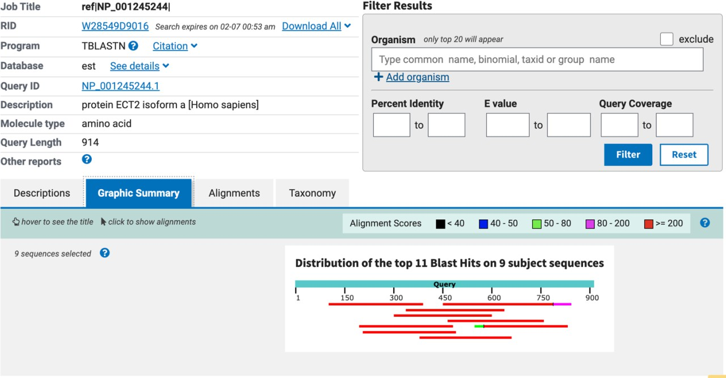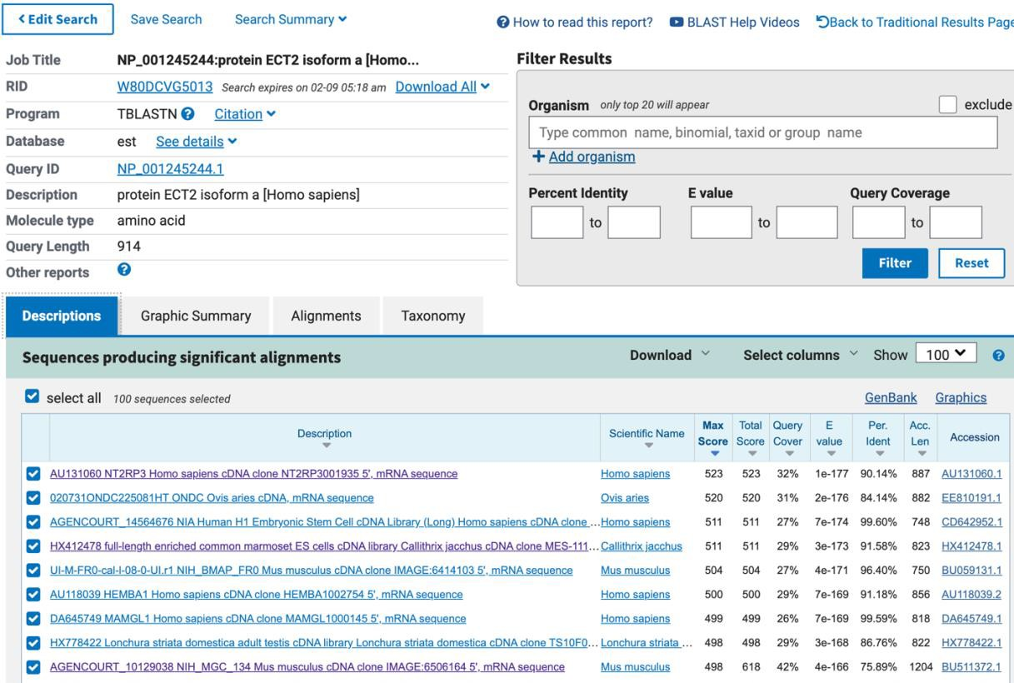

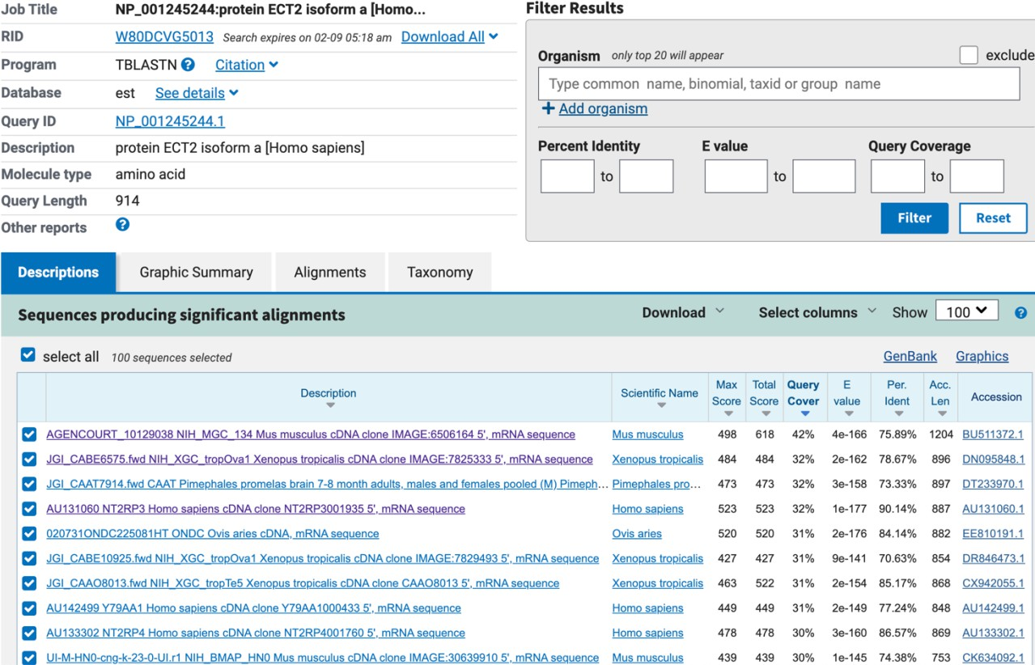**Refiltered with highest query cover**

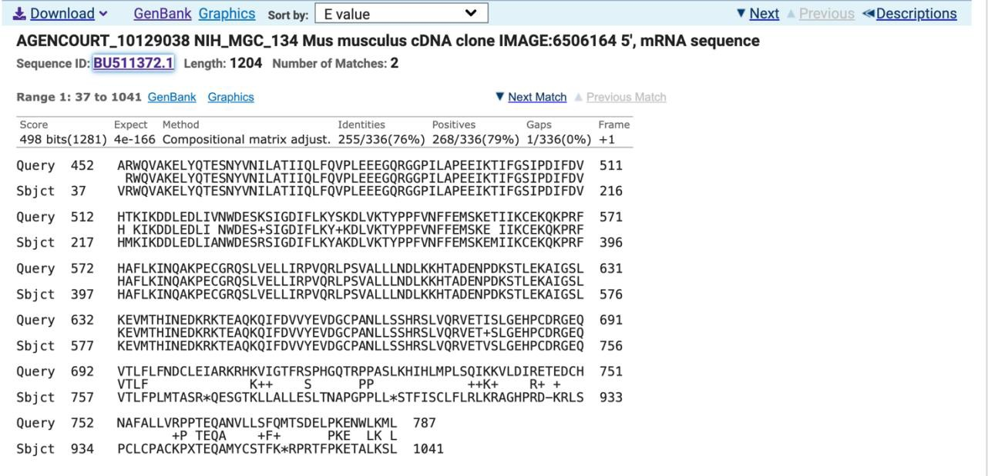

**AGENCOURT_10129038 NIH_MGC_134 Mus musculus cDNA clone IMAGE:6506164 5', mRNA sequence**

**Sequence ID:** [**BU511372.1**](https://www.ncbi.nlm.nih.gov/nucleotide/BU511372.1?report=genbank&log%24=nuclalign&blast_rank=1&RID=W28549D9016)**Length: 1204Number of Matches: 2**

Range 1: 37 to 1041[GenBank](https://www.ncbi.nlm.nih.gov/nucleotide/BU511372.1?report=genbank&log%24=nuclalign&blast_rank=1&RID=W28549D9016&from=37&to=1041)[Graphics](https://www.ncbi.nlm.nih.gov/nuccore/BU511372.1?report=graph&rid=W28549D9016%5bBU511372.1%5d&tracks=%5bkey%3Asequence_track%2Cname%3ASequence%2Cdisplay_name%3ASequence%2Cid%3ASTD1%2Ccategory%3ASequence%2Cannots%3ASequence%2CShowLabel%3Atrue%5d%5bkey%3Agene_model_track%2CCDSProductFeats%3Afalse%5d%5bkey%3Aalignment_track%2Cname%3Aother%20alignments%2Cannots%3ANG%20Alignments%7CRefseq%20Alignments%7CGnomon%20Alignments%7CUnnamed%2Cshown%3Afalse%5d&v=0%3A1091&appname=ncbiblast&link_loc=fromHSP)Next MatchPrevious Match

**Alignment statistics formatch #1**

|  |  |  |  |  |  |  |
| --- | --- | --- | --- | --- | --- | --- |
| Score | | Expect Method | Identities | Positives | | Gaps |
| 498 bits(1281) | | 4e-166 Compositional matrix adjust. | 255/336(76%) | 268/336(79%) | | 1/336(0%) |
| Query  Sbjct | 452  37 | ARWQVAKELYQTESNYVNILATIIQLFQVPLEEEGQRGGPILAPEEIKTIFGSIPDIFDV RWQVAKELYQTESNYVNILATIIQLFQVPLEEEGQRGGPILAPEEIKTIFGSIPDIFDV VRWQVAKELYQTESNYVNILATIIQLFQVPLEEEGQRGGPILAPEEIKTIFGSIPDIFDV | | | 511  216 | |
| Query  Sbjct | 512  217 | HTKIKDDLEDLIVNWDESKSIGDIFLKYSKDLVKTYPPFVNFFEMSKETIIKCEKQKPRF H KIKDDLEDLI NWDES+SIGDIFLKY+KDLVKTYPPFVNFFEMSKE IIKCEKQKPRF HMKIKDDLEDLIANWDESRSIGDIFLKYAKDLVKTYPPFVNFFEMSKEMIIKCEKQKPRF | | | 571  396 | |
| Query  Sbjct | 572  397 | HAFLKINQAKPECGRQSLVELLIRPVQRLPSVALLLNDLKKHTADENPDKSTLEKAIGSL HAFLKINQAKPECGRQSLVELLIRPVQRLPSVALLLNDLKKHTADENPDKSTLEKAIGSL HAFLKINQAKPECGRQSLVELLIRPVQRLPSVALLLNDLKKHTADENPDKSTLEKAIGSL | | | 631  576 | |
| Query  Sbjct | 632  577 | KEVMTHINEDKRKTEAQKQIFDVVYEVDGCPANLLSSHRSLVQRVETISLGEHPCDRGEQ KEVMTHINEDKRKTEAQKQIFDVVYEVDGCPANLLSSHRSLVQRVET+SLGEHPCDRGEQ KEVMTHINEDKRKTEAQKQIFDVVYEVDGCPANLLSSHRSLVQRVETVSLGEHPCDRGEQ | | | 691  756 | |
| Query | 692 | VTLFLFNDCLEIARKRHKVIGTFRSPHGQTRPPASLKHIHLMPLSQIKKVLDIRETEDCH | | | 751 | |
| Sbjct | 757 | VTLF K++ S PP ++K+ R+ + VTLFPLMTASR*QESGTKLLALLESLTNAPGPPLL*STFISCLFLRLKRAGHPRD-KRLS | | | 933 | |
| Query  Sbjct | 752  934 | NAFALLVRPPTEQANVLLSFQMTSDELPKENWLKML 787  +P TEQA +F+ PKE LK L PCLCPACKPXTEQAMYCSTFK*RPRTFPKETALKSL 1041 | | |  | |

Range 2: 774 to 1202[GenBank](https://www.ncbi.nlm.nih.gov/nucleotide/BU511372.1?report=genbank&log%24=nuclalign&blast_rank=1&RID=W28549D9016&from=774&to=1202)[Graphics](https://www.ncbi.nlm.nih.gov/nuccore/BU511372.1?report=graph&rid=W28549D9016%5bBU511372.1%5d&tracks=%5bkey%3Asequence_track%2Cname%3ASequence%2Cdisplay_name%3ASequence%2Cid%3ASTD1%2Ccategory%3ASequence%2Cannots%3ASequence%2CShowLabel%3Atrue%5d%5bkey%3Agene_model_track%2CCDSProductFeats%3Afalse%5d%5bkey%3Aalignment_track%2Cname%3Aother%20alignments%2Cannots%3ANG%20Alignments%7CRefseq%20Alignments%7CGnomon%20Alignments%7CUnnamed%2Cshown%3Afalse%5d&v=753%3A1223&appname=ncbiblast&link_loc=fromHSP)Next MatchPrevious Match[First Match](https://blast.ncbi.nlm.nih.gov/Blast.cgi#hsp22817605_1)

**Alignment statistics formatch #2**

Score Expect Method Identities Positives Gaps

120 bits(300) 9e-26 Compositional matrix adjust. 76/147(52%) 89/147(60%) 4/147(2%)

|  |  |  |  |
| --- | --- | --- | --- |
| Query | 698 | NDCLEIARKRHKVIGTFRSPHGQTRPPASLKHIHLMPLSQIKKVLDIRETEDCHNAFALL | 757 |
| Sbjct | 774 | +DCLEIARKRHKVIGTFR H +TRPPASLKHIHLMPLSQIKK + + L HDCLEIARKRHKVIGTFRKSHERTRPPASLKHIHLMPLSQIKKGWTSERQKIVTMPLSCL | 953 |
| Query | 758 | VRPPTEQANVLLSFQMTSDELPKENWLKMLCRHVANTICKADAENLIYTADPESFEVNTK | 817 |
| Sbjct | 954 | +VLL+FQMTS +LPK N LK+ ++ T+CK A NL+ DP F+ N K  -*AXNRTGHVLLNFQMTSKDLPKGNCLKIFA-NIYPTLCKGKAGNLLDGLDPNPFKKN-K | 1124 |
| Query  Sbjct | 818  1125 | DMDSTLSRASRAIKKTSKKVTRAFSFS 844 DS A K SKK TR F FS  RWDSHWG-ALLNH*KNSKKGTRGFLFS 1202 |  |

In general, [Q2] is the most difficult for students because it requires you to have a “feel” for how to interpret BLAST results. You need to distinguish between a perfect match to your query (i.e. a sequence that is not “novel”), a near match (something that might be “novel”, depending on the results of [Q4]), and a non-homologous result.

If you are having trouble finding a novel gene try restricting your search to an organism that is poorly annotated.

[**Q3**] Gather information about this “novel” **protein**. At a minimum, show me the protein sequence of the “novel” protein as displayed in your BLAST results from [Q2] as FASTA format (you can copy and paste the aligned sequence subject lines from your BLAST result page if necessary) or translate your novel DNA sequence using a tool called

EMBOSS Transeq at the EBI. Don’t forget to translate all six reading frames; the ORF (open reading frame) is likely to be the longest sequence without a stop codon. It may not start with a methionine if you don’t have the complete coding region. Make sure the sequence you provide includes a header/subject line and is in traditional FASTA format.

**Chosen Sequence: protein sequence translated using EBI Transeq of cDNA**

**sequence from NCBI.**

>1-1092_1 AGENCOURT_10129038 NIH_MGC_134 Mus musculus cDNA clone IMAGE:6506164

5', mRNA sequence SRSSTPVPPKQSVRWQVAKELYQTESNYVNILATIIQLFQVPLEEEGQRGGPILAPEEIK TIFGSIPDIFDVHMKIKDDLEDLIANWDESRSIGDIFLKYAKDLVKTYPPFVNFFEMSKE MIIKCEKQKPRFHAFLKINQAKPECGRQSLVELLIRPVQRLPSVALLLNDLKKHTADENP DKSTLEKAIGSLKEVMTHINEDKRKTEAQKQIFDVVYEVDGCPANLLSSHRSLVQRVETV SLGEHPCDRGEQVTLFPLMTASR*QESGTKLLALLESLTNAPGPPLL*STFISCLFLRLK RAGHPRDKRLSPCLCPACKPXTEQAMYCSTFK*RPRTFPKETALKSLPTFTQPFVRAKLE IFWM

Here, tell me the name of the novel protein, and the species from which it derives. It is very unlikely (but still definitely possible) that you will find a novel gene from an organism such as *S. cerevisiae*, human or mouse, because those genomes have already been thoroughly annotated. It is more likely that you will discover a new gene in a genome that is currently being sequenced, such as bacteria or plants or protozoa.

**Name: Mus ECT-2 protein Species: Mus musculus**

**Eukaryota; Metazoa; Chordata; Craniata; Vertebrata; Euteleostomi; Mammalia; Eutheria; Euarchontoglires; Glires; Rodentia; Myomorpha; Muroidea; Muridae; Murinae; Mus; Mus.**

[**Q4**] Prove that this gene, and its corresponding protein, are novel. For the purposes of this project, “novel” is defined as follows. Take the protein sequence (your answer to [Q3]), and use it as a query in a blastp search of the nr database at NCBI.

* If there is a match with 100% amino acid identity to a protein in the database, from the same species, then your protein is NOT novel (even if the match is to a protein with a name such as “unknown”). Someone has already found and annotated this sequence, and assigned it an accession number.
* If the top match reported has less than 100% identity, then it is likely that your protein is novel, and you have succeeded.
* If there is a match with 100% identity, but to a different species than the one you started with, then you have likely succeeded in finding a novel gene.
* If there are no database matches to the original query from [Q1], this indicates that you have partially succeeded: yes, you may have found a new gene, but no, it is not actually homologous to the original query. You should probably start over.

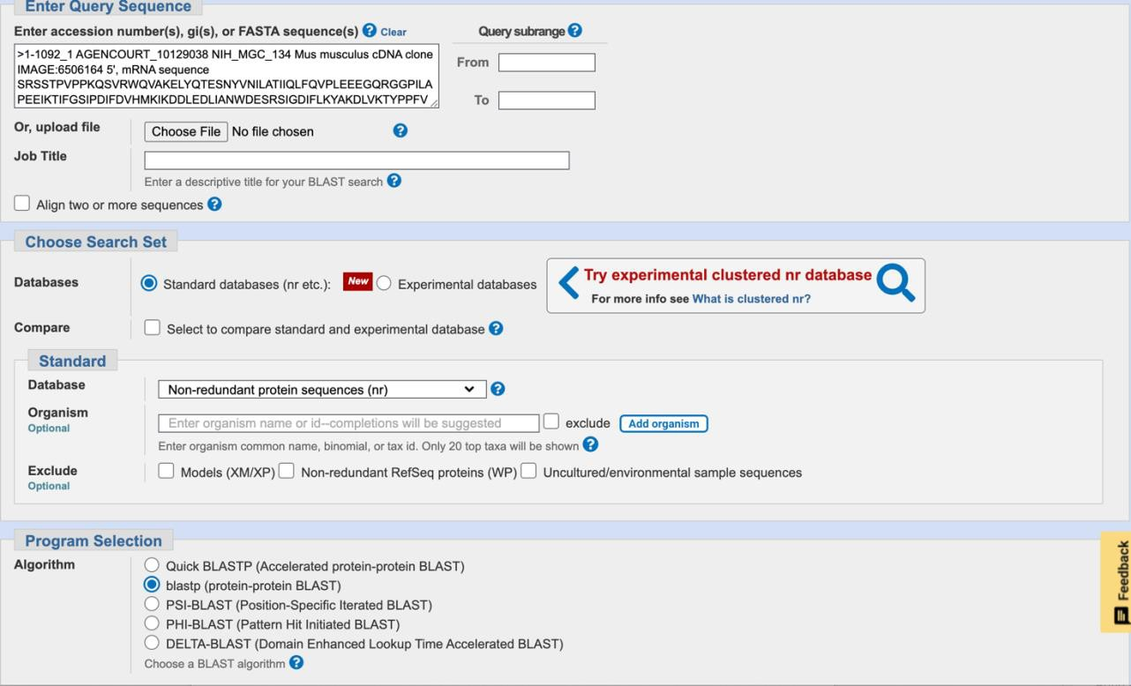

**Top hits are from Mus musculus**

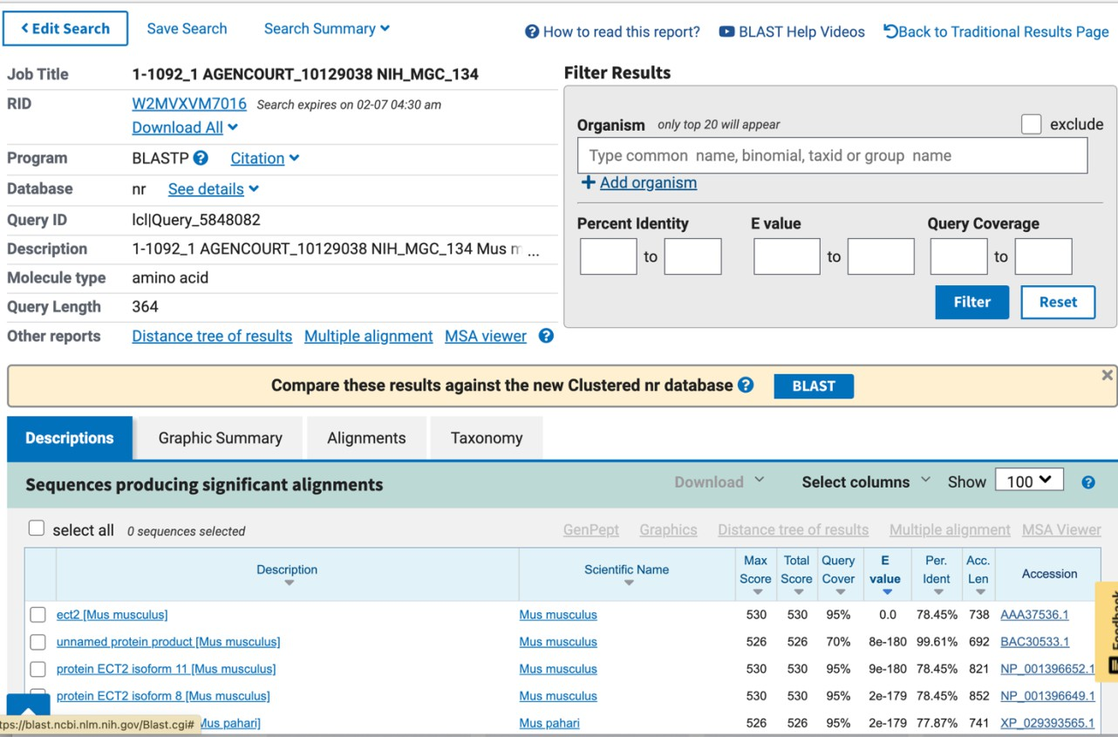

[**Q5**] Generate a multiple sequence alignment with your novel protein, your original query protein, and a group of other members of this family from different species. A typical number of proteins to use in a multiple sequence alignment for this assignment purpose is a minimum of 5 and a maximum of 20 - although the exact number is up to you. Include the multiple sequence alignment in your report. Use Courier font with a size appropriate to fit page width.

Side-note: Indicate your sequence in the alignment by choosing an appropriate name for each sequence in the input unaligned sequence file (i.e. edit the sequence file so that the species, or short common, names (rather than accession numbers) display in the output alignment and in the subsequent answers below). The goal in this step is to create an interesting an alignment for building a phylogenetic tree that illustrates species divergence.

1 . . . . . 60

novel_mouse_ECT2 ------------------------------------------------------------

HUMAN_query_ECT2 MAENSVLTSTTGRTSLADSSIFDSKVTEISKENLLIGSTSYVEEEMPQIETRVILVQEAG

blind_mole_rat MADSSVLATATGTASLVDSSIFDSKVTETSKENLCTESTSYVDEEMPQVQTRVVLVQEAG

night_monkey ------------------------------------------------------------

american_pika ------------------------------------------------------------

mouse_ear_bat ------------------------------------------------------------

elephant_seal MADSSVLTSTTGRTSLADSSIFDSKVTEISKENVVIRSASYVEEEMPQIETRLILVQEAG

1 . . . . . 60

61 . . . . . 120

novel_mouse_ECT2 ------------------------------------------------------------

HUMAN_query_ECT2 KQEELIKALKTIKIMEVPVIKIKESCPGKSDEKLIKSVINMDIKVGFVKMESVEEFEGLD

blind_mole_rat SREELLKAAK-------------------------------EIKAPCVKMDSMEEFGGLD

night_monkey ----------MFKVFT-------------------------DIKVCFVKMESVEEFEGLD

american_pika ------------------------------------------------------------

mouse_ear_bat ------------------------------------------------------------

elephant_seal KQEELIKALKTIKIMEVPVIKIRESCPGKSDEK--------LIKSVVNMMESLEEFESLD

61 . . . . . 120

121 . . . . . 180

novel_mouse_ECT2 ------------------------------------------------------------

HUMAN_query_ECT2 SPEFENVFVVTDFQDSVFNDLYKADCRVIGPPVVLNCSQKGEPLPFSCRPLYCTSMMNLV

blind_mole_rat SPEFENVFVVMDFQDPIFDDLYKADCRIIGPPVLLNCARMGEPVPFSCRPLYCASMVGLV

night_monkey SPEFENVFVVMDFQDSVFNDLYKADCRVIGPPVVLNCSQKGEPLPFSCRPLYCTSMMNLV

american_pika ------------------------------------------------------------

mouse_ear_bat ------------------------------------------------------------

elephant_seal SPEFENVFVVMDFQDSVFNELHKTDYRIIGPPVILNCAQKGE------------------

121 . . . . . 180

181 . . . . . 240

novel_mouse_ECT2 ------------------------------------------------------------

HUMAN_query_ECT2 LCFTGFRKKEELVRLVTLVHHMGGVIRKDFNSKVTHLVANCTQGEKFRVAVSLGTPIMKP

blind_mole_rat LCFTGFRRKEELVKLVTLVHHMGGVIRKDFNSRVTHLVANCTQGEKFRVAVSLGTPIMKP

night_monkey LCFTGFRKKEELVRLVTLVHHMGGVIRKDFNSKVTHLVANSTQGEKFRVAVSLGTPIMKP

american_pika ---------------------MGGVIRKDFNSKVTHLVANNTQGEKFRVAVSLGTPIMKT

mouse_ear_bat ---------------------MGGVIRKDFNSKVTHLVANCTQGEKFRIAVSLGTPIMKP

elephant_seal ------------VRLVTLVHHMGGVIRKDFNSKVTHLVANCTQGEKFR------------

181 . . . . . 240

241 . . . . . 300

novel_mouse_ECT2 ------------------------------------------------------------

HUMAN_query_ECT2 EWIYKAWERRNEQDFYAAVDDFRNEFKVPPFQDCILSFLGFSDEEKTNMEEMTEMQGGKY

blind_mole_rat EWIYKAWEKRNEQDFCAAVDDFRNEFKIPPFQDCILSFLGFSDDERTNMEEMTEMQGGSY

night_monkey EWIYKAWARRNEQDFCAAVDDFRNEFKVPPFQDCVLSFLGFSDEEKTNMEEMTEMQGGKY

american_pika EWIYKAWDRRNEQGFCAAVDDFRNEFKVPPFQDCVLSFLGFSEEDKTNMEEMTEMQGGKY

mouse_ear_bat EWIYKAWERRNEQDFCASADDFRNEFKVPPFQDCILSFLGFSDEEKTNMEEMTEMQGGSY

elephant_seal ------------------------------------------------------------

241 . . . . . 300

301 . . . . . 360

novel_mouse_ECT2 ------------------------------------------------------------

HUMAN_query_ECT2 LPLGDERCTHLVVEENIVKDLPFEPSKKLYVVKQEWFWGSIQMDARAGETMYLYEKANTP

blind_mole_rat LAVGDERCTHLVVEENTVKDLPFEPSKKLYVVKQEWFWGSIQMDARAGESMYLYEKANTP

night_monkey LPLGDERCTHLVVEENIVKDLPFEPSKKLYVVKQEWFWGSIQMDARAGETMYLYEKANTP

american_pika LPVGDERCTHLIVEENIVKELPFEPAKKLYVVKQEWFWGSIQMDARAGETMYLYEKASTP

mouse_ear_bat LQVGDERCTHLIVEENTVKELPFEPSKKLYVVKQEWFWGSIQMDARAGETMYLYEKANTP

elephant_seal -----------------------------------WFWGSIQMDARAGETMYLYEKANTP

301 . . . . . 360

361 . . . . . 420

novel_mouse_ECT2 ------------------------------------------------------------

HUMAN_query_ECT2 ELKKSVSMLSLNTPNSNRKRRRLKETLAQLSRETDVSPFPPRKRPSAEHSLSIGSLLDIS

blind_mole_rat ELKKSVSLLSLSTPNSNRKRRRLKETLAQLSRETDLSPFPPRKRPSAEHSLSIGSLLDIS

night_monkey ELKKSVSMLSLNTPNSNRKRRRLKETLAQLSRETDLSPFPPRKRASAEHSLSIGSLLDIS

american_pika ELKKSVSLLSLSTPNSNRKRRRLKESLAQLSRETDLSPFPPRKRPSAEHSLSIGSLLDIS

mouse_ear_bat ELKKSVSLLSLSTPNSNRKRRRLKETLAQLSRETDLSPFPPRKRPSAEHSLSIGSLLDIS

elephant_seal ELKKSVSLLSLNTPNSNRKRRRLKETLAQLSRETDMSPFPPRKRPSAEHSLSIGSLLDIS

361 . . . . . 420

421 . . . . . 480

novel_mouse_ECT2 -------------------SRSSTPVPPKQSVRWQVAKELYQTESNYVNILATIIQLFQV

HUMAN_query_ECT2 NTPESSINYGDTPKSCTKSSKSSTPVPSKQSARWQVAKELYQTESNYVNILATIIQLFQV

blind_mole_rat NTPESSINYGETPKSCTKSSRNSTPVPPKQSARWQVAKELYQTESNYVNILATIIQLFQV

night_monkey NTPESSINYGETPKSCTKSSKNSTPVPSKQSARWQVAKELYQTESNYVNILATIIQLFQV

american_pika NTPDSSINYGETPKSCTKSSKNSTPVPLKQSARWQVAKELYQTESNYVNILATIIQLFQV

mouse_ear_bat NTPESSINYGETPKSCTKSSKNSTPVPSKQSARWQVAKELYQTESNYVNILATIIQLFQV

elephant_seal NTPESSINYGETPKSCTKSSKNSTPVPSKQSARWQVAKELYQTESNYVNILATIIQLFQV

*^ ***** *** ****************************

421 . . . . . 480

481 . . . . . 540

novel_mouse_ECT2 PLEEEGQRGGPILAPEEIKTIFGSIPDIFDVHMKIKDDLEDLIANWDESRSIGDIFLKYA

HUMAN_query_ECT2 PLEEEGQRGGPILAPEEIKTIFGSIPDIFDVHTKIKDDLEDLIVNWDESKSIGDIFLKYS

blind_mole_rat PLEEEGQRGGPILAPEEIKTIFGSIPDIFDVHMKIKDDLEDLIVNWDENKSIGDIFLKYS

night_monkey PLEEEGQRGGPILAPEEIKTIFGSIPDIFDVHTKIKDDLEDLIVNWDESKSIGDIFLKYS

american_pika PLEEEGQRGGPILAPEEIKTIFGSIPDIFDVHTKIKDDLEDLIVNWDESKSIGDIFLKYS

mouse_ear_bat PLEEEGQRGGPILAPEEIKTIFGSIPDIFDVHTKIKDDLEDLIVNWDESKSIGDIFLKYS

elephant_seal PLEEEGQRGGPILAPEEIKTIFGSIPDIFDVHTKIKDDLEDLIVNWDESKSIGDIFLKYS

******************************** ********** **** ^*********

481 . . . . . 540

541 . . . . . 600

novel_mouse_ECT2 KDLVKTYPPFVNFFEMSKEMIIKCEKQKPRFHAFLKINQAKPECGRQSLVELLIRPVQRL

HUMAN_query_ECT2 KDLVKTYPPFVNFFEMSKETIIKCEKQKPRFHAFLKINQAKPECGRQSLVELLIRPVQRL

blind_mole_rat KDLVKTYPPFVNFFEMSKETIIKCEKQKPRFHAFLKINQAKPECGRQSLVELLIRPVQRL

night_monkey KDLVKTYPPFVNFFEMSKETIIKCEKQKPRFHAFLKINQAKPECGRQSLVELLIRPVQRL

american_pika KDLIKTYPPFVNFFEMSKETIIKCEKQKPRFHAFLKINQAKPECGRQSLVELLIRPVQRL

mouse_ear_bat KDLVKTYPPFVNFFEMSKETIIKCEKQKPRFHAFLKINQAKPECGRQSLVELLIRPVQRL

elephant_seal KDLVKTYPPFVNFFEMSKETIVKCEKQKPRFHAFLKINQAKPECGRQSLVELLIRPVQRL

***^*************** *^**************************************

541 . . . . . 600

601 . . . . . 660

novel_mouse_ECT2 PSVALLLNDLKKHTADENPDKSTLEKAIGSLKEVMTHINEDKRKTEAQKQIFDVVYEVDG

HUMAN_query_ECT2 PSVALLLNDLKKHTADENPDKSTLEKAIGSLKEVMTHINEDKRKTEAQKQIFDVVYEVDG

blind_mole_rat PSVALLLNDLKKHTADENPDKSTLEKAIGSLKEVMTHINEDKRKTEAQKQIFDVVYEVDG

night_monkey PSVALLLNDLKKHTADENPDKSTLEKAIGSLKEVMTHINEDKRKTEAQKQIFDVVYEVDG

american_pika PSVALLLNDLKKHTVDENPDKSTLEKAIGSLKEVMTHINEDKRKTEAQKQIFDVVYEVDG

mouse_ear_bat PSVALLLNDLKKHTAEENPDKSTLEKAIGSLKEVMTHINEDKRKTEAQKQIFDVVYEVDG

elephant_seal PSVALLLNDLKKHTAEENPDKSTLEKAIGSLKEVMTHINEDKRKTEAQKQIFDVVYEVDG

************** ^********************************************

601 . . . . . 660

661 . . . . . 720

novel_mouse_ECT2 CPANLLSSHRSLVQRVETVSLGEHPCDRGEQVTLFPL---MTASRQESGTKLLALLESLT

HUMAN_query_ECT2 CPANLLSSHRSLVQRVETISLGEHPCDRGEQVTLFLFNDCLEIARKRH--KVIGTFRSPH

blind_mole_rat CPANLLSSHRSLVQRVETVSLGEQPCDRGEQVTLFLFNDCLEIARKRH--KVIGTFRSPH

night_monkey CPANLLSSHRSLVQRVETISLGEHPCDRGEQVTLFLFNDCLEIARKRH--KVIGTFRSPH

american_pika CPANLLSSHRSLIQRVETISLGEHPCDRGEQVTLFLFNDCLEIARKRH--KVIGTFRSPH

mouse_ear_bat CPANLLSSHRSLIQRVETISLGEHPCDRGEQVTLFLFNDCLEIARKRH--KVIGTFRSPH

elephant_seal CPANLLSSHRSLVQRVETVSLGEHPCDRGEQVTLFLFNDCLEIARKRH--KVIGTFRSPP

************^*****^**** *********** ^ * *^^^ *

661 . . . . . 720

721 . . . . . 780

novel_mouse_ECT2 NAPGPPLLSTFISCLFL-RLKRAGHPRD-KRLSPCLCPACKPXTEQAMYCSTFK-RPRTF

HUMAN_query_ECT2 GQTRPPASLKHIHLMPLSQIKKVLDIRETEDCHNAFALLVRPPTEQANVLLSFQMTSDEL

blind_mole_rat GHTRPPASLKHIHLMPLSQIKKVLDIRETEDCRNAFALLVRPPTEQANVLLSFQMTSDEL

night_monkey GQTRPPASLKHIHLMPLSQIKKVLDIRETEDCHNAFALLVRPPTEQANVLLSFQMTSDEL

american_pika GHTRPPASLKHVRLMPLSQIKKVLDIRETEDCHNAFALLVRPPTEQANVLLSFQMTSYDL

mouse_ear_bat GQTRPPASLKHIHLMPLSQIKKVLDIRETEDCHNAFALLVRPPTEQANVLLSFQMTSEEL

elephant_seal GHTRPPASLKHIHLMPLSQIKKVLDIRETEDCHNAFALLVRPPTERANVLLSFQMTSEEL

** ^ ^ * ^*^ *^ ^* ** * ^*

721 . . . . . 780

781 . . . . . 840

novel_mouse_ECT2 PKETALKSL-PTFTQPFVRAKLEIFWMGLIP----IPLRKTKDGIAIGAR----------

HUMAN_query_ECT2 PKENWLKMLCRHVANTICKADAENLIYTADPESFEVNTKDMDSTLSRASRAIKKTSKKVT

blind_mole_rat PKENWLKMLCRHVANTICKADAENLIYTADPESFEVNTKDMDSTLSRASRAIKKTSKKVT

night_monkey PKENWLKMLCRHVANTICKADAENLIYTADPETFEVNTKDMDSTLSRASRAIKKTSKKVT

american_pika PKENWLKMLCRHVANTICKADAENLMYPADPESFEVNTKDMDSTLSRASRAIKKTSKKVT

mouse_ear_bat PKENWLKMLCRHVANTICKADAENLIYTADPETFEVNTKDMDSTLSRASRAIKKTSKRVT

elephant_seal PKENWLKMLCRHVANTICKAD---------------------------------------

*** ** * ^ ^*

781 . . . . . 840

841 . . . . . 900

novel_mouse_ECT2 --FTIKKTPKRVRG----------------------------------------------

HUMAN_query_ECT2 RAFSFSKTPKRALRRALMTSHGSVEGRSPSSNDKHVMSRLSSTSSLAGIPSPSLVSL---

blind_mole_rat RAFSFSKTPKRALRLALMSSHSSSEARSPPSSDKHAVSRLSSTSSLAGISSPSLVSL---

night_monkey RAFSFSKTPKRALRRALMTSHSSGEGRSPSSSDKHGMSRLSSTSSLAGIPSPSLVSL---

american_pika RAFSFSKTPKRAFRMTLTTSHSSAEGRSPTSSDKLAVSRLPSTSSLAITHSVSTSNIIGF

mouse_ear_bat RAFSFSKTPRRVLRRALMTSQSSVEGRSPLSSDKHVMSRMSSTSSLAIIHSVSTSSTIGF

elephant_seal ------------------------------------------------------------

841 . . . . . 900

901 . . . . . 960

novel_mouse_ECT2 -----------------VSFFQX-------------------------------------

HUMAN_query_ECT2 -----------------PSFFERRSHTLSRSTTHLI------------------------

blind_mole_rat -----------------PSFFERRSHTLSRSTTHLI------------------------

night_monkey -----------------PSFFERRSHTLSRSTTHLI------------------------

american_pika TRHSYGQRSNSTRGHSRSSWFRSIHHSSSQASFSEILEGNTDFQISQKFYPTHL------

mouse_ear_bat TKHVYAQCSHSTGGRSQNSWFPSIRHSASRVSFSETLKENIDFSNFKKSSIQVIFGICEE

elephant_seal ------------------------------------------------------------

901 . . . . . 960

961 . 974

novel_mouse_ECT2 --------------

HUMAN_query_ECT2 --------------

blind_mole_rat --------------

night_monkey --------------

american_pika --------------

mouse_ear_bat LRDMPTSNGNKPQV

elephant_seal --------------

961 . 974

[**Q6**] Create a phylogenetic tree, using either a parsimony or distance-based approach. Bootstrapping and tree rooting are optional. Use “simple phylogeny” online from the EBI or any respected phylogeny program (such as MEGA, PAUP, or Phylip). Paste an image of your Cladogram or tree output in your report.

[**Q7**] Generate a sequence identity based **heatmap** of your aligned sequences using R.

If necessary convert your sequence alignment to the ubiquitous FASTA format (Seaview can read in clustal format and “Save as” FASTA format for example). Read this FASTA format alignment into R with the help of functions in the **Bio3D package**. Calculate a sequence identity matrix (again using a function within the Bio3D package). Then generate a heatmap plot and add to your report. Do make sure your labels are visible and not cut at the figure margins.

[**Q8**] Using R/Bio3D (or an online blast server if you prefer), search the main protein structure database for the most similar atomic resolution structures to your aligned sequences.

List the top 3 *unique* hits (i.e. not hits representing different chains from the same structure) along with their Evalue and sequence identity to your query. Please also add annotation details of these structures. For example include the annotation terms PDB identifier (structureId), Method used to solve the structure (experimentalTechnique), resolution (resolution), and source organism (source).

HINT: You can use a single sequence from your alignment or generate a consensus sequence from your alignment using the Bio3D function consensus(). The Bio3D functions blast.pdb(), plot.blast() and pdb.annotate() are likely to be of most relevance for completing this task. Note that the results of blast.pdb() contain the hits PDB identifier (or pdb.id) as well as Evalue and identity. The results of pdb.annotate() contain the other annotation terms noted above.

Note that if your consensus sequence has lots of gap positions then it will be better to use an original sequence from the alignment for your search of the PDB. In this case you could chose the sequence with the highest identity to all others in your alignment by calculating the row-wise maximum from your sequence identity matrix.

I used the human query sequence to do the blast.pdb() function as my consensus sequence and novel sequence had lots of gaps and could not connect to blast when using the function. So, I used the human sequence for the blast, with the top 3 results displayed below.



[**Q9**] Using AlphaFold notebook generate a structural model using the default parameters for your novel protein sequence.

Note that this can take some time depending upon your sequence length. If your model is taking many hours to generate or your input sequence yields a “too

many amino acids” (i.e. length) error you can focus on a single domain from your sequence - identify region by searching for PFAM domain matches.

Once complete save the resulting PDB format file for your records. Finally, generate a molecular figure of your generated PDB structure using the **Mol* viewer** online (or VMD/PyMol/Chimera if you prefer). To complete your analysis you can optionally highlight *conserved residues* that are likely to be functional as **spacefill** and the protein as **cartoon** colored by local alpha fold *pLDDT quality score*. This score is contained in the B-factor column of your PDB downloaded file. Please use a white or transparent background for your figure (i.e. not the default black in PyMol/VMD/Chimera etc.).

Colored by residue uncertainty

Top 5 prediction superimposed on top of each other.

[**Q10**] Perform a “Target” search of ChEMBEL ( https://[www.ebi.ac.uk/chembl/](http://www.ebi.ac.uk/chembl/) ) with your novel sequence. Are there any **Target Associated Assays** and **ligand efficiency data** reported that may be useful starting points for exploring potential inhibition of your novel protein? If there are no assays listed here simply list “non available as of [date]”.

None were found.

**Scoring Rubric**: [50 total points available]

**Q1** (4 points)

Protein name 1

Species 1

Accession number 1

Function known 1

**Q2** (6 points)

Blast method 1

Database searched 1

Limits applied 1

Search output list (top hits) 1

Alignment of choice 1

Evalue and other alignment stats 1

**Q3** (3 points)

Protein sequence of choice matches Subject above 1

|  |  |
| --- | --- |
| Name in header | 1 |
| Species | 1 |
| **Q4** (3 point)  Blastp output list with identities & Evalue | 1 |
| Top alignment shown with alignment statistics | 1 |
| Results indicates a “novel” gene found | 1 |
| **Q5** (3 points)  MSA labeled with useful names | 1 |
| MSA trimmed appropriately (i.e. no gap overhangs) | 1 |
| Pasted MSA fits report page width (i.e. font, format) | 1 |
| **Q6** (1 point)  Figure illustrates sequence clustering pattern | 1 |
| **Q7** (10 points)  Heatmap figure included in report | 5 |
| Heatmap is legible (i.e. no labels obscured) | 5 |
| **Q8** (9 points)  PDB identifiers from multiple species reported | 5 |
| Annotation of PDB source, resolution and technique | 4 |
| Annotation of Evalue and Sequence Identity | 1 |
| **Q9** (10 points)  Structure figure provided | 2 |
| Uses white background for molecular figure | 1 |
| Figure of high resolution (i.e. not just snapshot) | 1 |
| Conserved residues as spacefill | 3 |
| Protein cartoon colored by pLDDT quality score | 3 |
| **Q10** (1 point)  Evidence of ChEMBEL searches | 1 |