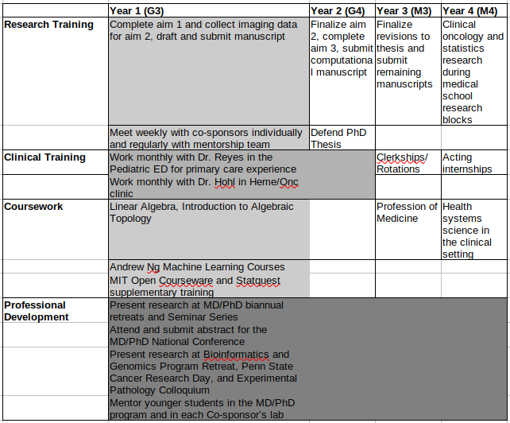

 | Year 1 (G3) | Year 2 (G4) | Year 3 (M3) | Year 4 (M4)
Research Training | Complete aim 1 and collect imaging data for aim 2, draft and submit manuscript | Finalize aim 2, complete aim 3, submit computational manuscript | Finalize revisions to thesis and submit remaining manuscripts | Clinical oncology and statistics research during medical school research blocks
 | Meet weekly with co-sponsors individually and regularly with mentorship team | Defend PhD Thesis
Clinical Training | Work monthly with Dr. Reyes in the Pediatric ED for primary care experience |  | Clerkships/Rotations | Acting internships
 | Work monthly with Dr. Hohl in Heme/Onc clinic
Coursework | Linear Algebra, Introduction to Algebraic Topology |  | Profession of Medicine | Health systems science in the clinical setting
 | Andrew Ng Machine Learning Courses
 | MIT Open Courseware and Statquest supplementary training
Professional Development | Present research at MD/PhD biannual retreats and Seminar Series
 | Attend and submit abstract for the MD/PhD National Conference
 | Present research at Bioinformatics and Genomics Program Retreat, Penn State Cancer Research Day, and Experimental Pathology Colloquium
 | Mentor younger students in the MD/PhD program and in each Co-sponsor’s lab

