SOMERSAULT

March 2018

Vol 41, No 2

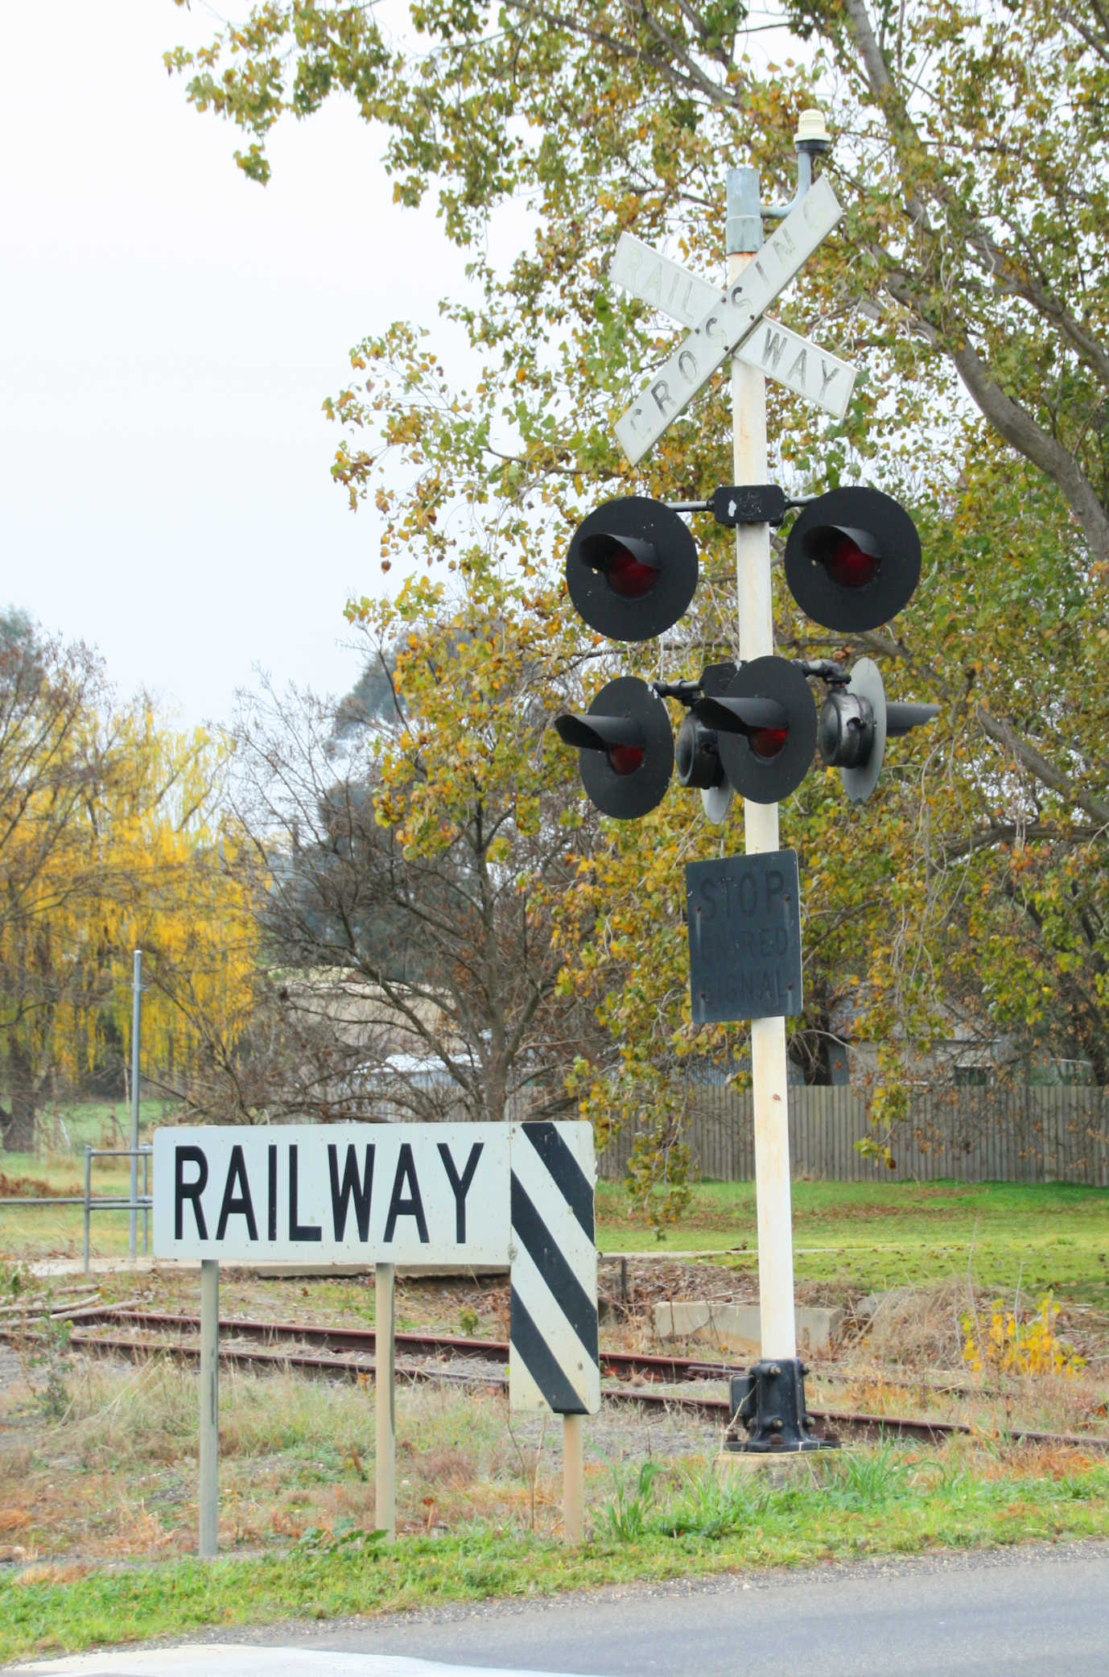Signalling Record Society of Victoria

# Society Contact Information

(Front cover) February 2018 sees the restatement of the mothballed line between Maryborough and Ararat, part of the project to standardise the lines to Yelta, Murrayville, Sea Lake, and Manangatang. Significant improvements have been undertaken on the line as part of this project, and one aspect of this is the provision of boom barriers at many of the level crossings. Previously, only six of the level crossings were protected, and all by flashing lights. This flashing light mast was one of the six – the Sunraysia Highway at Avoca. Level crossing protection at this crossing was installed as late as July 1977. This photo was taken in June 2017, and in the thirteen years since a train has run, the flashing light mast has developed a noticeable lean towards the roadway. Photo Andrew Waugh

Published by the Signalling Record Society Victoria Inc (A0024029F)

EDITOR: Andrew Waugh, 28 Amelia St McKinnon, VIC, 3204  
Phone (03) 9578 2867 (AH), (03) 9348 5724 (BH), email andrew.waugh@gmail.com

PRESIDENT: David Langley, P.O. Box 8, Avenel, VIC, 3664, Phone (03) 5796 2337

SECRETARY and MEMBERSHIP OFFICER: Glenn Cumming,  
Unit 1/4-6 Keogh St, Burwood, VIC 3125. Phone (03) 9808 0649 (AH)

NSW CONTACT: Bob Taaffe, 63 Hillcrest Rd, Tolmans Hill, TAS, 7007, Phone: (03) 6223 1626

QUEENSLAND CONTACT: Phil Barker  
PO Box 326, Samford, QLD, 4520, Phone: 0400 334403, email: signal01@bigpond.net.au

Unless articles use copyrighted information, articles may be reprinted without prior permission but acknowledgment is required. Opinions expressed in articles appearing in SOMERSAULT or supplements are not necessarily those of the S.R.S.V. (Inc.)

# Minutes of 2017 Annual General Meeting held Friday 17 March, 2017, At the Surrey Hills Neighbourhood Centre, 1 Bedford Avenue, Surrey Hills.

Present: – Wilfrid Brook, Glenn Cumming, Graeme Dunn, Ray Gomerski, Chris Gordon, Judy Gordon, Bill Johnston, David Jones, David Langley, Andrew McLean, Phillip Miller, Colin Rutledge, Rod Smith, David Stosser and Rob Weiss.

Apologies: – Jon Churchward, Keith Lambert, Laurie Savage, Peter Silva, Andrew Waugh and Andrew Wheatland.

Apologies: – David Langberg.

The President, Mr. David Langley, opened the 2017 Annual General Meeting at 20:07 hours.

Minutes of the March 2016 and May 2016 Annual General Meeting: – Accepted as read. Bill Johnston / Phillip Miller. Carried.

Business Arising: – Nil.

President's Report: – The President, David Langley, presented the President’s Report to the meeting.

Where does time go? I seem to have commenced my report with this comment before and then reflect on the signal boxes we have lost. It would seem that we have reached the point where there are almost no signal boxes left to close, yes there are still a few around and they are hanging on but the demise of non-computer interlocking is accelerating.

I don’t actually lie in bed and think where the society is headed but a real question must be – where is the society headed? I believe that we play a significant part in the recording of the history of railways in Victoria and perhaps even Australia, we are recording the signalling changes, others are recording the changes to traffic, rolling stock and perhaps even business structures. One of the very useful ways of learning what is happening is the Weekly Notice – born 1894 and sort of still going strong although a lot of SG information is lately going unreported – to form the basis of our work but, and it’s a big but, it’s the observations of the members of the SRSV that fill in the gaps, explain the detail of the changes. Not everything is in the Weekly Notice.

The Archives continues to improve and latterly has received much attention. Work continues on the sorting and rearranging the contents of the room by a few members, following the laying of a new floor and the provision of some long-needed shelving. There is still much, much, more to do and all members are encouraged to get involved.

“Somersault” continues to be published for the entertainment of members although recently has been a bit tardy and that is caused by many, many, reasons. Principally it has been by the dearth of material coming in to the Editor whose time is very must limited and who has had the onerous task of sourcing material. “Somersault” is the very place for historical articles as well as placing on record the everyday happenings so I urge you all to support “Somersault” by contributing anything of interest, even if it is just a couple of photographs with informed captions if you don't feel up to an article. This would reassure the Editor that his work is valued. I value “Somersault”, now in its 39th year, which from its humble beginnings in May 1978, has now become a valuable historical record. I wonder how many journals with such a narrow focus have lasted so long.

Six meetings were held in 2016 with the February meeting being a visit to Racecourse Junction in Montmorency, the AGM in March, and the May, July and September meetings being at Surrey Hills with syllabus items of Chris Gordon on CBIs in May, Keith Lambert testing our knowledge in July, and Wilfrid Brook showing some UK images of signalling interest in September. Our November meeting was held at the clubrooms of the Box Hill Miniature Steam Railway Society and long-time members Ken Ashman and Bob Taaffe gave a joint talk on Absolute Permissive Block signalling in Australasia.

Our annual tour in September this year was to Epping, Bell, Heidelberg and Macleod, a low-key day of locations but a very entertaining day nonetheless. My thanks to Keith, Trevor Wyatt and David Ward for assisting in making this day one worth attending.

Societies like the SRSV do not run themselves and thus we are eternally in debt to the various members entrusted with the onerous business of keeping the society on the straight and narrow. Thank you to Glenn our Secretary for the mammoth job of keeping the paperwork in order, Peter our Treasurer for keeping the money in order, Bill our Vice-President for standing in for your President at times and keeping the meeting in order, also Bill continues to assist the organising of the syllabus items, and finally Wilfrid and Colin our Committee members for voicing their opinions at our electronic committee meetings. Also thank you to Andrew for expertly editing Somersault again for another 12 months and to Jon Churchward for auditing the accounts.

Finally, it falls to me to thank the members of the society for attending meetings and supporting tours thus giving the Committee a feeling of having done something worthwhile.

I move the report.

David Langley, President.

David Langley / Phillip Miller. Carried.

Treasurer's Report: – In the absence of The Treasurer, Peter Silva, the presentation of the the Treasurer’s Report for the year ended 31 December 2016 was deferred.

Auditor's Report: – In the absence of The Auditor, Jon Churchward, the presentation of the Auditor’s Report was deferred.

Tours Report: – The Tours Officer, Glenn Cumming, presented his report.

I am pleased to report that the SRSV conducted one signal box tour during 2016.

The tour for the year was held on Saturday 17th September 2016.

The locations visited this year were Epping, Bell, Heidelberg and Macleod. A variety of signalling equipment was viewed and the signalmen at each location were friendly and co-operative.

As was to be expected, this tour was well attended and this justified the effort required to arrange this tour. SRSV members travelled from interstate to attend this tour.

Thanks to all members & friends who participated & helped to ensure the success of the tour. A pleasant day out was enjoyed by all.

Special thanks must go to the officers of the various railway operating & engineering companies who allow the SRSV to visit areas not normally open to the general public. Their assistance is very much appreciated. Without their co – operation, SRSV tours would not occur. This year, the SRSV appreciated the co – operation and assistance of David Ward, Trevor Wyatt and Keith Lambert at Metro Trains Melbourne. My thanks to these gentlemen for their assistance.

The Tours Officer always welcomes suggestions & comments regarding the conduct of SRSV tours, especially ideas for future tours.

Glenn Cumming, Tours Officer.

Glenn Cumming / Colin Rutledge. Carried.

Membership Report: – The Membership Officer, Glenn Cumming, tabled the Membership Report.

Type 2016 2015 Movement

V 61 63 – 2

K 28 29 – 1

N 2 2

KL 2 2

VH 3 3

Total 96 99 – 3

Analysis of Movement

Additions: – Nil

Non – Renewals: – Nil

Transfers: – Steven Dunne (K – V)

Final Departures: – John Briggs (V), Tom Murray (V)

Glenn Cumming, Membership Officer.

Glenn Cumming / Andrew McLean. Carried.

Editorial Report: –In the absence of the Editor, Andrew Waugh, the President tabled the Editor’s Report for 2016.

All six issues of “Somersault” were published in 2016, and apologies were tendered for times when the magazine runs late.

I would like to acknowledge the members that help with proofreading and supplying additional information. I would also like to acknowledge the work done by David Langley (reproducing “Somersault”) and Glenn Cumming (distributing it).

As usual, I would like to encourage members to produce items for “Somersault” – however short. Content does need to be related to signalling, though not necessarily just about Victoria. Content can be historical or current technologies or events. These can even be photographs of signalling interest to which captions can be added. Please be aware of copyright issues when submitting content – the Editor can help if you have questions.

Andrew Waugh, Editor.

Graeme Dunn / Colin Rutledge. Carried.

SRSV President David Langley urged all SRSV Members to assist the Editor wherever possible.

Archives Report: – Colin Rutledge presented the Archives Report for 2016.

Progress with our Archives at Seymour has been quite significant in the 2016 year. Following many years of ‘treading water’ early in the year the Committee accepted a proposal to begin major works.

The plan adopted has been to complete fitting out of the second room and make arrangements to bring on site a large collection of material recently donated to the Society. Accordingly a design was prepared and approval for specific funding received.

Over a few working bees the bare concrete with its imperfections was prepared and a laminated floor was laid. With the floor covering completed a start was made on re-erecting the 32 lever McKenzie & Holland A1 power lever frame originally from South Yarra and later from the signal technician’s school at Caulfield. The basis of the frame has now been assembled along with the mechanical interlocking. The electric locks and circuit controllers along with assembling of the wooden casing are yet to be completed.

Concurrently with assembling the lever frame arrangements were made to obtain and install shelving for the full length of one wall. Once assembled some of our ‘artefacts’ such as the western line CTC track indication panel, the Morwell thumb switch panel and the Warragul control panel were mounted. Additionally, the former Seymour train control desk with its characteristic Western Electric selector ringing keys was brought out of storage and put in the room.

Finally around a tonne and a half of archival materials that have been stored off site were delivered. A fair portion of the material has been placed in the shelves. Although there has been no sorting or cataloguing at this time, it is obvious that there are some historical gems amongst the material.

Although enthusiasm for works at the Archives was dampened somewhat by V/Line as the landlord indicating that they wanted us to move out so that they could use the space, it has been determined to push ahead with our plans and activities. It is now over six months and V/Line seem to have lost interest in a ‘takeover’.

Whilst the physical activities noted above have been progressing, consideration has been given to the challenges of digitisation of the entire archives collection. Some decisions have been made and the coming year should see purchase of suitable equipment with a start being made on scanning. Coupled with this is the need to sort, classify and index the entire collection which promises to be an extensive but very rewarding task.

Our thanks are extended to all of the members who have risen to the challenge of getting involved. Much has been achieved and much is to be done in coming years.

Colin Rutledge, Archives Co-ordinator.

Colin Rutledge / Andrew McLean. Carried.

Market Street Report: – Glenn Cumming presented the Market Street Project Report for 2016.

There has been no progress in 2016.

We are waiting for the ARHS Victorian Division to make key decisions on this matter.

Glenn Cumming, Market Street Sub – Committee.

Elections: – The Vice-President, Bill Johnston , chaired the meeting for the election of the new Committee.

No written nominations were received.

The following verbal nominations were received at the meeting: –

President: – David Langley, nominated by Grareme Dunn and seconded by Rod Smith.

Vice President: – Bill Johnston, nominated by David Stosser and seconded by Rob Weiss.

Secretary: – Glenn Cumming, nominated by David Stosser and seconded by Bill Johnston.

Treasurer: – Peter Silva, nominated by Bill Johnston and seconded by Ray Gomerski.

Committeeman: – Wilfrid Brook nominated by David Stosser and seconded by Phillip Miller.

Committeeman: – Colin Rutledge nominated by Bill Johnston and seconded by Rob Weiss.

There being no further nominations, all nominees were declared duly elected to the position.

General Business: – David Stosser noted the progress with the new SRSV website. The meeting expressed its thanks to Rob Weiss for his efforts in establishing the new website.

Phillip Miller asked if discounts offered to members of SRSUK were available to SRSV members who subscribe to SRSUK “Signalling Record”.

David Langley proposed creating a sub-committee for the Archives. It was agreed to invite expressions of interest from SRSV members to join the new Archives sub-committee.

Phillip Miller asked about the current status of the archives collection. This led to a lengthy discussion about the archives, documents, scanning, indexing and the website.

Meeting adjourned @ 21:05 hours.

The March 2017 Annual General Meeting was followed by the March 2017 Ordinary Meeting.

# Minutes of The Resumed 2017 Annual General Meeting held Friday 19 May 2017 At the Surrey Hills Neighbourhood Centre, 1 Bedford Avenue, Surrey Hills.

Present: – Noel Bamford, Graeme Dunn, Michael Formaini, Darren French, Ray Gomerski, Chris Gordon, Judy Gordon, Andrew Gostling, Bill Johnston, David Jones, Keith Lambert, David Langberg, David Langley, Neil Lewis, Andrew McLean, Phillip Miller, Alex Ratcliffe, Colin Rutledge, Peter Silva, David Stosser and Andrew Wheatland.

Apologies: – Wilfrid Brook, Jon Churchward, Glenn Cumming, Laurie Savage, Chris King, Brian Sherry and Andrew Waugh.

The Vice-President, Mr. Bill Johnston, took the chair & opened the meeting at 20:04 hours.

The President, Mr. David Langley, acted as Minutes Secretary in the absence of the Secretary.

Treasurer's Report: – The Treasurer, Peter Silva, presented the Profit and Loss Statement and the Balance Sheet for the year ended 31 December 2016.

The SRSV recorded a small profit for the year.

Peter spoke to the statements and explained the details of the statements and noted variations when compared with the previous year and the reasons for the profit in 2016. The receipt of the grant funding from the AREA was noted.

Motion: That the Treasurer’s report is received and adopted.

Peter Silva / Andrew Wheatland. Carried.

There were no questions and no further discussion.

Auditor's Report: – In the absence of The Auditor, Jon Churchward, the Treasurer, Peter Silva, tabled the Auditor’s Report.

Motion: That the Auditor’s Report be accepted.

Peter Silva / Andrew McLean. Carried.

There were no questions and no further discussion.

General Business: – Nil.

Meeting closed @ 20:15 hrs.

The May 2017 Annual General Meeting was followed by the May 2017 Ordinary Meeting.

# Minutes of Meeting held Friday 16 February 2018, at the SRSV Archives, Seymour, Victoria.

Present: – Glenn Cumming, Graeme Dunn, Ray Gomerski, Chris Gordon, Judy Gordon, Andrew Gostling, Bill Johnston, David Jones, Keith Lambert, David Langberg, David Langley, Steve Malpass, Phillip Miller, Trevor Penn, Colin Rutledge, Rod Smith, David Stosser and Andrew Wheatland.

Apologies: – Wilfrid Brook, Laurie Savage, Brian Sherry and Andrew Waugh.

Visitors: – Jim Gordon.

The President, Mr. David Langley, took the chair & opened the meeting at approximately 17:00 hours, and welcomed everybody to the SRSV Archives at Seymour.

General Business: –The February 2018 meeting consisted entirely of a visit to the SRSV Archives at Seymour.

SRSV members enjoyed a pleasant evening at Seymour where activities included viewing of the collection, watching a variety of trains (both Broad and Standard Gauge), manipulating the levers of the South Yarra power frame along with much discussion on a variety of topics, mostly related to railway signalling.

It was noted that many members spent much of the evening looking through the drawers of railway signalling plans and studying a variety of documents that are held on site.

No other business was transacted during the meeting.

Meeting closed at approximately 21:45 hours.

The next meeting will be on Friday 16 March, 2018 at the Surrey Hills Neighbourhood Centre, Bedford Avenue, Surrey Hill, commencing at 20:00 hours (8.00pm).

# Signalling Alterations

The following alterations were published in WN 1/18 to WN 7/17, and ETRB A circulars. The alterations have been edited to conserve space. Dates in parenthesis are the dates of publication, which may not be the date of the alterations.

05.05.2017 Emerald (A7/17)

On Friday, 5.5., the Up and Down Crossing Protection signals at Gembrook Rd were replaced by 8” (200 mm) white LEDs.

A red Crossing Protection Indication (A 5/15) was provided below the Up Crossing Protection signal. When lit, this indicates that the boom barrier timeout has operated and Up trains are to stop at Permissive Signal L1680 (which will be at stop) for at least 10 seconds. The train is then to be drawn forward cautiously past L1680 until the flashing lights activate. The boom barriers will clear automatically when the train clears the crossing. Drivers of Down trains are to act in accordance with A 6/15.

22.05.2017 Cockatoo (A 8/17)

On Monday, 22.5., two quadrant levers were provided on the platform to work the Home signals. The quadrant working the Down signal has a white ‘D’ painted on the lever side, and the other quadrant a ‘U’. Both quadrants can be secured either normal or reverse. The temporary quadrants beyond the ends of the platforms have been removed.

30.08.2017 Lakeside (A 10/17)

On Thursday, 30.8., the manual controls for the pedestrian gates on No 1 Road were abolished and the gates will now operate automatically on the approach of trains. An additional bell was provided which will sound when the gates are closed. The Up approach bell for No 1 Road in the corridor of the station building was abolished. New S1 key switches to control the gates were provided at the ground frame and the lower shelter.

When Down trains arrive into No 1 Road, the gates will automatically close when the train enters the platform. The gates will remain closed for 70 seconds and then re-open. When the train is ready to depart from No 1 Road (or an engine is to cut off) the Down end main line points are to be set and locked for No 1 Road. One of the S1 key switches will then be used to close the gates. When the gates are fully closed the Crossing Protection Signals will go to proceed (flashing white light) and the train or engine can depart. The gates will open automatically after the train clears the pedestrian crossing. In the case of an engine that leaves its train in No 1 Road, the gates will open 35 seconds after the engine clears the pedestrian crossing. If it is necessary to open the gates, one of the key switches must be turned to the ‘open’ position. The Crossing Protection Signals will be immediately extinguished, but there will be a time delay of 35 seconds before the gates start to open.

The gates will close automatically if the Down end main line points are set and locked for No 1 Road and an Up train occupies the track circuit starting at the whistle post between the Wig Wag pedestrian crossing and Lake-Park Rd level crossing. The gates will open when the train clears the pedestrian crossing.

When it is necessary for an engine to run around using No 1 Road, the gates will automatically close when the engine has moved beyond the Down end main line points and those points have been set and locked for No 1 Road. The gates will reopen when the engine clears the pedestrian crossing. The gates will also reopen if the points are reset for No 2 Road, provided the engine is still on the main line beyond the points.

A radio control unit is fitted to the gates for use by trolleys. This will only be effective when the Down end points are set and locked for No 1 Road.

The controls for the light Calling-on signals associated with Up Homes 13 and 14 were altered. The existing push buttons and indication lights for the Calling-on signals were abolished. The Home and associated Calling-on are now both worked by the signal lever (13 or 14) in the ground frame; which signal clears depends on the occupancy of track circuits. The needle type indicators will now show ‘Off’ if either the Home or Calling-on is at clear. Up Homes 13 and 14 will automatically be restored to Stop as soon as the train passes the whistle post. The Calling-on signals will not track cancel, and will remain off until the lever is restored. In either case the lever must remain reverse until the train has passed over the Down end main line points. If a Down departure will be the next Up arrival, the appropriate Up Home signal lever is to be left reverse. In this case, the Calling-on signal will go to Proceed when the lever is reversed. The Calling-on signals will go out as the train clears whistle post and the Home signal will clear.

The track circuited area was extended to cover both platform roads. It now extends from the Up end of the platforms to the whistle post midway between the Wig Wag crossing and the Lake-Park Rd level crossing.

09.11.2017 Clematis (A17/17)

On Sunday, 7.11., the Up and Down Crossing Protection signals at Belgrave - Gembrook Rd were replaced by 8” (200 mm) white LEDs. Red Crossing Protection Indications (4” LED lights) were provided for both Up and Down trains.

20.12.2017 South Geelong (SW 208/17, WN 1)

On Wednesday, 20.12., the existing automatic pedestrian gates at Yarra St (74.341 km) were equipped with emergency gate control locks. Amend Diagram 22/11 (South Geelong).

27.12.2018 Maryborough (SW 209/17, 213/17 & 217/17, WN 1)

Between Wednesday, 27.12., and Sunday 30.12., No 2 Road was abolished.

Point 5 (Up end main line), 9 (Up end No 2 Rd), 15 (Down end No 2 Rd), 17 (Down end main line) were abolished. Derail/Crowder 5 (Up end No 2 Rd) was abolished. Catch 15 (No 3 Rd) and 17 (No 2) were abolished. Hand Points A, B, & C were abolished.

Points 5 and 17 were replaced by dual gauge track panels.

Operating Procedure 80 (Maryborough) was reissued. SW 193/17 was cancelled.

Diagram 70/17 (Maryborough) replaced 48/17.

(02.01.2018) Murtoa (SW 207/17, WN 1)

The Master Key Box has been relocated from the station building to a secured box on the platform. Operating Procedure 77 (Murtoa) was reissued. SW 173/10 is cancelled.

(02.01.2018) Ararat – Maryborough (SW 215/17, WN 1)

The ‘Down’ direction on this line has been changed to be from Ararat to Maryborough. Note that this is the opposite of the kilometre posts which increase from Maryborough to Ararat.

(02.01.2018) Dunolly (SW 210/17 & 216/17, WN 1)

The junction points DLY29 have been replaced by a Gauge Splitter DLY29.

Operating Procedure 84 (Dunolly) was reissued. SW 193/17 is cancelled.

Amend Diagram 42/17 (Dunolly).

02.01.2018 Caulfield (SW 385/17 & 31/18, WN 1 & 3)

Between Tuesday, 2.1., and Wednesday, 10.1., the following alterations took place:

* The Works Siding (former Horse Dock) was abolished
* The leads from the Up and Down Dandenong lines towards Nos 1 & 2 Roads were abolished and a portion of the track removed.
* The lead to and from No 4 Road and the Centre Frankston line, Up Through Siding, and Siding A was abolished
* The lead from the Up Dandenong to No 4 Road was abolished.
* Dwarfs CFD709 & CFD710 were abolished.
* Crossovers 608, & 613 and Points 610D, 623 & 633 were secured normal.
* Points 652 & 662 were secured reverse.
* Points 610U were abolished

The affected routes will be disabled in the SigView system.

Diagram 1/18 (Caulfield) replaced 19/17.

13.01.2018 Maryborough (SW 7/18, WN 3)

On Saturday, 13.1., Down Home MYB2 from the Ararat line was abolished. The Absolute Occupation was extended from the site of Home MYB2 to a point clear of the Ballarat line at 187.440 km. Amend Diagram 70/17 (Maryborough).

19.01.2018 Long Island Junction (SW 21/18, WN 4)

On Friday, 19.1., the point machines on Crossover 91 were disconnected from the UPS (Uninterruptable Power Supply) and connected directly to the external mains supply. Separate ‘DC’ and ‘UPS’ power alarms were provided on the WestCad at Frankston signal box.

If mains (DC) power fails it will not be possible to operate Crossover 91. The WN implies that it would be possible to manually operate the points. Positive detection of the points will continue to operate (by the UPS) and it is possible to signal trains to/from Stony Point if the point have failed, but are detected normal. If the points are reversed (or are reverse when the power fails), they will show “Out of Correspondence”, but will be detected normal by manually restoring the points to the normal position.

23.01.2018 South Geelong (SW 4/18, WN 3)

On Tuesday, 23.1., the crib crossing at McKillop St (73.445 km) between Geelong and South Geelong was replaced by automatic pedestrian gates and emergency gate control locks. Amend Diagram 22/11 (South Geelong).

24.01.2018 Rosanna (SW 14/18, WN 4)

On Wednesday, 24.1., the Rosanna station pedestrian crossing (15.536 km) was restored to use for access by construction staff.

28.01.2018 Maryborough (SW 9/18, WN 4)

Between Saturday, 27.1, and Sunday, 28.1., the following alterations took place:

* Down Home MYB4 was equipped with TPWS
* Gauge detectors were installed for Up trains 140 metres from the Up end of the platform, opposite the 3VL stop line for Up trains, and for Down trains 300 metres on the Up side of Down Home MYB30
* Down Home MYB30 and Up Home MYB10 were provided with illuminated “V: and “S” indicators. The gauge of the approaching train must be proved before either Home will clear. Train crews must ensure that Up trains are standing past the 3VL platform stop line prior to advising Train Control that the train is ready to depart.

Amend Diagram 70/17 (Maryborough).

29.01.2018 Southern Cross (SW 5/18 & 23/18, WN 4)

Between Thursday, 25.1., and Monday, 29.1., Crossover SST423 was converted from clamp lock to dual control point machines. The operating handles were secured with SMT padlocks. Signal Post SST505 was replaced by a new mast located half a metre on the Down side of its former location.

Between Friday 26.1., and Monday 29.1. the interlocking will be disarranged in the Melbourne Yard interlocking area for a data update. During this time no movements can be made.

Amend Diagram 116/14 (Southern Cross V/Line Passenger Lines).

29.01.2018 Newport Workshops (SWP 1/18, WN 3)

Commencing Monday, 29.1., Metro Northern Group Operating Procedure 6 (Newport Workshops – Operating Procedures North & South Yard) was reissued.

Train movements within the MTM Maintenance Yard and the Train Maintenance Facility will be directed by the MTM Yard Co-ordinator. All safeworking arrangements for signalled or non-signalled moves in the MTM Maintenance Yard, however, will be managed by the Signaller, Newport. The Signaller will grant authority to drivers or shunting staff for the commencement of each movement by fixed signal or verbal permission.

30.01.2018 Sandown Park – Yarraman (SW 32/18, WN 5)

On Tuesday, 30.1., an absolute occupation was taken between Westall and Dandenong. The level crossings at Corrigan Rd (26.406 km), Heatherton Rd (26.995 km), and Chandler Rd (28.422 km) were abolished. The existing station at Noble Park (27.376 km) was closed.

Automatics D793, D794, D809, D810, D826, D829, D845, D846, D862, D863, D881, D882, D899, D906, D919, & D920 were abolished. The 5P keyswitches to control Automatics D829 & D846 were abolished.

05.02.2018 Sydenham (SW 7/18, WN 5)

On Monday, 5.2., the first half of the overbridge at Melton Hwy was brought into service. The level crossing was closed and the boom barriers at Melton Highway were abolished. The Up and Down side pedestrian crossings will remain in use. The boom barriers and flashing lights were removed to allow construction of the other half of the bridge.

No changes will be made to the existing control panel at Craigieburn or JZA telemetry field stations.

05.02.2018 Dandenong (SW 32/18, WN 5)

On Monday, 5.2., a new Dandenong Signal Control Centre was commissioned. The new centre is adjacent to the main station building at Dandenong and the existing signal control room in the building was closed.

The existing Sigview screens controlling Westall and Dandenong were transferred to the new control centre, and a new WestCAD screen was provided to display the section between Westall and Dandenong. A VCS (Voice Communication System) radio console is to be provided at a future date to allow communication with non Metro operators.

(06.02.2018) Train Register or Log Books (SW 37/18, WN 6)

Commencing forthwith when a Signaller applies or removes a blocking facility, the following must be recorded across the figure column:

* The reason for applying the blocking facility
* The name of the person requesting the blocking facility (where applicable)
* The time the blocking facility was applied
* The time the line was safe for normal traffic
* The time the blocking facility was removed

This will apply when: rail traffic must be worked under absolute block; track machines or road/rail vehicles operate or travel on track; an authority is issued to allow for work on track or access to the danger zone; the locking has been disarranged; or when any other blocking facilities are applied.

(06.02.2018) Mooroopna (SW 14/18, WN 6)

The notice board that applies to Down trains shunting in the siding has been amended to read “Shunting trains must not pass this sign until booms are horizontal’. A VPSW key switch is provided opposite the Down end points to manually control the operation of the booms during shunting. Amend Diagram 60/13 (Mooroopna – Shepparton).

07.02.2018 Maryborough – Ararat (SW 16/18, WN 7)

From Monday, 7.2., commissioning of the level crossing protection equipment will commence.

Boom barriers will be provided at the following level crossings: Mariners Reef Rd (187.985 km), **Derby Rd (188.504 km)**, **Pyrenees Hwy (191.237 km)**, Bung Bong – Longs Rd (199.664 km), Gordon Rd (201.403 km), Homebush – Bung Bong Rd (205.091 km), Homebush Rd (211.677 km); **Sunraysia Hwy (211.992 km)**, Vinoca Rd (212.563 km), Mountain Hut Rd (220.789 km), **Pyrenees Hwy (224.683 km)**, Amphitheatre Rd (225.204 km), Lexton – Ararat Rd (228.098 km), Keiths Rd (232.085 km), **Pyrenees Hwy (234.802 km)**, Landsborough – Elmhurst Rd (241.827 km), **Pyrenees Hwy (242.773 km)**, Eversley Rd (248.441 km), Warrayatkin Rd (268.754 km), Burn St (272.284 km), and Grano St (273.528 km).

This represents about 40% of the PCR crossings on this line. The crossings in bold font were previously equipped with level crossing protection equipment, but in all cases only flashing lights were provided. All protection equipment will be operated by axle counters.

08.02.2018 Maryborough – Dunolly (SW 21/18, WN 7)

On Thursday, 8.2., the line between Maryborough and Dunolly was restored to use by standard gauge trains. Standard gauge trains into Maryborough and beyond will only operate when authorised by SW circular.

At Maryborough the following alterations took place:

* A new 3 position Down Home MYB2 was provided at 188.555 km on the Up side of Derby Rd.
* A new Repeating signal NE1911 was provided at 191.300 km on the Up side of the Pyrenees Hwy.
* The standard gauge Ararat line was connected to the dual gauge line via a gauge splitter located immediately on the Up side of Home MYB6.
* The dual gauge line from the gauge splitter to Dunolly was restored to use.

At Dunolly the following alterations took place:

* A new standard gauge No 2 Track was provided between the Up end gauge splitter (DLY7) and the Down end gauge splitter (DLY27) on the Down side of Thompson Rd. Dual gauge track then continues to the gauge splitter (DLY29) that forms the junction to the Manangatang line.
* Operation of the Thomson Rd level crossing for Down standard gauge moves is by a level crossing predictor (the speed limit on the new standard gauge line is 15 km/h).
* Standard gauge points were provided in No 2 Track at the Up and Down ends for the future Nos 3 & 4 Tracks. These were secured normal.
* There are no changes to the fixed signals or their controls. Dunolly remains an Intermediate Train Order station.

10.02.2018 Sandown Park – Yarraman (SW 32/18, WN 5 & 6)

On Thursday, 10.2., the Up and Down lines will be slued onto the viaducts between Sandown Park and Yarraman. The northern viaduct is on the Down side of the original line and is 1050 metres long. The southern viaduct is on the Up side of the original line and is 235 metres long. The line briefly returns to ground level between the two viaducts, in the vicinity of the Callaghan St pedestrian underpass. The existing station at Noble Park (27.376 km) was replaced by a new station on the viaduct (27.225 km) with a 160 metre island platform.

Rail vehicle detection on the new lines will be by axle counters. The axle counter territory on the Down line will commence at the Up end of Sandown Park station (25.510 km) and end at Post DNG700 (30.083 km), and on the Up line it will commence at the Bennett St bridge (30.137 km) and end at Post WTL775 (25.467 km). Fixed signals will be three position LED (UGL tri-colour) intermediate Home signals on tilt masts. TPWS and train stops will be provided at all new signals. Signal post telephones are not provided.

Homes WTL696, WTL775, D793, D794, D811, D825, D826, D836, D847, D865, D868, D884, D885, D898, D907, D920, & D929 were provided.

The line speed is 80 km/h for EMU and railcar movements, 70 km/h for diesel hauled passenger trains, and 45 km/h for freight trains.

Diagrams 5/18 (Clayton – Springvale), 7/18 (Sandown Park – Yarraman), & 9/18 (Dandenong – Hallam) replaced 13/16, 11/16, & 9/16 respectively.

A new clause 15 (Dandenong – Westall section) has been added to the Caulfield Group Operating Procedures.

The intermediate signals between Sandown Park and Yarraman are Home signals. Should a train arrive at a Home signal at Stop, the Driver must immediately contact the Signaller, Westall Panel, at Dandenong.

If the Signaller can confirm from the VDU that the section ahead of the signal is clear, the Signaller will complete a form and read a portion of it to the Driver. The text read gives the train number, signal number, and emphasises that the train is to proceed at extreme caution. The driver must repeat back the train and signal numbers, but the driver does not need to write down the details. A second rail movement is not permitted until the first train is confirmed as being complete beyond the next fixed signal.

When the Signaller cannot confirm that the section is clear from the VDU, an alternative means of confirmation is required. Possibilities include the provision of a competent person to visually confirm that the track is unoccupied; the use of station CCTV (where specifically approved); or the use of a roll-by inspection (Book of Rules, Section 13, Rule 7F).

The axle counter sections are provided with a ‘next train reset’ function, where the successful completed train passage will reset the section. Due to the axle counter failure modes, it will sometimes be necessary for two consecutive trains to be authorised through a failed section before it resets.

(13.02.2018) Wendouree – Beaufort (SW 25/18, WN 7)

Diagram 66/17 (Wendouree – Beaufort) replaced 44/17 as in service.

15.02.2018 Sandown Park – Yarraman (SW 32/18, WN 5)

On Thursday, 15.2., the viaducts between Sandown Park and Yarraman will be opened for revenue traffic. The new station at Noble Park was opened for passenger traffic.

17.02.2018 Ararat – Maryborough – Birchip AWB

The first standard gauge revenue train operated from Ararat to Birchip AWB. The train consisted of G523, 8110, & 8164 hauling 43 WGBY grain wagons. The train ran around in both directions at Pyrenees Loop.

End£

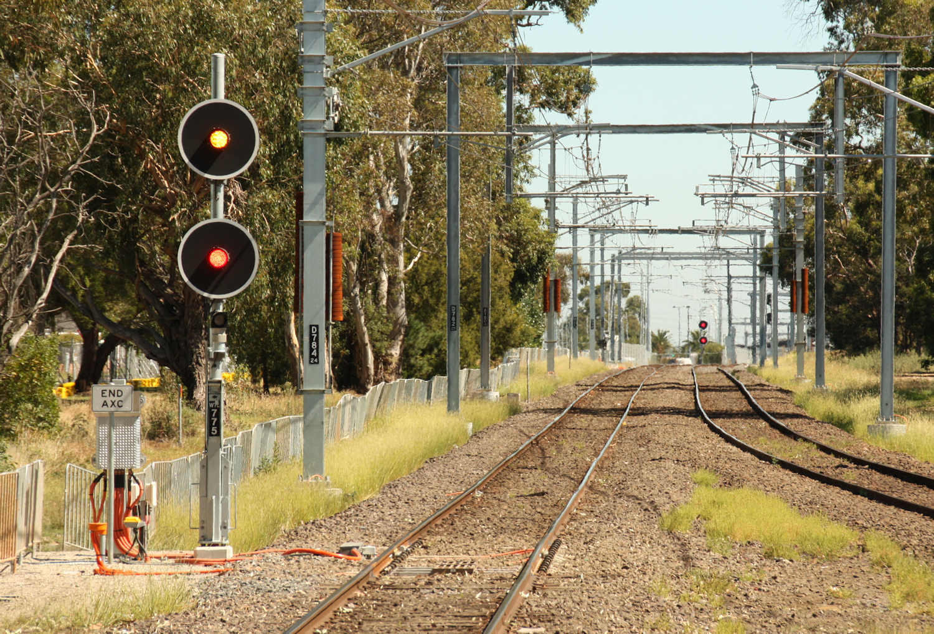

As part of the grade separation projects between Sandown Park and Yarraman, the line was resignalled and the three position Automatic signals driven by conventional track circuits was removed. This view looks north from the platform at Sandown Park and shows the northern most point of the resignalling on the Up line. Train detection on the resignalled section is now by axle counters, and the terminating axle counters can just be seen on the rails adjacent to the TPWS (TSS) loop. The sign ‘End AXC’ indicates that conventional track circuits commence at this point. All of the new signals are tri colour LEDs Home signals mounted on tilt masts. TPWS (TSS) is fitted at all signals.

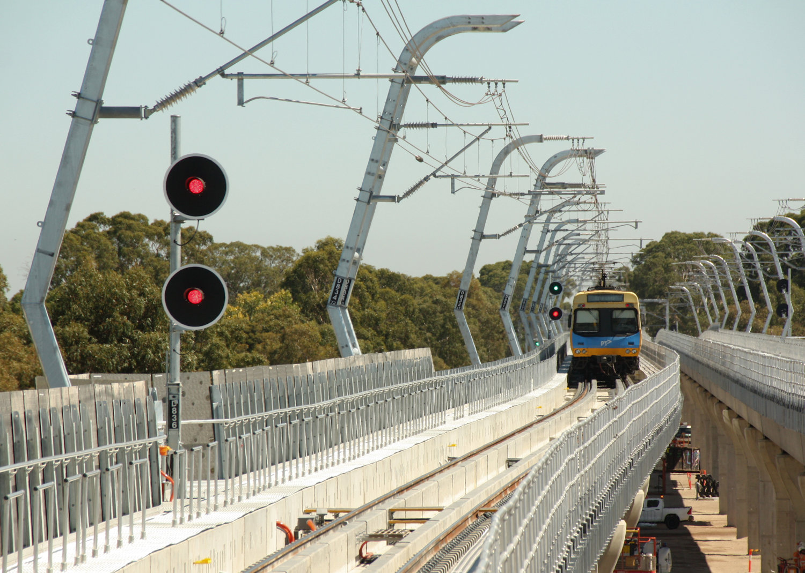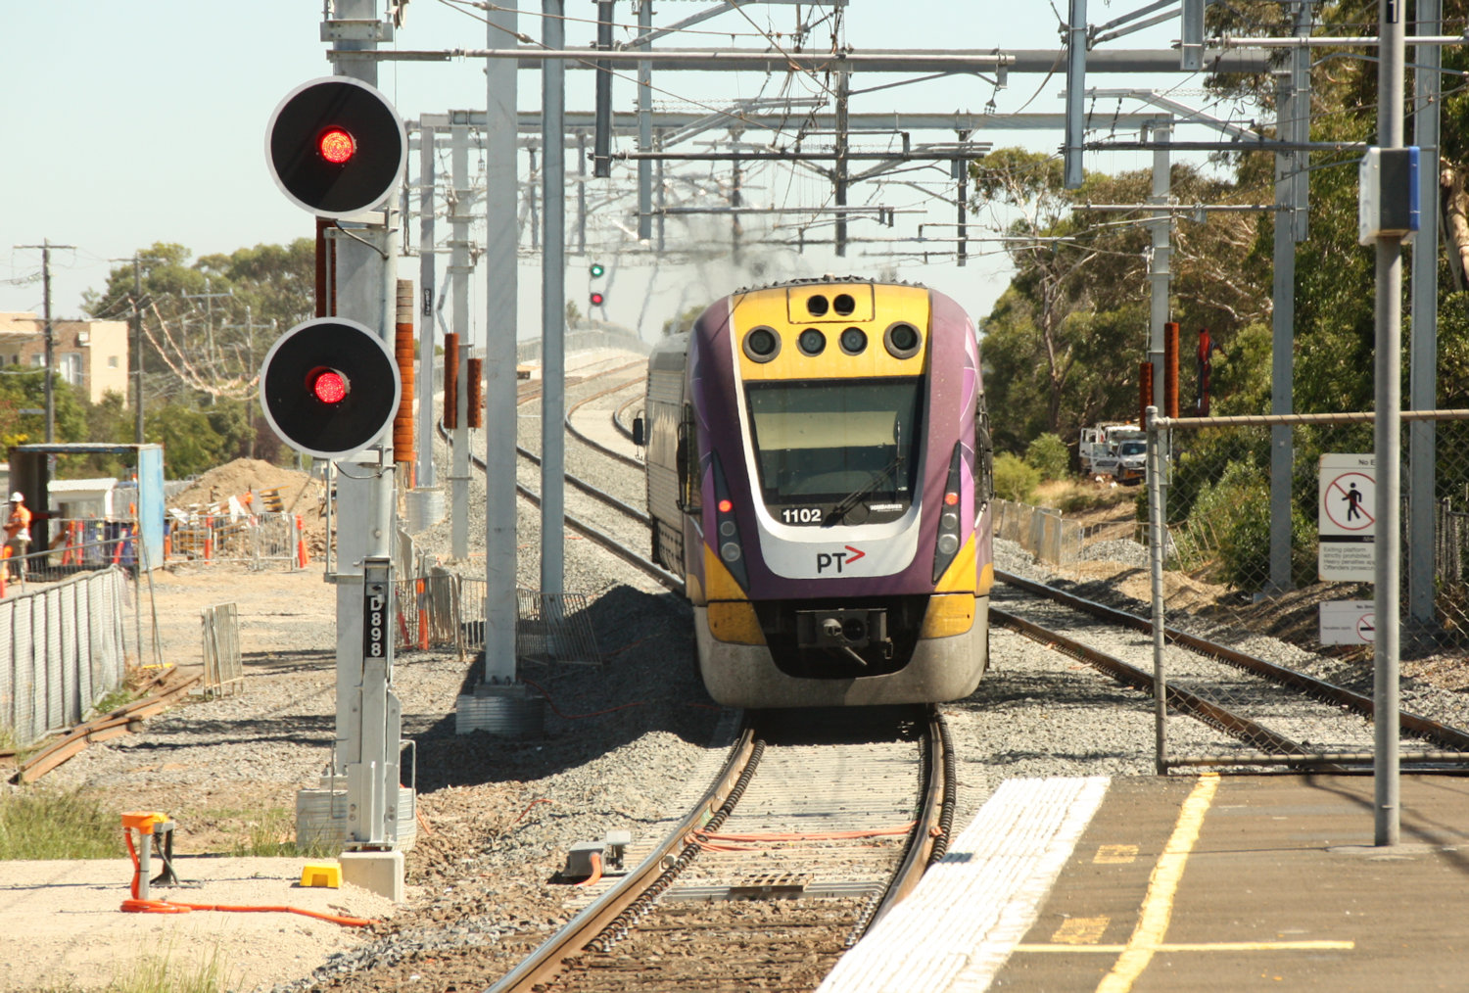

(Above) A view north from the new Noble Park station showing the new ‘skyrail’ section. The signals are all Home signals with no low speed head. The Home signals operate automatically, however. All movements past these signals at Stop require the Signaller’s permission. Conventional sleepers are not used on the northern section of viaduct through Noble Park. Instead, the rails are mounted on the top of longitudinal concrete walls. If nothing else, this will pretty much guarantee that any derailment will stay on the viaduct. An emergency walkway is provided by the side of the track for maintenance and emergency evacuation. (Below) Looking north from Yarraman station showing the approach to the southern viaduct, which is a conventional double track structure.

# NSWGR SIGNAL & TELEGRAPH BRANCH 1939-1945

# (HISTORY OF THE NSW RAILWAYS DURING THE WAR PERIOD)

(Continued from Somersault Vol 41 No 1)

## MAIN WESTERN LINE

## 21 Emu Plains – Orange

A survey of the list of signalling works carried out on this line reveals that, with one exception, the alterations were necessitated by new connections or other structural alterations. In other words the abnormal traffic between Sydney and Lithgow was handled adequately without any additional signal facilities between Emu Plains and Lithgow.

## 22 Bowenfels

The one exception, referred to above, in which greater flexibility in traffic working was required was the section Lithgow - Bowenfels.

There were several contributory factors, chief of which, was the passenger service inaugurated between Katoomba and Cooerwul, a new station immediately on the Sydney side of Bowenfels and serving the Lithgow Small Arms Factory.

Workmen’s trains, conveying shift workers, were run from Katoomba three times a day and, as they terminated at Bowenfels, engines had to be run back to Lithgow for reversing and fresh engines brought out to take the return trips, all of which intensified traffic between Lithgow and Bowenfels at certain hours of the day.

A further difficulty associated with the working at Bowenfels was in respect of the shunting of the Goods Siding from the Up Main. The Officer-in-Charge had no indication of approaching trains and further, he had no means of placing the automatic signals on either side to ‘Stop’. This unsatisfactory condition gave rise to a reluctance on the part of the Control Officer to despatch an Up train from Wallerawang whilst a train was about to shunt Bowenfels.

In order to meet traffic requirements extensive alterations were made although they were concentrated in a relatively small area.

A miniature lever unit was provided at Bowenfels with provision for operation by the Station Officer when the station was open or by the Guard of a Goods train requiring to shunt. This lever unit controls Up and Down Signals on either side, and with full track indication, ensures satisfactory working under all conditions.

Additional signals were installed between Lithgow and Bowenfels - one Up and one Down Automatic Signal - thus providing closer headway and facilitating shunting trips ex the Colliery Line.

In Bowenfels Yard additional releasing switches were provided for two Goods Siding connections, and also for the Up Siding to permit of refuging Up trains and immediately west of Bowenfels the provision of a new Down automatic signal permitted earlier clearance of the signal admitting Down trains into Bowenfels platform.

The whole of this work was carried out and completed in 1943.

## 23 Marrangaroo

The establishment of a large Commonwealth Stores, in 1942, some miles from the railway line at Marrangaroo, necessitated connections to both the Uo and Down Main Lines, the latter being a facing connection, at the western end of the platform.

Traffic requirements introduced several special features into the signalling arrangements which are unique so far as this system is concerned.

Under normal working conditions the automatic signals clear for the through road and a Down train arriving at Marrangaroo, preparatory to entering the Branch line receives a clear signal at the Down Facing Points. A special cancelling button was provided on the signal post to be operated by the driver and after a pre-determined time the Home signal returns to ‘Stop’ and the guard is then enabled to obtain an electrical release for the points, provided the Up Road is clear. This is the only instance where provision is made for the automatic release of a facing connection.

A second requirement was in respect to despatch of Down trains which necessitated a Wrong Road movement on the Down Main from the Stores Branch Line. To provide adequate protection an additional Down Automatic Signal was necessary and the controls for the special move extended back a distance of 2 1/4 miles.

Two releasing switches, an Upper Quadrant power worked signal at the Facing Points and a six lever machine to operate the connections completed the requirements.

## 24 Miscellaneous

Loop Sidings were provided between Orange East Fork and Orange and between Cowra and Wattamondara.

The former was located within the single line track block section necessitating special releasing arrangements, whilst the latter involved the provision of an intermediate electric staff instrument.

Sidings for the Commonwealth Stores at Kelso, which were brought into use in 1943, made connection with the Main Line in Kelso Yard and considerable signalling alterations were necessary to provide for traffic movements.

Work of a somewhat similar nature were carried out at Bathurst West for another Stores Siding connection. This latter installation was the initial step in providing additional traffic facilities in Bathurst Yard - a major undertaking which is still in hand.

## 25 Telephone facilities

A single channel carrier telephone system was installed between Sydney and Orange, thereby providing direct communication between Sydney, Parkes and Narromine.

## METROPOLIAN AREA

A great deal of work, directly and indirectly associated with the war effort of the Railway Department, was carried out within the immediate Metropolitan Area.

The immense amount of traffic passing through on its way north or south was handled successfully by the signalling system as it existed in 1939, and only in isolated instances was it found necessary to provide additional signalling to meet traffic demands. For the most part, the efforts of the Branch, so far as the Metropolis was concerned, were directed towards the provision of signal and interlocking facilities rendered necessary by new installations.

These varied between minor works such as an additional siding on the Botany Goods Line and major undertakings such as the provision of a power interlocking to control the new yard at St Marys consequent upon the establishment of a Munitions Factory by the Commonwealth Government.

## 26 Ingleburn

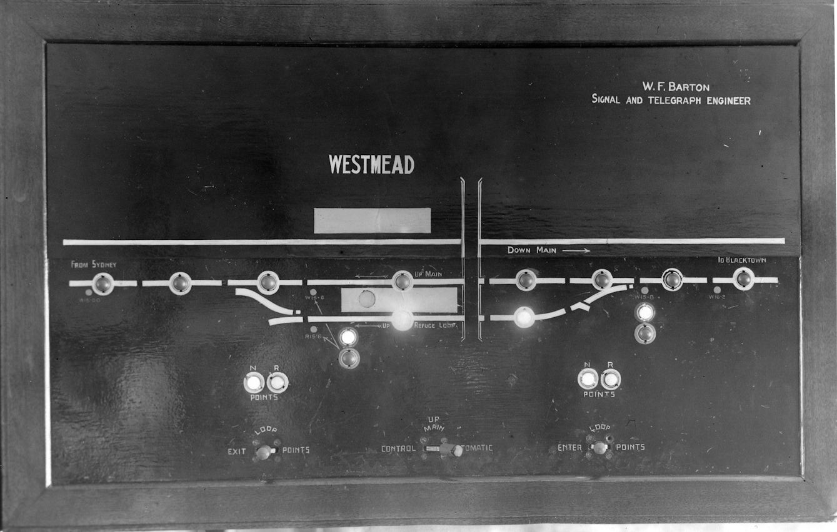From an historic point of view, the alterations and additions carried out at Ingleburn in November 1939 are important in that they were the first undertaken as a war measure.

(Below) Westmead panel – The first route set panel in NSW was installed in Parramatta signal box to remotely control the points at Westmead. When the Up Refuge Loop was extended to Seven Hills and a complimentary Down Relief Line was later opened, the panel was reconfigured so that one Kellogg Key operated the entry points to the Down Relief and the other the exit points from the Up Relief.

The platforms were lengthened and arrangements made for the termination of Down trains in the Up Platform, all in preparation for the heavy military traffic to the local camp.

## 27 Sydney station

Wartime traffic accentuated a difficulty that had been experienced at Sydney Station for some years in the handling of long passenger trains at certain platforms. Conditions, which occurred principally at holiday periods in normal times, became a daily occurrence during the War and some measure of relief became imperative.

Special Starting Signals were installed for Platforms 1, 4, 8, and 10. Track locking circuits were amended accordingly and a special type of dwarf running signal, of new design, was necessary on account of limited clearance preventing the erection of standard signals.

## 28 Parramatta

Parramatta, on the western section, is the terminus of the electric service and, apart from the electric trains dealt with, there is a very heavy steam traffic - both passenger and goods. A number of steam passenger trains, connecting with the electric trains, terminate at Parramatta. During the war period, the platform accommodation and the track layout were inadequate for the requirements, and additional platforms, tracks and crossover facilities were designed and undertaken.

The problem in respect of the signalling was that some of the new point connections were outside the range of the existing mechanical Signal box, and the track alterations were so extensive that to carry out the signalling as an extension of its original mechanical form would have necessitated more than one signal box.

This was avoided by the provision of a small electric lever unit, immediately above the mechanical interlocking machine, and the installation of electro-pneumatically operated signalling at the Sydney end of the Parramatta interlocking. Small air compressors in duplicate, directly coupled to electric motors, were installed to provide the necessary air pressure. These compressors cut in and out automatically on the lowering or raising of the air pressure. The arrangement has proved entirely satisfactory.

Associated with the station alterations at Parramatta was a complete train indicator system, worked from a central control point, to enable the train departure indications to be displayed simultaneously at four entrance locations, the whole operation being synchronised by the use of Selsyn motors. This installation was completed in August 1942.

A further addition to the Parramatta machine was a small panel controlling the Up Refuge Loop at Westmead. This panel, which came into use in February 1944, incorporated several unique features:

1. The Controlling levers or Keys are mounted directly on the Indicator Diagram Panel.
2. The Track Indicator Lights are normally extinguished and give a red light indication when the track is occupied.
3. The levers are “Route” levers, in so far that both points and signals for a particular route are controlled by the same lever. One lever designated “Loop Enter”, controls the points and signal leading into the loop whilst a second lever, “Loop exit”, controls the exit points and signal. A third lever allows the signalman to set the main line for automatic working when the loop is not required.

These features were provided specially to facilitate the work of the Signalman who is fully occupied in dealing with local traffic at Parramatta.

The Remote Control Circuits are similar in principle to those used at Villawood, the only variation being in respect of the ‘route’ method of signalling.

Wire recovered from Parramatta was used, for the most part, between Parramatta and Westmead and considering the number of functions controlled and the indications returned to the Signalman a relatively small amount was required.

The installation, though small, is the most modern in NSW.

## 29 Blacktown

The provision of a new platform serving the loop line on the Richmond Branch together with power operation of the loop points at the Richmond end necessitated extensive additions to the Blacktown machine.

In common with works of a similar nature an electric lever unit was added and a relay location was erected adjacent to the Signal box.

The space available clear of the interlocking machine was so small that the indicator diagram, to which the miniature lever unit was attached, was mounted on special rollers so that it could be push back clear of the levers for normal operation and drawn forward for maintenance purposes. Flexible connections were used for the wiring to the diagram and the lever unit.

## 30 Seven Hills and Rooty Hills

Works on considerable magnitude were carried out at both Seven Hills and Rooty Hill, all of which formed part of the quadruplication programme.

## 31 St Marys

The largest power interlocking installed during the War was that at St Marys. The Dunheved Branch line into the Munitions Factory, which was built in conjunction with this work, was also equipped with automatic signalling. An all-relay interlocking was installed at St Marys similar to the installation at Sutherland, which came into use in October 1939.

The track layout at St Marys was designed to form part of the western duplication scheme and to that end and the two Down Roads and two Up Roads were provided adjacent to one another. This arrangement permitted the installation of the permanent track and signal facilities - an important consideration when the four roads to Penrith are completed.

A connection to the new Down line through St Mary’s - known at this stage as a “Down Refuge Loop” was take off the Down Main some 25 chains on the Sydney side, whilst the new Up road connection was made a short distance west of the platform and extended for a little over half a mile. Access to and from the Dunheved Branch was provided from all four roads and island platforms served the Up and Down Lines.

These connections together with a Goods Siding on the Down side and power operated boom gates protecting the level crossing necessitated the provision of a 64 lever machine, all electric.

An elevated signal box was erected at the western end of the Up Platform, a position commanding an uninterrupted view of both road and rail traffic. The road traffic passing over the level crossing was particularly heavy and it was realised, early, that every facility would be required by the Signalman to protect the Crossing and at the same time handle the fast main line train traffic. Signal controls extended for a mile on either side of the Signal box on the Main lines and for a similar distance on the Branch line.

Difficulty was experienced in obtaining much vital equipment during construction and for that reason it was impossible to standardise on point and signal mechanisms.

Light signals were used extensively, but in order to ease the position in the Signal Workshops, a number of 110 volt direct current Upper Quadrant Signals were utilised.

These mechanisms were all that remained in stock after the completion of the Wollongong - Port Kembla installation.

A similar position arose in regard to the point mechanisms. A number of 110 volt DC machines were on hand and, being unsuitable for use elsewhere, it was decided to make use of them for this work. Sufficient were available to equip all but three pairs of points on which 110 volt AC machines were used.

A main 110 volt secondary battery was installed for signal and point operation, the same supply being used also for control purposes. This latter provision reduced the requirements of AC relays.

Power supply at 120 volts AC was obtained from the Departmental 66kV line through suitable transformers with an emergency supply from the local Council mains. An Automatic Change-over Switch cut either supply into service should the other fail.

A special feature was a “Code Call Discriminator” designed and manufactured within the Department. This device is so designed that it responds only to the code call of St Marys on the Omnibus Telephone Circuit, thereby saving the annoyance of continual ringing from other stations.

## 32 St Marys – Ropes Creek

The construction of a Branch line from St Marys to Dunheved and Ropes Creek, serving the Munitions Factory, was undertaken in conjunction with the remodelling of St Marys.

The line was equipped with power signalling and mechanical interlocking were provided at Dunheved and Ropes Creek. The former required a 32 lever machine and the latter 40 levers.

Six colour light signals were installed requiring in all, twelve track circuits. The track circuits were similar to those on the Wollongong - Port Kembla section using an alternating current supply with direct current track relays and rectifiers.

A special signalling pole line was erected between St Marys and Ropes Creek. This line was used, also for power distribution, supply being taken at Dunheved and Ropes Creek.

## 33 Villawood

A Munitions Factory covering a large area was erected between Chester Hill and Villawood. Connections from the Up and Down Main lines to the factory area were laid in at both the Chester Hill and Villawood ends and, for traffic purposes, it was necessary that both connections should come under the control of Villawood.

In addition, a connection south of Villawood was provided from the Up Main to a store associated with the factory on the opposite side of the line.

The connections to the factory at the Villawood end and to the Stores Siding at the southern end of the platform came within the range for mechanical operation from the existing signal box at Woodville Road Level Crossing. Those at the Chester Hill end, however, were 3/4 mile away and thus necessitated power operation.

A Miniature electric level unit containing 30 keys was added to the 12 lever mechanical machine and the electric levers used to control all signals and power worked points, the mechanical levers being reserved for points within range and facing point locks. This arrangement avoided an extension to the machine and Signal box.

On account of the distance to the connections near Chester Hill special remote control circuits were designed using telephone type relays and telephone cable, thereby effecting considerable economy in the use of insulated wire.

## 34 Quakers Hill

At the instigation of the Fleet Air Arm of the Royal Navy, signal protection was provided for a Runway on the Schofields Aerodrome which impinged on the Railway Line, approximately midway between Quakers Hill and Schofields.

The single line was track circuited between the two stations and power operated signals installed on either side of the runway.

Control of these signals was exercised by a single miniature lever in Quakers Hill Signal box operating in two positions.

The signalling pole line was dispensed with across the area approaching the runway and insulated wire in troughing substituted.

Telephone communication was provided between Quakers Hill Station and the Aerodrome authorities so that complete co-ordination could be obtained during the passage of trains or the movement of aeroplanes on the runway concerned.

## COMMUNICATIONS

Reference has been made, elsewhere, to additional telephone facilities provided throughout the lines, but two special sections have yet to be dealt with, viz: Automatic Telephones and Telegraphs.

## 35 Automatic Telephone System

To meet the increased demands of the service generally, many additions were made to the Railway Automatic Exchange network. In the Sydney Area additions included the installation of 100 line automatic exchanges at Homebush and Sydenham and a 200 line exchange at Darling Harbour to facilitate handling of the Goods Train Services.

An additional 100 line unit was installed at Newcastle and alterations were made to the direct automatic telephone circuit between Sydney and Newcastle which gave more reliable service. New branch exchanges were also provided at Port Waratah and Broadmeadow.

At Goulburn, traffic increases necessitated the introduction of speedier and more comprehensive services and a 100 line automatic exchange was installed, an innovation which was warmly welcomed by the hard pressed traffic staff owing to the speedier and more certain working which was brought about.

Departmental automatic telephone services were provided for various Service Departments as follows:

* Navy, Army and Air Force Transport Officers
* Movement Control Officers
* D.A., Q.M.G., Victoria Barracks
* HQ 2nd Australian Army, Carlingford
* HQ US Army
* Allied Works Council
* Board of Area Management, D.A.P.
* Commonwealth Land Transport Department.

Close co-operation was maintained with the Postmaster General’s Department and Service authorities in providing the necessary cables and wiring for the various communication services.

The establishment of an Aircraft Annexe and Small Craft Assembly Plant by the Department necessitated the provision of extensive communication facilities which involved modern common battery manual exchanges to handle incoming Postal and Railway automatic lines and local services and, in addition, an inter-office communication system in both plants.

## 36 Telegraph Services

Coupled with increasing demands on the telephone system were increases in telegraph business and, to meet these, improved methods were introduced to speed up the handling times.

A three channel carrier telegraph system was designed and manufactured within the Department and installed between Sydney and Newcastle to economically provide additional telegraphic facilities. On one of these channels a teletype system was installed to operate between Sydney - Enfield - Broadmeadow and Newcastle Control Offices to enable information respecting train loads to be sent promptly. At the same time a teletype service was provided between the Car Diagram Bureau at Sydney Station and the Newcastle Booking Office to meet the requirements of the Traffic Branch Booking Staff which needed a speedier interchange of information.

Duplex Telegraph equipment was designed and manufactured within the Department and installed between Sydney and Spencer St station, Melbourne, with a repeater station at Albury, and the Simplex Circuit from Sydney to Albury was replaced by Duplex working with an intermediate station at Junee. The success of these installations was so marked that the Victorian and South Australian Railways requested similar Duplex telegraph equipment to be made up by the NSW Railways, and this was purchased and installed between Melbourne and Adelaide during 1943.

## SIGNALLING EQUIPMENT

Prior to the outbreak of War the position was reviewed in respect of stocks of certain items of vital signalling material and steps were taken, as far as possible, to ensure that ample supplies would be available in the event of hostilities commencing.

The material concerned was equipment manufactured completely, in either England or the United States of America, together with raw material and component parts for manufacturing, in Departmental Workshops, equipment which, up to that time, had not been made locally.

The principal items concerned were as follows:

* Power signal and points mechanisms
* Primary batteries for signalling purposes
* Signalling relays
* Electric motors for train stop and points mechanisms
* Insulated signal wire and cable
* Lenses and roundels for signal lights
* Coloured sheet glass for signal roundels
* Electric lamps - Non commercial types and sizes
* Insulating materials, eg vulcanised fibre for insulated rail joints
* Telephone and general communication equipment

The stocks available were sufficient for 12 months requirements, based on experience of previous years, for both maintenance and new works programmes, and, with a view to meeting the anticipated construction work, arrangements were made to increase the quantities on order to meet any emergency.

As the War progressed, difficulty was experienced in respect of insulated wire, which, up to that time had not been manufactured in Australia, and arrangements were made for supplies to be obtained from Cable Makers Ltd., Liverpool NSW and Olympic Tyre and Rubber Co Melbourne, Victoria. These manufacturers were able to produce, locally, wire which conformed to the exacting specification for signalling requirements.

Difficulty occurred, also, in obtaining supplies of vulcanised fibre sheet for the manufacture of rail insulations and from time to time it was necessary to use substitutes.

Large quantities of channel steel, 1 5/8” x 1 1/4”, used for point rodding connections, were required for the extensive crossing loop programme and for other mechanical installations and at times requirements were barely met.

A satisfactory arrangement was made in 1942 with the Melbourne Iron and Steel Co., for consignments of uncropped and unstraightened channel iron steel to be forwarded directly to Cootamundra Depot where staff were assigned to process the material.

The work involved cropping, straightening and punching, and in all, about 300,000 feet were processed.

The position in respect to all supplies became much more acute with the entry of Japan into the War, but orders placed earlier in the USA were fulfilled in sufficient time to cover requirements. Equipment was obtained subsequently through the Division of Import Procurement and as a result it can be said that at no time was the standard of signal equipment modified to any great extent.

## 37 Dispersal of materials for safety

Signalling material and equipment are stored normally at Chullora and Sydney, but in view of the vulnerability of both locations it was deemed advisable, after the outbreak of the War, to disperse large quantities in country centres.

Signal depots and any station having suitable storage accommodation were used. Many locations were selected, amongst them being Brewongle, Bathurst, Goulburn, Breadalbane, Yass, Binalong, Harden, Cootamundra and Frampton.

## NATIONAL EMERGENCY SERVICES

Considerable NES activity was manifested in the Department following the entry of Japan into the War and together with other Branches, steps were taken to provide for any emergencies that might arise as a result of enemy action.

The following arrangements were made in the Metropolitan Area:

### 1 Emergency Metropolitan Depot and Signal Trouble Office

This was established in the disused Eastern Suburbs tunnel at Redfern Station and was fully equipped to maintain essential telephone services and otherwise serve as an emergency headquarters for Metropolitan Maintenance Staff.

### 2 Creation of Warden’s Posts

(A) Posts - The 26 Depots and four Field Offices in the Metropolitan Area were established as Wardens’ Posts, thereby inaugurating a scheme of decentralised control so that each squad could work independently should communications fail with the Central Authority.

(B) Wardens - All Chargehands and certain other employees possessing NES Certificates were appointed Wardens. Regular instruction regarding their special duties was given by the Supervising Officers.

(C) Staff under the Control of Wardens - Men were selected and appointed to act in Special Capacities under the direction of the Wardens.

(D) District NES Organisation - Each Warden was supplied with full particulars of the local district NES organisation, which information was also available in the Signal Trouble Office.

(E) Lectures to Wardens and Staff - A series of lectures was delivered by a Senior Officer to all Wardens another staff on various phases of ARP work. These lectures were supplemented by the Fire Appliance Officer of the Chief Mechanical Engineer’s Branch.

### 3 Issue of NES Equipment

This equipment was issued to all Supervising Officers and Maintenance Staff in the Metropolitan Area including specially selected Repair Gangs which were to be utilised in the case of emergency.

### 4 Emergency Materials and Ambulance Equipment

Materials for emergency purposes were distributed at various points throughout the Area, together with First Aid Equipment in addition to the Ambulance Boxes already supplied.

### 5 Air Raid Alarms

A comprehensive alarm system was provided for all Branches of the Railway and Road Transport Departments.

Air raid warning signals were given by means of hooters or bells and the system embraced the whole of the Eveleigh - Macdonaldtown Workshop Area, together with the Randwick Tramway.

## COMMENTS –

*This report and the photographs were supplied by Bob Taaffe, who also supplied the following explanatory details.*

*It has been noted that some works were omitted for some reason. On the line between Unanderra and Moss Vale new crossing loops were provided at Mt Murray and Calwalla, but it is believed that they were never brought into use. Another crossing station was operated at Dombarton, but as it was on a very steep grade, a special zig zag arrangement meant that most trains went into the zig zag sidings to allow crossing and a chance to restart trains on the level.*

*On the North Coast, Bartletts was also opened as an Electric Staff stations. Both it and Gaulds were closed when Landrigans was opened.*

*NSWR TERMINOLOGY*

*This section has been added to explain some of the terms and practices used in NSW that may be unfamiliar to some members.*

*Ordinary Staff or Ordinary Train Staff – the NSWR term for Staff and Ticket.*

*Receptacle Key – special key provided to allow trains to work intermediate sidjngs when travelling on a Staff Ticket. The key also had a receptacle to hold the staff ticket.*

*Long – Short Staff Sections – from about the 1920s it was unusual for NSW staff station to switch out as automatic operators were provided for operation by train staff.*

*Miniature Electric Levers or Electric Lever Unit – was an interlocking machine consisting of Kellogg (or Telephone) Keys. First used in 1937 and not superseded by rotary switches until the late 1950s. Originally the miniatures were used by themselves as relay interlockings. In 1941 they were combined with mechanical levers in some locations.*

*Boom gates were the normal in for level crossing protection operated from signal boxes from about 1913. It had been the practice in NSW for level crossings to be replaced or closed where possible from as early 1892. Interlocked swing gates were used early but were not used for new installations from about 1913 although the double purchase gates wheels were recycled until about the start of World War Two. The new gate control where were then used for mechanically operated gates until the introduction of Type F flashing lights and half booms by the mod 1950s.*

*Boom gates were probably adopted because they were simpler to construct and maintain as well as reduce damage due to accidents. In the Newcastle Area power operated gates were used from the later 1930s using compressed air or hydraulic systems. At some other locations the booms were operated electrically. At country and outer suburban locations hand gates were preferred until labour costs made it too expensive.*

*U Indicators were a means to allow trains to pass Starting signals in the Stop position at single line crossing loops. The U indicator was displayed below the Starting signal arm when the Guard’s lever was reversed and could be passed when the driver was in possession of the staff and the guard waved his piece of green cloth.*

*Electric Staff instruments for the War period were all manufactured in the Workshops.*

*Releasing Switches were the NSW version of a Switchlock were the operation of the releasing handle allow an Annett Key to be removed to unlock a ground frame.*

*The Australian War Memorial holds some documents and manuals of how to move traffic by rails and also proposals for gauge conversion between Port Pirie and Broken Hill by the US Army. This did not proceed as transshipping arrangements at Broken Hill were working and the conversion would take too long and then could not be justified.*

*Amongst the files referred to were:*

*Australian War Memorial – AWM242 Tec 7 “Transport of Coal and Iron Ore” 1940*

*“Railway Manual – War 1942” – Directorate of Railway Transpotation, General Headquarters, Melbourne*